
Development Request
Aria Systems
Modify # of ordered Packs

Short Ship Packs from SO screen

Program Add-in Template

Program Add-in Header
Product: | ARIA27
Module: | SO
Customer name: | GMA
Installed Modules: | AP AR GL SR SO PO MA MF IC AL RM SM
Parameters setting:

System Setting Report:
See attached GMAsetup.txt

Details Section
Add-in Name: Modify # of ordered packs

Add-in Objective:
- Add a new menu item to run the “Modify # of ordered packs” screen
- Allow the user to modify the number of ordered packs

Existing Initial situation: In the details folder of the SO screen, if a line belongs to a pack and this pack is not a range then the user is not allowed to manipulate the qty.

Description (Processing):
In this enhancement; we need to allow the user to short ship or increase number of packs in a sales order. We would like to request the following.

- Our Request:
- Add a new submenu item on (Transaction => Sales Order), which should be enabled in ADD mode (after a non-range pack is added) and/or EDIT mode (if the order contains non-range packs and the order status is different from ‘Complete’). This menu item should be labeled “Modify # of Ordered Packs”. When the user selects this menu item, non-range packs (spck_hdr.Lrange = .F.) should be collected from the current order, grouped by store and displayed in “Modify # of Ordered Packs” screen (See snapshot below).
- Allow the user to update the number of ordered packs by using the “Modify # of Ordered Packs” screen. The screen will show the number of ordered packs for each store in this order; the user will enter the new number of packs to go in this order from the ‘New Pack Qty’ column. When the user hits the update button the system should scan packs from the “Modify # of Ordered Packs” screen and if any pack has ‘New Pack Qty’’ > 0; update the corresponding pack qty in the order for the same store (incase there are no stores; then update qty for this pack in the order); see example below.
Note that this enhancement should work for both temporary and regular orders.

In EDI module:
- Update the new field cPckAcc in Ordline file with either ‘*****’ or Account code for the pack….
- Reject the PO if Qty ordered is not divisible by pack Qty.. and in this case
change the layout of the error report to the following:

File#:
Account:
Cust PO#:
Store#: (if sent, if multi store display the first store with division problem)
UPC: (if sent)
SKU: (if sent)
Pack id:
Qty Ordered: (Qty sent)
Pack Qty:
Rejection Reason: Qty ordered is not divisible by pack Qty

- gfdgdadasdfkghk

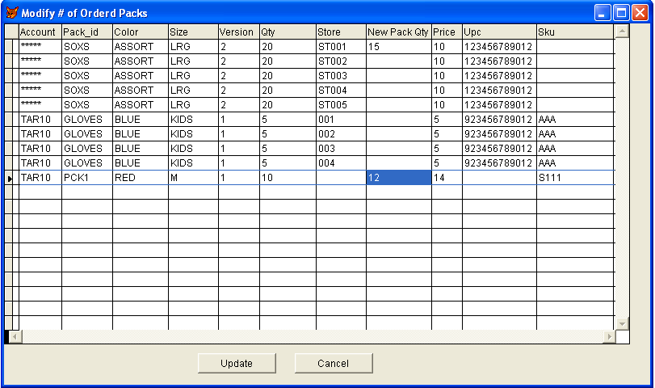

Referring to the above screen; the user enters 15 in the “New Pack Qty” column for Pack: *****- SOXS- ASSORT- LRG- 2; this means when the user hits update the system will update the qty for this pack for store ‘ST001’ from 20 to 15 (correspondingly the qty of component styles) and we are short shipping in this case.
Now for Pack: TAR10- PACK1- RED- M- 1; the new pack qty entered is 12; and since there is no store for this pack then for every occurrence of this pack in the order; update the # of packs from 10 to 12 (correspondingly the qty of component styles); in this case we are increasing the # of packs.

