
Development Request
Aria Systems
Unship Styles on Invoice SO screen

Custom Program # 200499

Screen Template

Product: | Aria 2.7
Module: | AR
Customer name: | GMA
Screen Name: | Invoice SO screen, Unship Styles
Installed Modules: | All modules except PS.
Parameters setting: | (see the Setting file)

Details Section
Screen Name: Invoice Sales Order, Unship option
Existing Initial situation:
Currently, in the Invoice Sales Order screen we have an option to clear (Unship) a particular style that we don’t need to invoice. GMA deals with multi store orders that include hundreds of stores. In such cases, if we need to unship a particular style on the whole order, we have to “Clear” this style on each store separately, which means hundreds of times in such huge orders.

This process of unshipping a style is very time consuming and subject to user errors.

Screen Objective:
To have a way that can globally “Unship” a particular style(s) on a multi-store order while invoicing.

Description:

Below screen is the standard Invoice SO screen in Aria, which has the option to “Clear” or unship any style on the selected Order/Store.

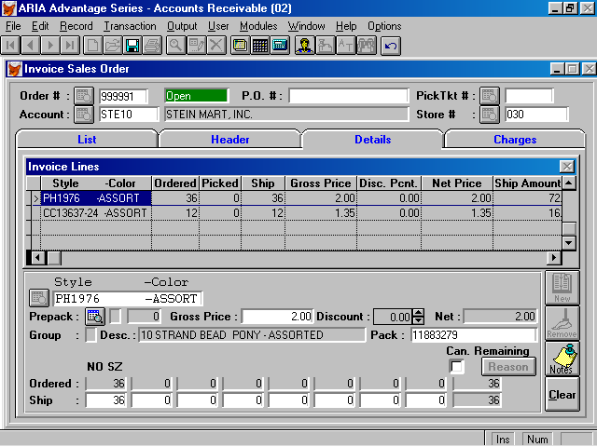

This button is currently used to unship the style

Required Changes:

We need to make this button “Clear” allow the user to unship the selected style for all the stores in the order in one shot. A message will popup once the user clicks on this button: “Do you want to Unship style # % for all the stores?” Y/N
- If the user choose “Yes”, the program will scan the selected style/color within the order and unship its qty from all the stores on the order.
- If the user choose “No”, then the program will unship only the current store.

Rules and Notes:

The function should validate if the order line belongs to a Pack. If the Pack_id field is not empty, then another warning message should popup:
“This Style belongs to Pack Id %. Unship the whole Pack?” Y/N
- If “Yes”, then the program will scan for all the lines related to this Pack_id and unship them (either for current store only or for all stores based on the 1st msg).
- If “No”, the program should return without unshipping the style/pack id.
- Updating the Charges folder with the qty and amount changes will be done normally as in the standard function.

