
Development Request
Aria Systems
Enhance GMA Manual Packing List

Custom Program # C200521

Screen Template

Product: | Aria 2.7
Module: | AL
Customer name: | GMA
Screen Name: | GMA Custom Manual Packing List
Installed Modules: | All modules except PS.
Parameters setting: | (see the Setting file)

Details Section
Screen Name: GMA Custom Manual Packing List
Existing Initial situation:

The current custom Manual Packing List screen does not save the Pack Id key (Pack Id, Color, Size, Version). Besides, we cannot pack using the quantity of the pack (number of packs).

Screen Objective:
- To save the Pack Id key (Pack Id, Color, Size, Version) in the Pack_lin table
- To allow the user generate the Cartons using the number of Packs in each Carton.
- To save the Pack Qty (Npackno) in the Pack_lin table.
- To prevent the user from selecting a Pack components partially in a Carton

Description:

- Save the Pack Id key:

The file structure for the Pack_lin file should be updated to include the Pack Id key:
Pack Id, Color, Size, Version and the Number of Packs (Npackno).
The custom Manual Packing List screen/program should update these fields upon saving the P/L and based on the corresponding order line.

- Generate Cartons using the Pack Qty:

When the user chooses the option “Pack Summary”, the screen consolidates all the lines related to a Pack Id/Color/Size/Version in one line. The Carton Qty. field in this case should represent the number of Packs to be packed in each carton in the selected range of cartons. This should update Pack_lin.Npackno for the applied range of cartons.

A validation should be performed to prevent the Carton Qty to be greater than the ordered number of packs (Ordline.Npackno).

If the user switched the option to “Pack Details”, the program should convert the Carton Qty. to show the qty for each style included in the Pack Id based on the number of packs entered multiplied by the style qty in the selected Pack Id from Spck_lin table.

The same concept when the user clicks Apply, the program should apply the styles qty in the range of cartons using the same calculation.

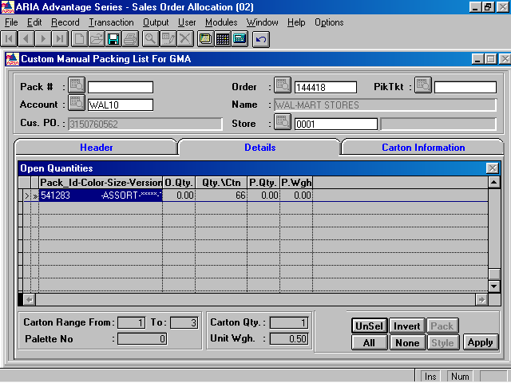
This should represent the Number of Packs if we choose “Pack Summary”

- The user should NOT be allowed to select individual Style(s) if it belongs to a Pack Id. The buttons This and Style should act the same way like when we click Pack button to select all lines belong to the current Pack Id (if not empty).

