
Development Request
Aria Systems
SEARS Shipping Manifest

SEARS Shipping Manifest

Program Add-in

Program Add-in Header
Product: | Aria27
Module: | AR
Customer name: | Hand Craft
Installed Modules: | AL,AP,AR,AS,EB,GL,IC,MA,MF,PO,RM,SM,SO,SR,UP
Parameters setting: | Setup will be emailed to AR module.

System Setting Report:
Sending the above in a txt file along with specs to AR module.

Details Section
Add-in Name : Sears Shipping Manifest.
Add-in Objective : To create a Shipping Manifest print out specific to the Sears Corporation.

Existing Initial situation: The JCP Shipping Manifest has a certain format (layout).

Detail Section: The JCP Shipping Manifest has a certain format (layout). We would like to change that by moving a few fields.

Please look at:

Illustration A. This is the ORIGINAL Manifest in Aria 2.7 (for comparison reason).
Illustration B. This is the requested Manifest in this customization.
Illustration C. This gives you the Programming logic that needs to be changed,

REQUIRED: There are two parts in the customization.
- Part 1 – Layout change. Outlined in the Illustration B with a # against each point in RED
- Part 2 – This is the change in the way the records for each Store/PO will print. We want to program an intelligent Group By. Explanation in detail will be given later. Observe Illustration C for this.

Details:

PART 1: This is the LAY-OUT change of the customization:
The Illustration B, has points marked in each case. Please print this out in a color printer, and observe each point marked, with the following detailed explanation.

#1 : The hard coded word “PEPS” on the left corner should be removed.
#2 : The hard coded word “JCPENNY MANIFEST” will be replaced with the word “CONSOLIDATED MANIFEST”
#3 : The hard coded word “PEPS” on the right side should be removed.
#4 : The hard coded field “SUPPLIER #” should be replaced by “BOL #” The BOL# currently prints on this field’s value.
#5 : Along with the current CITY, STATE, the user would like to see the Street address. In the database it will point to the Warehous.dbf.Caddress1 (This will specifically print the First line address of the Ship to location.)
#6 : The hard coded word “PEPS” will be removed from this Ship Via field.
#7 : The hard coded field “INCLUDE CHECK DIGIT” should be removed. The field “STORE NUMBER” will need to be re-aligned in the center of the box, due to the extra line that will be removed.
#8 : The hard coded field “JCPENNY” should be removed. The field “PURCHASE ORDER #” will need to be re-aligned in the center of the box, due to the extra line that will be removed.
#9 : The Column printing the “MERCHANDISE DESCRIPTION” should be removed. 
#10: There will be a NEW column introduced here. This will be the following field. “DEPARTMENT #”. The new field will contain the Department# field found in the Sales Order. Specifically the field (ORDHDR. Dept). We will print only the First three CHARACTER of this field. This column will specifically fall between Columns “WEIGHT” and “PURCHASE ORDER” 
#11 : The hard coded word “PEPS” will be removed from “PEPS CONSIGNMENT ADDRESS”. Its hould only read “CONSIGNMENT ADDRESS”

 PLEASE note: Points 9 and 10 will remove a column and introduce another column. We will need to shift the existing columns to make sure all the columns fit, and look aligned. Please take care of the lay out when removing and adding columns.

Illustration A
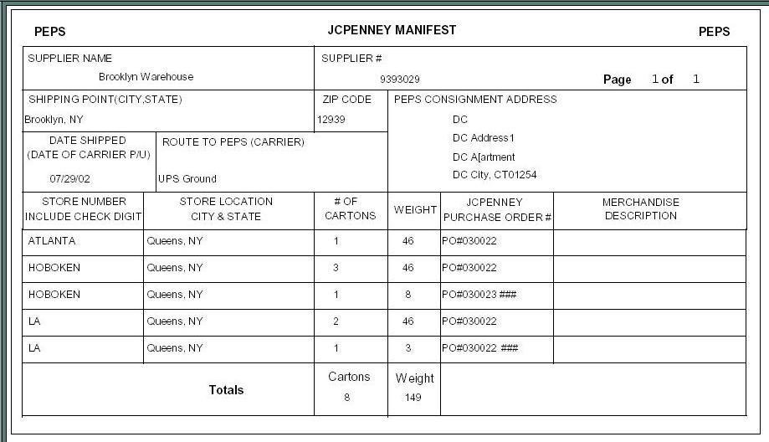
Illustration B
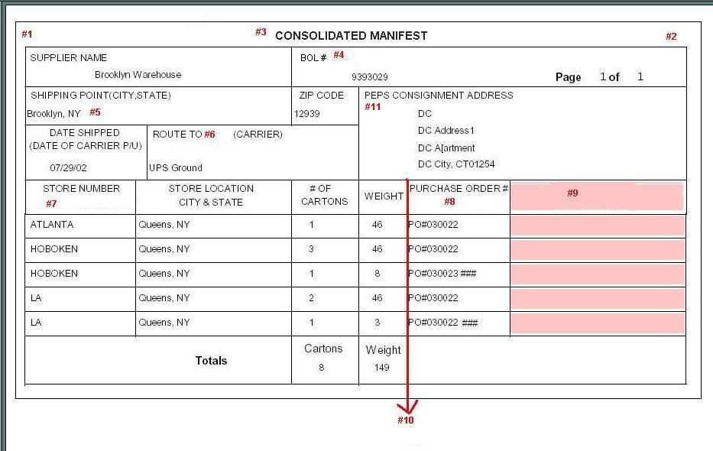

Illustration C

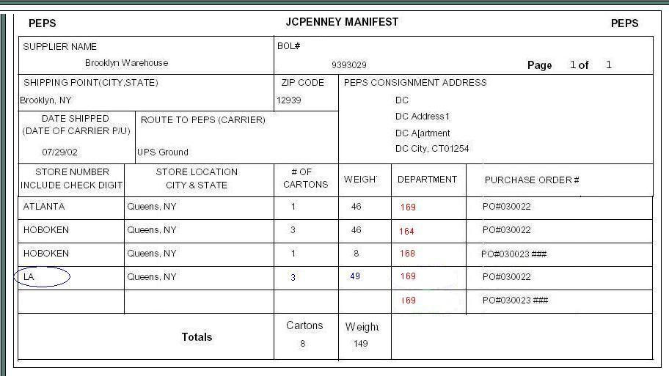
DETAILS: (Contd..)

PART II

The Manifest should group the records in the following manner.

Currently : In (Illustration B ) you can observe the way the records print one line for every Store for each PO.

Required: We want to print the Lines grouped together. We would like to see all lines that have the following:
- Common Store and common Location in one line.
- In this one line, they want to see the # of Carton field and Weight field equal to the sum of lines grouped.
- In a case where the Store and Location field is common, They would like the FIRST line to print the sum of Cartons and Weight
- They always want to print the Department and PO# in all cases for every line.

Please observe the LINES from Illustration B. and notice last 2 lines have common STORE, LOCATION and DEPARTMENT NUMBER.
This is how the current JCPENNY manifest prints each line.

STORE NUMER | STORE LOCATION | # OF CARTON | WEIGHT | DEPARTMENT (New field) | PURCHASE ORDER#
ATLANTA | Queens, NY | 1 | 46 | 169 | PO#030022
HOBOKEN | Queens, NY | 3 | 46 | 164 | PO#030022
HOBOKEN | Queens, NY | 1 | 8 | 168 | PO#030023 ###
LA | Queens, NY | 2 | 46 | 169 | PO#030022
LA | Queens, NY | 1 | 3 | 169 | PO#030023 ###

Please observe how we would like the SEARS ,manifest to print in the same situation:

- Notice that the LAST two records (Store, PO# , Location and Department ) are identical for the two lines. The Department # is common but will print in all cases.
- In such a case they would like us to combine the two lines, and print the WEIGHT and #Of Cartons field as a sum of the two line(s).
- Each with any one of the 2 fields common field print blank for those common fields (Observe empty fields marked in GREY)
- The # of Carton and WEIGHT will not print on all the records, as they should all be totaled and printed only on the FIRST record in these cases.
- Notice the PO# and Department no, will print in all cases.

STORE NUMER | STORE LOCATION | # OF CARTON | WEIGHT | DEPARTMENT (New field) | PURCHASE ORDER#
ATLANTA | Queens, NY | 1 | 46 | 169 | PO#030022
HOBOKEN | Queens, NY | 3 | 46 | 164 | PO#030022
HOBOKEN | Queens, NY | 1 | 8 | 168 | PO#030023 ###
LA | Queens, NY | 3 | 49 | 169 | PO#030022
 |  |  |  | 169 | PO#030023 ###

Option Grid :

We would like this selection for the SEARS MANIFEST to be programmed as part of the OPTION GRID used in the JCPENNY manifest.
It should not be a separate Menu bar, but an option that allows the user to select between the choice to print the JCPENNY MANIFEST or the SEARS Manifest.
User will need to run the Manifest from the MENU, and in the option grid they should be able to switch between JCPENNY and SEARS manifest.

Development Cost | $ 1200.00
Customer signature
  Date signed
Payment Terms | 50 % due upon signing.  50% due upon delivery of the project.  (No work on this project will begin until the deposit is received)
Estimated completion time | 09/23/2002

