
Development Request
Aria Systems
Invoice Form D modification.

Custom Program #102708

Invoice Form D modification

Report

Header
Product: | Aria27
Module: | Accounts Receivable.
Customer name: | Her Style.
Installed Modules: | AL,AR,AS,EB,IC,MA,PO,RM,SM,SO,SR,UP
Parameters setting:

System Setting Report:

Report Details
Report Name: Invoice form D.
Report Objective ( Purpose ): We would like to print the form D with a few field shifted from its original location,.

Description:
Please see Image of the Form D.

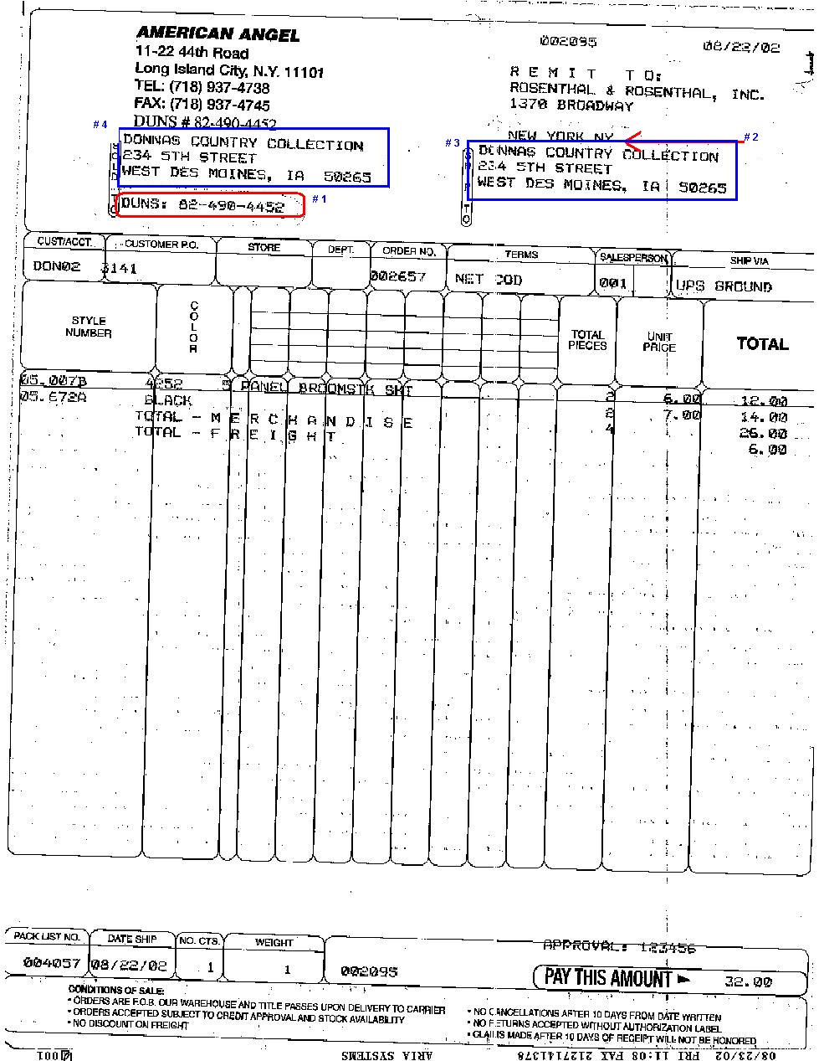

Report Layout
REQUIRED:
We would like the following points to be changed.
# 1- Duns # should be removed.
# 2 – There should be some space between REMIT To address and the Ship to address
# 3 – Move the Ship to address down by 2 lines.
# 4 – Move the Sold to address down by 2 lines.
#5 – Shift the Custom PO number to the right by 1 character

Layout Description
Description of the lay should be changed as per the image included.

Development Cost | 0.00
Customer signature
  Date signed
Payment Terms | 50 % due upon signing.  50% due upon delivery of the project.  (No work on this project will begin until the deposit is received)
Estimated completion time | 10-01-2002

