
Development Request
Aria Systems
Custom Program # (102594) Operation Management Report

New Report Template Description

Report Template

Template Header
Product: | Aria27.
Module: | MF
Customer name: | Jonna.
Installed Modules: | AR, AP, GL, MA, RM, MF, SO, SR, AL, IC, SM
Parameters setting : | We will customize our standard Operation Management Form to display total PCS and total costs by dozens.

System Setting Report:

Report Name: Operation Management
Report Objective ( Purpose ): To display the total pcs and total cost by dozens. The report will also pick up different cost then the one that is being picked up on our standard form.

Description: We need to customize our Standard Operation Management form that we are printing under the MF module (MF-Output-Transaction-Operation Management). We are going to customized this report so that it could display details in Dozens and also change the way the standard form is handling Costs per Piece for Operations. We are also going to make changes to the Selection Grid for this form

Selection Grid:

- We are going to keep the same Selection Grid but add a couple of more fields to the Criteria
- “Print by Dozens” will be a dropdown field with values “Yes” or “No”. If “No” is selected then we are going to print the same way that the form is currently printing. If “Yes” is selected then the program is going to calculate everything by Dozens ( * 12 )
- “Print Prices” will also be a dropdown field with values “Yes” or “No”. If “No” is selected then there will be no Price Amounts on the form
- “Optional Message” field which the user will be able to add any information they want to display on the Operation Management form.

Fields on the Form

Note….You can refer to the bottom of the specs for a visual of this fields

- “Lbs/Doz” field is a combination of two parts.
- “Lbs” portion is being picked up from that Style Cost Sheet under the “UOM” field for that Operation.
- “Doz” will be displayed when the “Print by Dozens” field has a value of “Yes”
Example
- If “UOM” field on the Style Cost Sheet for this Operation has value of “Lbs”
- If “Print by Dozens” is updated as “Yes”
- Then that field would be updated as Lbs/Doz.
- Note that UOM was flagged as “Pcs” instead of “Lbs” then it would read as Pcs/Doz

- The value under the “Lbs/Doz” field is being calculated from the “Net Units” of the Cost Sheet created for that style. You will take the value of “Net Units” and multiply it by 12
Example
- “Net Units” for that Operation under the Style Cost Sheet in MF module = 1.23
- Program will multiply 1.23 * 12 = 14.76

- The “Dozens” field on the form is showing the value of total pieces by dozens
Example
- If I have a Cutting Ticket for a total of 360 Style item (Pcs)
- And I have selected “Print by Dozens” = “Yes”
- Then 360 / 12 = 30
Another Example
- If I have Cutting Ticket for a total of 400 Styles item (Pcs)
- And I have selected “Print by Dozens” = “Yes”
- Then 400 / 12 = 33.33
- The value under the Total Lbs is being calculated by two fields
- The first value is the Lbs/Doz field
- The second value is the Dozens field
Example
- Lbs\Doz field = 15.75
- Dozens field = 30.00
- Then Total lbs = 15.75 * 30.00 = 472.50

- “Pieces” is displaying total Pcs for that Style color for that operation order
- “Total Price” Is the field where it is showing the total price for the work order based on the Style Cost Sheet and Total amount of Pieces for that Operation order
Example
- Total “Pieces” = 360
- “Total Cost” (Picked up from the Style Cost Sheet under “Total Cost” field) =1.66
- 360 * 1.66 = 597.60

Logic of Dozen Calculations

- The Logic of the Dozen Calculation is to show the Operation by Dozens (multiple of 12)
- The reason for this is because Jonna works with their contractors by Dozens and they get billed by Dozens instead of per piece.

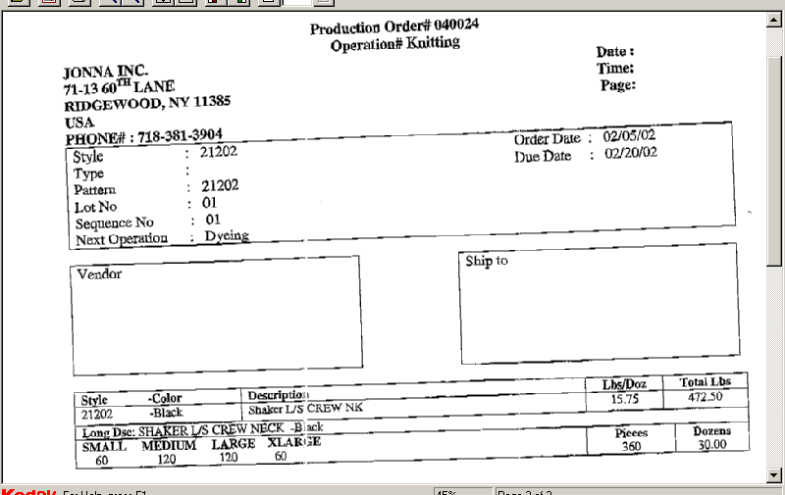
NOTES
If the user was to flag “Print Prices” as “Yes” then it would display here
Optional Messages would display here after the Style Color information
Total Dozens 30.00

This field will be displayed after total “Optional Message” (if any) on the bottom part of the Form. This field will display the Total Dozens of the Operation.

Development Cost | $500.00
Customer signature
  Date signed
Payment Terms | 50 % due upon signing.  50% due upon delivery of the project.  (No work on this project will begin until the deposit is received)
Estimated completion time

