 Development Request
Aria Systems
Custom order design link with thread information

CP # 102231

Approved by: ______________ Date: ___________

From Template

Template Header
Product: | Aria 2.7
Module: | SO
Customer name: | Sope Creek
Installed Modules: | AR, AL, IC, SO, PO, RM, SM, SR.
Parameters setting: | Multi-Currency = N  Multi-warehouse = Y  Extended sizes = NO  Style costing method = Average cost

Program description:
J & L is currently using a custom program in 2.6 (JL100) that allows them to update sales order with the embroidery and threads information.

What happens is that when the customer places an order for some styles and requests designs to put on them, the customer service updates this order in the system with the blank styles.

Afterwards, this order goes to the design department in order to put the design and threads information. At this point, the designs (entered through the design master screen) get married to the styles/colors in the order.

Important note:
All the styles in the style database are considered as blank styles. The link between a style and a certain design takes place at the sales order level.

Assumptions
All the designs used in a particular sales order are applied to all the styles in this order.

There are two pieces of information going to be linked to any sales order with styles going to be embroidered:

1-Embroidery information:

This information is entered at the order header level. It is entered for each design going to be used in the order. It includes a list of every design will be used in this order along with the information related to this design.

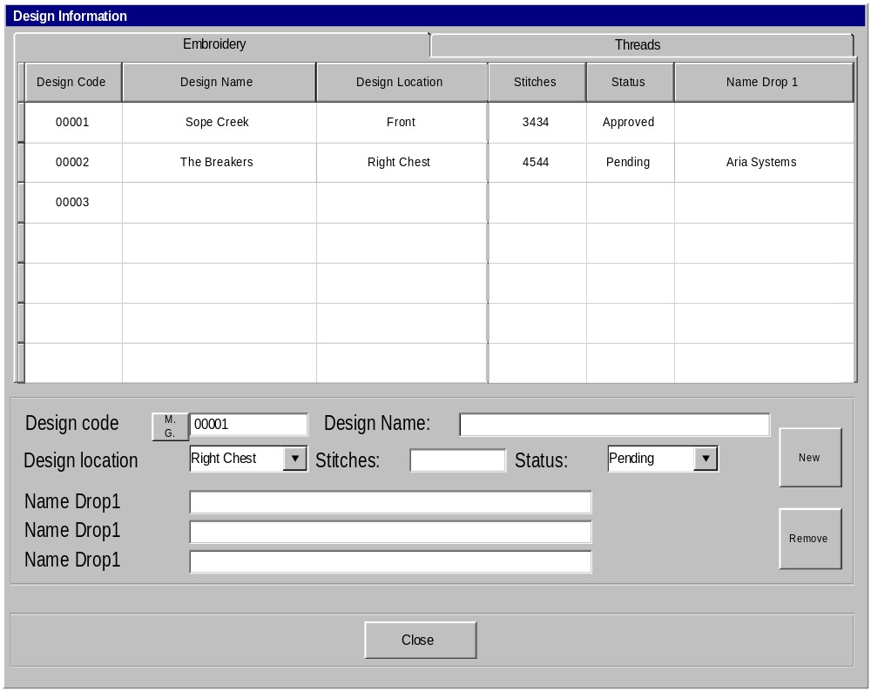

2-Threads information:

This information is entered at the level of each style/design in the sales order (refer to JL100.PRG to see how this information is entered in 2.6)

Basically, this information is just a list of all the threads colors and the description of each one.

Right now, the thread color is a free format field. Sometimes users make mistakes by entering a wrong thread color.

In order to avoid this problem, we are going to add a new code to our codes list
This code will be called thread color.
For each entry, the user will enter a color code and a description for it (no related fields are required)

Threads information screen layout:

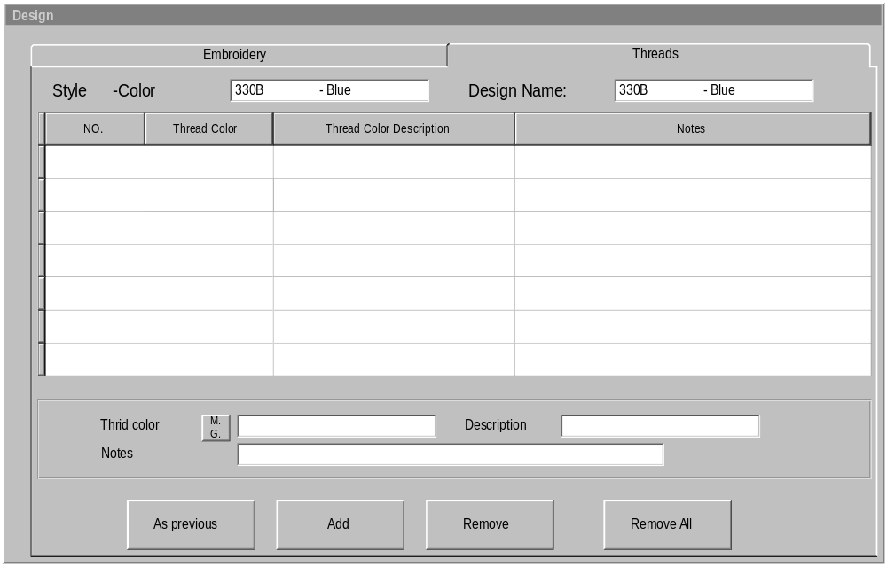

Notice that this screen (Embroidery and threads information) will be accessed from within our standard sales order screen.
The user will get into this screen when clicking on the CONFIGURE button in the details folder.
The same screen should be accessed also through the OPTIONS menu in the sales order screen. The reason is that the user doesn’t have to go to the details folder to enter the designs information.

Screen’s Functionality and business rules:

- The threads folder (Tab) should only be accessible if the current folder (in the sales order screen) is the details folder AND there is at least one design entered through the Embroidery folder.
- The Embroidery tab should be the default one if the current tab (in the sales order screen) is the header tab.
- If we are in the detail folder of the sales order screen, when running the design screen, the thread folder should be the default one.
- Under the Embroidery tab, When the user types in the design code, the rest of the fields should be pulled from the design file and displayed on this screen. The user should be able to edit these fields except for the STATUS field. This one should be disable.
Since the design code might have more than one location assigned to it (through the design master screen). This field will be defaulted to the first design location. Notice also the drop down menu will show the design location description (not the code)
- Upon entering the design code (under the Embroidery folder), the program should check on the status of this design code (we will look up the design code in the design file), if the design has a Pending status, the following message should be displayed to the user:
“Design code XXXXXX has not been approved yet. Are you sure want to proceed? (Yes/No) If yes, the user will proceed normally, else the program won’t allow entering this code.

- Every design entered through the Embroidery folder will be assigned to all
The styles in the sales order.
This is due to J & L business rule that all the designs entered in the sales order are applied to all the styles in this order.
If J & L customer places one order requesting different designs to go on different styles, such order will be split to more than order.

- Notice that in the threads folder, the threads colors that are entered belong to the design being highlighted (in the Embroidery folder) and the order line we are pointing to in the detail folder
In other words the threads information are entered at the level of each order line/design in the order.

- Notice that the small button in front of the thread color field(in the threads folder) is a magnifying glass (refered to as M.G.),
When the user clicks on the magnifying glass or type question mark, a browse screen will be displayed with a list of all the thread colors (entered through the codes screen)
If the user typed in a thread color that is not found in the codes file, the following message will be displayed:
“Thread color code xxxxxx is not found in the codes file. “
It will have the following options:
Add/Reenter/browse
If the user selects to Add, this code will be added to the CODES file as if it was entered through the CODES screen.

9- The As previous option under the Threads folder will work as follows:
Upon clicking on this button, the program will look for all the previous sales orders lines that are created for the same account/store/style/design code, then display a browse screen (refer to the below layout) with the all the orders lines that match with the above condition.
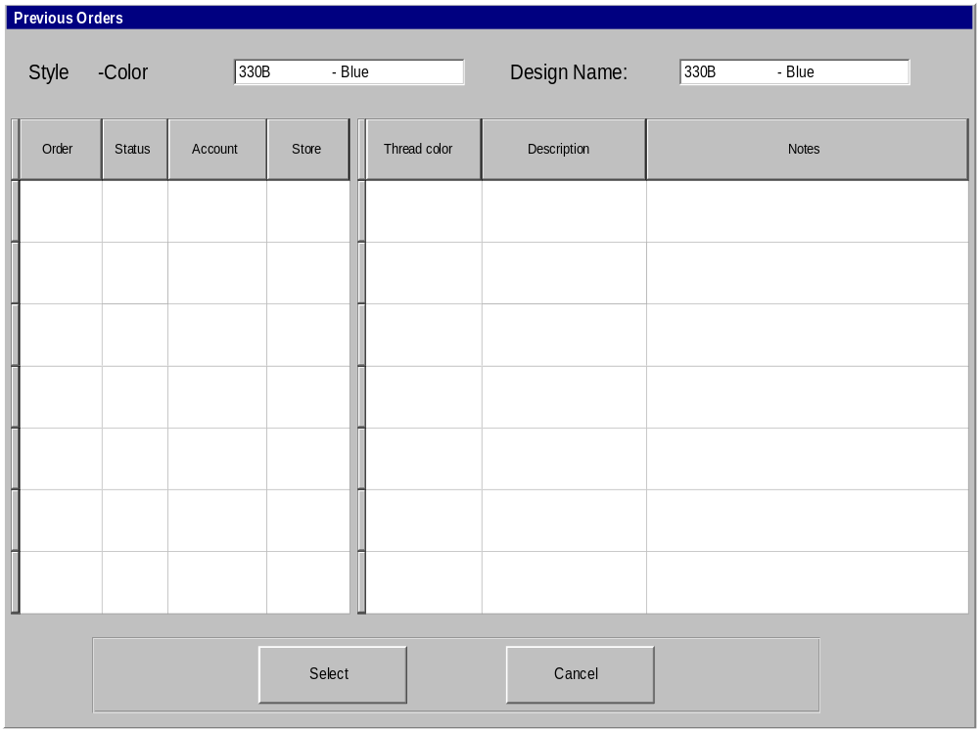
As shown above, the browse on the left hand side is the one that shows all the previous order lines for the style being pointed to.
As the user scrolls in this browse, the browse on the right side of the screen will show all the thread colors that belong to this order line and the design being pointed to.
When the user clicks on the select button (or hit enter), all the threads colors that are updated for this record will be displayed on the screen as the default threads information.
Notice that after copying the threads colors from a previous order, the user still can add/remove colors.

In order to accommodate the designs information explained above, we will need to have a new file created (it will be a custom file for J & L) OR we may modify the structure of BOMVAR file to accommodate the above design information.

The following table shows the fields that we need to have in this file

Field label | Description/updates
Type | It will hold “SO” for sales orders and “AD” for Adornment order.  The reason is that, we will use the same file to maintain the design information for the Adornment orders.
Order number | The sales order number OR the Adornment order #
Order line No | Sales order line No or Adornment order line No
Design code | A valid design code.
Design location(style position) | The code for the design location the user selects from the popup
Name drop1 | Whatever the user enters in this field.
Name drop2 | Same as above
Name drop3 | Same as above
Thread color code | The thread color selected/added by the user.
Notes | Can enter up to 50 characters. It will hold the notes entered for each thread color.

Indexes used with the file should be as follows:
- Type + order # + order line No + design code (Main index that will be used by this screen)
- Type + design location code + order # + order line No
(It will be used by some reports are location driven)

Important note
While entering the threads colors (for a particular Design/style), the number of thread colors entered cannot exceed 10 colors(as per 2.6) however, in 2.7 the design of the thread colors screen allows entering as many colors as needed.
As a result of that, you may consider adding each thread color in a new record.
OR you may define 15 fields for example for the thread colors assuming that the user will never exceed this number.

Following is the message between Amin & Sherif about this entry.

Hi Amin,

I spoke to the customer and they told me that this situation (putting the same design on two different locations on the same style) never happened therefore, you don’t need to consider this case.
Thanks,
Sherif.

-----Original Message-----

From: SO [mailto:SO@ARIA.COM.EG]
Sent: Thursday, May 17, 2001 8:01 AM
To: NY Sherif Attala
Subject: FW: Aria27 CP # 102231

Please try to reply ASAP.

-----Original Message-----

From: SO
Sent: Wednesday, May 16, 2001 5:24 PM
To: NY Sherif Attala
Subject: FW: Aria27

Hi Sherif,
Assuming we have the following :
Assume we have entered Design Code # 000001 in Embroidery folder with Design Location LEFT another one Design Code # 000001 with Design Location : RIGHT My question is, Is the above scenario is acceptable or not. In other words, If this is acceptable the thread color folder MUST be BY Style/Design/Design Location not only Style/Design. Also the Design Location in the Embroidery folder will be editable only in the Add mode. Please reply to me ASAP.

Thanks a lot
Amin Khodary
Aria System, Inc.

-----Original Message-----

From: Sherif Attala [mailto:SHERIF@ariany.com]
<mailto:[mailto:SHERIF@ariany.com]>
Sent: Tuesday, May 08, 2001 2:35 AM
To: EG SO
Subject: FW: J&L Custom program # 102231

<<102231.doc>> Hi Amin,
Please find the answers to your questions in the document you sent me.
Thanks,
Sherif.

-----Original Message-----

From: SO [mailto:SO@ARIA.COM.EG] <mailto:[mailto:SO@ARIA.COM.EG]>
Sent: Monday, May 07, 2001 9:16 AM
To: NY Sherif Attala
Subject: RE: J&L Custom program # 102231

Hi Sherif,
Please find attached document that have all my comments and questions about
the entry # 102231 for J&L. Please reply ASAP
<<102231.doc>>
Thanks a lot
Amin Khodary
Aria System, Inc.

-----Original Message-----

From: Sherif Attala [mailto:SHERIF@ariany.com]
<mailto:[mailto:SHERIF@ariany.com]>
Sent: Thursday, May 03, 2001 3:58 PM
To: EG SO
Subject: RE: J&L Custom program # 102231

Thanks,
Sherif.

-----Original Message-----

From: SO [mailto:SO@ARIA.COM.EG] <mailto:[mailto:SO@ARIA.COM.EG]>
Sent: Thursday, May 03, 2001 4:38 AM
To: NY Sherif Attala
Subject: RE: J&L Custom program # 102231

Hi Sherif,
Of course I know there will be a trigger to fire this custom screen. Anyway, I was trying to a void a testing of the sales order entry screen because any issues related to Sales order screen it requires to test it again.
Thanks a lot
Amin Khodary
Aria System, Inc.

-----Original Message-----

From: Sherif Attala [mailto:SHERIF@ariany.com]
<mailto:[mailto:SHERIF@ariany.com]>
Sent: Wednesday, May 02, 2001 9:47 PM
To: EG SO
Subject: RE: J&L Custom program # 102231

Hi Amin,
It is more convenient for the customer to enter the Embroidery and threads information from within the sales order screen. Since the designs information gets linked to the sales orders so it makes sense to have this information entered through the sales order screen. This should be similar to the configure option we currently have in the detail folder of the sales order screen.
I thought you guys can have a trigger that when clicking on the configure button, the program will call the new screen instead of the Existing screen. I’m wondering why it is easier to develop a new screen from scratch rather than adding to the existing functionality of the sales order screen.
Thanks,
Sherif.

-----Original Message-----

From: SO [mailto:SO@ARIA.COM.EG] <mailto:[mailto:SO@ARIA.COM.EG]>
Sent: Wednesday, May 02, 2001 3:42 PM
To: NY Sherif Attala
Subject: J&L Custom program # 102231

Hi Sherif,

Could you please let me know why you need to have this entry to be loaded within from Sales Order Entry screen. In 2.6 it called from a separate screen not from the SO entry screen and If we simulate the same case that found in 2.6 it will be easy for coding & testing.
Waiting for your reply.
Thanks a lot
Amin Khodary
Aria System, Inc.

