 Development Request
Aria Systems
Custom production scheduling report

CP # 102233

Approved by: ______________ Date: __________

Report template

Template Header
Product: | Aria 2.7
Module: | SO
Customer name: | Sope Creek
Installed Modules: | AR, AL, IC, SO, PO, RM, SM, SR.
Parameters setting: | Multi-Currency = N  Multi-warehouse = Y  Extended sizes = NO  Style costing method = Average cost

Report name:
Production scheduling report.

Purpose of the report
This report will be used to identify the production workload within a specific period of time. That will be done by calculating the time spent to finish producing the adornment (The embroidery operation)
The production work load within any period of time will be based on the
Open quantities of the sales orders that belong to this period.

Report’s calculations
The customer is currently using a time- table (an excel spread sheet) that shows how many minutes it takes to run one machine run (based on the # of stitches and the color change)

The below sheet shows part of the time table used to calculate the production time. 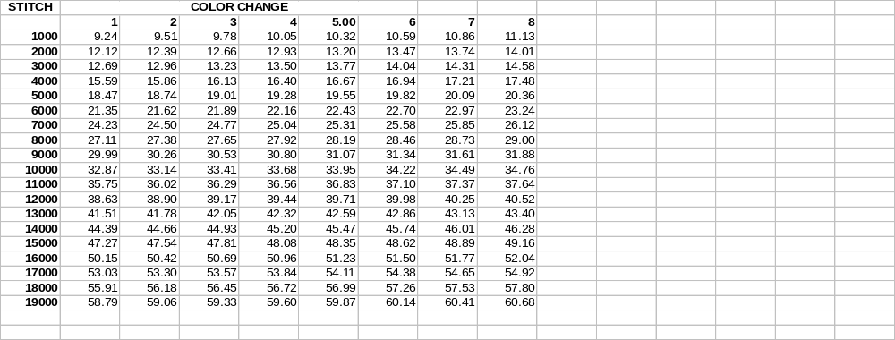
Example:
Sales order # 000100
Style Open quantity
A - 001 20
B - 003 15
Design information:
- Design code: 100
Design location: Left chest
Stitches count: 10200
Color change : 4

- Design code: 200
Design location: Right chest
Stitches count: 8000
Color change: 3

Based on this example, the calculations should work as follows:

Design location: Left chest
Number of runs = Total open quantity/12 (where 12 is the number of heads per machine) + 1 (one extra run for sample)

Number of runs = 35/12 (always round up) + 1
= 4

Production time = Number of runs * Minutes per run
= 4 * 36.56(refer to the time table)
= 146.24

Design location: Right Chest:
Number of runs = (35/12) + 1
= 4
Production time = 4 * 27.65
= 110.6
Total production time spent to produce this order:

146.24 + 110.6 = 256.84 Minutes

Selection criteria
- Report Format:
It will be either Summary OR Detail. If the user choose the detail format, the layout will be as shown below. If the user selects the summary format, the report will show only a subtotal for each design location and a grand total at the end.

- Design location:
The user will be able to select one or more design locations to be included in the report (A mover will be used for that purpose)

- Design status:
A mover will be used for that purpose.
- Order status
A mover will be used for that purpose.
- Select by (will have the same options as the order detail report)(i.e. Account, location, primary sales rep …etc)
- Partially shipped orders
A drop down menu with Yes and No (Same as the order detail report)
- Include allocated orders (same as the order detail report)
- Order Start date range
- Order complete date range
- Style groups
- Only these colors Same as the order detail report
- Season
- Division
- Priority
- Order category
- Import Time-table
The user will be able to select the Excel Comma delimited file that will be exported to Aria
Notice the following:
The Timetable spreadsheet has to be saved with the type of comma delimited. The format of the Excel file will be exactly the same as the one shown above. Once the user selects the Timetable comma delimited file, the system will append the information in this file to a DBF file, this DBF file will be used by the report (to retrieve the # of minutes per run) each time the report runs.
If the user selects to import the timetable again (the user will do that if there is any update happened on the figures shown in the time table), the program will replace the existing DBF with the new one.

Report Layout

Design location: C(35)
Order # Style -Color Design name Number of pieces Estimated PT Actual PT
C(6) C(19) C(35) N(9,2)
--------------------------------------------------------------------------------------------------------------------------------------------------------
(A subtotal per order is printed here) N(10,2) N(11,2) N(11,2)
--------------------------------------------------------------------------------------------------------------------------------------------------------
Design location description (a subtotal at the location level) N(10,2) N(12,2) N(12,2)
--------------------------------------------------------------------------------------------------------------------------------------------------------
=======================================================================================
Grand Totals N(10,2) N(12,2) N(12,2)
=======================================================================================
Important Notes:
- Notice that the information printed in the report will be sorted by:
Design location Code + Order # + Order Line #

The report will show the design location name then a list of all the order lines with designs belong to this location.
A subtotal will be printed at the level of each location/order #, another subtotal will be printed at the location level and a grand total will be printed at the end of the report.

- The report will be printed on a wide paper on a dot matrix printer. However, we still can print on a narrow paper (by selecting paper type as Narrow)

- The calculation for the estimated production time will be based on 8000 stitches and 5 colors change. In other words, we will be using the same formulas shown in the above example except that we will replace stitch count with 8000 and the color change with 5.

- Notice that the production time (PT) is not calculated at the order line level (Refer to the above layout)

