 Development Request
Aria Systems
Custom Adornment order

CP # 102244

Approved by: ____________ Date: __________

Program Add-in Template

Template Header
Product: | Aria 2.7
Module: | PO
Customer name: | Sope Creek
Installed Modules: | AR, AL, IC, SO, PO, RM, SM, SR.
Parameters setting: | Multi-Currency = N  Multi-warehouse = Y  Extended sizes = NO  Style costing method = Average cost

Program name:
Generate adornment orders from sales orders.

Program objective:
- To have the “Adornment order planning tool” program available in the Style purchase order module.
- To allow creating an adornment order per pick ticket.

Program description:
We need to do the following customizations in our standard “Adornment order planning tool” program:

- We need to run this program from the style purchase order module since the customer doesn’t have the manufacturing module.

- Right now the standard program creates one adornment order for all the selected pick tickets, we need to change that in order to create a separate adornment order for each pick ticket.
For example, if there are 5 pick tickets selected (to create adornment orders for), the program should create 5 adornment orders, each one will be created with the same styles and quantities of the pick ticket.

- Right now the main screen of the standard program displays a browse screen with all the designs that are used by the sales orders (Design lines browse screen)
We need to replace this browse screen with the “order lines” browse screen (the one that gets displayed when clicking on the order details button)

According to that, the screen the user will get when running the program should look like the following:

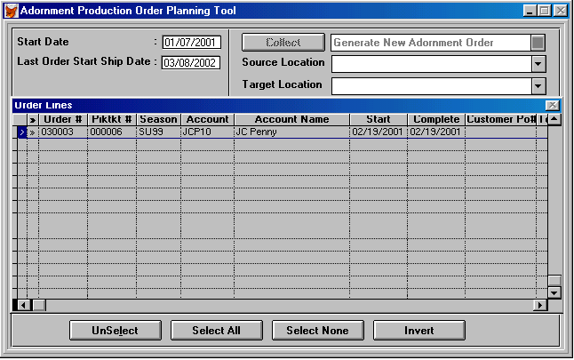

- The order lines browse screen will not show the pick tickets for which adornment orders are already created. It will also show only the open pick tickets with Type “A”
(The pick tickets that are created for orders with designs linked to them will show with type “A”. Please refer to the specification of the custom pick ticket program for further explanation)

- As you see in the above screen, there is a drop down menu to select either to generate a new adornment order OR Add to an existing adornment order.
We need to eliminate this option, as the program will never add to an existing adornment order, instead a new adornment order will always be created for each pick ticket.

- Right now the standard program is doing some validations upon which the adornment orders are created.
For example, it the total quantity ordered from a certain design doesn’t reach the minimum qty setup for this design, the program doesn’t create adornment orders for the order lines that use this design(refer to the original specification of the program for further explanation)
Notice that this sort of validations will not be applied to this custom program.

