 Development Request
Aria Systems
Custom Adornment order

CP # 102357

Approved by: ____________ Date: __________

Program Add-in Template

Template Header
Product: | Aria 2.7
Module: | PO
Customer name: | Sope Creek
Installed Modules: | AR, AL, IC, SO, PO, RM, SM, SR.
Parameters setting: | Multi-Currency = N  Multi-warehouse = Y  Extended sizes = NO  Style costing method = Average cost

Program name:
Adornment order.

Program objective:
Make the “Adornment order” screen available from the Style purchase order module with some changes in it to accommodate J & L requirements.
Program description:
The screen will have 3 folders: Header, details and summary.

The header folder: It will show the same exact information as the standard adornment order screen.

The details folder:
It will have the same layout as the standard adornment order screen except for the following:
- The Ador. Field displayed on the right hand side of the screen will be removed since J & L doesn’t add the adornment cost to the total cost of the adornment order.
- When the user clicks on the adornment/configure button (found in the detail folder), we will be displaying the same exact screen that we display when the user clicks on this button in the sales order screen (refer to CP # 102231)
Screen layout:
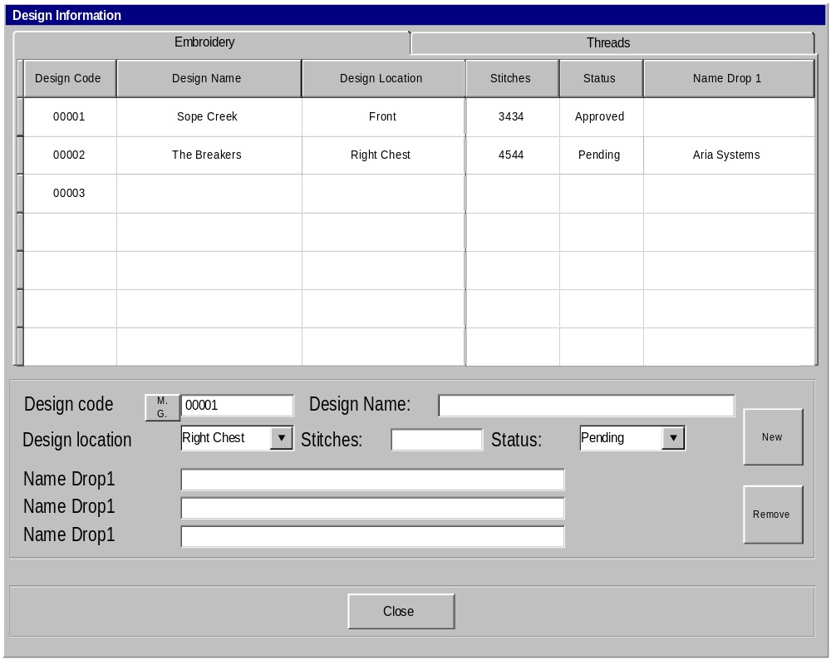
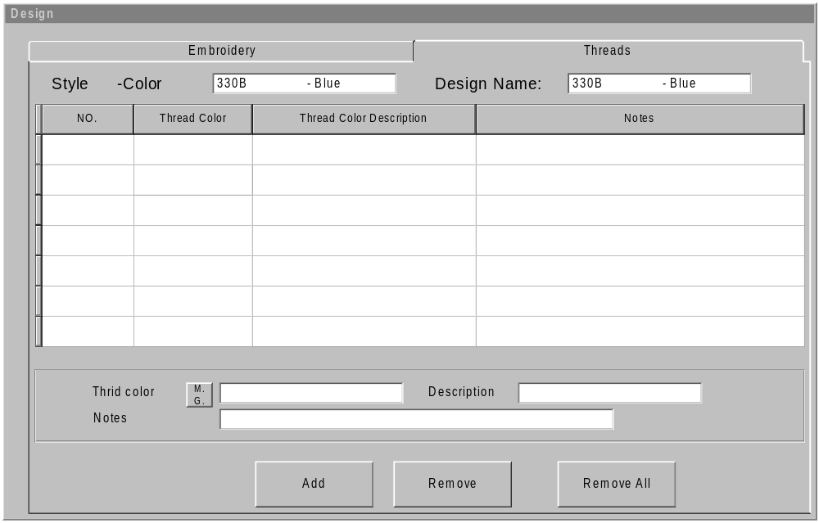

Screen’s functionality:
- As shown above, the screen is going to have two folders: Embroidery and threads

- The embroidery folder will show a list of the designs that are going to be embroidered on the styles included in the adornment order.
Notice that all the designs entered will be assigned to all the styles in the adornment order.

- The threads folder will show a list of the thread colors that are used with every style/design in the adornment order.
In other words, the thread colors will be entered at the level of each style/design.

- According to that, in the threads folder, the threads colors that are entered will be for the design being highlighted (in the Embroidery folder) and the adornment order line we are pointing to in the detail folder

- If we are viewing/editing an existing adornment order, the program should check if the adornment order is created through the adornment order-planning tool (refer to CP # 102244), if this is the case, the adornment screen should bring over the embroidery and threads information of the sales order from which the adornment order is created.

- Notice that this screen (embroidery and threads information screen) should be accessed through the OPTIONS menu option (as well as the adornment button in the details folder). The reason is that the user doesn’t have to go to the details folder to enter the designs information as this information doesn’t vary from one style to another.

- The threads folder (Tab) should only be accessible if the current folder (in the adornment order screen) is the details folder AND there is at least one design entered through the Embroidery folder.

- The Embroidery tab should be the default one if the current tab (in the adornment order screen) is the header or the summary tab.

- If we are in the detail folder of the adornment order screen, when getting into this screen, the thread folder should be the default one.

- Under the Embroidery tab, when the user types in the design code, the rest of the fields should be pulled from the design file and displayed on this screen. The user should be able to edit these fields except for the design name and status field. These two fields should be disable.

- Since the design code might have more than one location assigned to it (through the design master screen). This field will be defaulted to the first design location. Notice also the drop down menu will show the design location description (not the code)
- Upon entering the design code (under the Embroidery folder), the program should check on the status of this design code (we will look up the design code in the design file), if the design has a Pending status, the following message should be displayed to the user:
“Design code XXXXXX has not been approved yet. Are you sure want to proceed? (Yes/No) If yes, the user will proceed normally, else the program won’t allow entering this code.

- Notice that the small button in front of the thread color field(in the threads folder) is a magnifying glass (refered to as M.G.),
When the user clicks on the magnifying glass or type question mark, a browse screen will be displayed with a list of all the thread colors (entered through the codes screen)
If the user typed in a thread color that is not found in the codes file, the following message will be displayed:
“Thread color code xxxxxx is not found in the codes file. “
It will have the following options:
Add/Reenter/browse
If the user selects to Add, this code will be added to the CODES file as if it was entered through the CODES screen.

The summary folder: It will have the same exact layout as the standard adornment order screen except that the Ador. Cost element will be removed.

Files updates:

A new file will be created t OR we may modify the structure of BOMVAR file in order to accommodate the above design information.

The following table shows the fields that we need to have in this file

Field label | Description/updates
Type | It will hold “SO” for sales orders and “AD” for Adornment order.  The reason is that, we will use the same file to maintain the design information for the Adornment orders.
Order number | The sales order number OR the Adornment order #
Order line No | Sales order line No or Adornment order line No
Design code | A valid design code.
Design location(style position) | The code for the design location the user selects from the popup
Name drop1 | Whatever the user enters in this field.
Name drop2 | Same as above
Name drop3 | Same as above
Thread color code | The thread color selected/added by the user.
Notes | Can enter up to 50 characters. It will hold the notes entered for each thread color.

Indexes used with the file should be as follows:
- Type + order # + order line No + design code (Main index that will be used by this screen)
- Type + design location code + order # + order line No
(It will be used by some reports are that are location driven)

Please notice that this program will update the design information in the same file that is used when linking the design information to the sales order (refer to CP # 102231)

As far as updating the adornment order infromation( the header and details information), that should work exactly the same as the standard adornment order program.

Important note:
We need to allow the user to cancel an adornment order even if it has been issued already.
In this case, a return transaction should be updated in the inventory journal file to update the inventory back with the pieces that have been issued.

