
Development Request
Aria Systems
Customization on Custom Purchase Order for Momentrend

Custom Program ID - 102545

Consultant: Sadaf Sharif

Customization on Custom Purchase Order for Momentrends

Program Add-in Template

Program Add-in Header
Product: | Aria27
Module: | PO
Customer name: | Momentrends
Installed Modules: | AL,AR,AS,CR,EB,IC,MA,PO,RM,SM,SO,SR,,UP
Parameters setting: | They have 3 user defined fields, on the PO entry screen

Details Section
Add-in Name : Layout change on Custom Purchase Order for Momentrends

Add-in Objective : We would like to change the layout, and add more information to the existing layout, as well as add new Column totals.

Existing Initial situation: The PO form is currently a Custom PO. Please refer the original layout and compare with following details

ORIGINAL CUSTOM PO FORMAT
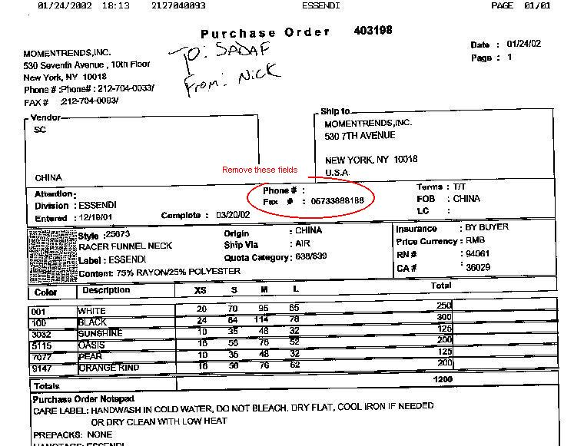

REQUESTED CUSTOM PO FORMAT

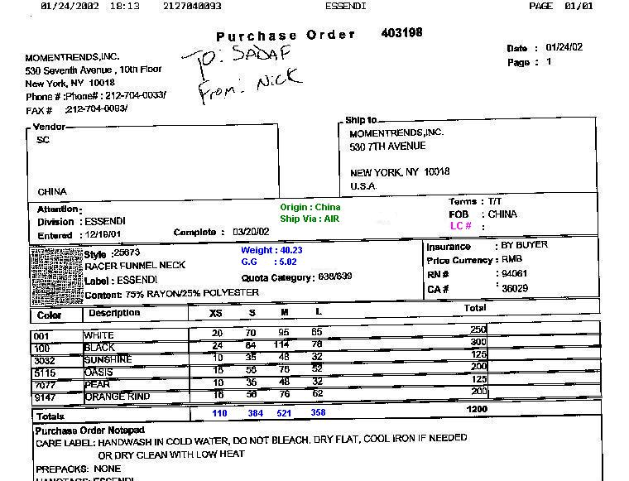

Description :
User Defined fields for the PO screen are –
Label | Field name | Format
Weight | Weight | Numeric 5 Decimal 2
G.G. | Gauge | Char 10
Customer cxl | Custcxl | Date

Existing: They have a Custom PO form, attached is a copy of the Original.

Required: We are required to do the following on certain fields.
Attached also is an illustrated copy of what we require.

- We will move the following fields. New position marked in RED
Origin
Ship Via

- We will remove following fields circled in RED
Phone
Fax #

- We will print the following new User defined fields, illustrated in BLUE
Weight (field name : weight)
G.G. (field name : gauge)

- We will change the Text name for the following Field
LC, will be changed to LC #

- We will create column totals for each scale size, illustrated in BLUE

Development Cost | $500.00
Customer signature
  Date signed
Payment Terms | 50 % due upon signing.  50% due upon delivery of the project.  (No work on this project will begin until the deposit is received)
Estimated completion time | 6 –8 weeks from the date of signing this document

