
Development Request
Aria Systems
Custom Order Confirmation - To print more characters in Style column.

Custom Order Confirmation - To print more characters in ‘Style’ column.

Program Add-in

Program Add-in Header
Product: | Aria27 – Order Confirmation
Module: | Sales Order – SO
Customer name: | MUL10 – Mulberry Neckwear
Installed Modules: | AL/AP/AR/AS/EB/GL/IC/MA/PO/RM/SM/SO/SR/UP
Parameters setting: | No specific settings required.

Details Section
Add-in Name :. Need to increase no. of characters printed for STYLE field on Custom Order Confirmation.

Add-in Objective : Customer has a custom Order Confirmation form, that prints only 7 characters for the STYLE field. This length is not enough. They need to print at least 12 characters for this field in order to identify the styles.

Existing Initial situation: This is a Custom Order Confirmation, designed to print on a Pre-formatted paper. This was done under JobID- 101106.
The format for the Column that prints Style/Color/Size was requested to prints as follows-

STYLE (7) + SIZE (0) + COLOR (2)

Description ( Processing ) :
NEW REQUEST - The customer would like to change the way Style/Color/Size prints as currently programmed in custom program 101106 -

PREVIOUSLY : STYLE (7) + SIZE (0) + COLOR (2)

The custom would like the new STYLE/COLOR/SIZE to be as follows-

REQUESTED : STYLE (12) + SIZE (0) + COLOR (2)

SUMMARY - Please add 5 characters more to the "STYLE" only.

Format Layout
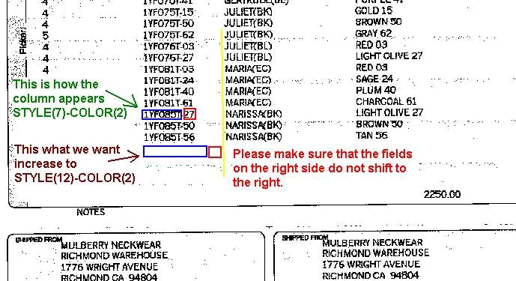

Constraints ( Global ) :
Not more than 5 characters can be added to STYLE/SIZE/COLOR, because the preformatted form does not have any more space for that column.

Consequences (Side Effects) : None

Development Cost | $ 900
Customer signature
  Date signed
Payment Terms | 50 % due upon signing.  50% due upon delivery of the project.  (No work on this project will begin until the deposit is received)
Estimated completion time | 6 –8 weeks from the date of signing this document

