
Development Request
Aria Systems
Key Change For Store Numbers

CP#102427

Program Add-in Template Description

Program Add-in Template

Program Add-in Header
Product: | Aria27
Module: | SM2
Customer name: | Mulberry Neckwear
Installed Modules: | List modules installed at the clients computers.
Parameters setting: | The setting of the key parameters of the current installation that could affect the requirements e.g. using Multi Currency, Multi Store, etc.

System Setting Report:
We need to get a list of all system settings.
You can export the system settings through Aria 2.7 as follows:
Select the menu “User” then the Menu Option “Settings” then the submenu option “Export System Settings” then finally write down the file name to which settings will be saved.

Details Section
Add-in Name : Key Change for Store Numbers
Add-in Objective : If Customer what to change their Store numbers for any reason they can change in the whole system, just to keep the consistency, we should do this change globally.

Existing Initial situation: Currently we don’t have a option to do the key change of customer’s store numbers.

Description ( Processing ) :
When we go in Global Change → Key Change option we should have the pull down option for Stores also. And when we select this option we should do the following
In this section you can:
- Select the option of Store
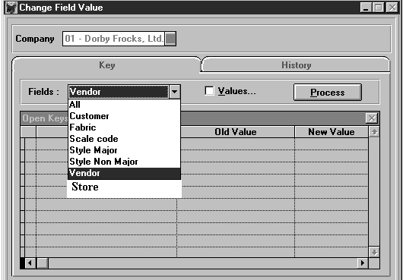

Description ( Processing ) :

- Click on Values should open the following screen
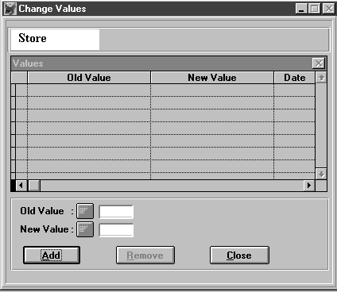

- Here we should enter the old store and new store numbers.
- Then close this screen.
- Then click Process will run the problem and change the store numbers in the following files.

ARHIST
ASN_SHIP
BOL_HDR
CONSINVH
CONSINVL
CREDIT
DEBIT
EDISTORE
ICNAMDRP
INVHDR
ORDLINE
PACK_HDR
PIKLINE
PIKTKT
POSHDR
POSLN
PRODACTI
PROFILE
REPCOMM
RETHDR
UPSBOX
CUSTOMER
PLANSCHH
PLANSCHD
CONTACT
EDIDRCRH
EBREMITT
ORDINQHD
ORDINQLN
INVLINE
SYSCHDUL
ORDCANLN
ORDREPLN
SYWCUST
HISTACTI
ORDHDR
RETAUTH

Note :
If this Add-in contains the development of a new branching screen, please use the “New Program Template” to hold this requirement.

Development Cost | $1500.00
Customer signature
  Date signed
Payment Terms | 50 % due upon signing.  50% due upon delivery of the project.  (No work on this project will begin until the deposit is received)
Estimated completion time | 6 –8 weeks from the date of signing this document

