
Development Request
Aria Systems
Mulberry PO Up Link Program

Custom program # 102511

PO Up Link Program

Program Add-in

Program Add-in Header
Product: | Aria27
Module: | Purchase Order
Customer name: | MUL10 – Mulberry Neckwear
Installed Modules: | AL/AP/AR/AS/EB/GL/IC/MA/PO/RM/SM/SO/SR/UP
Parameters setting: | Create Manual PO# - NO  Multiple Warehouse PO – NO

Details Section
Add-in Name : Custom PO Uplink Program..

Add-in Objective : Our program will interface the customers Temporary Database(s), in order to import a PO transaction into ARIA

Existing Initial situation: The customer has a program that converts Excel files into temporary files, namely Mulberry PO header, and Mulberry PO Detail files. We need to import the PO record(s), from these Mulberry PO Header and PO detail files, into ARIA.

Existing Initial situation: The customer has a program that converts Excel files into temporary files, namely Mulberry PO header, and Mulberry PO Detail files. We need to import the PO record(s), from these Mulberry PO Header and PO detail files, into ARIA.

Description ( Processing ) :
The following are the Mulberry PO files, The customer will write into these files. These are the files, we will import the data from, in order to populate ARIA POSHDR and POSLN.

COMPATIBILITY:
The Mulberry PO files, have all the mandatory fields required to create a valid PO record in ARIA. Each field in these databases were designed to match a corresponding field in the POSHDR and POSLN databases found in ARIA.

FILES: Illustrated in Figure a, are the two Mulberry PO tables.

The Mulberry PO Header file is called (POHEADER.dbf)
The Mulberry PO Temporary file is called (PODETAIL.dbf)

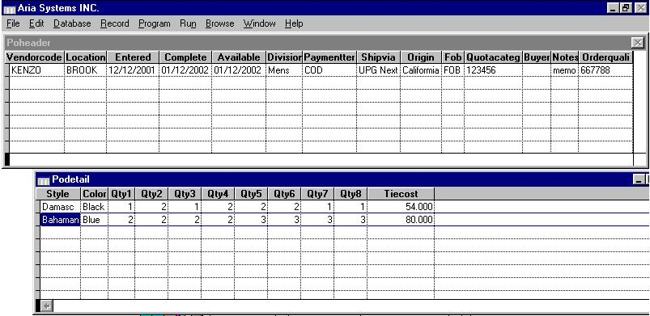

Figure (a.)

FUNCTIONALITY
The PO Header will contain only one PO header record at a time
The PO Detail will contain all the Styles ordered against that PO header.
The PO Header and the PO Detail will be related to each other by a common key field.

File Structure :

The following Mulberry PO Header Files will populate the Aria PO Header Table, as mentioned in the chart below.

POHEADER and POSHDR comparison.
Mulberry Fields | Type | Size | Aria fields | Type | Size
Vendorcode | Character | 8 | Vendor | Character | 8
Location | Character | 6 | Cwarecode | Character | 6
Entered | Date | 8 | Entered | Date | 8
Completed | Date | 8 | Complete | Date | 8
Available | Date | 8 | Available | Date | 8
Divisions | Character | 6 | Cdivision | Character | 6
Paymentter | Character | 6 | Ctermcode | Character | 6
Shipvia | Character | 6 | Shipvia | Character | 6
Origin | Character | 20 | Origin | Character | 20
Fob | Character | 18 | Cfob | Character | 18
Quotacateg | Character | 18 | Quotacat | Character | 18
Buyer | Character | 30 | Buyer | Character | 30
Notes | Memo | 10 | Wor_note | Memo | 10
OrderQuali | Character | 1 | ORDERQUAL  (User Defined field) | Character | 1
POHEADERID | Character | 11 | POHEADID  (User defined field) | Character | 11

The following Mulberry PO Header Files will populate the Aria PO Header Table, as mentioned in the chart below.

PODETAIL and POSLN comparison.
Mulberry Fields | Type | Size | Aria fields | Type | Size
Style | Character | 12 | Style-Color | Character | 12-6
Color | Character | 6 | Style-Color | Character | 12-6
Qty1 | Numeric | 6 | Qty1 | Numeric | 6
Qty2 | Numeric | 6 | Qty2 | Numeric | 6
Qty3 | Numeric | 6 | Qty3 | Numeric | 6
Qty4 | Numeric | 6 | Qty4 | Numeric | 6
Qty5 | Numeric | 6 | Qty5 | Numeric | 6
Qty6 | Numeric | 6 | Qty6 | Numeric | 6
Qty7 | Numeric | 6 | Qty7 | Numeric | 6
Qty8 | Numeric | 6 | Qty8 | Numeric | 6
Tiecost | Numeric | 12 D2 | Price | Numeric | 12 D2
POHEADERID | Character | 11 | POHEADID  (User defined field) | Character | 11
Please note:
- All the fields marked in “RED” do not correspond with the ARIA field structure and size.

PROCESSING:
PLEASE see the attached document “Interface Process” to see the full data flow.
Attachment included . “Interface process.doc”
Consequences (Side Effects) : Failure on ANY verification in the POHEADER or the PODETAIL , should reject the file, and the customer should be notified of the reason.

Development Cost | $2,600.00
Customer signature
  Date signed
Payment Terms | 50 % due upon signing.  50% due upon delivery of the project.  (No work on this project will begin until the deposit is received)
Estimated completion time | 6 –8 weeks from the date of signing this document

