Software Specifications Document (SSD)
Receiving Pick-Ticket from the EDI

Profile
Title | Receiving Pick-Ticket from EDI
Tracking # | 039447
Product Line | 2.7
Module(s) | EDI
Entity Type (Screen/Report) | SCREEN/PROGRAM
Entity(s) | Pick-Ticket
Customer | LOW
Date Created | 07 / 25 / 2005
Author | TWY
Date Edited | 07 / 25 / 2005
Editor | TWY
Analysis | Approved By | TWY
Analysis | Approval Date | 07 / 25 / 2005
Conceptual Design | Approved By | TWY
Conceptual Design | Approval Date | 07 / 25 / 2005
Detailed Design | Approved By | TWY
Detailed Design | Approval Date | 07 / 25 / 2005

Table of Contents
Profile 1
Table of Contents 2
Document Sections 3
Versions 3
Vision 4
Stakeholders 4
Needs 5
CFN – Customer Functional Needs 5
CTC – Customer Technical Needs 5
AFN – Aria Functional Needs 5
ATC – Aria Technical Needs 5
ATT – Aria Testing Needs 5
AMT – Aria Marketing Needs 5
ADT – Aria Documentation Needs 5
AST – Aria Supplementary Needs 5
Project Scope 5
1. In/Out Domains 5
2. Project Phases 5
Entity Features 6
User Interface (UI) 6
Option Grid 6
Use Cases 6
UI Rules 7
Option Grid Rules 7
Application Tier 8
Database Design 9
Testing Cases 9

Document Sections
Section | Included?
Analysis
Vision
Stakeholders
Needs *
Customer Functional Needs
Customer Technical Needs
Aria Functional Needs
Aria Technical Needs
Aria Testing Needs
Aria Marketing Needs
Aria Documentation Needs
Supplementary Needs
Project Scope
Conceptual Design
Entity Features | Yes
User Interface (UI)
Option Grid
Use Cases
Detailed Design
UI Rules
Option Grid Rules
Application Tier
Database Design
Testing Cases
* At least one of the two functional needs sections must be filled.

Versions
Ver # | Date | Modified By | Sections Change Tracking
Ver # | Date | Modified By | New | Deleted | Changed
0.1 | 07 / 25 / 2005

Vision
- To let the user to make the inventory Declartion within the EDI module
- To include the Inventory Declaration into EDI

Stakeholders
Role | Category | Description | Comments
UK Branch | Partner

* The category can be one of the following:
- User
- Sponsor
- Customer
- Partner
- Other

Needs

CFN – Customer Functional Needs

- The inventory declaration report first
- User makes selection then run and it creates the Ma3 file
- this is the file that they are sending at the moment thru the KEWILL EDI system
- They need to have two more criteria added to the selection grid
- the file to be sent as it is, no need another modifications
“NICKDELL: no modifications I don’t think”
- The Actual needs is to generate this kind of files from the EDI module
- This transaction is for a specific trading partner Marks and Spencer

The following changes will be in the Screen of the Inventory Declaration
As Said “NICKDELL: can we have the criteria to select styles, season series and purchasing groups in EDI”

Notice that the Arai ERP application and the EDI are intergraded

“NICKDELL: how are you getting on with the picking ticket? “

AHZ: now show me the related info for the pick ticket
NICKDELL: 200572 was the recieummary picking ticket
Issue# 200568 was the availability report according to my spread sheet

- Style created
- ORDER taken
- P.O. to factory
- Receive some of the PO
- Send inventory declaration file to say how h stock in warehouse
- Receive picking tickets from MARKS AND SPENCER
- Pick stock
- Send ETOS file to MARKS AND SPENCR 3rd party warehouse
- Invoice picking ticket
NICKDELL said: “that is the cycle”
NICKDELL: The sending of the declaration onwards may happen 30 time to 1 style
NICKDELL: as MARKS AND SPENCER call off goods 3 times a week

ETOS File Definition
ETOS File is a file to tell MARKS AND SPENCERS warehouse what is being delivered so that they can prepare the warehouse

CTC – Customer Technical Needs

The Customer need to generate a file for MARK AND SPENCER *.MS3

This will use the .MS3 layout file as per the notes and sample attached. The MS3 file always has 5 header records - Y50, TYP, SDT, CDT and FIL which can be ignored.

The next record has the heading ORD – if this is set to 0000 – search for the next ORD record.

The ORD record is followed by a PLD record which holds the following:

Position 10-17 holds the style SKU number – which relates back to the SPCK_LIN.SKU field – you will have to create another key in this file (TYPE + ACCOUNT + SKU) in order to link.

Position 25-30 holds the number to be used as the Aria Picking Ticket No – Use the System Date as the Picking Ticket Date. Ignore the PIC records and the quantity picked can be found in position 23-32 of the PTR record.

In order to find the Sales Order to update you take the SKU number to find the Style and then find the earliest Sales Order that has open quantities for that SKU and use it. If the total picked is greater than the quantity open on that order and there is another order with an open quantity for that SKU – then put the balance to that order. If no more orders are available then over allocate on the order that has an open qty and increase the Order – OPEN and BOOKED.AFN – Aria Functional Needs
[Write Aria functional needs here, if any. Otherwise omit this section]

ATC – Aria Technical Needs
[Write Aria technical needs here, if any. Otherwise omit this section]

ATT – Aria Testing Needs
[Write Aria Testing needs under the following subsections, if any. Otherwise omit this section]

- Performance Standards
- Usability Measures
- Integration Testing

AMT – Aria Marketing Needs
[Write Aria Marketing needs here, if any. Otherwise omit this section]

ADT – Aria Documentation Needs
[Write Aria Documentation needs here, if any. Otherwise omit this section]

AST – Aria Supplementary Needs
[Write Aria Supplementary needs here, if any. Otherwise omit this section]

Project Scope

In/Out Domains
- This Project concerning on an add-in module to let the customer of UK “LOW” to let EDI support the *.MS3 file from MARK & SPENCER

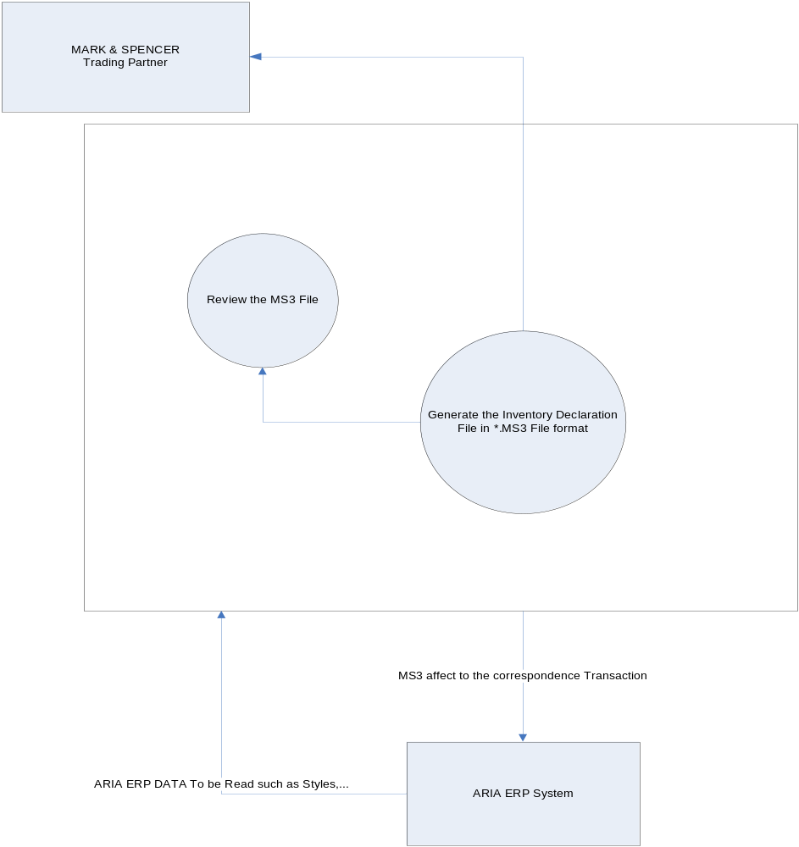

Project Phases
This project has a special Characteristics that the Customer needs already developed in an old version of FOXPRO 2.6 that based on the non visual development environment so we have the following phases:

- Study the current situation in the Custom program of Inventory Declaration
- Write down the Structure of the Code we need in

Entity Features
[Write the required system features here. This section must explain in details any modifications required based on the needs given above.]

User Interface (UI)

___________________________________________________________________

Choose a Path

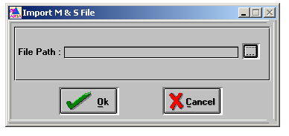

___________________________________________________________________

___________________________________________________________________
Processing the file

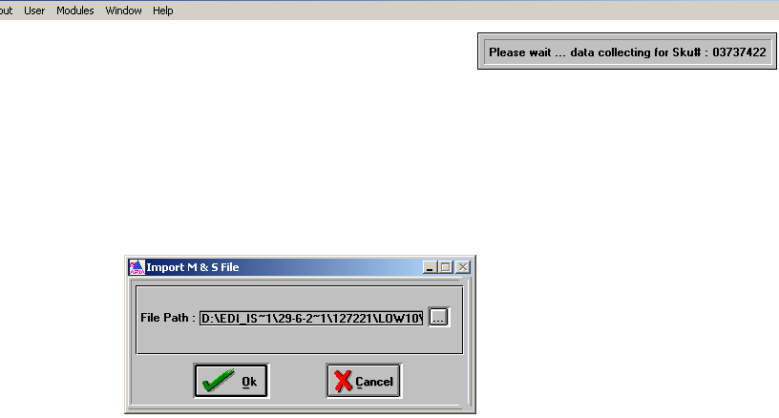
___________________________________________________________________

Errors Log Screen Appears when occurs

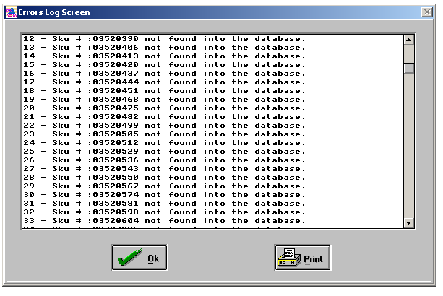

User Can print out the log
Example of Pick-Ticket {Notice it’s Format is TRADACOM, it’s file ext. is *.ms3}

STX=ANA:1+5012068015509+5012068015509+000214:151533+NT20 11498093+EEEEEEEE+PICHDR' MHD=1+PICHDR:3'
TYP=1000+PICHDR'
SDT=:0114980'
CDT=:4151'
FIL=1+3+000209'
MTR=6'
MHD=2+PICKER:3'
ORD=0000'
PLD=1+:02211558+++0+073'
PIC=1+1+:9987++++0'
PIC=1+2+:9990++++0'
PTR=1+2+0'
MTR=7'
MHD=3+PICKER:3'
ORD=0000'
PLD=1+:03925553+++0+073'
PIC=1+1+:9987++++128'
PIC=1+2+:9990++++1320'
PTR=1+2+1448'
MTR=7'
MHD=4+PICKER:3'
ORD=0000'
PLD=1+:04319474+++0+073'
PIC=1+1+:9987++++12235'
PIC=1+2+:9990++++4250'
PTR=1+2+16485'
MTR=7'
MHD=5+PICKER:3'
ORD=0000'
PLD=1+:05667390+++0+073'
PIC=1+1+:9987++++240'
PIC=1+2+:9990++++1788'
PTR=1+2+2028'
MTR=7'
MHD=6+PICKER:3'
ORD=0000'
PLD=1+:05667406+++0+073'
PIC=1+1+:9987++++43'
PIC=1+2+:9990++++5440'
PTR=1+2+5483'
MTR=7'
MHD=7+PICKER:3'
ORD=0000'
PLD=1+:08113276+++0+073'
PIC=1+1+:9987++++65'
PIC=1+2+:9990++++5832'
PTR=1+2+5897'
MTR=7'
MHD=8+PICKER:3'
ORD=0000'
PLD=1+:08267856+++0+073'
PIC=1+1+:9987++++3080'
PIC=1+2+:9990++++4044'
PTR=1+2+7124'
MTR=7'
MHD=9+PICKER:3'
ORD=0000'
PLD=1+:08853639+++0+073'
PIC=1+1+:9987++++671'
PIC=1+2+:9990++++1558'
PTR=1+2+2229'MTR=7'
MHD=10+PICKER:3'
ORD=0000'
PLD=1+:08853707+++0+073'
PIC=1+1+:9987++++332'
PIC=1+2+:9990++++5092'
PTR=1+2+5424'
MTR=7'
MHD=11+PICTRL:1'
PFT=9'
MTR=3'
END=11'¬¬¬¬¬¬¬¬¬¬¬¬¬¬¬¬¬¬¬¬¬¬¬¬¬

___________________________________________________________________

Use Cases
Scenario | Step # | Description | # | User Actions | System Action
 | 1 |  | 1
 |  |  | 2
 |  |  | 3
 | 2 |  | 1
 |  |  | 2
 |  |  | 3

Application Tier

ALIMPLW.PRG

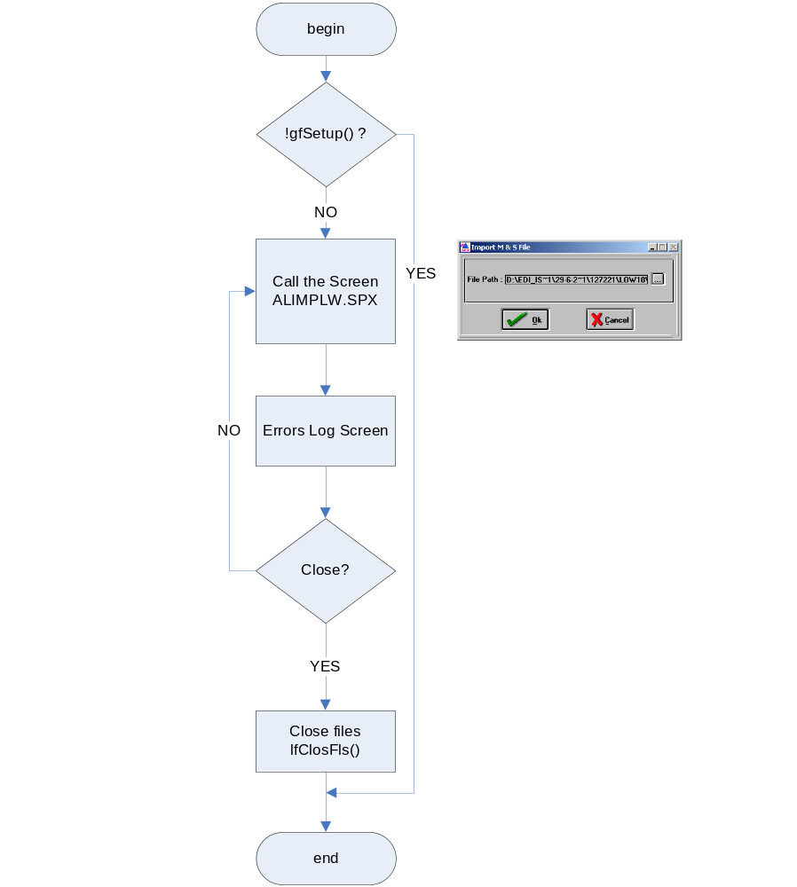

Database Design
[Describe the system database modifications here, if any. Otherwise omit this section.]

Testing Cases
Test Setup:

# | Test Settings
1
2

Test Cases:

Test | Repeat by Setting?  (Y/N) | Test Actions | Test Results | OK?  (Y/N)

