
Development Request
Aria Systems
Cut ticket form A’s BOM needs to print Fabric field and a “Sort by” option

Custom Program # 102681

Cut ticket form A’s BOM needs to print Fabric field

Header
Product: | Aria27 – Cut Ticket Form A’ Bill Of Material.
Module: | MF
Customer name: | Vital Apparel
Installed Modules: | □AL □AR □AS □EB □IC □MA □MF □PO □RM □SM □SO □SR □UP
Parameters setting: | Parameter settings will be sent to MF module via email.

Report Details
Report Name: Cut ticket form A’s BOM needs to print Fabric field and a “Sort by” option

Report Objective ( Purpose ): We would like to modify the Bill of Material for Cut ticket A in order to see the field LOC from the Fabric file. We would also like to sort the BOM with this field. In order to do this we need to create a new SORT BY, and change the field lay out of the BOM. This would create a Custom Cut ticket for A for the customer.

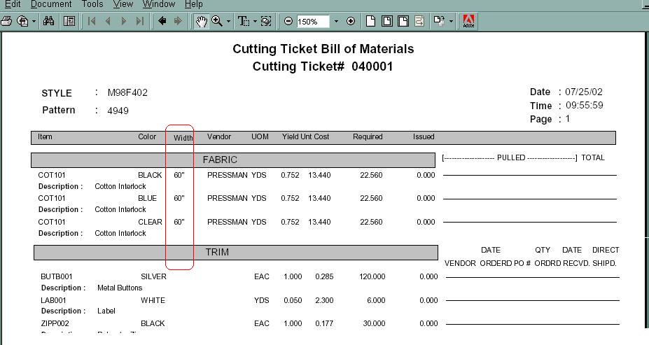

Illustration A. This is the current BOM printing the field WIDTH. We would like to replace this field with the
Description:

Currently:

- The Cut ticket A BOM print the field “WIDTH”.
- There is no way to sort the items with in the Cost group Trim, Fabric, etc.

Required:

- We would like to replace the field WIDTH, which prints the field Fabric.WIDTH (Chr 6), with the following field fabric.LOC (Chr 5)
- We would also like to introduce an option in the main option grid, so the customer can sort each section of the Bill of Material by the field “LOC” found in the fabric file. This sort will let the user see each Cost group in an ascending order by field LOC. (details mentioned in section below)

Layout Description
The layout has been represented in the Illustration A. Showing the circled field that needs to be replaced with Fabric.LOC
Hidden Data Filters: There are no hidden Filters in addition to the existing
Group By Options: There is no change in the Group by.
Order By Options: Order by will apply in each Costing group.
For example the TRIM is a costing group, and so is the FABRIC, DUTY and so on. We would like each COST group to have a sort on Field “LOC”. Currently the default order on the Material item and in an alphabetical order.

Option Grid Parameters: The main option grid would now include the following function.

Presentation Parameters: The option grid parameters related to the report layout.
Parameter Label | Parameter Description (effects) | Operator | Valid Values
Sort By | It will sort each section of the Bill of Material by the following field. | is | Fabric.LOC
 Note: The sort will require an index. This index should be programmed as a Temporary index during the running of the program. It will not be an index tag on the Fabric file.

Development Cost | $ 750/-
Customer signature
  Date signed
Payment Terms | 50 % due upon signing.  50% due upon delivery of the project.  (No work on this project will begin until the deposit is received)
Estimated completion time | 9/23/2002

