
Development Request
Aria Systems
Standard Graphic Pick ticket ‘A’ needs to print STORE field in larger font.

Standard Graphic Pick ticket ‘A’ needs to print STORE field in larger font.

Report Template

Template Header
Product: | Aria27
Module: | AL module
Customer name: | Van Mar
Installed Modules: | AL,AP,AR,AS,EB,GL,IC,MA,MF,PO,SM,SO,SR,UP
Parameters setting : | Setup file will be emailed to AL module.

Report Details
Report Name:. Customized Pick ticket A
Report Objective ( Purpose ): Customer needs the STORE# to print in larger font because the warehouse would find it easier to read the Pick ticket

Description:

Here is the original PICK TICKET Form A.
You will notice the font size for STORE# Is standard.

ORIGINAL FORMAT:

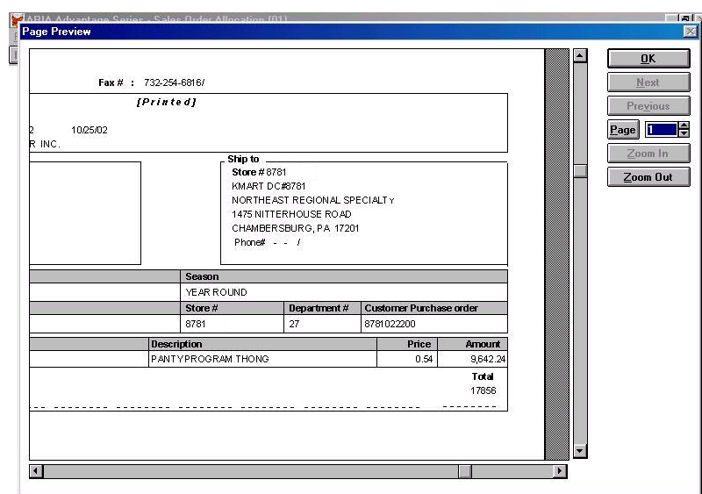

OBERVATION: We would like the two places which print the Store# to print with a font largest that can fit in the field box.

REQUIRED FORMAT:

We would like the STORE# ‘s to print as follows.

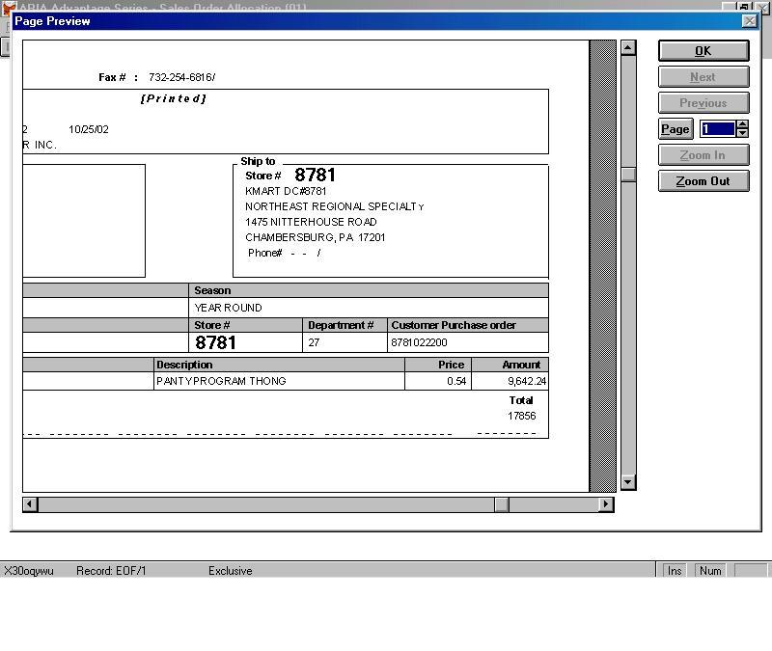

Development Cost
Customer signature
  Date signed
Payment Terms | 50 % due upon signing.  50% due upon delivery of the project.  (No work on this project will begin until the deposit is received)
Estimated completion time | 6-8 weeks

