
Development Request
Aria Systems
Style Order A – needs to show Full description.

Style Order needs to show full description in form A.

Report

Header
Product: | Aria27
Module: | SO
Customer name: | Liz Lange (LLM10)
Installed Modules: | AL,AP,AR,AS,EB,GL,IC,MA,MF,PO,RM,SM,SO,SR,UP
Parameters setting : | Setup.txt will be sent to module in charge

Report Details
Report Name: Custom SO with full Color and Style description.
Report Objective ( Purpose ): The purpose of the report is to show the full Color and Style Name on the SO form. This Color description is not the Long description entered in the color codes related field, but in fact the Color Description in the Codes screen. The Style Description is NOT the Long description entered in the Style screen, but is only the Style Name in the Style screen.

Description:

EXISTING SO: Currently the SO form A, prints the form in the following manner

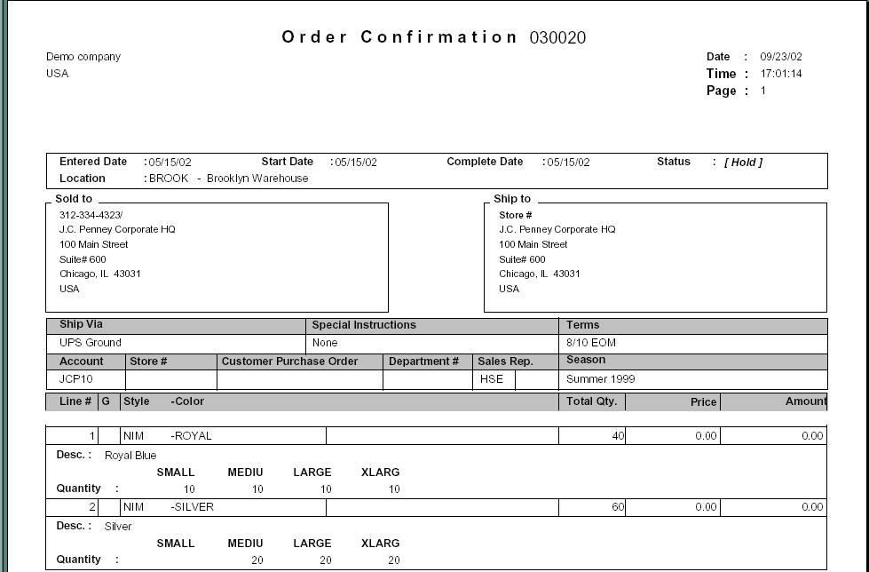

REQUIRED SO: We need the following modification:
- The Form A, should now contain the Color Description as well as the Style Name
- Please: Color Description is the field seen in the Codes setup. (Please note this is NOT the long description entered in the related fields of the Color code)
- The position of this new field has been illustrated in RED and BLUE in the following diagram.
- The Color description is marked in RED and the Style Description is mentioned in BLUE.
- Please note that the Lines in the forms have been erased and moved to accommodate the Color Description and the Style Name field.(Illustrated in GREEN)
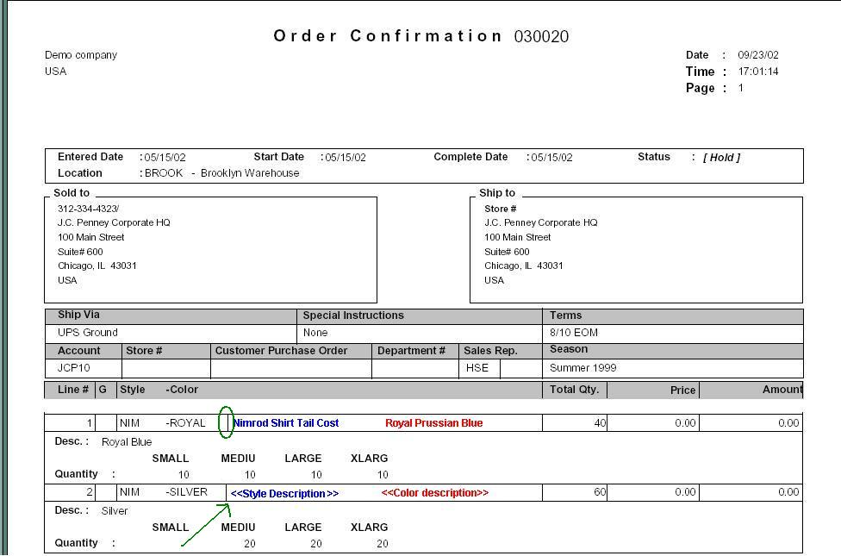

Layout Description
Lay out change has been described in the above Detail section. Please print this is COLOR to look at the illustrated figures.

Hidden Data Filters: Nothing changed here

Group By Options: nothing changed here.
Order By Options: Nothing changed here
Option Grid Parameters: Nothing changed here

Development Cost | $300.00
Customer signature
  Date signed
Payment Terms | 50 % due upon signing.  50% due upon delivery of the project.  (No work on this project will begin until the deposit is received)
Estimated completion time | 6-8 weeks

