
Development Request
Aria Systems
Cutting Ticket A – needs to show Full description for Color.

Cut ticket to show full color description in form A.

Report

Header
Product: | Aria27
Module: | MF
Customer name: | Liz Lange (LLM10)
Installed Modules: | AL,AP,AR,AS,EB,GL,IC,MA,MF,PO,RM,SM,SO,SR,UP
Parameters setting : | Setup.txt will be sent to module in charge

Report Details
Report Name: Custom Cut ticket with full color description
Report Objective ( Purpose ): The purpose of the report is to show the full Color description on the Cut ticket form. This description is not the Long description entered in the color codes related field, but in fact the Color Description

Description:

EXISTING Cut Ticket: Currently the Cut ticket form A, prints the form in the following manner

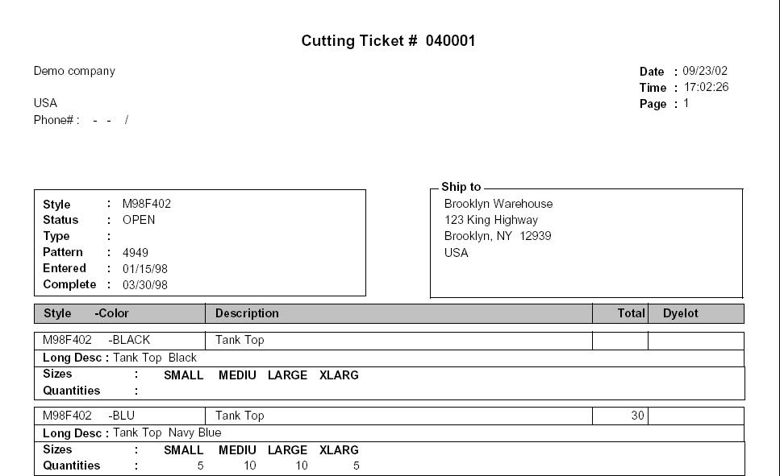

REQUIRED CUT TICKET: We need the following modification:
- The Form A, should now contain the Color Description.
- This is the Color Description seen in the Codes setup. (Please note this is NOT the long description entered in the related fields of the Color code)
- The position of this new field has been illustrated in RED in the following diagram.
- Please note that the Lines in the forms have been erased and moved to accommodate the Color Description field.
- The style description (which already exists), has just been illustrated in BLUE, to show the programmer the relative position of the Color description.

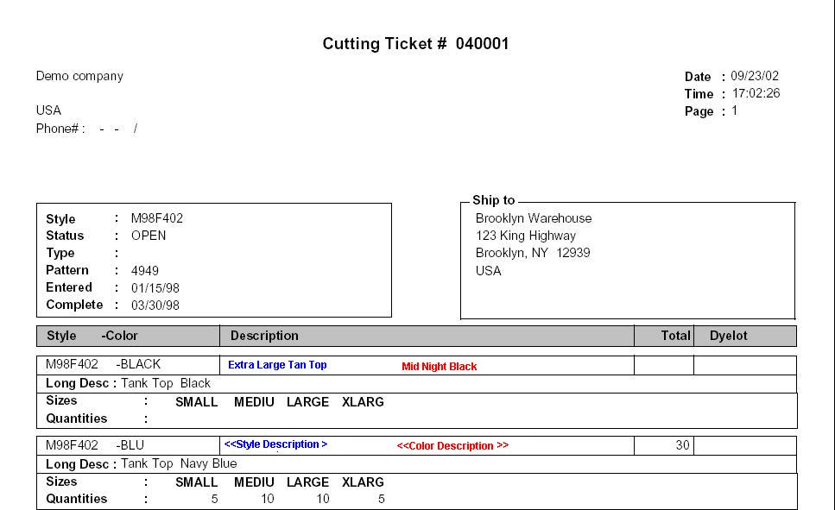

Layout Description
Lay out change has been described in the above Detail section. Please print this is COLOR to look at the illustrated figures.

Hidden Data Filters: Nothing changed here

Group By Options: nothing changed here.
Order By Options: Nothing changed here
Option Grid Parameters: Nothing changed here

Development Cost | $300.00
Customer signature
  Date signed
Payment Terms | 50 % due upon signing.  50% due upon delivery of the project.  (No work on this project will begin until the deposit is received)
Estimated completion time | 6-8 weeks

