 Development Request
Aria Systems
ASCII style importing program for Rena Lange

Custom program # 102763

ASCII Style importing program for Rena Lange

Header
Product: | Aria27
Module: | IC
Customer name: | Rena Lange
Installed Modules: | AR, IC, SM, SO, SR
Parameters setting: | The setting file will be emailed to IC module.  This ICISTRU file along with related Style ASCII files will be emailed to IC module.

Details Section
Add-in Name : ASCII style importing program for Rena Lange.

Add-in Objective : To imported styles from an ASCII file into the Style Master list in Aria.

Existing Initial situation:

The styles are currently being entered on the style screen.
We would like to import style information from an ASCII file.

THE STYLE IMPORT INTERFACE SCREEN.

We would like the user to see the following screen (Figure 1), when they run the Style Import link from the IC module.

Figure 1
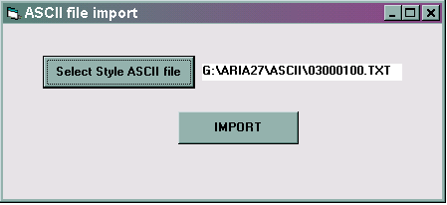

The fields: on this screen are:

 | Field Label | Field Meaning-Semantics | Field Format
1 | Select Style ASCII file | This is a Command button which will let the user select the Directory and TXT file they would like to import the styles from. The default path for this Directory box will be the root of ARIA27 | Command button
2 | <File Path name> | This will display the full path and name for the file selected. | Label field.
3 | IMPORT | This is a command button when clicked, will start reading the ASCII file and perform the following processes mentioned in below | Command button

Style ASCII file.

WE have an ASCII file (Figure 2) that contains style color records.
The file contains fields separated by the character “|” The ASCII value for this separator is CHR(124).

Figure 2

33-89201C|shoes|35,0 - 42,0|31|16|L112|508|natural/turquoi|14700|24000|52000|
33-89201C|shoes|35,0 - 42,0|31|16|L112|509|natural/coral|14700|24000|52000|
33-89203C|shoes|35,0 - 42,0|31|26|L112|013|blanc|9900|16000|34500|
33-89203C|shoes|35,0 - 42,0|31|26|L112|044|blossom|9900|16000|34500|
33-89203C|shoes|35,0 - 42,0|31|26|L112|090|noir|9900|16000|34500|
33-89204C|shoes|35,0 - 42,0|31|26|L112|013|blanc|9100|15000|32000|
33-89204C|shoes|35,0 - 42,0|31|26|L112|044|blossom|9100|15000|32000|

Figure 3
Style | Style Desc. | Scale description | Season code | Group Name | Fabric | Color code | Color description | Cost | Price A | Price B
1 | 2 | 3 | 4 | 5 | 6 | 7 | 8 | 9 | 10 | 11
33-89201C | shoes | 35,0 - 42,0 | 31 | 16 | L112 | 508 | natural/turquoi | 14700 | 24000 | 52000
33-89201C | shoes | 35,0 - 42,0 | 31 | 16 | L112 | 509 | natural/coral | 14700 | 24000 | 52000

The table above (Figure 4) is an explanation of fields in a STYLE ASCII file

VALIDATIONS RULES: During the FILE READING stage: System should create a log that will contain all the styles that are rejected in the importing program.

Important thing here is the validation rules for rejecting a style from being imported.

RULE 1: If in any style line from the ASCII file, a FIELD does not pass a validation, the system should LOG which field failed the validation, and display this at the end of the importing session in a rejection log. (As the system reads the file, this log report will grow with one record for every field rejected)

VALIDATIONS for each field.

NOTE: The Style ASCII file has one record for each STYLE-COLOR illustrated in Figure 5

Figure 5
Name on file | Position on file | Aria field name | Special instructions and formatting | Validations
Style | 1 | This will be the Style Code  STYLE.STYLE | Based on the style code structure this will take the first 12 characters as the style Code. | Seek the Aria STYLE file to see if the Style code already exists.  - If it exists, perform the following validation –  - = It should jump to the segment 7 and perform the color code validations  - If it does not exist, this field is passed, and will become the Aria Style Code
Style Desc | 2 | This will be the Style Description field  STYLE.DESC | This will be short description in the style. | Only validation required is the segment should not be empty.
Scale Desc. | 3 | This segment is the Scale description found in our scale maintenance. | The segment will be compared to the Scale file. In the scale file we will look up the scale matching the description sent in this segment, and locate the scale they are referring to. | - This will look for SCALE.Cscl_desc if it finds a record which matches this scale description. It will accept this as the scale for the style.  - If it does not find a match it will add to the rejection log file.
Season code | 4 | This will be the style season. | This is the Season code. | Validation should be that the season should exist in the Codes file. If not it should add to rejection log
Group name | 5 | This will be the style Group. | This is the Style Group code. | Validation should be that the Style Group should exist in the Codes file. If not it should add to rejection log
Fabric | 6 | This position holds the Pattern info. | This would write into the Pattern text field of the Style. | No validation required here.
Color code | 7 | This position refer to color assigned to the style. | This color will be assigned to the style if it does not exist, it will be the only color on this style.  If the style already existed, this color will ADD to the existing colors. | - The color code should exist in the color codes library.  - The color code should not already be part of the existing style’s non-major. (This style-color should not already exist)  If any validation fails it should add to reject report mentions both the STYLE as well as COLOR and the reason why this field was not validated.
Color description | 8 | We can ignore this field. | N/A | N/A
Cost | 9 | This position holds the Style cost. This will be the P.Price of the Style. | The field sent in the ASCII file is as follows  45678 which should be formatter as follows :  $456 and 78 cents. To get the dollar value from the string, we would need to divide by 100. | No validation required.
Price A | 10 | This segment will be Price A. | The field sent in the ASCII file is as follows  56789 which should be formatter as follows :  $567 and 89 cents. To get the dollar value from the string, we would need to divide by 100 | No validation required
Price B | 11 | This segment will be Price B. | The field sent in the ASCII file is as follows  45678 which should be formatter as follows :  $456 and 78 cents. To get the dollar value from the string, we would need to divide by 100 | No validation required

NOTE: Mandatory fields in Style screen.

The WAREHOUSE field is not imported. The customer has a single warehouse. The import program will always default the values of the following fields.

Warehouse: Default to the Default warehouse set up in the system.
Status: Default the status to “Active”

The Validation results:

The style-colors which are validated need to be displayed at the end in a Final selection screen.(discussed later)
Prior to that a Rejection log should print for all the Style-colors that did not pass the validation. Along with reason for each rejection.

REJECTION REPORT:

The validation process will create a list of styles that will not be validated.

For every style-color that is rejected in the validations mentioned in the Table 5, the report should show display a report at the end of the Style Importing process, after reading each field in each line of the STYLE ASCII file.

the Style-color rejected needs to be printed at this point.

The report will print the rejections that were logged in the Rejection log while bring in the ASCII file.

Figure 6

Style | Style Desc. | Scale description | Season code | Group Name | Fabric | Color code | Color description | Cost | Price A | Price B
1 | 2 | 3 | 4 | 5 | 6 | 7 | 8 | 9 | 10 | 11
33-89201C | shoes | 35,0 – 42,0 | 32 | 16 | L112 | 508 | natural/turquoi | 14700 | 24000 | 52000
33-89201C | shoes | 34,0 – 40,0 | 31 | 16 | L112 | 509 | natural/coral | 14700 | 24000 | 52000

For example purpose, we have marked fields in RED to show these fields have a problem, and what the rejection report will look like figure 7 Report
The following Style-color records were rejected.

Report (Figure 7)

STYLE ASCII FILE REJECTION REPORT

Style color 33-89201C 508

33-89201C|shoes|35,0 – 42,0|32|16|L112|508|natural/turquoi|14700|24000|52000|

Scale description 35,0 – 42,0 is not a valid scale description
Division 32 is not a valid Division

Style color 33-89201C 509

33-89201C|shoes|35,0 - 42,0|31|16|L112|509|natural/coral|14700|24000|52000|

Style color 33-89201C 509 does not exists.

PRINT

FINAL IMPORTED STYLE SELECTION SCREEN:

The validation process will create a list of styles that have passed the validations.

For every style-color that passes all the validations mentioned, the report should show display each style color in a final Selection screen for the Style Importing process, for the user to perform a final selection and make any modifications if necessary to the editable fields.

The following functionality will be performed in this screen

-This should should be an interactive screen, that will allow user to further select styles they would like to import or reject by the ACCEPT field.
-It should let the user accept the default fields values, or let the user change the value of the editable fields. (List of “editable” fields will be specified)
To the Programmer: This is a basic layout, the programmer can create the screen in a similar manner, but the functionality should be the same. The placement of the button, page scale etc can be determined by the programmer. We would just like maintain the screen functionality.

Field description:

The Style final selection screen will appear as follows.
Field on screen |  |  | Valid values
Style – Color | This will display the STYLE CODE – COLOR CODE of the style | Non editable | N/A
Style Desc | This will be editable field displaying the Style description that was sent. If user wants they can modify what is in this field. If they don’t modify, the description will be saved with the description sent in the ASCII file | Editable field | Free text
Color description | This displays the Color Description seen in the Codes file | Non editable | N/A
Scale | This displays the Scale Code’ | Non editable | N/A
Scale Desc. | This displays the Scale Code’s Description | Non editable | N/A
Season | This displays Season code | Non editable | N/A
Group | This displays the Group Code | Non editable | N/A
Fabric | Displays the Fabric field text that was imported into the Pattern field | Non editable | N/A
Cost | This displays the Cost in following format $ 999.99 | Non editable | N/A
Price A | This displays the Price A in following format $ 999.99 | Non editable | N/A
Price B | This displays the Price B in following format $ 999.99 | Non editable | N/A
Accept | This will let the user decide what style colors should add to the Master list and what should not add to the master list | Editable field | Combo box with value YES or NO

Figure 8
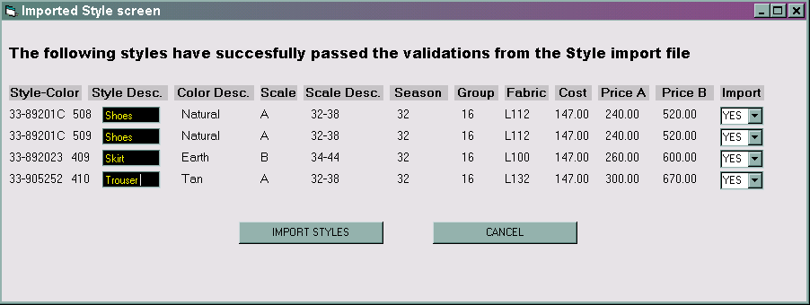

FINAL STEPS:

Once the user set the IMPORT field with YES or NO. The user will be able import all the style-colors selected.
Eventually if the user hits the button:

IMPORT STYLES : The program should create the styles with the default warehouse. At the end it should say “Styles imported successfully”

CANCEL: The program should prompt a verifying message to confirm aborting, and then return to the Main menu of Aria.

Development Cost | Note quoted yet
Customer signature
  Date signed
Payment Terms | 50 % due upon signing.  50% due upon delivery of the project.  (No work on this project will begin until the deposit is received)
Estimated completion time | 4 weeks from date of signing

Hi Sadaf,
I want to confirm some points regarding this spec:
1- All the styles are set to domestic 'No'?
2- We will pick the division code from the default division?
3- Does this customer use Multi Currency?

Hi Ashraf.
1 – All their styles that are imported in this program will be IMPORTING and not domestic.
2- Division will be picked up from the Codes set up. The default division at the time will be the division of the style simported.
3 – NO. they do not have Multi-currency setup.

Mail from Mohamed Hassan on 12/12/2002:
Rena Langa is facing a problem with the upload style program. They have 3 divisions and the upload program assign the styles to the first division. They need to have a popup in the upload screen were they can specify which division they are uploading the styles for.
This is very urgent to be added to the program because they have a lot of orders pending for this operation.

