Monopoly

A multi-player online board game that can interact with others

**Group 5**

|  |  |
| --- | --- |
| Zijian Guo | 20189863 |
| Chengkun Li | 20081652 |
| Zhaoyi Tan | 20051212 |
| Jiamin Wang | 20111824 |

16/12/2020

**Content**

**1.** **Game Overview** 2

**2.** **Gameplay Mechanics** 2

2.1 Dice 2

2.2 Money 2

2.3 Buy a building on the current block 2

2.4 Build a house together 3

2.5 Puzzle 3

2.6 Network Connection 4

2.6.1 Avatar 4

2.6.2 Puzzle 4

2.6.3 Establish house 4

2.7 Interaction 5

**3.** **Game Progression** 5

**4.** **Game Menu** 5

4.1 Create and Join a Room 5

4.2 Start Monopoly Game 5

4.3 Game Map 6

4.4 Material Store 6

4.5 Puzzle Game 6

**5.** **Challenges and Group Work Division** 6

1. **Game Overview**

*Monopoly* is a multi-player game with a huge game map and a networking connection to implement the user interaction. The purpose of this game is to earn more money to build a house together in the center of the map. In order to achieve the goal, participants need to communicate with others to complete a puzzle game together and buy materials to establish their building.

1. **Gameplay Mechanics**

The following subsections report parts of the code in our game that we are particularly proud of. Also, the interaction functions will be mentioned below.

* 1. Dice

The mechanism of throwing dice is shown below.

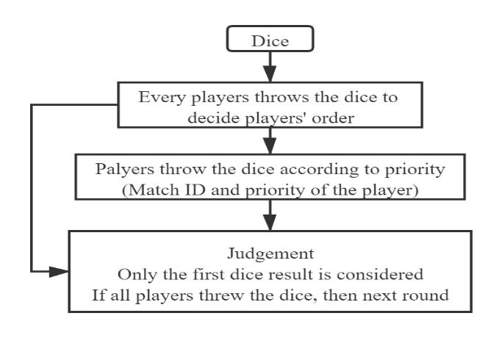

Figure 1. Flow chart of throwing a dice

* 1. Money

The following flow chart shows the change of money for each player.

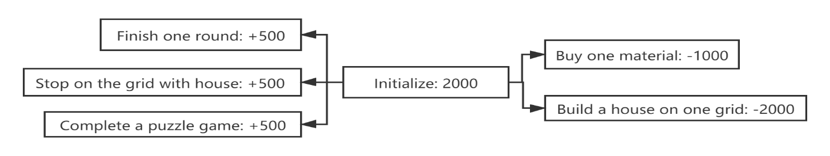

Figure 2. Money

* 1. Buy a building on the current block

Players can buy a building on the current block and shown a landmark will be shown at that place.

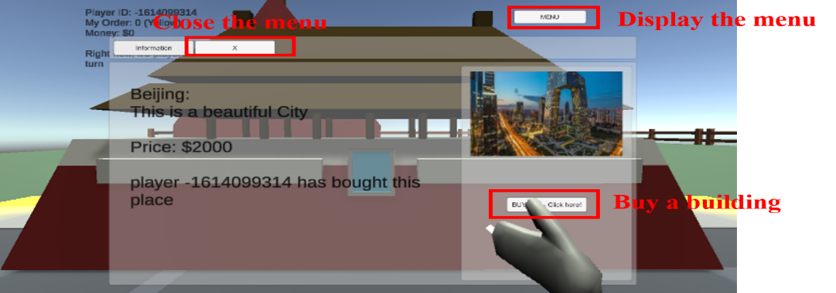

Figure 3. Buy a landmark building on the current block

* 1. Build a house together

The goal of this game is to establish a house in the center of our game map. When players earn enough money, they can build the house with materials. If seven materials are bought and set at the correct place, the game ends.

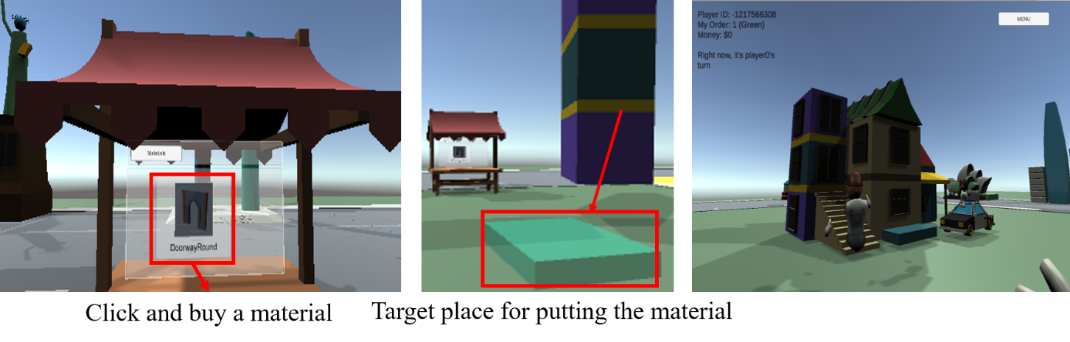

Figure 4. Buy materials and build a house together

* 1. Puzzle

Puzzle is a mini-game in our game design which aims to increase the interaction between players. When a player triggers an even, he/she needs to invite other players to complete the puzzle game. One player can click START button and everyone can drag puzzle pieces. If the puzzle is completed, the timer will be stopped and participants can obtain rewards. There are two scripts to control the puzzle game:

Puzzle Manager: Monitor the puzzle game when players drag pieces.

Shift pieces to the closest grid automatically.

If complete the puzzle, stop the timer and show a text to congratulate players

Puzzle Drag: For each piece, monitor the dragging event and update the transform.

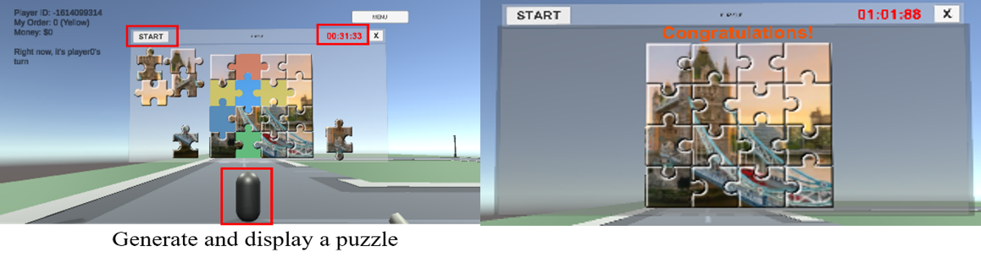

Figure 5. Puzzle game

* 1. Network Connection

Network connection is one of the significant parts in our game which is used to send and receive messages from other players and implement the interaction of the multi-player online game.

* + 1. Avatar

There are two parts to control the networking connection of players including *local* and *remote*, which are used to synchronize performance of avatar.

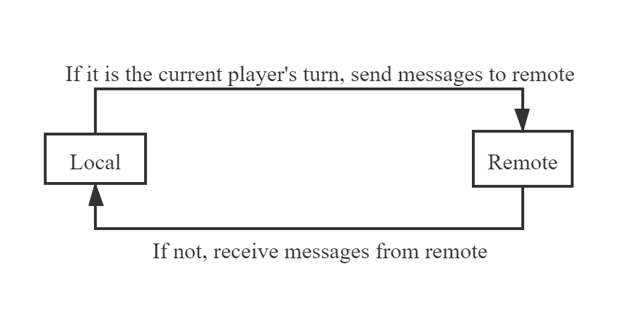

Figure 6. Synchronize avatars’ information

* + 1. Puzzle

When a player starts a puzzle game, the game panel can also be shown to others and the transform of the dragging piece can be sent to server and synchronized to others.

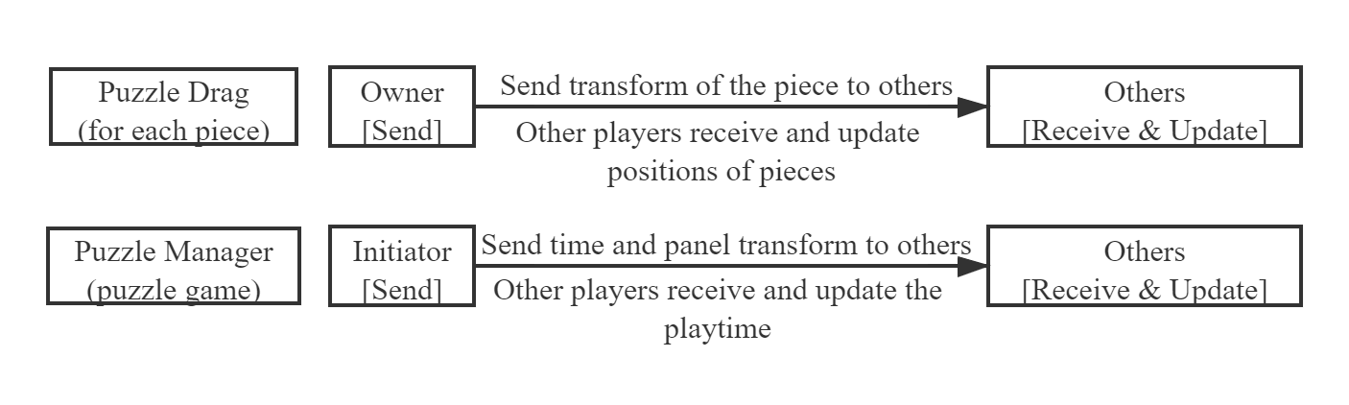

Figure 7. Update and synchronize positions of pieces and the time

* + 1. Establish house

This graph shows the implementation of building a house together.

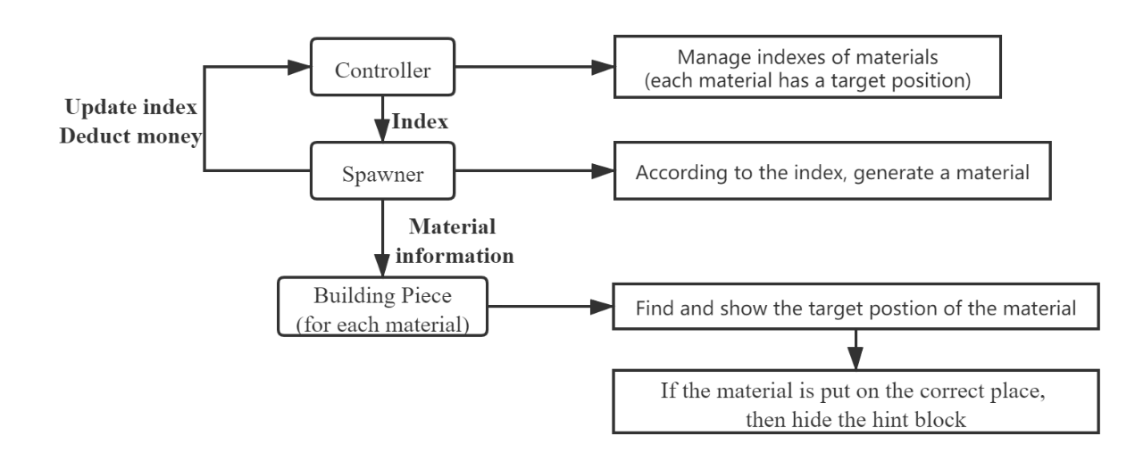

Figure 8. Build a house together

* 1. Interaction

This game focuses on interaction between players and our game designed several mini-games and components to increase the interaction function.

1. Play on the same game map and players can talk with each other
2. Throw a dice and walk following their colorful position grid
3. Complete the puzzle game together to earn money
4. Build a house in the center of the game map
5. **Game Progression**

In this *Monopoly* game, the maximum number of players is 4. At the beginning, a player can create a room and wait other players to join in. Then one of them can click the start button on the panel and go outside. First, all players need to throw a dice to decide the order. Depends on the order shown in the upper left corner of the screen, players can throw the dice and follow the fluorescent boxes (position of each player). Players can buy materials to build a house. If the house is completed, the game is over. There are several situations that players can earn money:

1. Players play one turn on the map
2. One player triggers a puzzle game and multiple players complete the puzzle
3. Establish a building in one grid and when other players stop on this grid
4. **Game Menu**

This section mainly introduces the user interface (menu) designed in our game.

* 1. Create and Join a Room

Add button (+) 🡪 Create a room and display the information on the panel

Join button🡪 Join a room

* 1. Start Monopoly Game

Start button 🡪 One player clicks the button and all players in the room start to play

Introductions 🡪 Introduce the rules and process of our game

* 1. Game Map

Menu 🡪 Show the information of the current grid on the map

Building 🡪 Buy a building on the selected grid

‘X’ 🡪 Close the panel

* 1. Material Store

Doorways 🡪 Generate selected materials near the store

* 1. Puzzle Game

Start 🡪 a button to start the game and the timer is started

Timer 🡪 a text to show the time

'X' 🡪 a button to close the panel of the puzzle game

'Congratulation!' 🡪 a text to tell players if the puzzle game is completed

1. **Challenges and Group Work Division**

When we designed the game, how to implement networking connection and how to update and synchronize the performance of objects and elements in the game is the most difficult part, since our game has lots of interaction function. The first challenge is to synchronize the performance of each player. In order to avoid the confliction in sending and receiving messages, Zijian figured out to split the function into two parts including *local* and *remote*. The local function is used to send messages to others with their transform and other events of the current player. In the remote function, other players should receive messages to synchronize information of that player. In addition, in the puzzle game, the challenge is to update the location of pieces if multiple players drag pieces at the same time. Therefore, Zhaoyi solved the problem to judge if each piece at the correct position in each frame. If all pieces are put on the correct grids, the puzzle game is finished.

In this group coursework, every team member cooperated to design our *Monopoly* game and the team work was well done. First, we divided the tasks into two parts including game map structure and interactive puzzle game, and for about two weeks, we implemented basic game structure. After that, we combined the two parts together and added networking connection function in the game. In the coursework, Zijian achieved the game controller and part of networking connection of updating avatars’ performance. Chengkun did most of UI in the game and implemented the fluorescent grids connecting the dice numbers. Zhaoyi completed the puzzle game and the synchronization of puzzle pieces. Also, Zhaoyi and Zijian perfected the functions of generating materials and building a house together. Jiamin did the basic function and UI of the puzzle game.