Speed Dating Project

Aria Wang

setwd("~/Desktop/MSiA 420/speed-dating-project")  
data <- read.csv("Speed Dating Data.csv")  
library(caret)

# check NA  
na_rate <- rep(1, dim(data)[2])  
# drop the variables that end with _3   
for (i in 1:156){  
 na_rate[i] <- sum(is.na(data[,i]))/nrow(data)  
}  
na_columns <- colnames(data)[na_rate > 0.5]

library(dplyr)  
data <- data %>%   
 select(-na_columns)

data$gender <- as.factor(data$gender)  
data$career_c <- as.factor(data$career_c)  
data$samerace <- as.factor(data$samerace)  
data$race <- as.factor(data$race)  
data$dec <- as.factor(data$dec)  
data$date <- as.factor(data$date)

# scale the ratings  
data <- data %>%   
 mutate(pf_sum_o = pf_o_att + pf_o_sin + pf_o_int + pf_o_fun + pf_o_amb + pf_o_sha,  
 sum_o = attr_o + sinc_o + intel_o + fun_o + amb_o + shar_o,  
 sum1_1 = attr1_1 + sinc1_1 + intel1_1 + fun1_1 + amb1_1 + shar1_1,  
 sum4_1 = attr4_1 + sinc4_1 + intel4_1 + fun4_1 + amb4_1 + shar4_1,  
 sum2_1 = attr2_1 + sinc2_1 + intel2_1 + fun2_1 + amb2_1 + shar2_1,  
 sum3_1 = attr3_1 + sinc3_1 + intel3_1 + fun3_1 + amb3_1,  
 sum5_1 = attr5_1 + sinc5_1 + intel5_1 + fun5_1 + amb5_1,  
 sum1_2 = attr1_2 + sinc1_2 + intel1_2 + fun1_2 + amb1_2 + shar1_2,  
 sum4_2 = attr4_2 + sinc4_2 + intel4_2 + fun4_2 + amb4_2 + shar4_2,  
 sum2_2 = attr2_2 + sinc2_2 + intel2_2 + fun2_2 + amb2_2 + shar2_2,  
 sum3_2 = attr3_2 + sinc3_2 + intel3_2 + fun3_2 + amb3_2,  
 sum5_2 = attr5_2 + sinc5_2 + intel5_2 + fun5_2 + amb5_2) %>%   
 mutate_at(c("pf_o_att", "pf_o_sin", "pf_o_int", "pf_o_fun", "pf_o_amb", "pf_o_sha"),   
 funs(./pf_sum_o*100)) %>%   
 mutate_at(c("attr_o", "sinc_o", "intel_o", "fun_o", "amb_o", "shar_o"),   
 funs(./sum_o*100)) %>%   
 mutate_at(c("attr1_1", "sinc1_1", "intel1_1", "fun1_1", "amb1_1", "shar1_1"),   
 funs(./sum1_1*100)) %>%   
 mutate_at(c("attr4_1", "sinc4_1", "intel4_1", "fun4_1", "amb4_1", "shar4_1"),   
 funs(./sum4_1*100)) %>%   
 mutate_at(c("attr2_1", "sinc2_1", "intel2_1", "fun2_1", "amb2_1", "shar2_1"),   
 funs(./sum2_1*100)) %>%  
 mutate_at(c("attr3_1", "sinc3_1", "fun3_1", "intel3_1", "amb3_1"),   
 funs(./sum3_1*100)) %>%  
 mutate_at(c("attr5_1", "sinc5_1", "fun5_1", "intel5_1", "amb5_1"),   
 funs(./sum5_1*100)) %>%  
 mutate_at(c("attr1_2", "sinc1_2", "intel1_2", "fun1_2", "amb1_2", "shar1_2"),   
 funs(./sum1_2*100)) %>%  
 mutate_at(c("attr4_2", "sinc4_2", "intel4_2", "fun4_2", "amb4_2", "shar4_2"),   
 funs(./sum4_2*100)) %>%  
 mutate_at(c("attr2_2", "sinc2_2", "intel2_2", "fun2_2", "amb2_2", "shar2_2"),   
 funs(./sum2_2*100)) %>%  
 mutate_at(c("attr3_2", "sinc3_2", "intel3_2", "fun3_2", "amb3_2"),   
 funs(./sum3_2*100)) %>%  
 mutate_at(c("attr5_2", "sinc5_2", "intel5_2", "fun5_2", "amb5_2"),   
 funs(./sum5_2*100)) %>%  
 select(-c("pf_sum_o", "sum_o", "sum1_1", "sum4_1", "sum2_1", "sum3_1",   
 "sum5_1", "sum1_2", "sum4_2", "sum2_2", "sum3_2", "sum5_2"))

## Warning: funs() is soft deprecated as of dplyr 0.8.0  
## Please use a list of either functions or lambdas:   
##   
## # Simple named list:   
## list(mean = mean, median = median)  
##   
## # Auto named with `tibble::lst()`:   
## tibble::lst(mean, median)  
##   
## # Using lambdas  
## list(~ mean(., trim = .2), ~ median(., na.rm = TRUE))  
## This warning is displayed once per session.

library(ggplot2)  
# career distribution plot  
career_label <- c("Lawyer", "Academic/Research", "Psychologist",   
 "Doctor/Medicine", "Engineer", "Creative Arts/Entertainment",   
 "Banking/Business", "Real Estate", "International Affairs",   
 "Undecided", "Social Work", "Speech Pathology", "Politics",   
 "Sports/Athletics", "Other", "Journalism", "Architecture")  
  
data %>%   
 filter(!is.na(career_c)) %>%   
 select(iid, gender, career_c) %>%   
 unique(by = iid) %>%   
 ggplot() +  
 geom_bar(aes(career_c, fill=gender)) +   
 scale_x_discrete(label = career_label) + coord_flip() +   
 labs(title = "Distribution of Career Fields", x = "Career Field", y = "Count") +   
 scale_fill_manual(values=c(rgb(0.7, 0.3, 0.5, 0.4), rgb(0.2, 0.5, 0.8, 0.4)),   
 "Gender", labels = c("Female", "Male")) + theme_light()

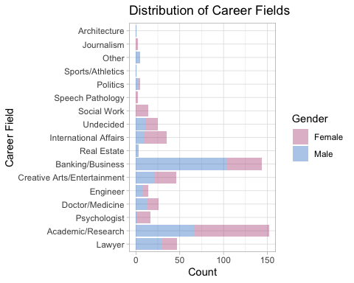

# scale_fill_brewer(palette="Set3", "Gender", labels = c("Female", "Male")) + theme_light()

# age distribution plot  
temp_age <- data %>%   
 filter(!is.na(age)) %>%   
 filter(age < max(age)) %>%   
 select(iid, gender, age) %>%   
 unique(by = iid)   
  
ggplot(data = temp_age, aes(x = age,fill = gender)) + coord_flip() +   
 geom_histogram(data = subset(temp_age, gender == "0"), binwidth = 2, color = "white") +   
 geom_histogram(data = subset(temp_age, gender == "1"),   
 aes(y = ..count.. * (-1)), binwidth = 2, color = "white") +   
 scale_y_continuous(breaks = seq(-70, 70, 10), labels = abs(seq(-70, 70, 10)))+   
 scale_x_continuous(breaks = seq(10, 45, 5), labels = seq(10, 45,5)) +   
 labs(title = "Distribution of Age", x = "Age", y = "Count") +   
 scale_fill_manual(values=c(rgb(0.7, 0.3, 0.5, 0.4), rgb(0.2, 0.5, 0.8, 0.4)),   
 "Gender", labels = c("Female", "Male")) + theme_light()

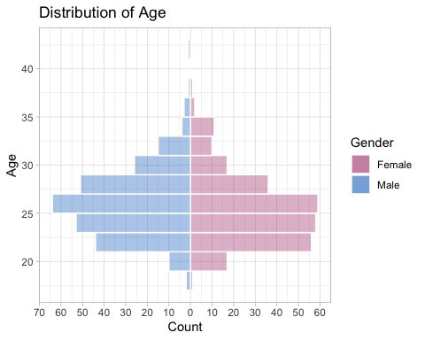

# race distribution plot  
race_label <- c("Black/African American", "European/Caucasian American",   
 "Latino/Hispanic American", "Asian/Asian American",   
 "Naitive American", "Other")  
  
data %>%   
 filter(!is.na(race)) %>%   
 select(iid, gender, race) %>%   
 unique(by = iid) %>%   
 ggplot() +   
 geom_bar(aes(x = gender, fill = race), position = "fill") +   
 labs(title = "Distribution of Race", x = "Gender", y = "Relative Frequency") +  
 scale_fill_brewer(palette="Set3", name="Race", labels = race_label) +   
 scale_x_discrete(labels=c("0" = "Male", "1" = "Female")) + theme_light()

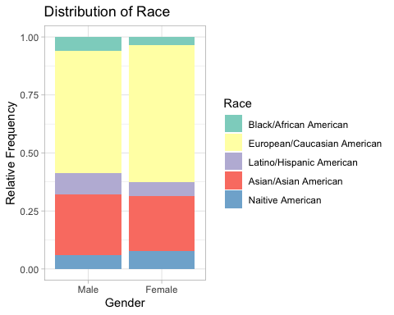

hist(data$match)

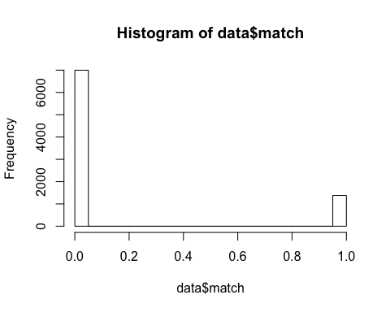

library(fmsb)  
# what do you look for in the opposite sex  
test1 <- data %>%   
 filter(!is.na(attr1_1 + sinc1_1 + intel1_1 + fun1_1 + amb1_1 + shar1_1)) %>%   
 select(iid, gender, attr1_1:shar1_1) %>%   
 unique(by = idd) %>%   
 group_by(gender) %>%   
 summarise(Attractive = mean(attr1_1), Sincere = mean(sinc1_1),   
 Intelligent = mean(intel1_1), Fun = mean(fun1_1),   
 Ambitious = mean(amb1_1), Interest = mean(shar1_1))  
  
test1forplot <- test1 %>%   
 select(-gender)  
   
maxmin <- data.frame(  
 Attractive = c(36, 0),  
 Sincere = c(36, 0),  
 Intelligent = c(36, 0),  
 Fun = c(36, 0),  
 Ambitious = c(36, 0),  
 Interest = c(36, 0))  
  
test11 <- rbind(maxmin, test1forplot)  
  
test11male <- test11[c(1,2,4),]  
test11female <- test11[c(1,2,3),]  
  
radarchart(test11,  
 pty = 32,  
 axistype = 0,  
 pcol = c(rgb(0.7, 0.3, 0.5, 0.4), rgb(0.2, 0.5, 0.8, 0.4)),  
 pfcol = c(rgb(0.7, 0.3, 0.5, 0.4), rgb(0.2, 0.5, 0.8, 0.4)),  
 plty = 1,  
 plwd = 3,  
 cglty = 1,  
 cglcol = "gray88",  
 centerzero = TRUE,  
 seg = 5,  
 vlcex = 0.75,  
 palcex = 0.75,  
 title = "What do people look for in the opposite sex?")  
legend(x = 1, y = 1.2, legend = c("Female", "Male"),  
 bty = "n", pch = 20 , col = c(rgb(0.7, 0.3, 0.5, 0.4), rgb(0.2, 0.5, 0.8, 0.4)),   
 text.col = "black", cex = 0.8, pt.cex = 2)

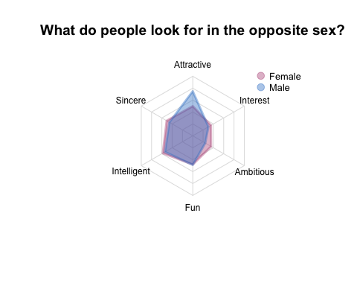

## Decision Tree

# drop 3 or s  
data <- data[, !grepl(".*_[3s]$",colnames(data))]  
  
# drop columns with >50% null values  
t = data.frame(colSums(is.na(data))/nrow(data))  
colnames(t)=c("nullrate")  
t <- t %>% subset(nullrate<0.5)  
data <- data[,rownames(t)]  
  
# other  
data <- data[, colnames(data)!='match_es']  
data <- data[, colnames(data)!='pid']  
data <- data[, colnames(data)!='dec_o']  
data <- data[, colnames(data)!='dec']  
data <- data[, colnames(data)!='like_o']  
data <- data[, colnames(data)!='like']  
data <- data[, colnames(data)!='partner']  
# data <- data[, colnames(data)!='attr_o']  
# data <- data[, colnames(data)!='attr']  
  
  
data$income <- as.numeric(data$income)  
data$tuition <- as.numeric(data$tuition)  
data <- data[, !(colnames(data) %in% c('zipcode','from','career','field','undergra','mn_sat','attr5_2'  
 ,'attr5_1'))]

# fit inital model by cv  
library(rpart)  
set.seed(420)  
control <- rpart.control(minbucket = 5, cp = 0.001, maxsurrogate = 0, usesurrogate = 0, xval = 10)  
date.tr <- rpart(match ~.,data, method = "class", control = control)   
plotcp(date.tr) #plot of CV r^2 vs. size

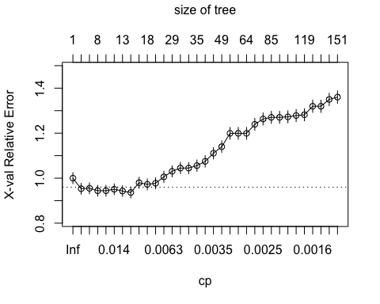

date.tr1 <- prune(date.tr, cp=0.011)  
date.tr1$variable.importance

## fun prob_o prob attr shar fun_o attr_o   
## 144.494863 106.295276 29.474435 27.760189 21.157164 16.199978 15.171390   
## intel_o pf_o_int   
## 13.931836 8.071229

# data preprocessing  
selected = colnames(data) %in%  
 c("fun", "prob_o", "prob", "attr", "shar", "fun_o", "attr_o", "intel_o", "pf_o_int", "match")  
dataNN = data[,selected]  
dataNN[,1] = as.factor(dataNN[,1])  
dataNN[, -1] <- sapply(dataNN[,-1], function(x)   
 (x-min(x, na.rm = TRUE))/(max(x, na.rm=TRUE) - min(x, na.rm = TRUE)))  
data_clean <- dataNN %>%   
 mutate_at(vars(colnames(dataNN[-1])), ~ifelse(is.na(.), median(., na.rm = TRUE), .))  
write.csv(data_clean, '~/Desktop/MSiA 420/speed-dating-project/data_clean.csv')

======================= end of data cleaning ========================

## Logistic regression

hist(data_clean$attr)

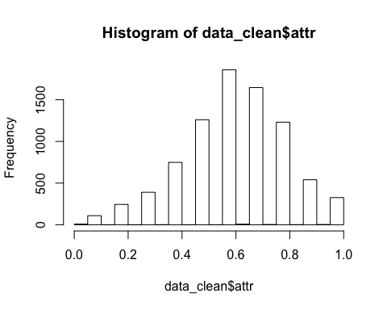

hist(data_clean$attr_o)

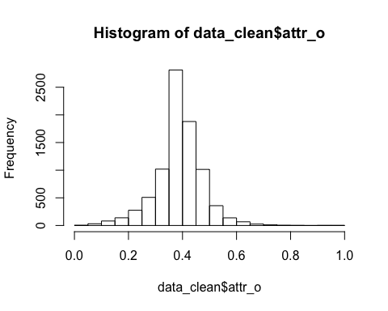

hist(data_clean$fun_o)

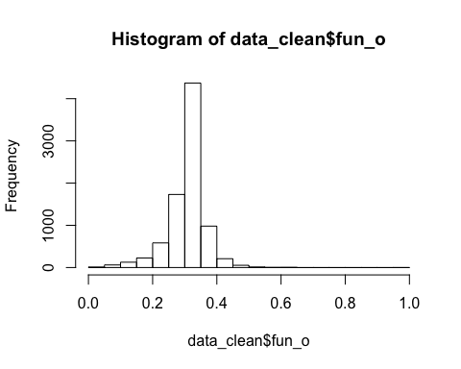

hist(data_clean$fun)

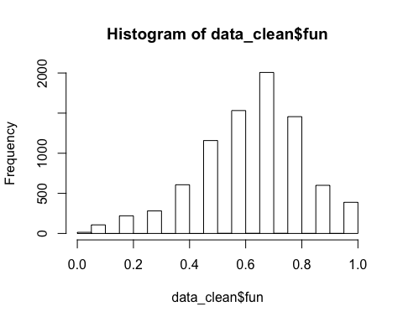

hist(data_clean$prob)

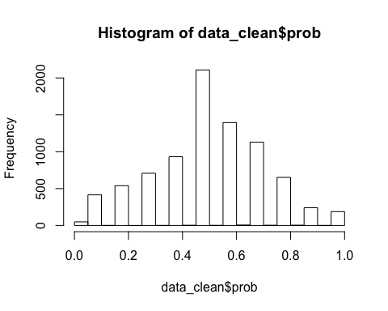

table(data_clean$match)

##   
## 0 1   
## 6998 1380

logistic1 <- glm(match ~., data=data_clean, family = 'binomial')  
summary(logistic1)

##   
## Call:  
## glm(formula = match ~ ., family = "binomial", data = data_clean)  
##   
## Deviance Residuals:   
## Min 1Q Median 3Q Max   
## -2.7641 -0.5755 -0.3610 -0.1728 3.0049   
##   
## Coefficients:  
## Estimate Std. Error z value Pr(>|z|)   
## (Intercept) -9.9489 0.5819 -17.098 < 2e-16 ***  
## pf_o_int 0.8436 0.2522 3.344 0.000824 ***  
## attr_o 3.9463 0.4582 8.612 < 2e-16 ***  
## intel_o -2.7648 0.7780 -3.554 0.000380 ***  
## fun_o 3.9869 0.6961 5.727 1.02e-08 ***  
## prob_o 2.9293 0.1815 16.143 < 2e-16 ***  
## attr 2.5224 0.2317 10.885 < 2e-16 ***  
## fun 1.7454 0.2636 6.620 3.59e-11 ***  
## shar 1.0923 0.2269 4.814 1.48e-06 ***  
## prob 1.6896 0.1888 8.951 < 2e-16 ***  
## ---  
## Signif. codes: 0 '***' 0.001 '**' 0.01 '*' 0.05 '.' 0.1 ' ' 1  
##   
## (Dispersion parameter for binomial family taken to be 1)  
##   
## Null deviance: 7496.8 on 8377 degrees of freedom  
## Residual deviance: 5898.0 on 8368 degrees of freedom  
## AIC: 5918  
##   
## Number of Fisher Scoring iterations: 6

library(car)

## Loading required package: carData

##   
## Attaching package: 'car'

## The following object is masked from 'package:dplyr':  
##   
## recode

vif(logistic1) # no multicollinearity

## pf_o_int attr_o intel_o fun_o prob_o attr fun shar   
## 1.011868 1.180550 1.249889 1.144091 1.069263 1.349581 1.578344 1.476627   
## prob   
## 1.178891

# cv function  
CVInd <- function(n,K) { # n is sample size; K is number of parts; returns K-length list of   
 # indices for each part   
 m <- floor(n/K) #approximate size of each part   
 r <-n - m*K   
 I <- sample(n,n) #random reordering of the indices   
 Ind <- list() #will be list of indices for all K parts   
 length(Ind) <- K   
 for (k in 1:K) {   
 if (k <= r) kpart <- ((m+1)*(k-1)+1):((m+1)*k)   
 else kpart <- ((m+1)*r+m*(k-r-1)+1):((m+1)*r+m*(k-r))   
 Ind[[k]] <- I[kpart] #indices for kth part of data   
 }   
 Ind  
}  
  
# misclass rate (return the best rate threshold)  
misclass <- function(rate = seq(0,1,0.01), true_class, predicted_value) {  
 misclass_ratio <- c()  
 model_class <- c()  
 result_table <- data.frame()  
 for (i in rate) {  
 predicted_class <- as.character(ifelse(predicted_value > i, 1, 0))  
 model_class <- c(model_class, predicted_class)  
 temp <- mean(predicted_class != as.character(true_class))  
 misclass_ratio <- c(misclass_ratio, temp)  
 }  
 # index <- which(misclass_ratio == min(misclass_ratio))  
 return(c(min(misclass_ratio), rate[which(misclass_ratio == min(misclass_ratio))]))  
}

K <- 5 # K-fold CV on each replicate  
n <- nrow(data_clean)  
Ind <- CVInd(n, K)  
y <- data_clean$match  
  
yhat <- as.numeric(y)  
yhat_class <- as.character(y)  
misclassCV <- c()  
  
set.seed(2020)  
for (k in 1:K) {   
 out <- glm(match ~., family = 'binomial', data = data_clean[-Ind[[k]],])  
 yhat[Ind[[k]]] <- predict(out, newdata = data_clean[Ind[[k]],-1],   
 type = 'response')  
 temp <- misclass(true_class = y[Ind[[k]]], predicted_value = yhat[Ind[[k]]])  
 mc <- temp[1]  
 threshold <- temp[2]  
 yhat_class[Ind[[k]]] <- as.character(ifelse(yhat[Ind[[k]]] > threshold, 1, 0))  
 misclassCV <- c(misclassCV, mc)  
 }  
misclass_logistic <- mean(misclassCV)  
misclass_logistic # 0.1471695

## [1] 0.1481263

confusionMatrix(as.factor(yhat_class), y)

## Confusion Matrix and Statistics  
##   
## Reference  
## Prediction 0 1  
## 0 6776 1019  
## 1 222 361  
##   
## Accuracy : 0.8519   
## 95% CI : (0.8441, 0.8594)  
## No Information Rate : 0.8353   
## P-Value [Acc > NIR] : 1.787e-05   
##   
## Kappa : 0.2992   
##   
## Mcnemar's Test P-Value : < 2.2e-16   
##   
## Sensitivity : 0.9683   
## Specificity : 0.2616   
## Pos Pred Value : 0.8693   
## Neg Pred Value : 0.6192   
## Prevalence : 0.8353   
## Detection Rate : 0.8088   
## Detection Prevalence : 0.9304   
## Balanced Accuracy : 0.6149   
##   
## 'Positive' Class : 0   
##

## Ridge

selected_ridge <- c('match','fun','prob_o','attr','attr_o','fun_o','prob','shar','amb_o',  
 'shar_o','age_o','sinc_o','intel_o','pf_o_int','tuition',  
 'attr2_2','attr3_1','shopping','fun1_1','sinc4_1','sinc2_2','pf_o_fun',   
 'income','fun3_2','sinc5_1','sinc','theater','pf_o_sin','pf_o_amb','intel1_1')  
data_ridge = data[, selected_ridge]  
data_ridge[,1] = as.factor(data_ridge[,1])  
data_ridge[, -1] <- sapply(data_ridge[,-1], function(x)   
 (x-min(x, na.rm = TRUE))/(max(x, na.rm=TRUE) - min(x, na.rm = TRUE)))  
data_ridge <- data_ridge %>%   
 mutate_at(vars(colnames(data_ridge[-1])), ~ifelse(is.na(.), median(., na.rm = TRUE), .))  
  
library(glmnet)

## Loading required package: Matrix

## Loaded glmnet 3.0-1

x <- model.matrix(match~., data_ridge)[,-1]  
y <- data_ridge$match  
cv.ridge <- cv.glmnet(x, y, alpha = 0, family = "binomial")  
ridge1 <- glmnet(x, y, alpha = 0, family = "binomial",  
 lambda = cv.ridge$lambda.min)  
cv.ridge$lambda.min

## [1] 0.01002687

coef(ridge1)

## 30 x 1 sparse Matrix of class "dgCMatrix"  
## s0  
## (Intercept) -6.972393839  
## fun 1.782331216  
## prob_o 2.465521694  
## attr 2.267925439  
## attr_o 2.508546501  
## fun_o 2.297859623  
## prob 1.674172996  
## shar 1.088681665  
## amb_o -2.726511357  
## shar_o 1.528721515  
## age_o -0.664971212  
## sinc_o -2.440517071  
## intel_o -2.207143313  
## pf_o_int 0.800729816  
## tuition -0.081638440  
## attr2_2 -0.696859934  
## attr3_1 -0.194644761  
## shopping -0.280235923  
## fun1_1 0.605202152  
## sinc4_1 -0.469174686  
## sinc2_2 -1.046376039  
## pf_o_fun 0.365593839  
## income 0.229045250  
## fun3_2 0.144550031  
## sinc5_1 0.341061831  
## sinc 0.001714128  
## theater -0.104959328  
## pf_o_sin 0.244974745  
## pf_o_amb -0.187747735  
## intel1_1 0.888335088

K <- 5 # K-fold CV on each replicate  
n <- nrow(data_clean)  
Ind <- CVInd(n, K)  
  
yhat <- as.numeric(y)  
misclassCV <- c()  
  
set.seed(2020)  
for (k in 1:K) {   
 out <- glmnet(x[-Ind[[k]],], y[-Ind[[k]]], alpha = 0, family = "binomial",  
 lambda = cv.ridge$lambda.min)  
 yhat[Ind[[k]]] <- predict(out, newx = x[Ind[[k]],], type = 'response')  
 temp <- misclass(true_class = y[Ind[[k]]], predicted_value = yhat[Ind[[k]]])  
 misclassCV <- c(misclassCV, temp)  
 }  
misclass_ridge <- mean(misclassCV)  
misclass_ridge # 0.1466937

## [1] 0.3709679