Tutorial [Optional]
This tutorial has been designed to show how easy content can be added and changed for the timeline.

Accessing the files you need
- Make sure that you do not have the timeline open, in any of your browsers, in fact fully close all your browsers, before you begin.
- Go to https://github.com/Ariadne-S/ariadne-s.github.io/tree/tutorial
Will take you to this… Check that you are on the tutorial Branch.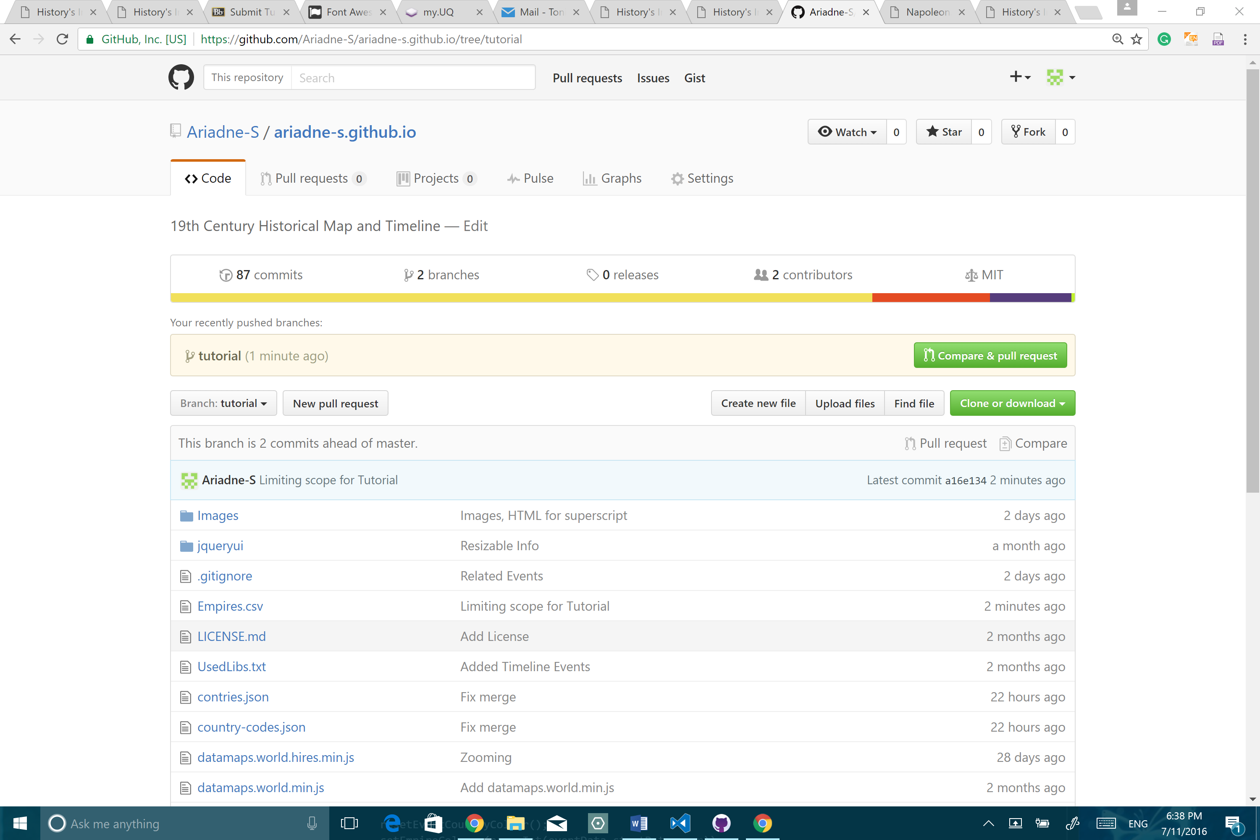
- Before you continue, check again that you are on the tutorial branch (not master), the click on the Clone of Download button.
- Download Zip
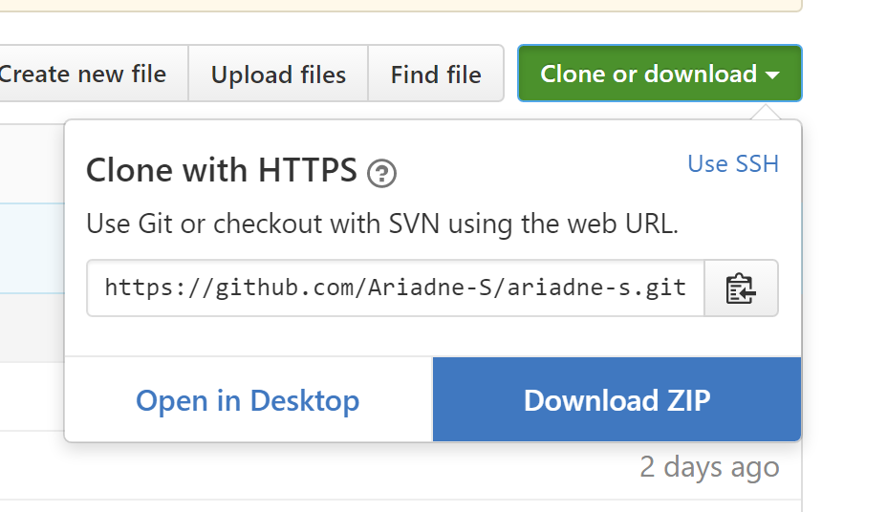
- Right-click, on Zip file in your download folder and Extract all.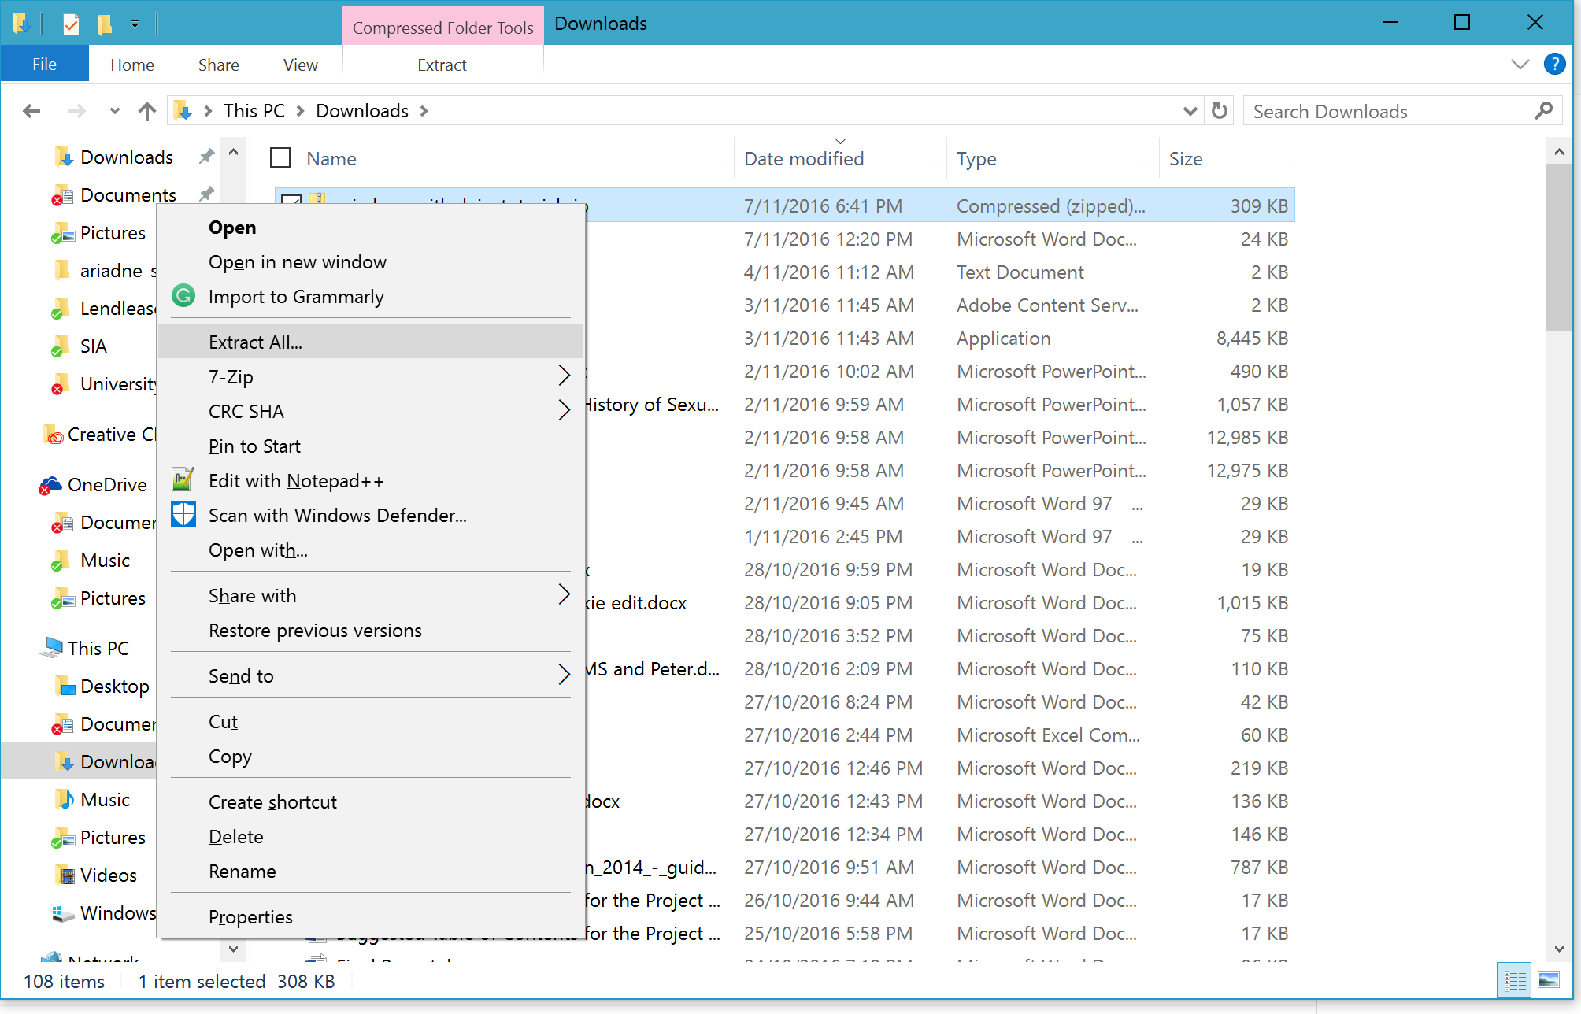
- Extract.
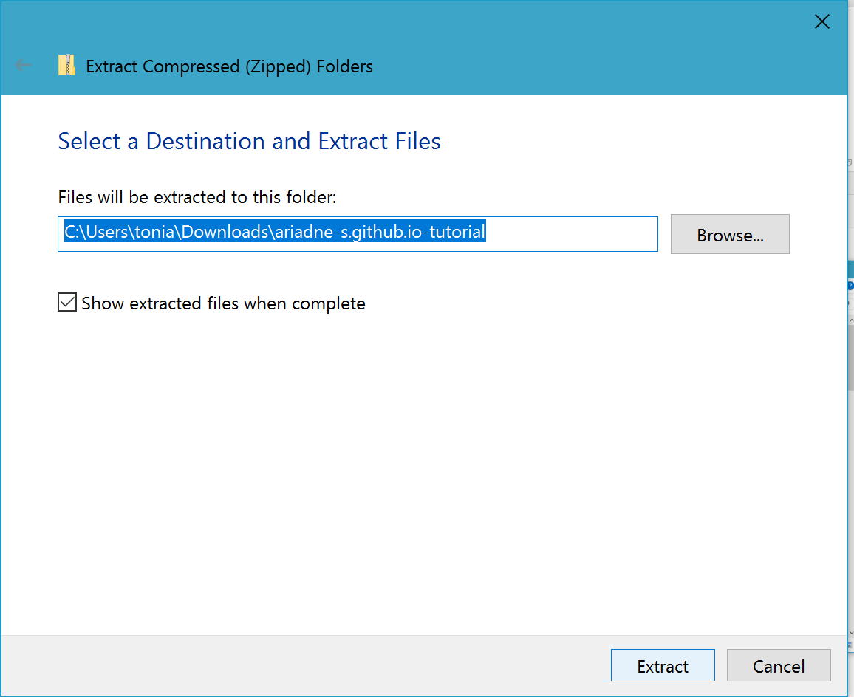
- You now have a folder of all the files needed for the tutorial.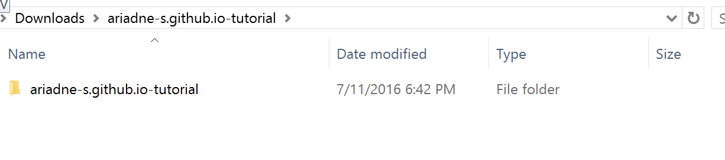
- Right-click Mongoose
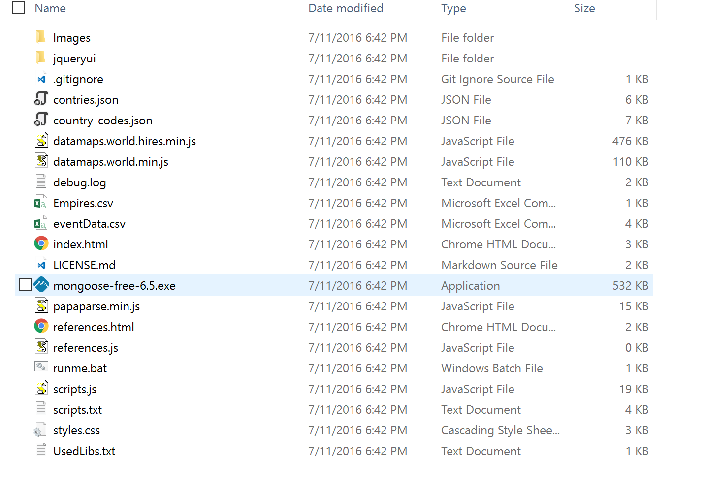
- Click Properties
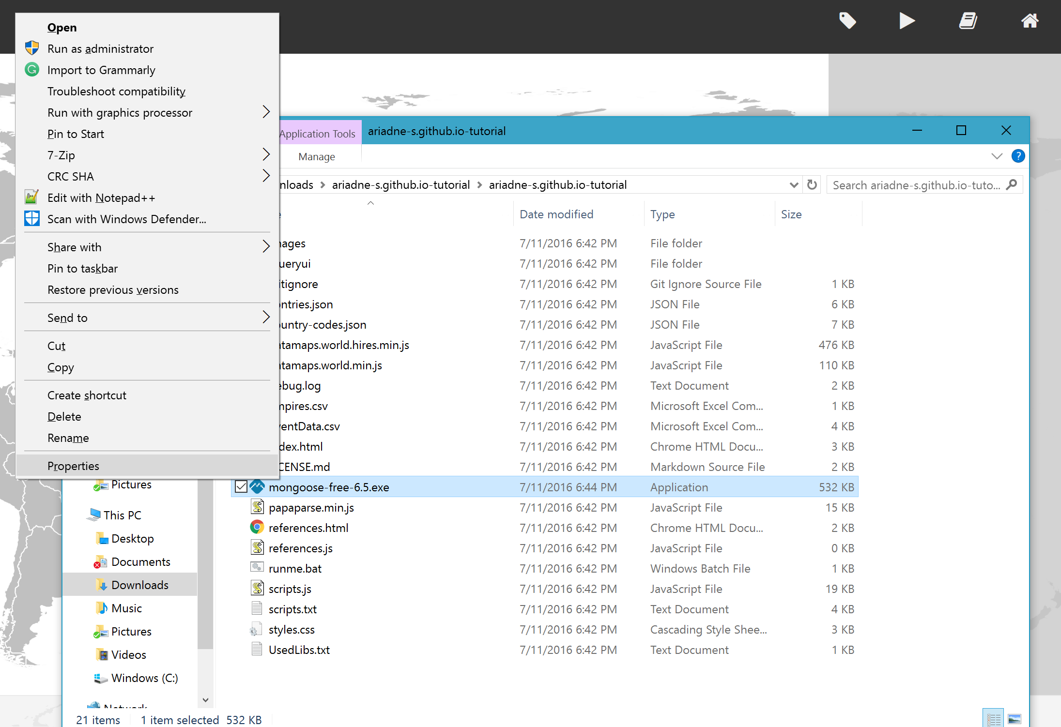
- Click Unblock
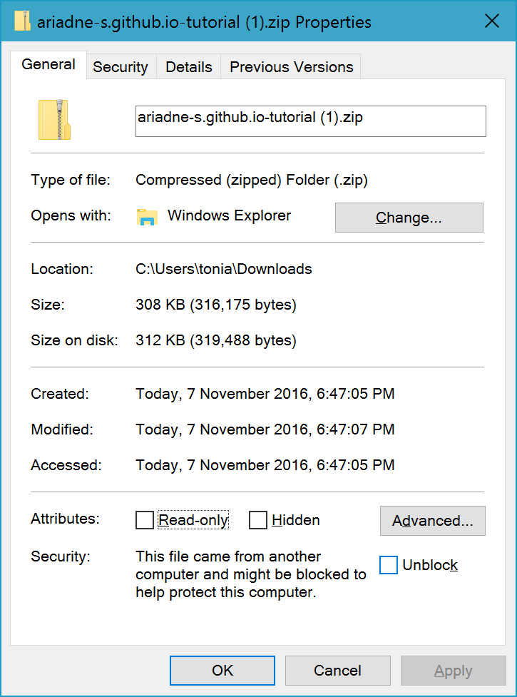
- Open Mongoose It will open your default internet browser. Ideally use Chrome.
- If you the map opens as usual, check that you accessed the right Branch in GitHub.

Fixing an error
- You will see a page with an error. I have done this on purpose. Read the error
  - Line (?): Location has an invalid country code: (?) (Did you mean to use the code (?)?)
- Go back to the files and open eventData.csv in EXCEL.
- The error you read in step 11, told you the line the mistake is in. It also told you what it was wrong and what to change it to. Please make these changes now.
- Save
- Refresh the page with the error. Using ctrl+F5 (this is a full refresh, that ignores Cache)
- Ideally it should now work – You just fixed your first error. (if it doesn’t work, maybe close the entire internet browser (all windows) and reopen the Mongoose file or google how to disable cache in the browser you are using)

Adding an Event
- Adding an event. Following the example of the previous rows, please copy and paste the following data (no need to transfer the headings). Alternatively, there is a file in the folder called Tutorial Event Text, if you cannot copy and paste out of turnitin.

Start Date:
1806

End Date:
1807

Title
Continental Blockade

Related Events
Napoleonic War

Description
Implemented by Napoleon, the Continental Blockade was designed to weaken Great Britain through the destruction of British commerce.<span class="super">1</span> By not allowing countries that were aligned with France or neutral to trade with Britain, therefore cutting them off. Britain reacted with a counterblockade, in the form of 'Orders in Council' that "were the main causes of the Anglo-American War of 1812."<span class="super">2</span> So while the Continental Blockade was designed to weaken Britain, it had further ranging influences in that it did not only impact upon Britain's prosperity but also of all those involved or whom became the targets of Britain's counter. While historians agree that had it worked, the Continental Blockade was a great idea that could have won Napoleon the war.<span class="super">3</span> However, due to the British's overwhelming superiority at sea, Napoleon could not enforce the Blockage and is regarded as the turning point in the war, as it led Napoleon to his doomed invasion of Russia and consequently his ultimate downfall. <span class="super">4</span>

Footnotes
<span class="super">1</span> "Continental System". Encyclopedia Britannica. Encyclopedia Britannica Online.Encyclopedia Britannica Inc., 2016. Web. 04 Nov. 2016, https://www.britannica.com/event/Continental-System; <span class="super">2</span> Ibid.; <span class="super">3</span> Dugdale-Pointon, T. (25 December 2000), Continental System, http://www.historyofwar.org/articles/concepts_continentalsystem..html; .<span class="super">4</span> Ibid: "Continental System". Encyclopedia Britannica. Encyclopedia Britannica Online. Encyclopedia Britannica Inc., 2016. Web. 04 Nov. 2016, <https://www.britannica.com/event/Continental-System>.

Location
GBR; FRA

- Save
- Refresh the page. Using ctrl+F5.
- If there are any errors, please fix them now, save and refresh.
- Hopefully everything should work.

References
This is the reference list for the entire project.
Technical/Third-party libraries
Mark DiMarco, Datamaps (Code, 2012) at http://datamaps.github.io/
Matthew Holt. Papaparse (Code, 2015) at https://github.com/mholt/PapaParse
Mike Bostock. D3 - Data-Driven Documents (Code, 2015) https://d3js.org/
Mozilla Developer Network. Mozilla Developer Network (Website, 2016) at https://developer.mozilla.org/en-US/.
Northwestern University Knight Lab. Timeline.Js (Code, 2015) at https://timeline.knightlab.com/index.html
Refnes Data. W3schools Online Web Tutorials. (Website, 2016) http://www.w3schools.com/.
Secondary Sources
Arnold Wiener and Ebooks Corporation, American Civil War the Essential Reference Guide (Calid: Abc-clio, 2011).
Bayly, & Atkinson. (1989). Atlas of the British Empire / [editor, C.A. Bayly; contributors, Alan Atkinson ... et al.]. New York: Facts on File.
BBC, British History (Website, 2014) http://www.bbc.co.uk/history/british/
Bernard Porter, The Lion’s Share: A History of British Imperialism 1850 to the present (London: Pearson, 2012)
Dorling Kindersley Limited, The British Empire (Website, 2016) http://www.dkfindout.com/uk/history/victorian-britain/british-empire/
Encyclopædia Britannica. Encyclopædia Britannica (Website, 2016)
Frank Smitha, Macrohistory: World History (Website, 2016) http://www.fsmitha.com/h3/in-path.html
Information Technology Associates. "Geographical Names." (National Geospatial-Intelligence Agency, Bethesda, MD, US). http://www.geographic.org/geographic_names/name.php?uni=-473628&fid=1611&c=egypt.
Jeremy Black and Donald MacRaid, Nineteenth-Century Britain (Basingstoke: Palgrave, 2003).
Jonathan King, Great Moments in Australian History (Sydney: Allen & Unwin, 2009).
Luscombe, Stephen. The British Empire (Website). http://www.britishempire.co.uk/.
Matthew, Adam. Empire Online (Website, 2016) http://www.empire.amdigital.co.uk.ezproxy.library.uq.edu.au/
National Film and Sound Archive of Australia. Australian Historical Timeline (Website, 2015). http://www.aushistorytimeline.com/
New World Encyclopedia. Anglo-Maratha Wars (Website, 2016) http://www.newworldencyclopedia.org/entry/Anglo-Maratha-Wars.
New World Encyclopedia. British Empire (Website, 2016) http://www.newworldencyclopedia.org/entry/British_Empire.
Stephen van Dulken, Inventing the 19th Century: the great age of Victorian inventions (The British Library, 2001)
The International Organization for Standardization. Online Browsing Platform (Website, 2016) https://www.iso.org/obp/ui/#home
Unknown. ISO 3166-1 Alpha-3. https://en.wikipedia.org/wiki/ISO_3166-1_alpha-3.
———. "Latitude and Longitude." http://www.latlong.net/.

