Kuali Ready
Developer Workstation
Setup Guide
Setup, Checkout, Build:
Maven, Eclipse, SVN, and Plug-ins
As used by the Kuali Ready Project
March 31, 2010

Table of Contents
Table of Contents 3
Introduction 5
What you need 5
What you should be able to do 6
A Developers Setup Check-List 7
1 Install SVN Workstation Client 8
2 Install Maven 9
2.1 Settings.XML 9
2.2 Add Local Jars to Maven Repository 9
3 Install Eclipse IDE and Plugins 11
3.1 Install M2Eclipse 11
3.2 Installing MyLin 11
3.3 Installing Subclipse 11
3.4 Installing WTP 11
4 Setup Project 12
4.1 Checkout the Code 12
4.2 Enable the Maven Dependencies 13
4.3 Set IDE and Project Settings 13
4.4 Prepare Log File Directories 14
5 Running Maven Builds (in Eclipse) 15
5.1 Maven Builds from Command Line 15
5.2 Setting up Maven Builds in Eclipse 15
5.3 Run the Maven Build and Deploy 16
5.4 Run External TomCat in Debug Mode with Eclipse 16
5.5 Validate Spring Server Side and DAO Layers: Spring Config 16
6 Deployment 17
6.1 Preparing the Application Server 17
6.2 Deployment using Eclipse 17
6.3 Ensure Deployment Operates Correctly 19
6.4 Login and Run the Application 20
7 Other Add-ins 21
7.1 GWT & GWT Designer 21
7.2 Jasper Assistant and iReports 21

Introduction
This document describes how to install and set up the Developer Stack used for Kuali Ready. The Stack consists of Maven, the Eclipse platform, SVN, a PKI infrastructure to connect to SVN, Tomcat, Eclipse Plug-ins and Ant. Note that the Eclipse platform incorporates the Web Tool Kit (WTP) that enables you to perform rapid testing of Web applications.
Eclipse also enables interactive immediate design and testing of other features such as Google Web Toolkit, and Jasper Reports. Maven, however, is geared for full application builds and delivery rather than immediate testing. This can cause some issues for Web development. If your application is complex, (requiring GWT for instance) then a Maven build may take a fairly significant amount of time. Also, Maven may put its output files in places that Eclipse WTP is not used to picking them up.
The objective of this document is to ensure that you can do all of these things: install both Eclipse WTP and Maven and make them work together. Here are the steps to check out your project using SVN and setup your environment for Maven and Eclipse.

What you need
This guide assumes you already have installed the version of Eclipse and plug-ins you are going to use and you have SVN setup for your system. If not, please first obtain Eclipse and obtain instructions on setting up access to the SVN repository for your department. The department used for this guide is IST Application Services Web Applications. For this guide we use:
Recommended Software |  | From
Operating System Windows or Mac OS X. | Required
Cygwin SVN (Windows) or TortoisSVN (Win/Mac) |  | http://www.cygwin.com/  http://tortoisesvn.tigris.org/
Java 6 (JDK 6.0) or Java 5 | Required | http://java.sun.com/javase/downloads/index_jdk5.jsp
Eclipse 3.4.0 Ganymede (not 3.4.2)  or Eclipse 3.5, 3.5 SR1 3.5 SR2 Galileo | Required | http://www.eclipse.org/
M2Eclipse Maven Integration for Eclipse  (The M2 Plugin) | Required | http://m2eclipse.sonatype.org/sites/m2e (as of Mar 2010)  Previously was http://m2eclipse.sonatype.org/update/
Mylin | Required | http://download.eclipse.org/webtools/updates/
Subclipse 1.2 or 1.4 only DO NOT use 1.6 | Required | http://subclipse.tigris.org/update_1.2.x/ or  http://subclipse.tigris.org/update_1.4.x/
WTP | Required | http://download.eclipse.org/webtools/updates/
Maven 2.0.9 or 2.10 | Required | http://maven.apache.org/download.html
Tomcat 5.5, Tomcat 6.0, Jetty 6.0 or Glassfish | Required | http://tomcat.apache.org/download-55.cgi (or Use Tomcat from the Developers Kit)
SSH Shell client: SSH.Org, or PuTty, or Cygwin | Required | Ssh.org or http://www.chiark.greenend.org.uk/~sgtatham/putty/download.html
MS SQL Server database | Required | Database scripts for Kuali Ready can be found at /support/KualiReadyDBScripts.sql  After the database has been created, some tables will need to be pre-populated with specific information relevant to your institution.
For Windows, Cygwin is useful for many things including testing and verifying your SSH configuration and connection to the SVN repository. If you use Cygwin a full-install is recommended. (After starting Setup, click the “All” line so that it displays “Install”

What you should be able to do
The table below describes what you should be able to do with the Developer stack. After software installation, you should be able deploy to your internal Eclipse Server as well as run a Maven build as follows:
Capability | Description of Goal | Overview of Operating Instructions
Checkout | You should be able to checkout from SVN and set up the project (by following the procedures in this manual) | Read this, cover-to-cover and follow the instructions.
JUnit | Your JUnit test cases should run correctly under Eclipse.  There should be one and only one set of configuration files (Spring, Struts, etc) that is used for running all developer deployments and all JUnit tests. When you change configuration, you should change it in just one place. | Right click on a JUnit test case and select run as JUnit. First test Spring configuration. You should have a single Spring configuration (except where a separate one is required for a special mock case).
Hosted Mode | You should be able to run GWT in hosted mode (With GWT Designer, an Ant script, or the Google Plugin) | GWT Designer: right click on gwt.xml file  Ant: Run Plugin Script
Build | You should be able to do a complete Maven Build for your whole project and create a War to deploy to an external Tomcat. | Use Run Config to do Maven Clean Install
Deployment | Using the Eclipse Server View, you can define an internal Tomcat/JBOSS/Jetty/Glassfish Web Server. Using Eclipse, should be able to deploy your project to this internal. | Window | Show View | Servers to Open Server View. Right Click to create server. Add project. Deploy
GWT Compile – non repetitive. | You should be able to do just a single GWT Compile and not repeat the compile step unless (you decide that) a GWT file has been replaced. You should be also able to repeat just that one compile. | Use the Eclipse Deployment to avoid GWT compiles.
Getting files in the right place | GWT Compiles, Jasper JRXML, and all other resources should wind up in the right place for deployment
Maven-JUnit | Maven test:test should be able to run JUnit test cases | Use Run Config to setup Maven Test cases.

A Developers Setup Check-List
Here is a checklist of steps covered in this guide.
Step | Check |  | Section
 |  | Install:
 |  | - Your ssh public key | 1
 |  | - SVN client for your workstation | 1
 |  | - Maven | 2
 |  | - Setup .m2/settings.xml | 2
 |  | - Load Jars | 2
 |  | - Eclipse | 3
 |  | - M2Eclipse Plugin | 3
 |  | - Mylin Plugin | 3
 |  | - Subclipse Plugin | 3
 |  | - WTP Plugin | 3
 |  | Setup for Project:
 |  | - Eclipse IDE Preferences: SVN, Validation, and JDK Preferences | 4
 |  | - Checkout Source Code | 4
 |  | - Project Preferences and Facets | 4
 |  | - Logging Directory | 4
 |  | Test, Build and Run:
 |  | - Junit: SpringConfigITests | 5
 |  | - War: (Set up and Run Run Config for Maven Build) | 5
 |  | - Deploy to Eclipse Server | 5
 |  | - Login and Run the Application | 5
 |  | - Debug in Eclipse | 5
 |  | - Deploy to External Local Server | 5
 |  | - Debug in Eclipse in External Local Server | 5
 |  | - Prepare to Deploy to Unix Development and Q/A Servers | 5

Install SVN Workstation Client
All projects require you to have to a source code repository. For internal admin projects you will need public key access to the SVN repository for your department.
Once this is set up, you can use the Collabnet Subclipse plugin in Eclipse for visual access the SVN repository. You can also use your operating systems’ SVN client. In the case of Windows, the svn client for Cygwin works very well. There is also an SVN client available from Tortoise for Windows and the Mac.
This manual considers that you are using Subclipse under Eclipse. Installation of Subclipse is described in the Eclipse Software and Plug-in section. It’s generally a good idea, however, to have a 2nd SVN client so that you can verify your SVN connection. The Mac has native svn and ssh command. On Windows, you can use Cygwin or Tortoise. Cygwin is highly recommended.

Install Maven
You should start by installing Maven on your computer. This is done externally to Eclipse. The version of Maven we are using is 2.09 or 2.10. This set of instructions describes setting up Maven for the Kuali Ready project:

Settings.XML
Copy the support\settings.xml to your root local Maven repository.
It should be \.m2 (your user directory\.m2)

1a) Modify the settings.xml file your just copied to adapt to your environment:
A. Change the value of <google.webtoolkit.home> element to your GWT build bolder.
B. Change the USERNAME and PASSWORD of the Hibernate db connection parms.
C. Change the Tomcat.home of your local application server (it should be tomcat 5.x).
D. Change the username and password of your local application server (it should be tomcat 5.x).
1b) Make sure you have corresponding user with role manager in the tomcat config file at:

$CATALINA_HOME/conf/tomcat-users.xml.

Add Local Jars to Maven Repository
Set up a Jar Repository. Create a directory (c:\Jars on Windows or /Jars on Mac. Use Maven to copy the Jars directory into this with the following commands

For Windows:

cd c:\Jars
mvn install:install-file -DgroupId=javax.security -DartifactId=jacc -Dversion=1.0 -Dpackaging=jar -Dfile=C:\jars\jacc.jar
mvn install:install-file -DgroupId=javax.resource -DartifactId=connector -Dversion=1.0 -Dpackaging=jar -Dfile=C:\jars\connector.jar
mvn install:install-file -DgroupId=com.sun -DartifactId=ldapbp -Dversion=1.0 -Dpackaging=jar -Dfile=C:\jars\ldapbp.jar
mvn install:install-file -DgroupId=com.gwtextux -DartifactId=gwtextux -Dversion=1.0-beta-SNAPSHOT -Dpackaging=jar -Dfile=C:\jars\gwtextux.jar
mvn install:install-file -DgroupId=com.gwtext -DartifactId=gwtext -Dversion=2.0.5 -Dpackaging=jar -Dfile=C:\jars\gwtext.jar
mvn install:install-file -DgroupId=de.foo.commonj -DartifactId=commonj-twm -Dversion=1.0.1 -Dpackaging=jar -Dfile=C:\jars\commonj-twm.jar
mvn install:install-file -DgroupId=javax.sql -DartifactId=jdbc -Dversion=2_0-stdext -Dpackaging=jar -Dfile=C:\jars\jdbc.jar
mvn install:install-file -DgroupId=javax.jdo -DartifactId=jdo -Dversion=2.0 -Dpackaging=jar -Dfile=C:\jars\jdo2-api.jar
mvn install:install-file -DgroupId=com.sun -DartifactId=jmxri -Dversion=1.2.1 -Dpackaging=jar -Dfile=C:\jars\jmxri.jar
mvn install:install-file -DgroupId=com.sun -DartifactId=jmxremote -Dversion=1.0.1_04 -Dpackaging=jar -Dfile=C:\jars\jmxremote.jar
mvn install:install-file -DgroupId=com.sun -DartifactId=jmxremote-optional -Dversion=1.0.1_04 -Dpackaging=jar -Dfile=C:\jars\jmxremote_optional.jar
mvn install:install-file -DgroupId=org.objectweb -DartifactId=jotm -Dversion=2.0.10 -Dpackaging=jar -Dfile=C:\jars\jotm.jar
mvn install:install-file -DgroupId=javax.persistence -DartifactId=persistence -Dversion=1.0 -Dpackaging=jar -Dfile=C:\jars\persistence.jar
mvn install:install-file -DgroupId=javax.portlet -DartifactId=portlet-api -Dversion=1.0 -Dpackaging=jar -Dfile=C:\jars\portlet-api.jar
mvn install:install-file -Dfile=fontextension.jar -DgroupId=com.jasperforge -DartifactId=fontextension -Dversion=1.0.0 -Dpackaging=jar

For Mac:
mvn install:install-file -DgroupId=javax.security -DartifactId=jaas -Dversion=1.0.01 -Dpackaging=jar -Dfile=/Jars/jaas.jar
mvn install:install-file -DgroupId=javax.security -DartifactId=jacc -Dversion=1.0 -Dpackaging=jar -Dfile=/Jars/jacc.jar
mvn install:install-file -DgroupId=javax.resource -DartifactId=connector -Dversion=1.0 -Dpackaging=jar -Dfile=/Jars/connector.jar
mvn install:install-file -DgroupId=com.sun -DartifactId=ldapbp -Dversion=1.0 -Dpackaging=jar -Dfile=/Jars/ldapbp.jar
mvn install:install-file -DgroupId=com.gwtextux -DartifactId=gwtextux -Dversion=1.0-beta-SNAPSHOT -Dpackaging=jar -Dfile=/Jars/gwtextux.jar
mvn install:install-file -DgroupId=com.gwtext -DartifactId=gwtext -Dversion=2.0.5 -Dpackaging=jar -Dfile=/Jars/gwtext.jar
mvn install:install-file -DgroupId=de.foo.commonj -DartifactId=commonj-twm -Dversion=1.0.1 -Dpackaging=jar -Dfile=/Jars/commonj-twm.jar
mvn install:install-file -DgroupId=javax.sql -DartifactId=jdbc -Dversion=2_0-stdext -Dpackaging=jar -Dfile=/Jars/jdbc.jar
mvn install:install-file -DgroupId=javax.jdo -DartifactId=jdo -Dversion=2.0 -Dpackaging=jar -Dfile=/Jars/jdo2-api.jar
mvn install:install-file -DgroupId=com.sun -DartifactId=jmxri -Dversion=1.2.1 -Dpackaging=jar -Dfile=/Jars/jmxri.jar
mvn install:install-file -DgroupId=com.sun -DartifactId=jmxremote -Dversion=1.0.1_04 -Dpackaging=jar -Dfile=/Jars/jmxremote.jar
mvn install:install-file -DgroupId=com.sun -DartifactId=jmxremote-optional -Dversion=1.0.1_04 -Dpackaging=jar -Dfile=/Jars/jmxremote_optional.jar
mvn install:install-file -DgroupId=org.objectweb -DartifactId=jotm -Dversion=2.0.10 -Dpackaging=jar -Dfile=/Jars/jotm.jar
mvn install:install-file -DgroupId=javax.persistence -DartifactId=persistence -Dversion=1.0 -Dpackaging=jar -Dfile=/Jars/persistence.jar
mvn install:install-file -DgroupId=javax.portlet -DartifactId=portlet-api -Dversion=1.0 -Dpackaging=jar -Dfile=/Jars/portlet-api.jar
mvn install:install-file -Dfile=fontextension.jar -DgroupId=com.jasperforge -DartifactId=fontextension -Dversion=1.0.0 -Dpackaging=jar

Install Eclipse IDE and Plugins
The main task in setting up Eclipse is installing plug-ins that are compatible. In doing this, we have found that some versions of Eclipse are possible to install while other ones are not. In particular Eclipse Galileo SR1 works better than the original version, while Eclipse 3.4.0 works better than 3.4.2.
Important: Recent changes in the M2Eclipse plug-in require that you install this first.
Setup the plug-ins in this order:
- M2Eclipse (as of Mar 2010)
- Mylin
- Subclipse: Client and Interface.
- WTP – all but the test section.

Install M2Eclipse
After completing WTP and Subclipse, you are now ready to install the M2Eclipse plug-in. Note that the plugin install procedure changes from time to time. You will need to deselect AJDT option (otherwise install the AJDT update before M2Eclipse. But we don’t currently use it).

Installing MyLin
Mylin is a normal Eclipse Plugin. As of Eclipse 3.5 it automatically appears in the update site list.

Installing Subclipse
Run the install for Subclipse 1.2 or 1.4. When you are finished follow the instructions in next chapter to setup your connection to the SVN repository.

Installing WTP
ln is a normal Eclipse Plugin. As of Eclipse 3.5 Galileo, it automatically appears in the update site list.For WTP installation on Gallileo, do not install the test section.

Setup Project

After completing the environment setup, to checkout the code, and set the preferences.

Checkout the Code
- Start Eclipse
- For Eclipse 3.4 (but not 3.5): set SVN Options Window/Eclipse | Preferences | Team | SVN | Client Select SVNKit (Pure Java) SVNKit vxxxxx
- Select menu: Window | Open Perspective | Other | SVN Repository Browsing
- Select Window/Eclipse | Preferences | Validation and turn off DTD, XML Schema, HTML and any other unused Validators
- Right click the SVN Repositories pane and install the repository address for your department. For WebApps this is:
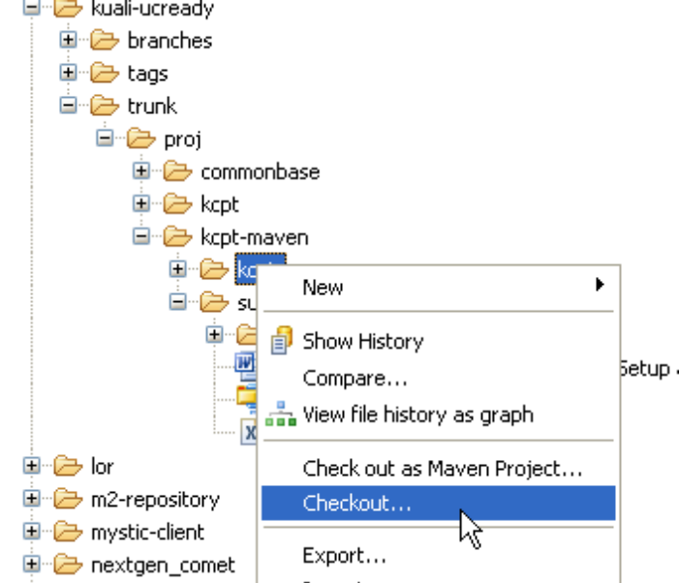
svn+ssh://youruserid@your.svn.server/your/project
The first time you do this (on Eclipse 3.5) you will probably need to specify the key file.
- You are prompted for a password. Instead, select “Private Key.”
- Check the “Save information check box.
- When prompted, navigate to your .ssh directory and select the private key file.

- This example shows checking out the Kuali Ready project from WebApps.For Kuali Ready, open the section kuali-ucready/trunk/proj/kcpt-maven/ you will see two directories: kcpt, and support.
- Right click kcpt to Checkout as a project (as shown at the right) a project (not a Maven project, just a project).
- After checkout do the following:
  - Open Project | Properties | Build Path | Libraries. If you are using Java 6: Remove any reference to JDK 5.0 library and add in a reference to the default JDK 6.0 Library.

Generally Maven dependencies are already turned on. If not, use the M2 Plugin to enable them.

Enable the Maven Dependencies
Kuali Ready is stored in SVN with Maven Dependencies already enabled. For other projects that are not stored this way, in the Project Explorer in Eclipse point to the project and right click and select Maven | Enable Dependency Management
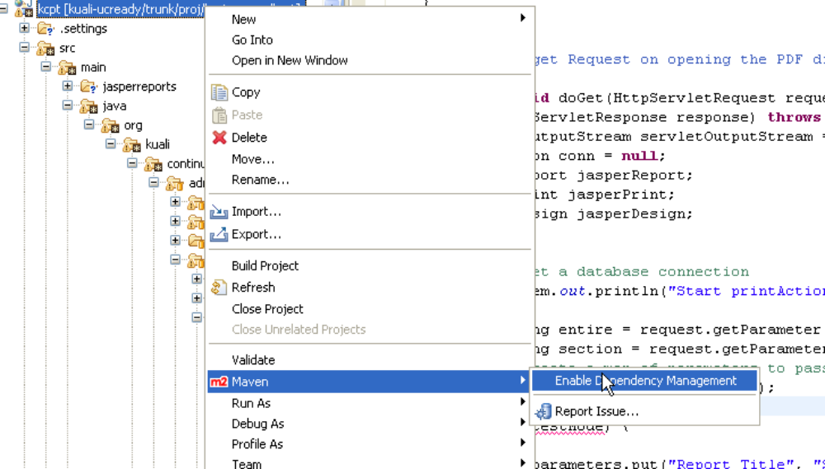

Set IDE and Project Settings
Eclipse controls its Java version and build path in several ways.
- IDE JDK Settings: Open Windows/Eclipse | Preferences | Java | Installed JREs. Ensure that a JDK (not a JRE) 6.0 is installed and is the default.
- Project JDK Settings: Set usage to the proper JDK. Go to the .settings directory. Open Project | Properties | Build Path | Libraries. If you are using Java 6: Remove any reference to JDK 5.0 library and add in a reference to the default JDK 6.0 Library.
- Project Facets: Ensure the project facets are set to match. Use Windows| View | Navigator. The open
.settings/org.eclipse.wst.common.project.facet.core.xmlp To use JDK 6, set the facets as follows:

.
<?xml version="1.0" encoding="UTF-8"?>
<faceted-project>
<runtime name="Apache Tomcat v5.5"/>
<fixed facet="jst.web"/>
<fixed facet="jst.java"/>
<installed facet="jst.java" version="6.0"/>
<installed facet="jst.web" version="2.4"/>
<installed facet="wst.jsdt.web" version="1.0"/>
</faceted-project>

- Project Validation: Turn off extraneous validation to reduce build time. In Windows/Eclipse | Preferences | Validation
- Project Rebuild. Do a refresh. Then Clean, Compile, Package, Install the application under Eclipse.
Additional setup can be done on the Eclipse IDE. See: Managing Fonts and Colors in the Eclipse IDE http://www.eclipsezone.com/eclipse/forums/m91973737.html

Prepare Log File Directories
Set up the following directory on your local system:
Unix/Mac: /var/tmp/kr/logs
Windows: c:/var/tmp/kr/logs

Running Maven Builds (in Eclipse)
Before doing any internal deploy with Eclipse, first you need to ensure that you can do a both a complete Maven build and set up its target directory. This will enable Eclipse deployment to work. Dev, Q/A and Prod use Maven, Maven build functionality is essential to the integrity of the project.

Maven Builds from Command Line
You can run a build from the command line, or set it up in Eclipse. To run from the command line:
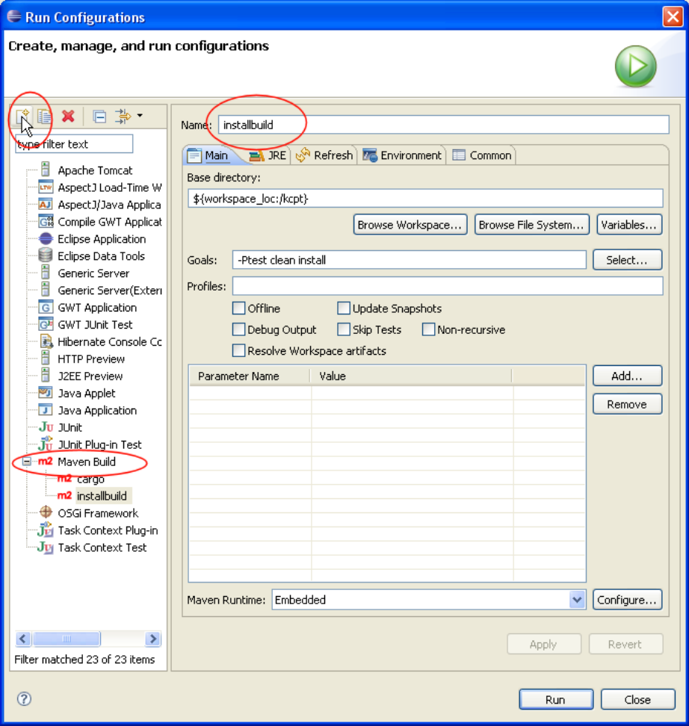
mvn -Ptest clean install

Setting up Maven Builds in Eclipse
To run from Eclipse, go into Eclipse:
- Right click on the pom.xml file
- Select Run As | Run Configurations
- The Run Configurations Dialog appears. Select Maven Build in the left-menu.
- Click the Plus-box in the upper left-hand corner to create a new Run Configuration.
- Click the Browse Workspace button and select the base directory for the project.
- Key in the Goals -Ptest clean install as shown below.
- Click Apply.
If you want to deploy it to production, modify profile production and run mvn -Pproduction clean install.

5. Use cargo to deploy and run the application. You can setup a cargo script in Eclipse just as you set up the install script. Or from the command line:

mvn -Ptest cargo:deployer-deploy cargo:start

Run the Maven Build and Deploy
Before doing a turnover, you should do a Maven Build and Deploy.
- Use the Run Configuration you just setup to do the build.
- Do a refresh of the target directory
- As of this writing, the local copy of hibernate.properties must be re-configured manually. Load from target/..hibernate.properties copy and save into src/resources/hibernate.properties
- Do a refresh of the project, and rebuild (if Project | Build Automatically is not checked)
- Using the Run Configurationyou setup, now do the Maven build.

Run External TomCat in Debug Mode with Eclipse
In your environment set the following:x
JPDA_ADDRESS=8000
JPDA_TRANSPORT=dt_socket
Then do:
catalina jpda start
In Eclipse Open the Debug button pull-down on the toolbar. Select Debug Configurations. Create a new one and name it "Tomcat" or some such thing and save it.

Validate Spring Server Side and DAO Layers: Spring Config
Open (Ctrl-Shift-R) the file SpringConfigITests.java. Right click and Run | as JUnit
It should print “OK.”
If there are any errors check to ensure that the required Service, DAO and other files are checked out and configured properly.
If you have a database connection problem, run the program JDBCConnectTest.java to check it out, then SpringJDBCTest

Deployment
You can do two kinds of deployment:
- Rapid Deployment within Eclipse using the Server Window.
- External Deployment to Tomcat

Preparing the Application Server
You will need to setup Tomcat. Kuali Ready is an extensive application and it has two special requirements
- Mail.jar must be placed in the Servers lib directory.
- To deploy on the Linux operating system, you need to setup the environmental variable: JAVA_FONTS that points to a directory containing the fonts uses by Kuali Ready. This is not necessary for OS X or Windows which already have fonts that can run with the program.

It’s recommended that you set up two copies of Tomcat in different locations. This will provide you the ability to do rapid deployments separately.

Deployment using Eclipse
1. Use Window | View | Other | Servers to open the Server view if it isn’t already open. In the Server Dialog Window, create a new TomCat 5.5 Server. Then double-click on the Server.
- Under Server Locations: Set Use Tomcat Installation
- Set the deploy path to webapps
- Under General Information: Click Open launch configuration
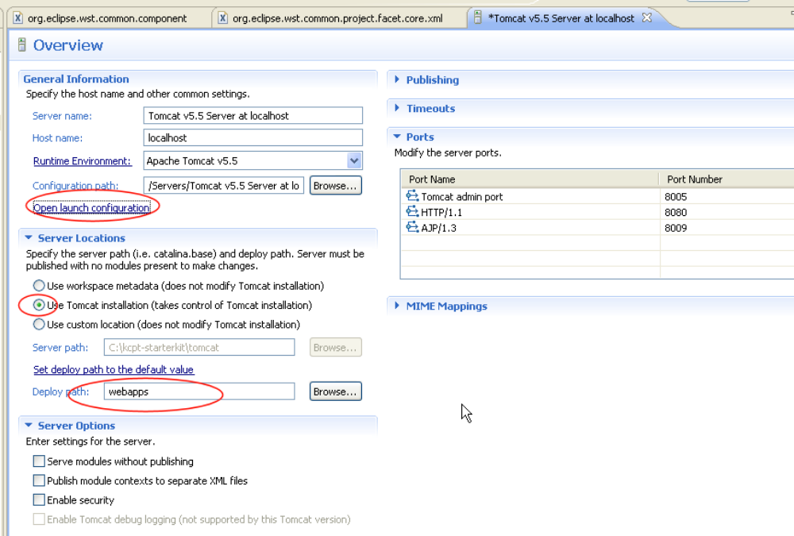
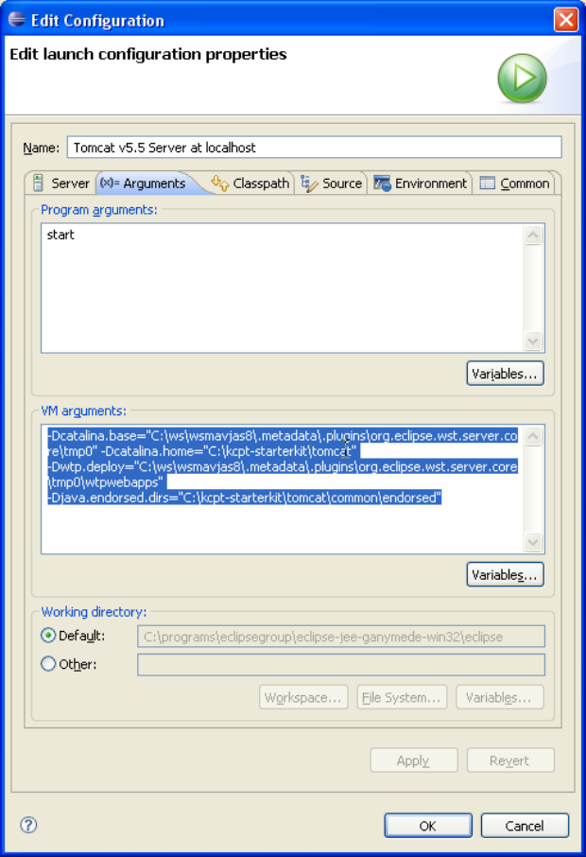
- With the Launch configuration open, set Tomcat VM startup arguments. If you are using Cygwin:
-Dcatalina.base="C:\cygwin\opt\apache\apache-tomcat-5.5.27"
-Dcatalina.home=" C:\cygwin\opt\apache\apache-tomcat-5.5.27"
-Dwtp.deploy=" C:\cygwin\opt\apache\apache-tomcat-5.5.27\webapps"
-Djava.endorsed.dirs=" C:\cygwin\opt\apache\apache-tomcat-5.5.27\common\endorsed"
-Djava.util.logging.config.file=" C:\cygwin\opt\apache\apache-tomcat-5.5.27\conf\logging.properties"
-Djava.util.logging.manager="org.apache.juli.ClassLoaderLogManager"
If you are using the developer kit enter as
-Dcatalina.base="C:\kcpt-starterkit\tomcat"
-Dcatalina.home="C:\kcpt-starterkit\tomcat"
-Dwtp.deploy="C:\kcpt-starterkit\tomcat\webapps"
-Djava.endorsed.dirs="C:\kcpt-starterkit\tomcat\common\endorsed"
-Djava.util.logging.config.file="C:\kcpt-starterkit\tomcat\conf\logging.properties"
-Djava.util.logging.manager="org.apache.juli.ClassLoaderLogManager"

- Add the Project to the Tomcat Server
- Ensure that hibernate.properties is configured correctly. If it is not, change it now so that it contains the proper database address.
hibernate.dialect=org.hibernate.dialect.SQLServerDialect
hibernate.connection.driver_class=net.sourceforge.jtds.jdbc.Driver
hibernate.connection.username=insert_kualiready_user_here
hibernate.connection.password=insert_kualiready_password_here
hibernate.connection.url=jdbc:jtds:sqlserver://sql-dnon02.ist.berkeley.edu:1433;DatabaseName=insert_kuali_ready_database_here

Place the updated hibernate.properties in both /src/resources and target/classes.

- If you have just done a Maven Build, you need to refresh. Right click on KCPT and select Refresh.
- Right click on the Server and select Publish. The server status should now read “Synchronized.”
- Right Click on the Tomcat server and select Start

Ensure Deployment Operates Correctly
In the Apache Tomcat log, you should see
INFO: Starting Coyote HTTP/1.1 on http-8080
Jan 27, 2010 10:44:28 AM org.apache.jk.common.ChannelSocket init
INFO: JK: ajp13 listening on /0.0.0.0:8009
Jan 27, 2010 10:44:28 AM org.apache.jk.server.JkMain start
INFO: Jk running ID=0 time=0/15 config=null
Jan 27, 2010 10:44:28 AM org.apache.catalina.storeconfig.StoreLoader load
INFO: Find registry server-registry.xml at classpath resource
Jan 27, 2010 10:44:28 AM org.apache.catalina.startup.Catalina start
INFO: Server startup in 23059 ms

If, however, you see a warning like:
SEVERE: /kcpt did not start due to previous errors

Check the application.log in /var/tmp/kr/logs for additional information. Some common issues are
- Running remote, but you forgot to start the VPN to communicate with the database
- mail.jar wasn’t loaded.

Login and Run the Application
The application runs in your local environment at localhost:8080/kcpt

Other Add-ins

GWT & GWT Designer
GWT and GWT Designer be run from the Eclipse Maven project. GWT Compilation is controlled Maven from with the POM. GWT Designer is installed as a plug-in to Eclipse. GWT Designer refers to a local copy of GWT which is downloaded separately.

Compilation
You should simply have compile turned on to compile GWT into the Maven-generated War. If While you can turn off GWT compilation if you don’t wish to see GWT operate, to reduce WAR generating time this shouldn’t be necessary since you can deploy to the Eclipse Server almost instantly.

Jasper Assistant and iReports
Jasper Assistant is a very easy-to-use plug-in to manage Jasper Reports. It enables rapid and fine-grained graphical editing of a report and testing of the report.

