**SMART WATER MANAGEMENT**

| **S.No** | **Reg.No** | **Name** | **Role** | **Email** | **Contact** |
| --- | --- | --- | --- | --- | --- |
| 1 | 950521205004 | S.Ariakash | Leader | ariaksh067@gmail.com | 9344369681 |
| 2 | 950521205006 | G.Arun Vignesh | Member | arunvignesh9747@gmail.com | 8248929747 |
| 3 | 950521205008 | V.Chidambaraganapathi | Member | chidambaram862003@gmail.com | 8925373984 |
| 4 | 950521205012 | 1. Hrithikesh Adityan S | Member | abijith1009@gmail.com | 8778014575 |
| 5 | 950521205027 | M.Shanmugakumar | Member | murugavenish3424@gmail.com | 6382785978 |

**Problem Definition:**

**Problem Statement:**

**\*Urban areas are facing critical issues related to water supply, distribution, and consumption. Inefficient management of water resources, leakages in the water supply system, and lack of real-time monitoring lead to wastage, uneven distribution, and higher operational costs.\***

**Specific Problems:**

1. **Water Losses and Leakages: Current water distribution systems suffer from high rates of leakages and losses. Identifying and fixing these leaks promptly is crucial to conserving water.**
2. **Uneven Distribution: Certain areas face water shortages, while others have an excess supply. Balancing the distribution to ensure equitable access to clean water is a priority.**
3. **Inefficient Consumption: There is a lack of awareness among residents about their water usage patterns. Many households and businesses are unaware of their excessive water consumption and do not have the means to track or control it.**
4. **Outdated Infrastructure: Aging water infrastructure hampers efficient water supply. Upgrading and modernizing the existing systems are necessary for better control and management.**
5. **Lack of Real-time Monitoring: There is a need for real-time monitoring systems to track water flow, detect leakages, and assess consumption patterns. Current systems are often manual, leading to delayed responses to issues.**

**Project Objective:**

**The objective of this smart water management project is to develop and implement an integrated system utilizing IoT (Internet of Things) devices, data analytics, and smart technology to address the identified problems. The goal is to reduce water losses, ensure equitable water distribution, promote efficient water usage, modernize infrastructure, and enable real-time monitoring for proactive management and conservation of water resources in urban areas.**

**This problem definition provides a clear overview of the challenges faced and the goals of the smart water management project. It forms the basis for further research, planning, and implementation of the project.**

**Design thinking approach:**

**Design thinking is a human-centered problem-solving approach that can be highly effective for tackling complex issues like smart water management. It emphasizes understanding the needs of the end-users, generating creative solutions, prototyping, and continuous iteration. Here's how you can apply the design thinking approach to a smart water management project:**

**Empathize:**

**Identify and empathize with various stakeholders involved, such as residents, local authorities, and environmentalists. Conduct interviews, surveys, and observations to understand their perspectives, challenges, and expectations regarding water usage and management.**

**User Journey Mapping:**

**Create user journey maps to visualize the experiences and interactions of different users with the water management system. This helps in identifying pain points and opportunities for improvement.**

**Define**

**Problem Reframing:**

**Based on the empathetic understanding, redefine the problem statement if necessary. Ensure that the problem is defined from the perspective of the users and their needs rather than just technical or operational constraints.**

**Identify Constraints:**

**Understand the technical, financial, and regulatory constraints that might affect the project. These constraints should be considered while brainstorming solutions.**

**Ideate:**

**Brainstorming Sessions:**

**Organize brainstorming sessions with a diverse group of participants, including engineers, designers, community members, and policymakers. Encourage the generation of a wide range of ideas without immediate criticism.**

**Mind Mapping:**

**Use mind mapping techniques to explore connections between various ideas and concepts. This can help in identifying innovative solutions and potential synergies.**

**Prototype:**

**Rapid Prototyping: Create quick and low-cost prototypes of potential solutions. These can be physical prototypes (such as IoT devices) or digital prototypes (such as user interfaces for monitoring systems). Prototyping helps in visualizing ideas and getting feedback from stakeholders.**

**Iterative Testing:**

**Test the prototypes with real users to gather feedback. Be open to feedback and use it to refine the prototypes further. Iterate the prototyping and testing process multiple times to arrive at an optimal solution.**

**Block Diagram:**

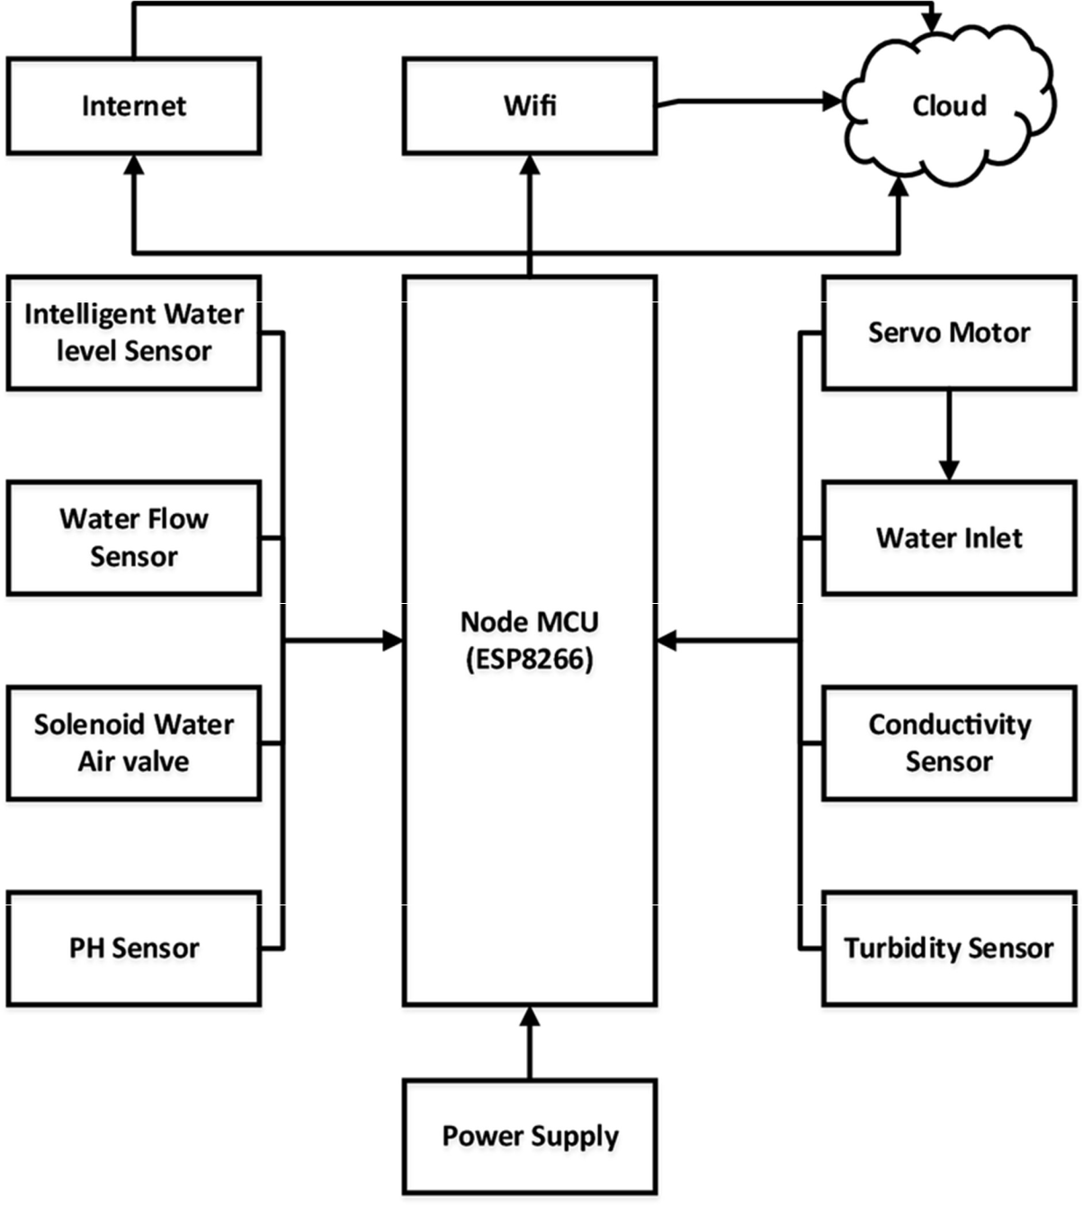

**Intelligent water level sensor;An intelligent water level sensor is a device designed to measure the water level in a specific area, such as a tank, reservoir, or a natural water body.**

**Water level sensor: A water flow sensor is a device that measures the rate of water flow in a pipeline or plumbing system. It typically consists of a sensor and a transmitter. When water flows through the sensor, it produces an electrical signal proportional to the flow rate, which is then transmitted to a display or data collection system for monitoring and analysis.**

**PH Sensor: A pH sensor is a device used to measure the acidity or alkalinity of a solution. It detects the concentration of hydrogen ions in the solution, providing a numerical pH value to indicate its acidity (pH values below 7) or alkalinity (pH values above 7). This information is crucial in various applications, including water quality testing, chemical analysis, and industrial processes.**

**Turbidity Sensor: A turbidity sensor measures the cloudiness or haziness of a liquid caused by suspended particles. It quantifies the degree of clarity in the liquid by analyzing the amount of light scattered or absorbed, providing valuable data for water quality assessment and environmental monitoring.**

**Hardware:**

**Water flow sensor,PH sensor,power supply,Turbidity sensor,solenoid water sensor.**

**Software:**

**Python,C**