Start Document Final Assignment C#

Arian Atapour (5088453)

1. **Problem Description**

5. Skating championship

A number of skaters take part in a skating championship. The following

distances are skated consecutively: 500 metres, 5000 metres, 1500 metres and 10000 metres. Times are registered precisely to hundredths of seconds. The time achieved for the various distances is converted into points by reducing each time to a 500 metre time. The skater with the lowest total number of points wins the championship.

A program must be developed in which the name and times (format mmsshh)

can be entered for each consecutive competitor. The points total of each skater must then be calculated and shown, as well as who the winner is.

1. **Input & Output**

In this section the input and output of the application will be described.

**Input**

|  |  |  |
| --- | --- | --- |
| **Case** | **Type** | **Condition** |
| Skater(name,distance, points) | Skater | not null |
| Distance(Skater skater) | Distance | not null |
| Championship(Distance distance) | Championship | not null |
| addName{set} | String | not null |
| setDistance | Double | not null |
| setPoints | Double | not null |
| addSkater | Skater | not null |
| addDistance | Distance | not null |

**Output**

|  |  |
| --- | --- |
| **Case** | **Type** |
| getName | String |
| getDistance | Double |
| getPoints | Double |
| getSkaters | List<Skater> |
| getWinner | String |

**Calculations**

|  |  |
| --- | --- |
| **Case** | **Calculation** |
| winner | Calculating the winner for each meters based on time and distance |

1. **Class Diagram**

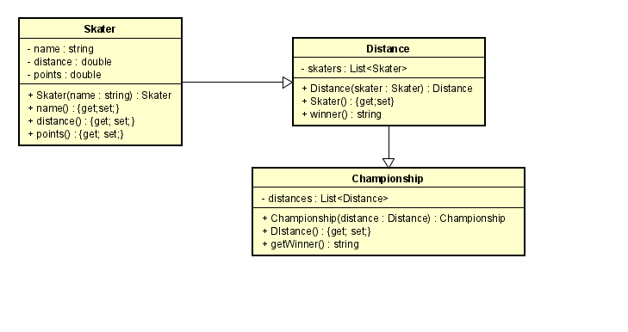

1. **Test Plan**

In this section the testcases will be described to test the application.

**Test data**

In the following table you’ll find all the data that is needed for testing.

**Skater**

|  |  |
| --- | --- |
| **Id** | **Input** |
| Skater1 | name: Test, time:00:00:30, distance:500m |
| Skater2 | name: Test2, time:00:00:45, distance:500m |

**Test cases**

In this section the testcases will be described. Every test case should be executed with the test data as starting point.

**#1 Creating the skater**

The process to instantiate the skater object.

|  |  |  |  |
| --- | --- | --- | --- |
| **Step** | **Input** | **Action** | **Expected output** |
| 1 | name | addName(name) | void |

**#2 Adding distance and time to the skater**

The process of selecting the skater adding time and distance.

|  |  |  |  |
| --- | --- | --- | --- |
| **Step** | **Input** | **Action** | **Expected output** |
| 1 | combobox(selecting the skater) | getName() | Test |
| 2 | timePicker(selecting the time) | Skater(time) | void |
| 3 | distance | Skater(distance) | void |

**#3 Getting the results**

Calculating the points and getting the results

|  |  |  |  |
| --- | --- | --- | --- |
| **Step** | **Input** | **Action** | **Expected output** |
| 1 | - | getWinner() | Test, 30 |