The Virtual Partner

Ariana Hernandez  
*Long Island University*   
New York, United States  
Ariana.Hernandez@my.liu.edu

Masheha Rashid   
*Long Island University*New York, United States  
Masheha.Rashid@my.liu.edu

*Abstract*—The world of artificial intelligence continues to expand, allowing for new and exciting ways for users to interact with computers. Computers are now learning the ability to understand human language and respond through the practice of natural language processing. Natural language processing is broken down into two components, natural language understanding and natural language generation. Natural language understanding is the ability of the computer to understand sentences from text or speech including tone, sentence structure and sentiment. Natural language generation is the ability of the computer to use its understanding to generate its own sentences that are relevant to context and coherent. This type of process is utilized throughout chatbots, a type of program where users can “chat” with the computer. Chatbot can be in a variety of industries in order to help consumers solve various issues. In this paper, the usage of a chatbot will be utilized for social and entertainment purposes.

Keywords—natural language processing, chatbot, artificial intelligence

# Introduction

The concept of chatbot’s has been around since the late 1900s when computer programmers began to theorize about a robot that humans could communicate with. The first chatbots were text-based like Cleverbot before becoming more advanced like Eviebot which used text-to-speech to create a more immersive experience. Presently, Chatbots act as a conversational agent that utilizes text, voice and even images in some cases to respond to user input.

Chatbots can be utilized throughout a variety of industries. Businesses can use chatbots in order to answer frequently asked questions as well as provide solutions to simple problems. This can help the business become more efficient as workers are not wasting time dealing with users.

Chatbots are commonly also used for social and entertainment purposes. A person who deals with social anxiety and has trouble communicating with others, may use a chatbot to practice talking to a human person. Communicating with a robot can also prove to be a very fun and enjoyable experience as sometimes AI can come up with interesting ideas that one would not think of. There are many AI chatbots such as Replika which have shown how humans bond with and form relationships with AI.

In this project, The Virtual Partner, the program's chatbot utilizes data from a popular dating simulator, Mystic Messenger to create a more romantic response from the AI. The chatbot is designed to respond just as the in-game character would. The chatbot's main goal is to provide an entertaining experience but can also be used to combat loneliness.

# Related Work

## A critical review of state‐of‐the‐art chatbot designs and applications.

This paper focuses on the various chatbot designs that are utilized. According to this work, “There are six types of chatbots: template-, corpus-, intent-, recurrent Neural network (RNN)-, reinforcement learning (RL)-based, and those with hybrid approaches” [1]. Template-, corpus- and intent-based chatbots do not utilize artificial intelligence which makes them the simplest to implement. Each of these approaches contains a predefined template with responses that the program can grab from though they use different management techniques in order to grab this information. While simple to implement, these types of chatbots do not learn and are very static. RNN-based chatbots utilize deep learning techniques like the Seq2Seq model to learn and generate conversations. These neural network-based chatbots are not commonly used as they still often give uncertain responses. Reinforcement learning-based chatbots are a type of retrieval-based chatbot that uses reinforcement learning in order to generate responses based on pre-defined dialogues. Reinforcement learning is much more complicated than non-AI chatbots but often provides better, more appropriate responses. Hybrid approaches are the process of combining any of the six types of chatbots in order to have better results. This paper found that hybrid approaches show the best results but reinforcement learning-based chatbots are showing a lot of promise.

## A survey on Different Algorithms used in Chatbot.

This paper discusses the various algorithms that can be used to define a Chatbot. The first type of algorithm is the pattern matching algorithm where questions and answers are stored in a database where questions are patterns and answers are templates. “The Virtual Partner” program utilizes a very similar algorithm. Next, there is the Naïve Bayes algorithm where sentences are tokenized, and data is trained using a dictionary of classes that are defined and contained a list of words. This algorithm is good when inputs are defined but has issues if the input sentence does not match the stored data. There is also the Seq2Seq Model which utilizes a recurrent neural network to take in an input as a sequence of words or sentences and returns an output that is a sequence of words. Unfortunately, this model has difficulty in processing long sentences as it often loses context from the beginning of the sentence. There is the Hybrid Emotional Inference Model which uses Latent Dirichlet Allocation (LDA) and Long Short-Term Memory (LSTM) to create a more emotive chatbot. Long short-term memory is a type of recurrent neural network that can process images, speech and video. In the context of chatbots, it is very good for classification techniques and is good for classifying more than one phrase. This paper concluded that each of the models has their own benefits and drawbacks. It also looked towards a future where upgrades can be made to allow these algorithms to understand common text slang.

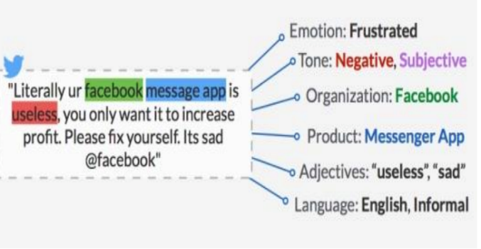

## Exploring relationship development with social chatbots: A mixed-method study of replika.

Replika is a common social chatbot app that utilizes artificial intelligence. This application has a 3D model of a character that can be dressed up as well as communicated with. The bot can act as a friend, sibling or even a romantic partner. In this paper, the researchers utilized three different studies in order to determine the validity of two different theories. The first was social response theory (SRT) which states that people will respond to computer screens that exhibit social cues. The second is computers-are-social-actors theory (CASA) which states that humans will humans will apply the same social rules for human interactions to computers as they do to humans because the computer acts or responds similarly to humans. The first study conducted by researchers had users communicate with the Replika AI for at least 1 month (and until they reached at least level 10 in the app). This study concluded that people preferred more human-like interactions. In the second study, users (a collection of students) were told to talk to the Replika app for 2 weeks then fill out a survey. The study concluded that the “greater perceived SC anthropomorphism and authenticity intensify users’ social interactions with AI-based social chatbots” [3]. Social anthropomorphism is how human-like AI is and authenticity refers to if the AI felt as though it was really learning rather than regurgitating pre-written responses. The third study had users fill out a survey about why they used the app. The survey concluded that social motivation was the largest dominant motivator for users with information and curiosity being the second highest. This research supports the current theories on relationships between humans and AI which say that humans like AI the more human-like they are.

# Motivation

The motivation for this project is simply entertainment. The authors are both enjoyers of dating simulator games and wanted to create an experience where the dating simulation felt more realistic and human-like. Most dating simulators (like the game that the data utilized in this program is from) only allow the user to pick from a binary set of options. This does not allow the user to feel like they are truly engaging with another person as they aren’t able to speak freely. This program allows the user to type in whatever they want and while the program is not perfect, it will still provide a response regardless of the input. The program was even implemented with hedging language (“uhm”, “oh” and other phrases that represent uncertainty) so rather than simply saying, “I don’t know”, the program can pick from any number of responses. Humans don’t always know what to say when someone speaks so it is realistic to assume that the program should exhibit the same behavior of pausing during moments of uncertainty.

Another motivation for this project was to create something that would be beneficial for those who do not have strong social skills. As a result of the pandemic, many people have a hard time going out, meeting people and making friends. This chatbot could serve as a method to practice these social skills in a safe and judgement-free environment. In addition, the chatbot can serve as a friend for moments where a user is feeling especially lonely.

While the program still has some issues with its responses, we have found that it still serves its purpose in a roundabout way. While undergoing training, the bot would sometimes respond in silly or nonsensical ways which can be very amusing. Since the robot's primary purpose is to be entertaining, it has technically done so. Compared to our previous models of the project, this chatbot is able to respond in a much more sensical way.

# Code Analysis

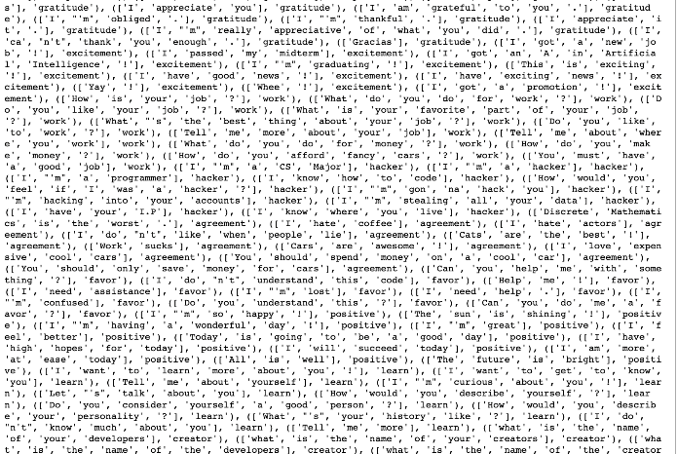

In our code, we first install PyTorch as well as nltk (natural language tool kit) packages in order to be able to teach and train the model. The Natural language toolkit is responsible for stemming the words. In this model, we split the sentences by words and those words are deposited into an array. The code takes in the data from the 707.json file and unpacks it based on the patterns. The original data was a long CSV file from in-game dialogue which the creators of this project (Masheha and Ariana) spent hours working through line-by-line in order to determine the best tag that the quote belonged too. The patterns are the possible inputs that the program should learn from in order to be able to respond properly. These patterns are given a tag to place all the patterns under a specific group. For example, the "greeting" tag contains patterns such as "Hello", "Hi" and "Hey". The data also contains valid responses to the given tag. There are 29 tags in the code (including tags which respond to emoticons and laugh at jokes) and 333 patterns. The data is then organized into training data that is usable with the PyTorch model.

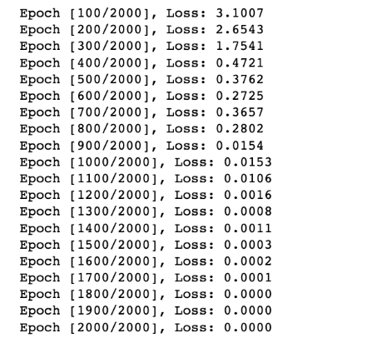

The PyTorch model creates a Feed forward neural network with three linear layers. Within this model, we are using the ReLU function for activation. The model also utilizes a cross entropy loss function and an Adam optimizer function. The model is trained with 2000 epochs. We also reduced the learning rate from its original 0.001 to 0.0001. According to the current training, the data is experiencing a small amount of loss which implies that it is learning well. The model's trained data is then saved into a torch file that is loaded into the model. After this, the model is able to make predictions based on inputs. If the input contains a tag that the model can recognize, it picks a random choice from the list of appropriate responses. If the input does not contain a tag that the model can recognize, it picks a random choice from an array of hedging language. This hedging language was also pulled from the original game data. Despite having a larger dataset, the chatbot still sometimes struggles with identifying what response to use. For example, it equates the word “Good” with phrases like “Good Morning” which is a greeting so if the user says something like, “I’m feeling good”, it will respond with a greeting like “Hi”. The final aspect of this program creates a graphical user interface which is a chat room that the user can type directly into to be able to talk to the bot. The program also allows the user to input their name to personalize the GUI.

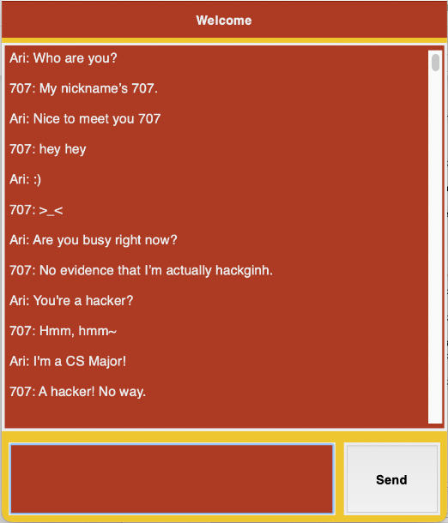

# Conclusion

In conclusion, chatbots are not a growing field in the world of artificial intelligence but they are still very fun and interesting to work with. The challenge is to create a bot that provides appropriate and realistic responses. Currently, our bot is doing much better at holding semi-realistic conversations though it does favor certain topics over others. As more tags and data are added, the AI will be retrained and learn to respond better. Our hope for the future of this project is to create a chatbot that is able to maintain a natural conversation and makes the user feel that they are being treated how they would like by a potential partner.

## Authors and Affiliations

### Ariana Hernandez, Author

### Masheha Rashid, Author

##### References

1. *Luo, B., Lau, R. Y., Li, C., & Si, Y. W. (2022). A critical review of state‐of‐the‐art chatbot designs and applications. Wiley Interdisciplinary Reviews: Data Mining and Knowledge Discovery, 12(1), e1434.*
2. Pardeshi, S., Ovhal, S., Shinde, P., Bansode, M., & Birajdar, A. (2020). A survey on Different Algorithms used in Chatbot. International Research Journal of Engineering and Technology.
3. Pentina, I., Hancock, T., & Xie, T. (2023). Exploring relationship development with social chatbots: A mixed-method study of replika. Computers in Human Behavior, 140, 107600.
4. Ahmedov, Aslan. “Asikpalysik/Star-Wars-Chatbot: Simple Chatbot Implementation with Pytorch.” GitHub, https://github.com/Asikpalysik/Star-Wars-Chatbot.
5. pineapple_soup. “707 Messages.” Kaggle, 17 July 2022, https://www.kaggle.com/datasets/pineapplesoup/707-messages.