**Supplementary material**

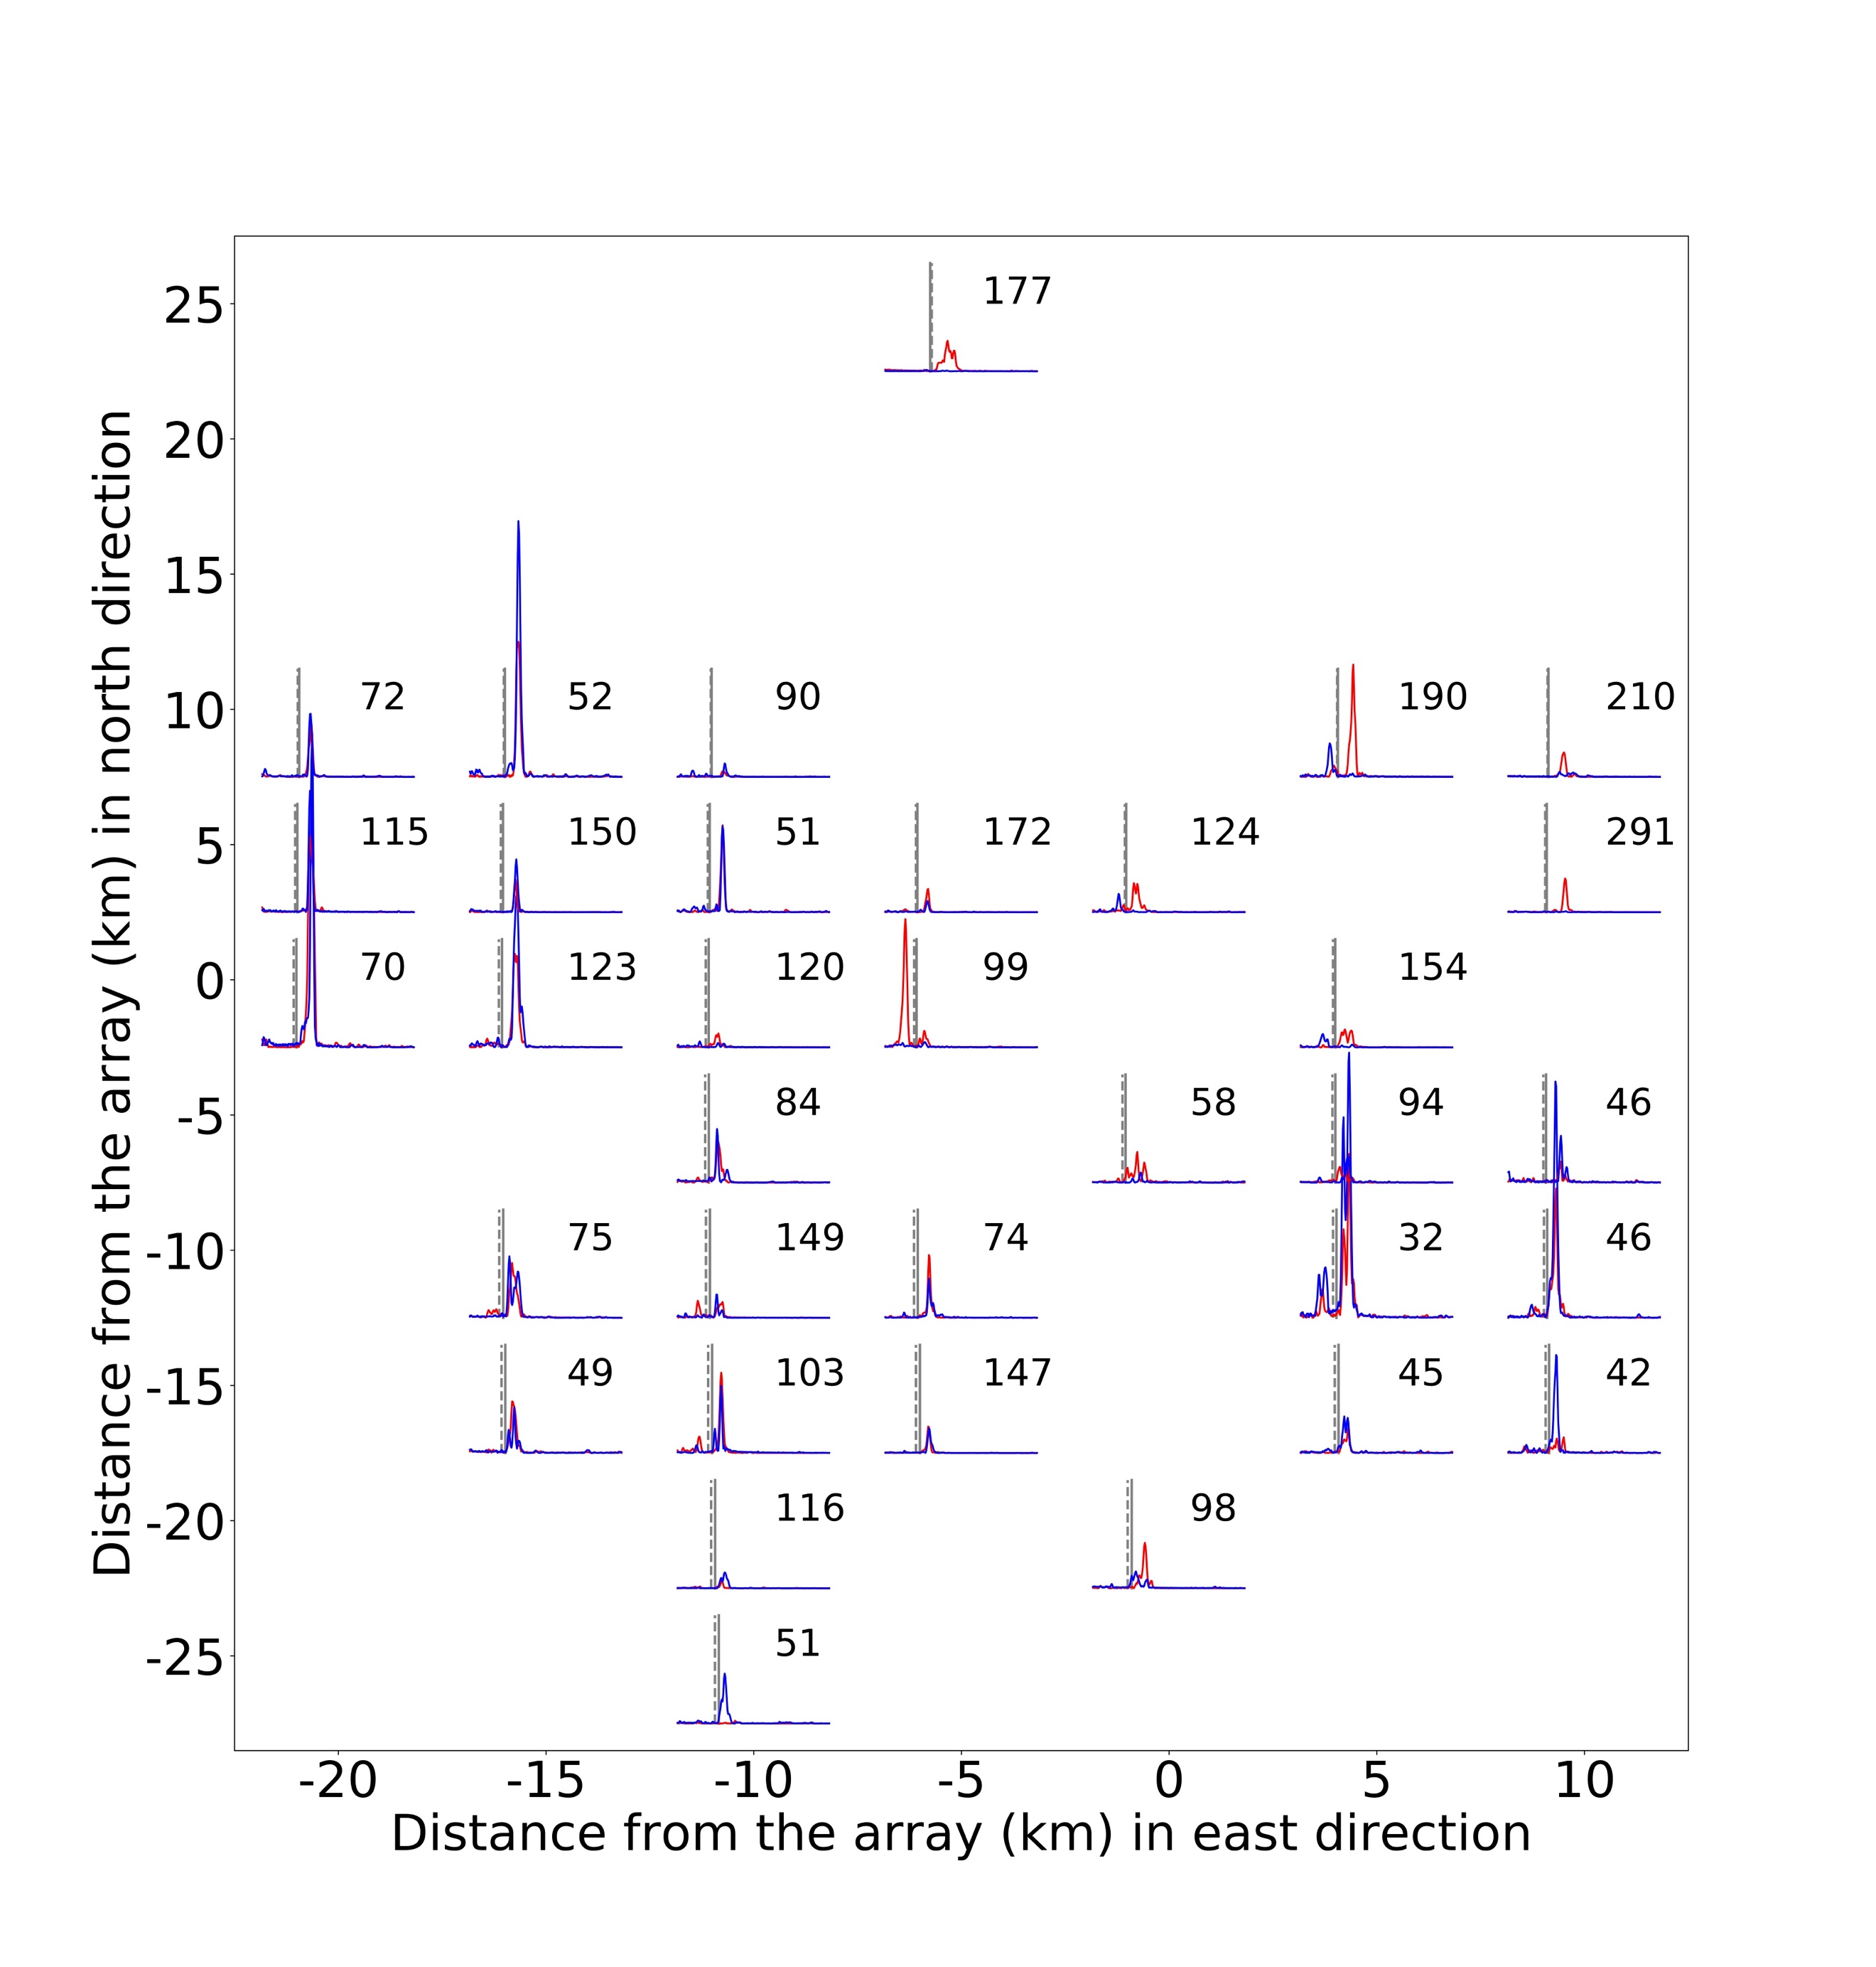

**Figure S1.** Envelopes of the stacked cross correlation signals for different positions of the tremor source relative to the Burnt Hill array.

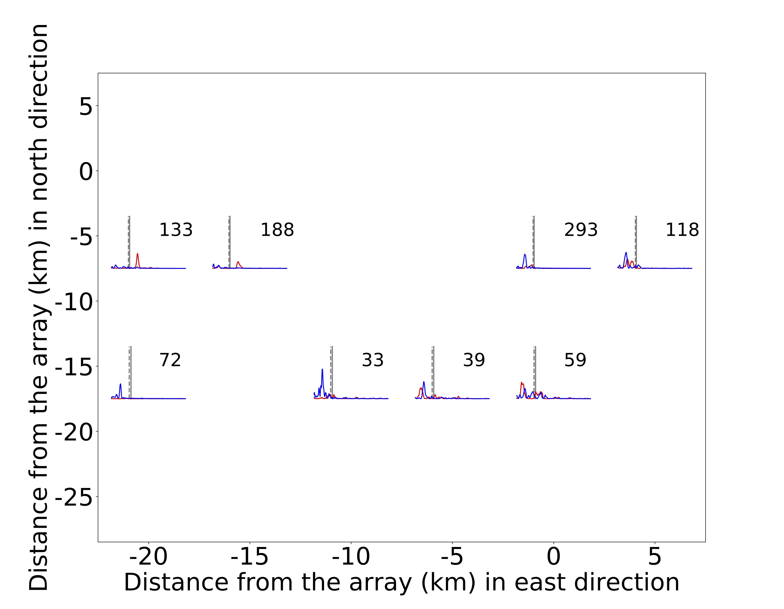

**Figure S2.** Envelopes of the stacked cross correlation signals for different positions of the tremor source relative to the Cat Lake array.

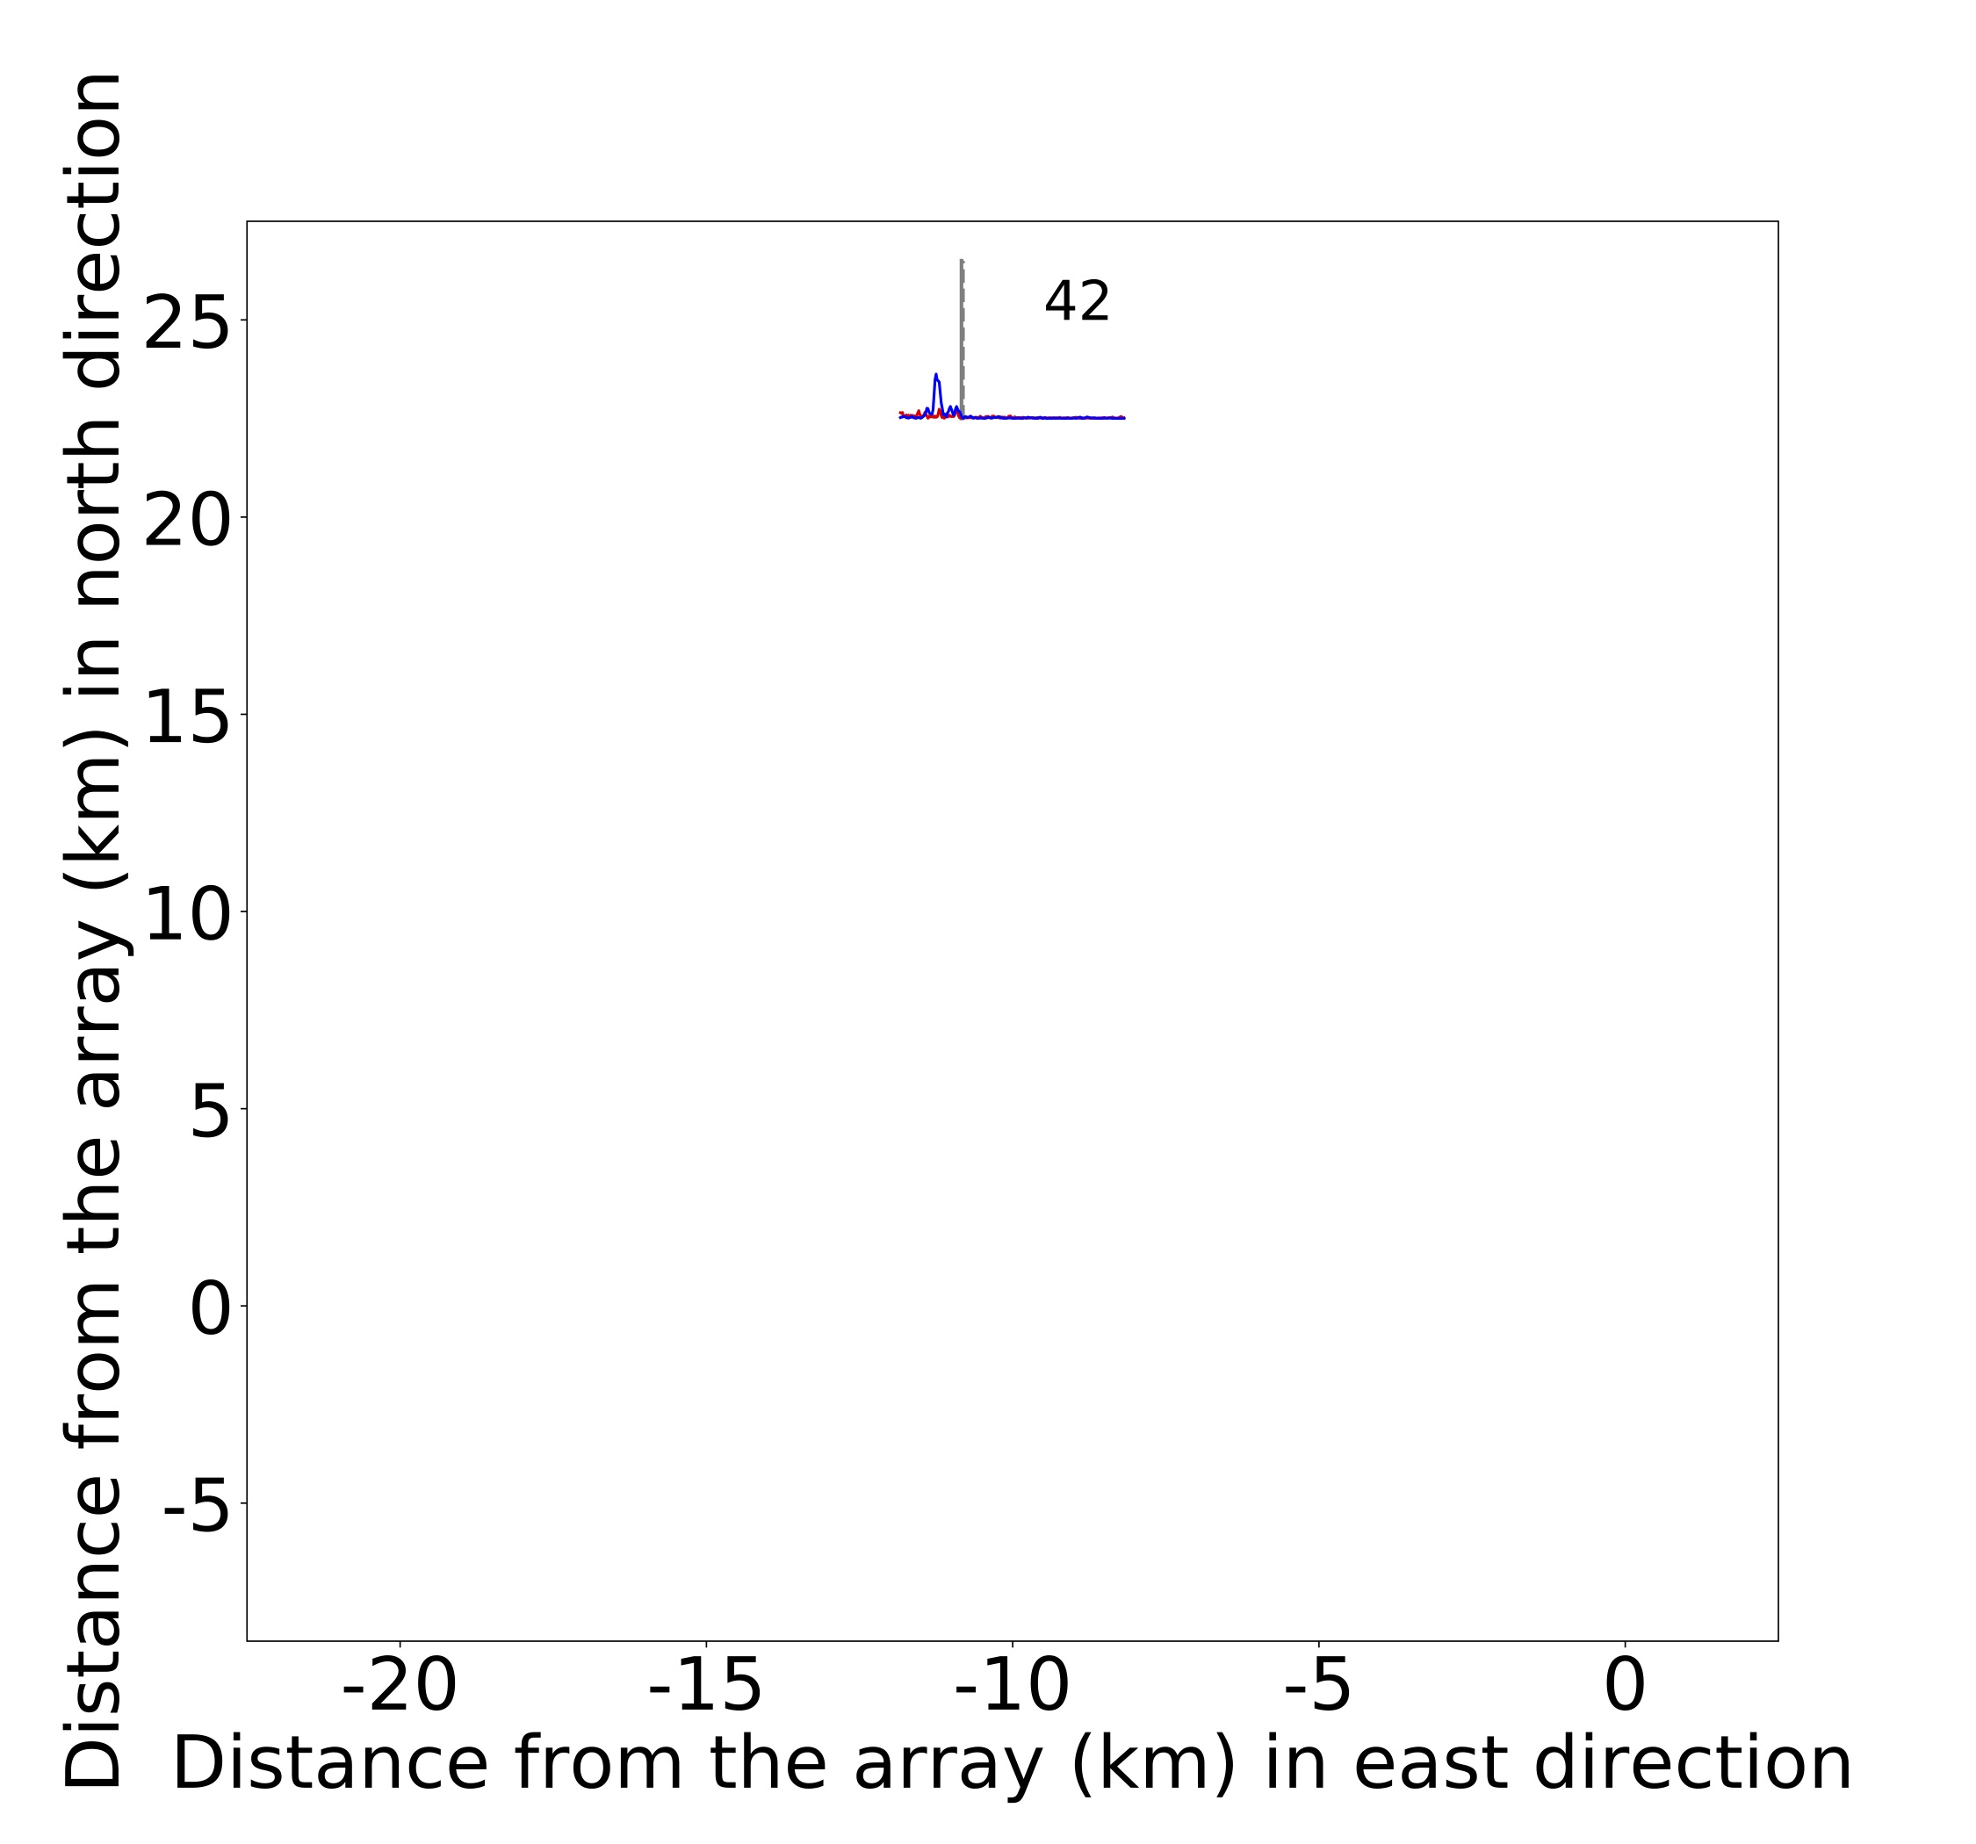

**Figure S3.** Envelopes of the stacked cross correlation signals for different positions of the tremor source relative to the Danz Ranch array.

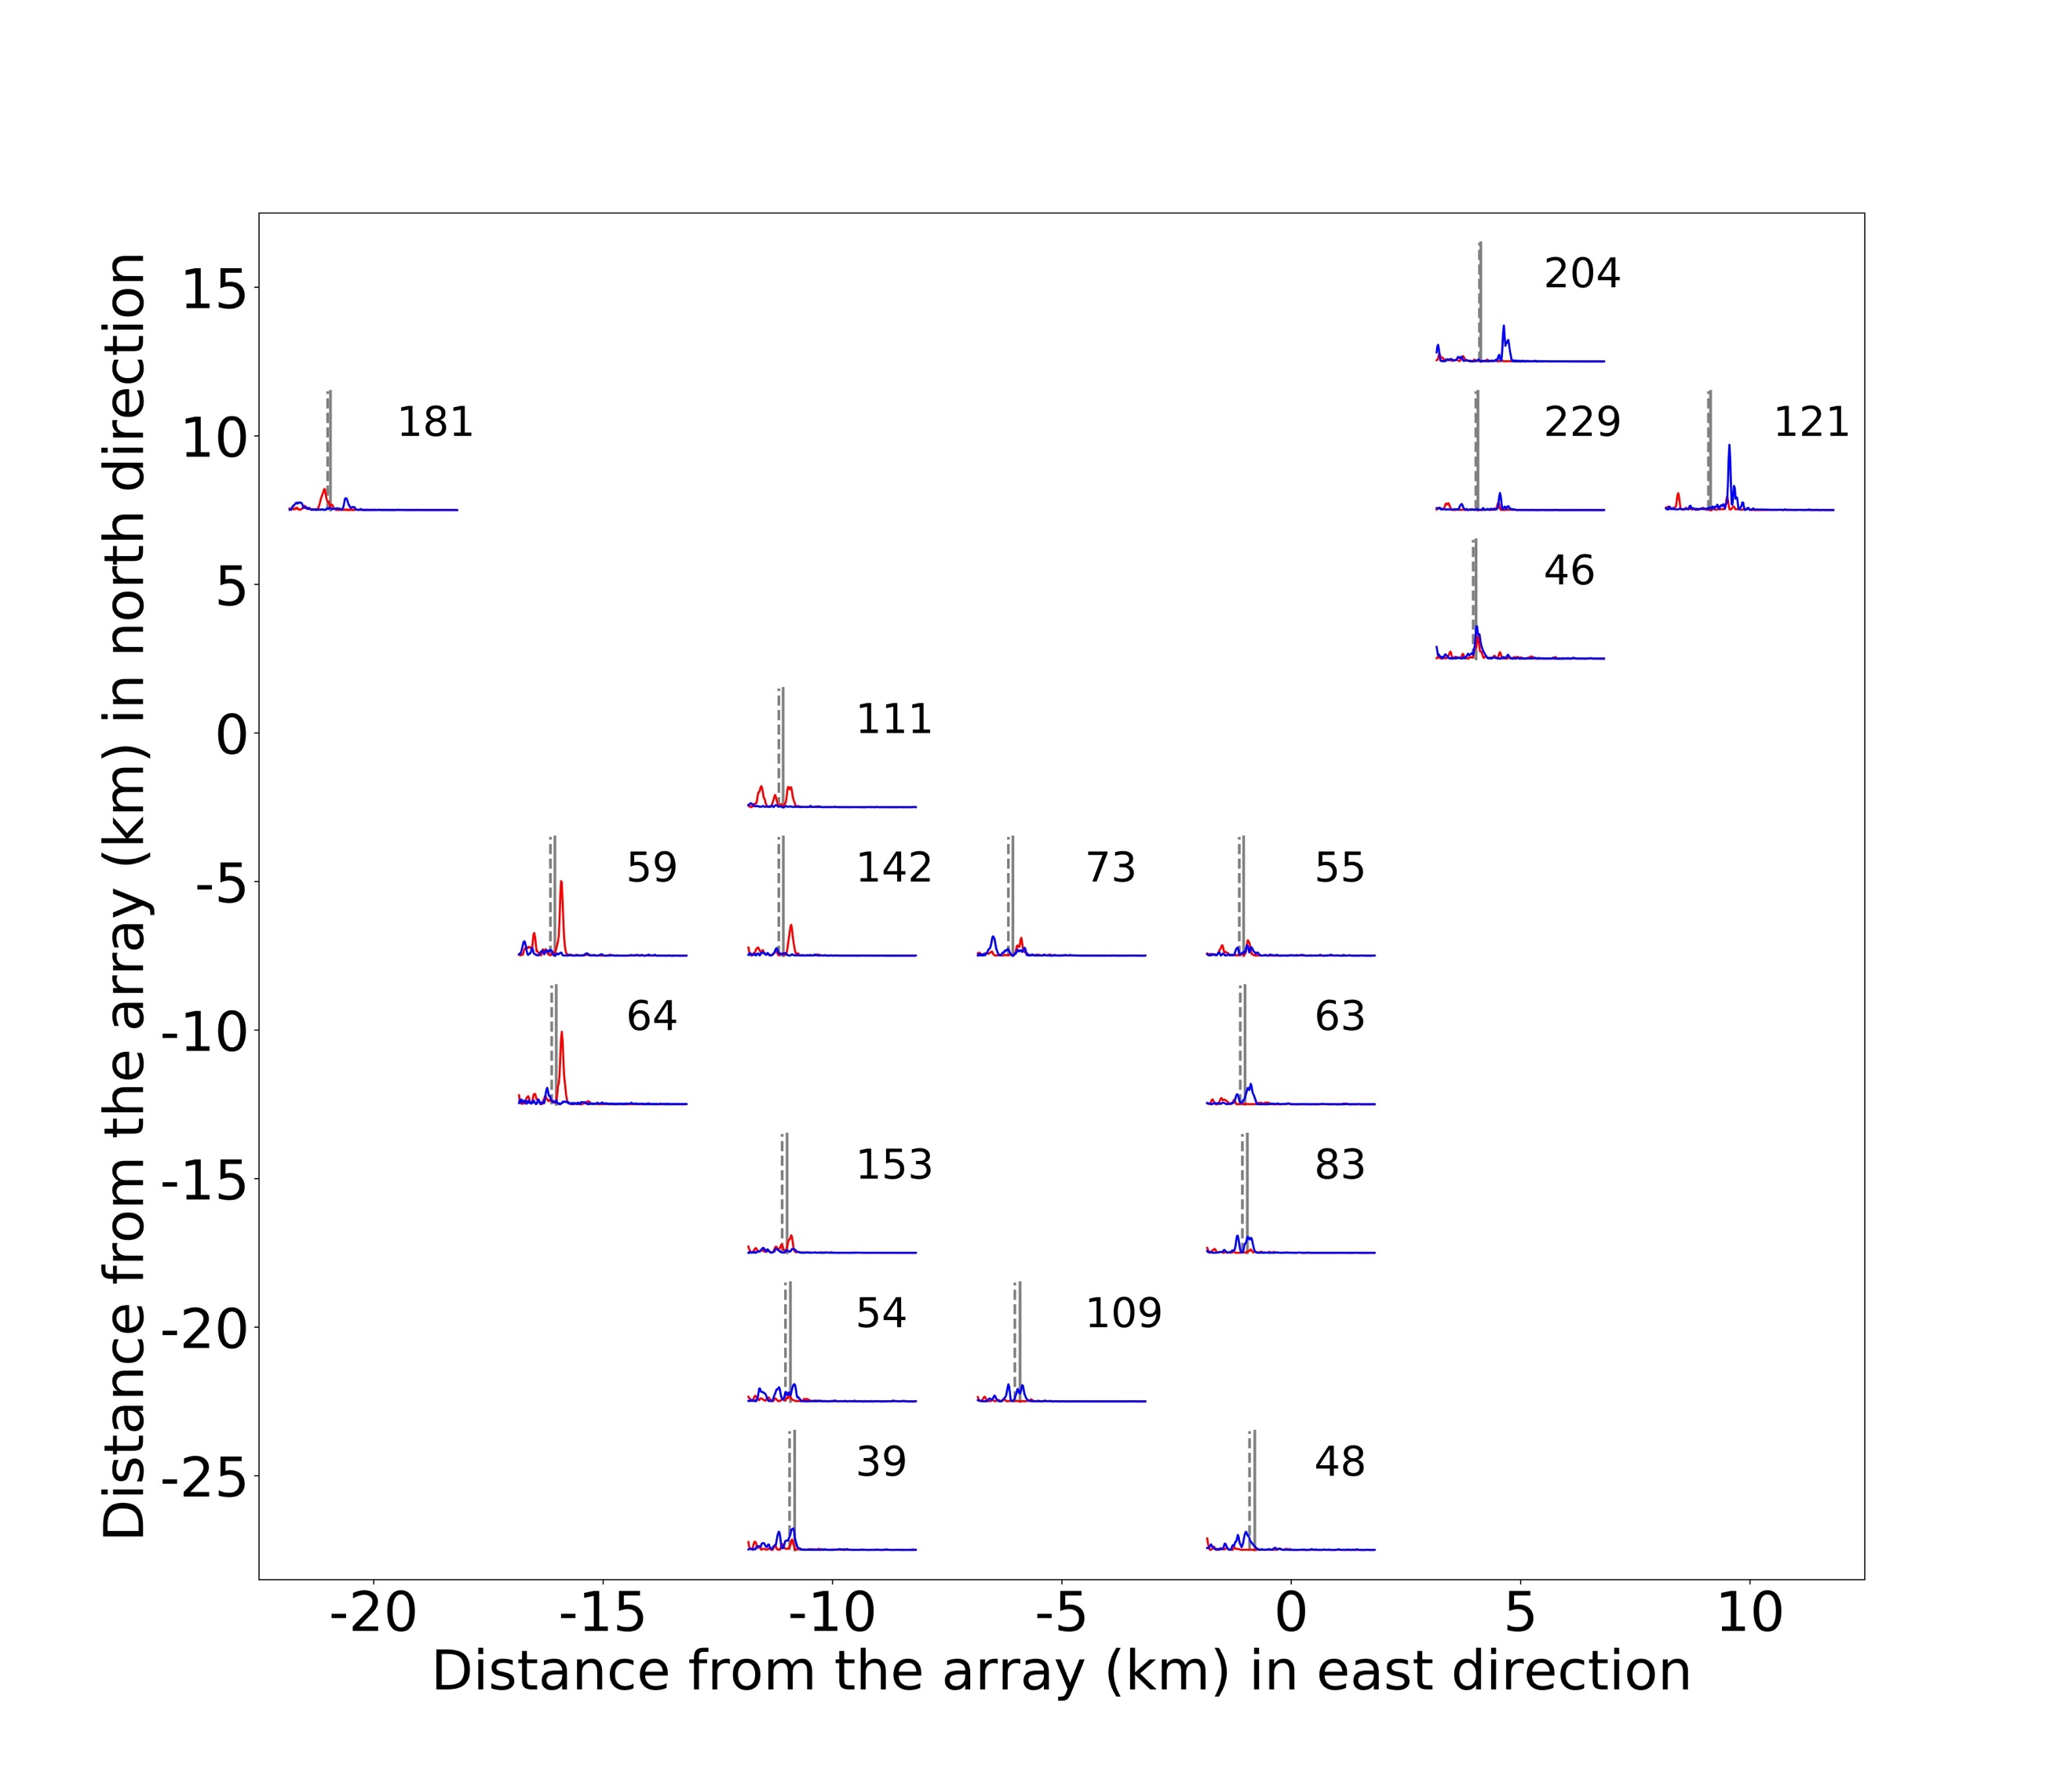

**Figure S4.** Envelopes of the stacked cross correlation signals for different positions of the tremor source relative to the Gold Creek array.

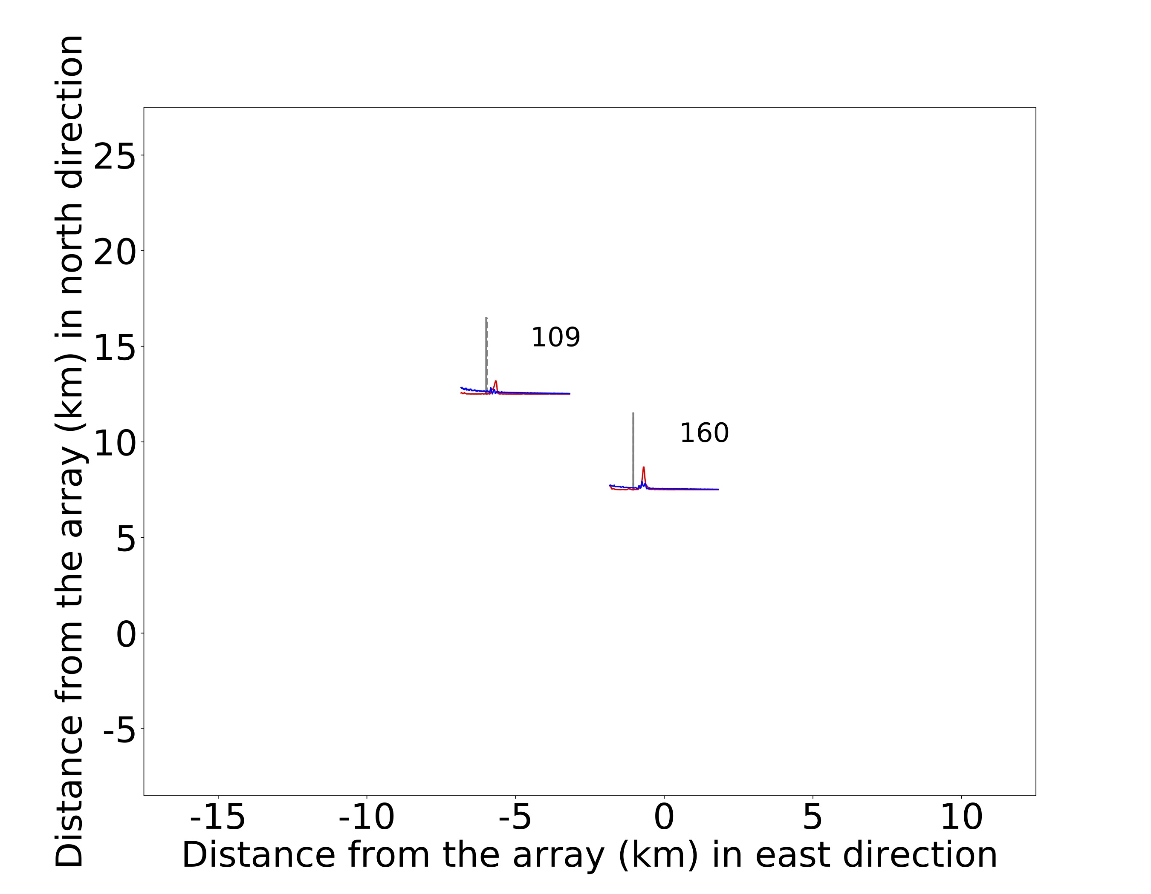

**Figure S5.** Envelopes of the stacked cross correlation signals for different positions of the tremor source relative to the Lost Cause array.

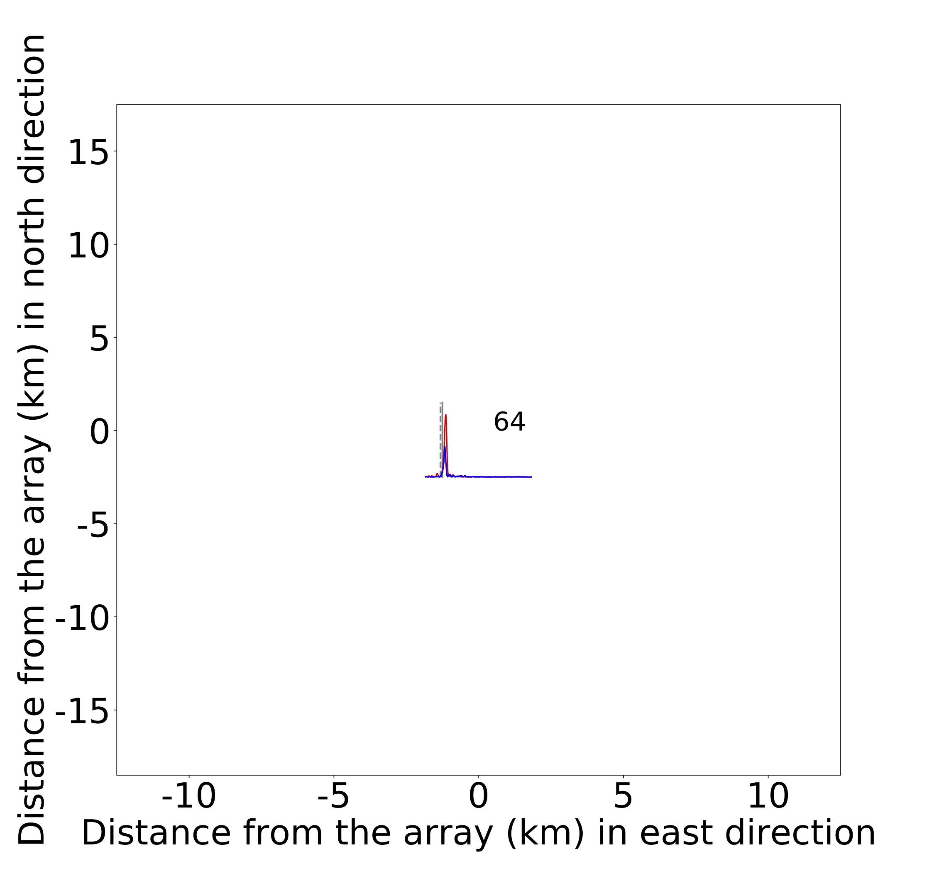

**Figure S6.** Envelopes of the stacked cross correlation signals for different positions of the tremor source relative to the Port Angeles array.

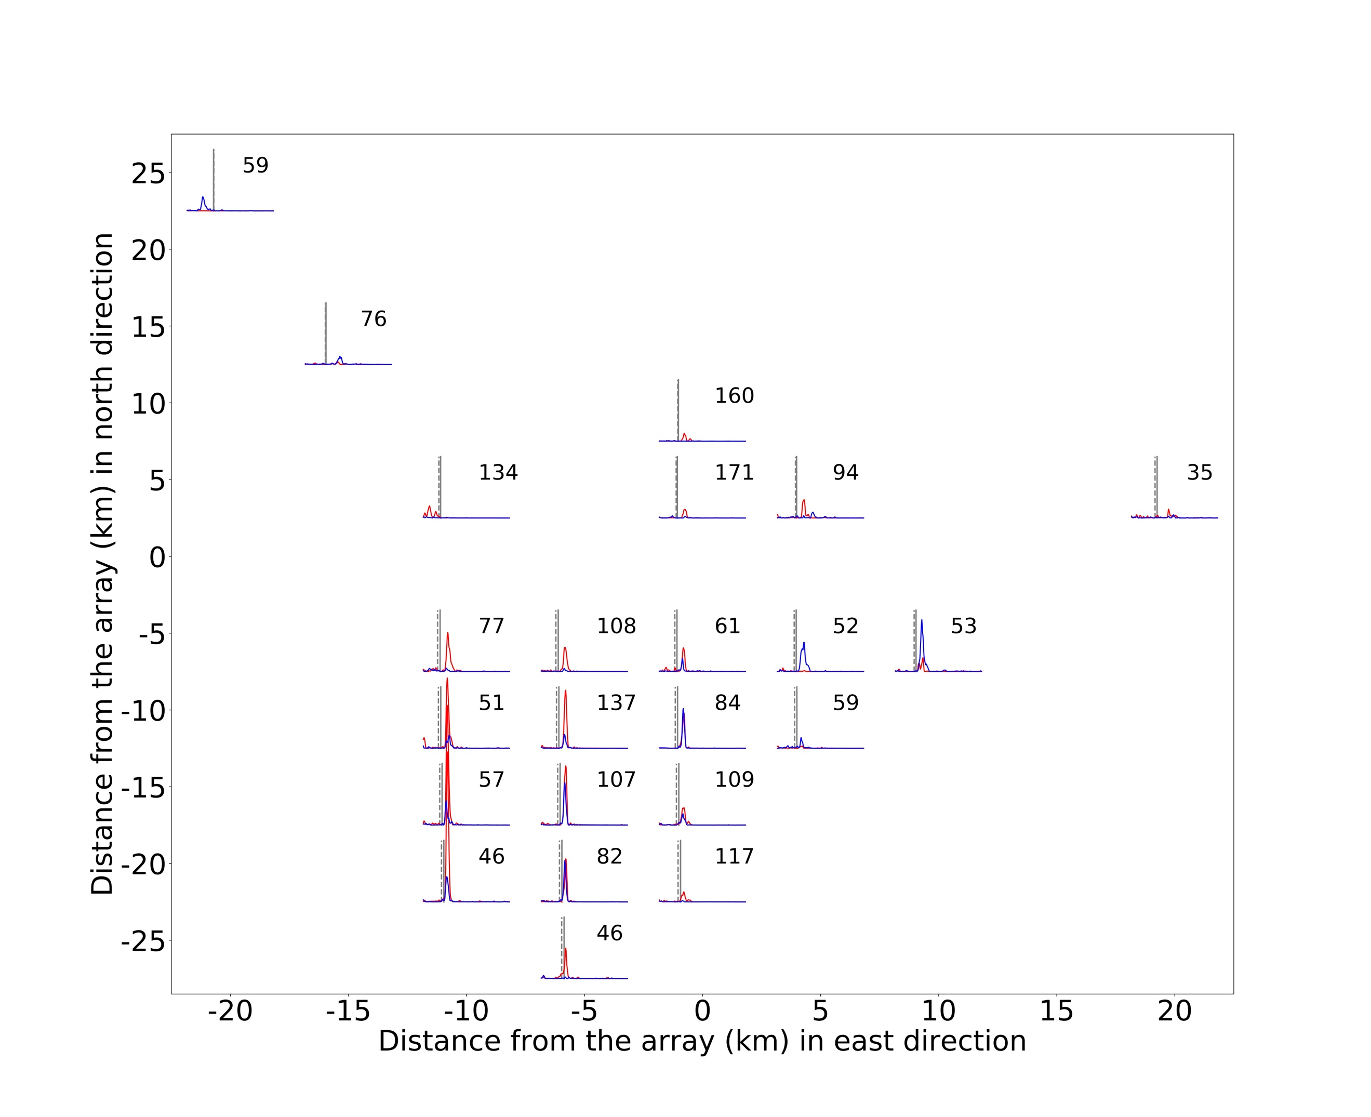

**Figure S7.** Envelopes of the stacked cross correlation signals for different positions of the tremor source relative to the Three Bumps array.