30 Years of Post-disturbance Recruitment in a Neotropical Forest _ Supplementary Materials

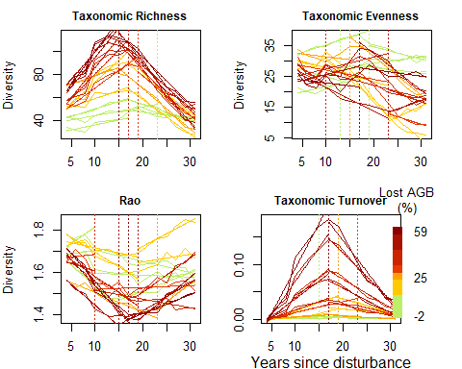

Figure 1: Figure S1: Breakpoint analysis of post-disturbance trajectories regarding, from left to right, taxonomic richness, taxonomic evenness, functional diversity, and taxonomic turnver of 2-years laps recuited communities. The best linear models segmented according to break points are selected based on their mean square errors. Dots are the observed trajectories, plain lines are linera model, and vertical dotted lines are the break points. Lines color correspond to initial disturbance intensity.