Ariane MIRABEL

UMR EcoFoG, CNRS

Campus Agronomique

93710 Kourou

French Guiana

email: ariane.mirabel@ecofog.gf

Kourou, 05th of August, 2018

To the editors, Journal of Ecology

Dear Editor,

Please find enclosed a manuscript entitled “*Post-disturbance Tree Community Trajectories in a Neotropical Forest*” by Ariane Mirabel, Eric Marcon and Bruno Hérault. We wish to submit for publication as a Research Article in Journal of Ecology. We believe this paper will be of great interest to your readers for the reasons detailed below.

The current threats to tropical forests biodiversity make it urgent to clarify their fate in the global changing context. This manuscript offers a timely research in forests ecology based on the detailed analysis of Neotropical tree community diversity from a unique dataset.

From the monitoring of the Paracou permanent experimental station in French Guiana we examined community response to a large disturbance gradient (from 10 to 50% of Above Ground Biomass removed) over 30 years. We specifically examined taxonomic and functional composition and diversity trajectories, using accurate botanical inventories and 7 key functional traits.

We demonstrated showed a tangible but decades-long resilience of taxonomic and functional characteristics. We also clarified the debated Intermediate Disturbance Hypothesis and elucidated the impact of disturbance intensity. Eventually we highlighted the contrasting response of community taxonomic and functional characteristics, revealing the crucial role of functional redundancy for the maintenance of tropical forests biodiversity.

While highlighting the ecological processes underlying tropical forests response to disturbance, our conclusions opened up discussions regarding forests exploitation and conservation management.

This manuscript has not been published or accepted for publication, and is not under consideration for publication in another journal or book. All authors and institutions have seen and approved the final version of the manuscript, and all persons entitled to authorship have been so named.

We thank you for considering our manuscript for publication in Journal of Ecology.

Please feel free to contact me should you have any questions regarding the manuscript and I look forward to your reply.

Best regards,

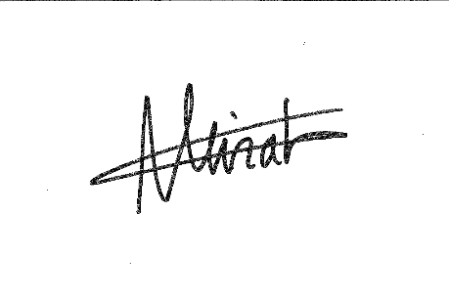Ariane Mirabel, in the name of all authors.