POST-DISTURBANCE TREE COMMUNITY TRAJECTORIES IN A NEOTROPICAL FOREST

Mirabel A.1, Hérault B.2,Marcon E.1

1 UMR EcoFoG, AgroParistech, CNRS, Cirad, INRA, Université des Antilles, Université de Guyane.

2 INPHB (Institut National Polytechnique Félix Houphouët Boigny), Yamoussoukro, Ivory Coast

Correspondence:

*Ariane Mirabel*

*Tel: +594 594329273*

*Email:* [Ariane.Mirabel@ecofog.gf](mailto:Ariane.Mirabel@ecofog.gf)

**ABSTRACT**

Understanding the ecological rules underlying the maintenance of tropical forests biodiversity, structure, functioning and dynamics is urgent to anticipate their fate in the global change context.

The huge diversity of tropical forests is often assumed to be regularly reshaped by natural disturbance yielding a diversity peak at intermediate intensity. This intermediate disturbance hypothesis (IDH), though, remains debated and the controversy questions the extent of community resilience regarding their taxonomic and functional facets.

To disentangle the ecological processes driving community response to disturbance, we analyzed the tree community trajectories over 30 years following a disturbance gradient in a Neotropical forest. Specifically, we examined community functional and taxonomic trajectories with regards to diversity, composition and redundancy. Functional trajectories were drawn based on 7 leaf, stem and life-history traits. We highlighted the cyclic recovery of community taxonomic and functional composition. While pre-disturbance taxonomic differences were maintained over time, functional composition trajectories were quite similar among communities. The IDH did predict community taxonomic diversity response while functional diversity was enhanced whatever the disturbance intensity.

**Synthesis** Although consistent, the recovery of community composition, diversity and redundancy remained unachieved after 30 years. This acknowledged the need of decades-long cycles with no disturbance to ensure a complete recovery, and questioned tropical forest community resilience after repeated disturbances.

**KEYWORDS:** Community Ecology;Community Diversity Determinants;Disturbance Trajectories; Intermediate Disturbance Hypothesis; Mid-term Resilience; Neotropical Forests; Taxonomic and Functional Biodiversity

# INTRODUCTION

The large areas covered with tropical forests worldwide hold crucial environmental, economic and social values. They provide wood and multiple non-timber forest products, shelter a diversified fauna, regulate the local and regional climates, the carbon, water and nutrient cycles, and ensure cultural and human well-being. The growing demand in forests products together with current global changes increases the pressure on remaining natural forests (Morales-Hidalgo, Oswalt, & Somanathan, 2015) and threatens the maintenance and dynamics in space and time of community structure, composition and functioning (Anderson-Teixeira et al., 2013).

In tropical forests, ecological communities are regularly re-shaped by natural disturbance events changing both the abiotic environment, through the fluxes of light, heat and water (Goulamoussène, Bedeau, Descroix, Linguet, & Hérault, 2017), and the biotic interactions such as competition among species (Chesson, 2000). One of the cornerstones of tropical forest ecology is to understand the processes and drivers of ecosystems response to disturbance (Chazdon, 2003). For now, this has been largely studied through forest structural parameters such as aboveground biomass, tree height or stem density (Piponiot et al., 2016; Rutishauser, Hérault, Petronelli, & Sist, 2016) that are rapid and convenient to measure. These structural parameters have been su**c**cessfully modeled, giving important insights into the recovery of ecosystem processes and services (Hérault & Piponiot, 2018). However, the response of forests diversity and composition remains unclear, albeit it determines the productivity, stability and functioning of ecosystems (Liang et al., 2016; D. Tilman, Isbell, & Cowles, 2014). In the short-term, moderate disturbance may lead to positive impacts on community diversity, an idea formalized by the intermediate disturbance hypothesis (IDH) which predicts maximum species diversity when disturbance intensity is not too high (Kariuki, Kooyman, Smith, Wardell-Johnson, & Vanclay, 2006; J. F. Molino & Sabatier, 2001).

Validations of the IDH though remain scarce in the long-term and mainly rely on the analysis of taxonomic richness (J. F. Molino & Sabatier, 2001). Taxonomic richness alone, however, gives limited or misleading information on forest recovery and functioning (Chaudhary, Burivalova, Koh, & Hellweg, 2016). More ecological-meaningful analysis would couple richness with (i) evenness, which would reveal the changes in the species abundance distribution and thus the underlying ecological processes, and (ii) composition, which is crucial for conservation issues (Bellwood, Wainwright, Fulton, & Hoey, 2006; Lavorel & Garnier, 2002). Furthermore, a functional approach accounting for species biological attributes would directly link community diversity, composition and redundancy to ecosystem functioning and to its environmental constraints (Baraloto et al., 2012; Violle et al., 2007). In that respect, the functional trait-based approach that focus on major traits related to species ecology and mediate species performance in a given environment was successfully adopted (Díaz et al., 2005). For instance, the functional approach revealed in tropical rainforests the deterministic processes entailing, after disturbance, a functional shift from a dominance of “conservative” slow-growing species dealing with scarce resources to “acquisitive” fast-growing species with rapid and efficient use of abundant resources (Hérault et al., 2011; Reich, 2014). This shift is translated into the trajectories of key functional traits related to resource acquisition (leaf and stem traits) and life-history traits (seed mass, maximum size) (Chave et al., 2009; Steege et al., 2006; Westoby & Wright, 2006; Wright et al., 2004). Eventually, a complete overview of community response to disturbance would encompass the changes in functional redundancy that quantifies the amount of shared trait values among species (Carmona, Bello, Mason, & Lepš, 2016). The high functional redundancy of hyper-diverse tropical forests (Bellwood et al., 2006) mitigates the impacts of species removal on ecosystem functioning and determines the resilience of communities after disturbance (Díaz et al., 2005; Elmqvist et al., 2003).

# In this study, we monitored over 30 years the response of 75 ha of Neotropical forest plots set up on a gradient of disturbance intensity, from 10 to 60% of ecosystem above-ground biomass (AGB) loss. We made use of a large functional traits database encompassing major leaf, stem and life-history traits in order to draw the taxonomic and functional trajectories in terms of richness, evenness, composition and redundancy. Specifically, we (i) elucidated community taxonomic and functional recovery and the underlying ecological processes, (ii) clarified the validity of the IDH in the long term for tropical forest and its translation into different trajectories in time, and (iii) examined community recovery time.

# MATERIAL AND METHODS

## STUDY SITE

Paracou station in French Guiana (51°8’ N and 52°53’ W) is located in a lowland tropical rain forest in a tropical wet climate with mean annual temperature of 26 °C, mean annual precipitation averaging 2980 mm.y-1 (30-y period) and a 3-month dry season (< 100 mm.month-1) from mid-August to mid-November, and a one-month dry season in March (Wagner, Hérault, Stahl, Bonal, & Rossi, 2011). Elevation ranges between 5 and 50 m a.s.l. and soils correspond to thin acrisols over a layer of transformed saprolite with low permeability which produces lateral drainage during heavy rains.

The experiment is a network of 12 6.25 ha plots that underwent a disturbance gradient of three logging, thinning and fuelwood cutting treatments (Table 1) according to a randomized plot design with three replicate blocks of four plots. The disturbance corresponds to an intensity gradient. For treatment 1 (T1) 10 trees of commercial species (of a diameter at 1.3 m height (DBH) equal or above 50 cm) were felled per hectare. For treatment 2 (T2) 10 trees/ha of commercial species (DBH ≥ 50 cm) were felled and 30 trees/ha of non-valuable species (DBH ≥ 40 cm) were removed by poison girdling. For treatment 3 (T3) 10 trees/ha of commercial species (DBH ≥ 50 cm) were felled and 30 trees/ha of non-valuable species (15 with DBH ≥ 50 cm and 15 with DBH ≥ 40 cm) were removed by poison girdling (Schmitt & Bariteau, 1989). Disturbance intensity was measured as the percentage of aboveground biomass (%AGB) lost between the first inventory in 1984 and five years after disturbance (Piponiot et al., 2016) estimated with the BIOMASS R package (Réjou-Méchain, Tanguy, Piponiot, Chave, & Hérault, 2018).

**Table 1.** Intervention table, summary of the disturbance intensity for the 4 plot treatments in Paracou

|  |  |  |  |  |
| --- | --- | --- | --- | --- |
| Treatment | Timber | Thinning | Fuelwood | %AGB Lost |
| Control | - | - | - | 0 |
| T1 | DBH ≥ 50 cm,  Commercial species,  ≈ 10 trees.ha-1 | - | - | [12−33] |
| T2 | DBH ≥ 50 cm,  Commercial species,  ≈ 10 trees.ha-1 | DBH ≥ 40 cm,  non-valuable species,  ≈ 30 trees.ha-1 | - | [33−56] |
| T3 | DBH ≥ 50 cm,  Commercial species,  ≈ 10 trees.ha-1 | DBH ≥ 50 cm,  non-valuable species,  ≈ 15 trees.ha-1 | 40 cm ≤ DBH ≤ 50 cm,  non-valuable species,  ≈ 15 trees.ha-1 | [35−56] |

## INVENTORIES PROTOCOL AND DATASET COLLECTION

The study site corresponds to a tropical rainforest typical of the Guiana Shield with a dominance of *Fabaceae*, *Chrysobalanaceae*, *Lecythidaceae* and *Sapotaceae*. In the 12 experimental plots, all trees above 10 cm DBH have been mapped and measured annually since 1984. Trees are first identified with a vernacular name assigned by the forest worker team, and afterward with a scientific name assigned by botanists during regular botanical campaigns. In 1984, specific vernacular names were given to 62 commercial or common species, whereas more infrequent ones were identified under general identifiers only distinguishing trees and palms. From 2003, botanical campaigns have been conducted every 5 to 6 years to identify all trees at the species level but identification levels still varied among plots and campaigns.

This variability of protocols in time raised methodological issues as vernacular names usually correspond to different botanical species. This resulted in significant taxonomic uncertainty that had to be propagated to composition and diversity metrics. The uncertainty propagation was done through a Bayesian framework reconstituting complete inventories at genus level from real incomplete ones on the basis of vernacular/botanical names association. Vernacular names were replaced through multinomial trials based on the association probability $[α_{1},α_{2},...,α_{V}]$ observed across all inventories between each vernacular name *v* and all species $[s_{1},s_{2},...,s_{N}]$:

$$\begin{matrix}M_{v}([s_{1},s_{2},...,s_{N}],[α_{1},α_{2},...,α_{V}])\end{matrix}$$

See Supplementary Materials -Figure S1 and Aubry-Kientz, Hérault, Ayotte-Trépanier, Baraloto, and Rossi (2013) for the detailed methodology.

Six functional traits representing leaf economics (leaf thickness, toughness, total chlorophyll content and specific leaf area) and stem economics (wood specific gravity and bark thickness), and life-history traits (maximum specific height and seed mass) came from the BRIDGE project (for complete details, see <http://www.ecofog.gf/Bridge/index.html>). Trait values were assessed from a selection of individuals located in nine permanent plots in French Guiana, including two in Paracou, and comprised 294 species pertaining to 157 genera. Missing trait values (10%) were filled using multivariate imputation by chained equation (van Buuren & Groothuis-Oudshoorn, 2011). Imputations were restricted within genus or family when samples were too scarce, in order to account for the phylogenetic signal. Whenever a species was not in the dataset, it was attributed a set of trait values randomly sampled among species of the next higher taxonomic level (same genus or family). As seed mass information was classified into classes, no data filling process was applied and analyses were restricted to the 414 botanical species recorded.

All composition and diversity metrics were obtained after 50 iterations of the uncertainty propagation framework.

## COMPOSITION AND DIVERSITY METRICS

Because of the variability in the precision of botanical identification efforts, we were constraint to conduct the taxonomic composition and diversity analysis at the genus level. Taxonomic and functional trajectories of community composition were followed in a two-dimensional NMDS ordination space. Two NMDS using abundance-based (Bray-Curtis) dissimilarity measures were conducted to map either taxonomic or functional composition, the latter based on the seven leaf, stem and life history traits (without seed mass classes). Trajectories along time were reported through the Euclidean distance between the target inventories and the reference inventories in 1989, i.e. 2 years after disturbance. Univariate trajectories of the leaf, stem and life-history traits were also visualized with the community weighted means (CWM) (Díaz et al., 2007). Species seed mass were given in 5 mass classes, seed mass trajectories were therefore reported as the proportion of each class in the inventories (Supplementary materials).

The taxonomic diversity was reported through species richness and the Hill number translation of the Simpson index (Hill, 1973). The comparison between richness and Simpson diversity assessed the variations in taxonomic evenness. Both indices belong to the set of HCDT or generalized entropy, respectively, corresponding to the 0 and 2 order of diversity (q), recommended for diversity studies (Marcon, 2015). The functional diversity was reported using the functional richness and functional evenness, *i.e.* the Rao index of quadratic entropy which combines species abundance distribution and average pairwise dissimilarity based on species functional traits.

The impacts of initial disturbance were tested with the Spearman rank correlation between the extremes of taxonomic and functional metrics reached over the 30 years and the initial %AGB loss. They were besides analyzed through polynomial regression between (i) taxonomic and functional richness and evenness, and (ii) the initial %AGB loss at 10, 20 and 30 years after disturbance.

Functional redundancy was measured as the species overlap in community functional space (Carmona et al., 2016). First, the individuals of the trait database were mapped in the plane of the two first axes from a PCA analysis. Then, for each species, the traits probability density (TPD) were computed through multivariate kernel density estimators. Second, for each community, the functional traits probability density were computed as the sum of the TDP of the inventoried species weighted by species abundance. Third, the whole functional space was divided into a 100 x 100 grid, before counting for each cell the number of species which TPD is positive. The average count across cells, minus 1, gives the average number of species in the community that share the same traits, which is the Community Functional Redundancy.

## RESULTS

## COMMUNITY COMPOSITION

From 1989 (2 years after disturbance) to 2015 (28 years after disturbance), 828 388 individual trees and 591 botanical species pertaining to 223 genera and 64 families were recorded.

While both taxonomic and functional composition remained stable in undisturbed communities (Fig. 1), they followed marked and consistent trajectories over post-disturbance time. In disturbed communities, these compositional changes corresponded to shifts towards species with more acquisitive functional strategies, from communities with high mean WSG to high mean SLA and chlorophyll content (see appendix I). For functional composition, this translated into cyclic compositional changes with an incomplete recovery of the initial composition (Fig. 1). The maximum dissimilarity with the initial state was positively correlated with the disturbance intensity for both taxonomic and functional composition ( and respectively). The maximum dissimilarity with the initial was reached for taxonomic composition between 15 to 25 years, for most of the plots, and around 22 years for functional composition.

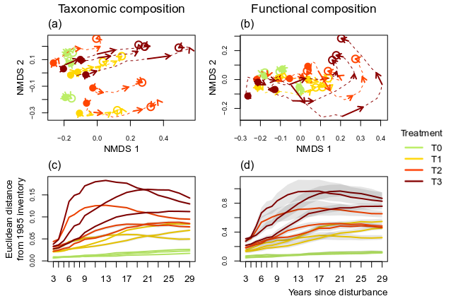

**Figure 1**. Plot trajectories in terms of taxonomic composition (**a.** and **c.**) and functional composition (**b.** and **d.**) in a two-dimensional NMDS space. Lower panels (**c.** and **d.**) represent the Euclidean distance to initial condition along the 30 sampled years.

Community CWM average value of all traits and seed mass proportions followed unimodal trajectories, either stabilizing or returning towards their initial values, to the exception of leaf chlorophyll content, which continued to increase for some T3 and T2 plots 30 years after disturbance.

Community CWM average value of Maximum height at adult stage (*Hmax*), leaf toughness and wood specific gravity (*WSG*) first decreased and then slightly increased but remained significantly lower than their initial value (Fig. 2). On the other side, Bark thickness and specific leaf area (*SLA*) increased and while bark thickness remained substantially high after 30 years, *SLA* had almost recovered to its initial value. For all traits, the maximum difference from their initial values was correlated to the disturbance intensity. Positive correlations were observed for Leaf thickness, chlorophyll content, SLA and bark thickness (,,,). Negative correlation was observed for Leaf toughness, WSG and Hmax ($ρ_{Spearman}^{Leaf toughness}$, $ρ_{Spearman}^{WSG}=-0.75$, $ρ_{Spearman}^{Hmax}= -0.40$). The proportions of the three lightest seed mass classes increased in all disturbed plots, and decreased after 30 years for the lightest class while it stabilized for the two other (Supp. Mat. – Fig. S2).

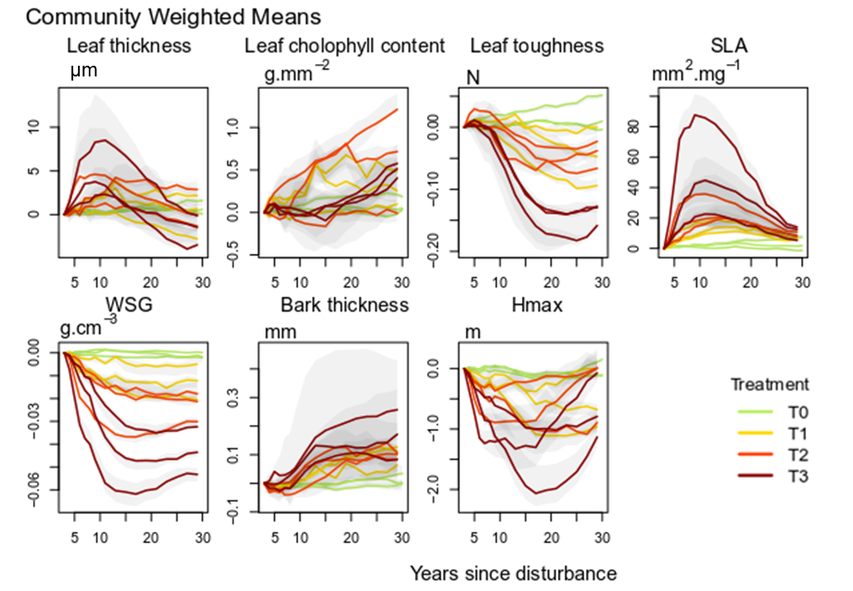

**Figure 2.** Trajectories of community weighted means over 30 years after disturbance of four leaf traits (Leaf thickness, chlorophyll content, toughness, and specific area), two stem traits (wood specific gravity, and bark thickness) and one life history trait (Specific maximum height at adult stage).

## COMMUNITY TAXONOMIC AND FUNCTIONAL DIVERSITY

For undisturbed plots, taxonomic richness and Simpson diversity remained stable over the 30 years of monitoring. In disturbed communities, after low disturbance intensity the taxonomic richness increased, reaching a maximum gain of 14 botanical genera (plot 3 from treatment 2). After intense disturbance, the taxonomic richness followed a more complex trajectory, decreasing for ten years after disturbance before recovering to pre-disturbance values. The maximum richness loss or gain after disturbance was positively correlated with the disturbance intensity (). In all disturbed plots, the Simpson diversity first increased until a maximum reached after around 20 years. This maximum was positively correlated with the disturbance intensity (). The Simpson diversity then stabilized except for two T3 plots (plots 8 and 12) for which it kept increasing (Fig. 3).

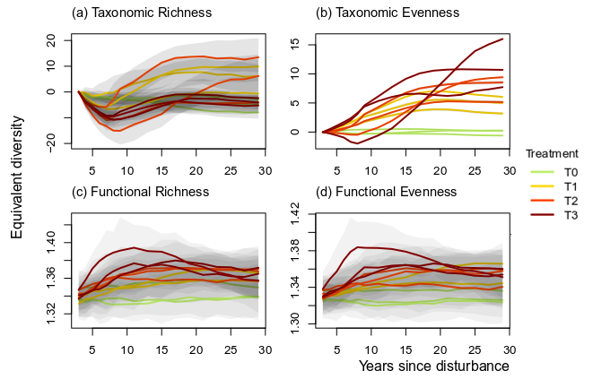

**Figure 3**. Trajectories over 30 years of the difference from the 1989 inventory (2 years after disturbance) of community taxonomic richness **(a)**, Simpson diversity **(b)**, functional richness **(c)**, and Rao diversity **(d)**.

The plot 7 from treatment 1 displayed constantly outlying functional richness and Rao diversity and was removed from the graphical representation for better readability. In undisturbed plots, both functional richness and Rao diversity remained stable along the years. In disturbed plots, both trajectories depended on the disturbance intensity, with their maximum being positively correlated to %AGB loss and. Functional richness and Rao diversity displayed for low disturbance intensity a low but long-lasting increase up to a maximum reached after 20-25 years, and for high intensity, a fast but short increase followed after 10 years by a slow decrease towards the initial values.

The second-degree polynomial regressions between (i) the percentage AGB loss and (ii) taxonomic and functional diversity after 10, 20 and 30 years best predicted the hump-shaped curve of the disturbance impact along the disturbance intensity gradient (Fig. 4). The relationship between the disturbance impact and its intensity was more markedly hump-shaped for the taxonomic richness than for the Simpson diversity. For both functional richness and Rao diversity, the relationship was almost linear. The regression model better predicted the functional richness and Rao diversity (, and) than the taxonomic richness and Rao diversity (, and respectively).

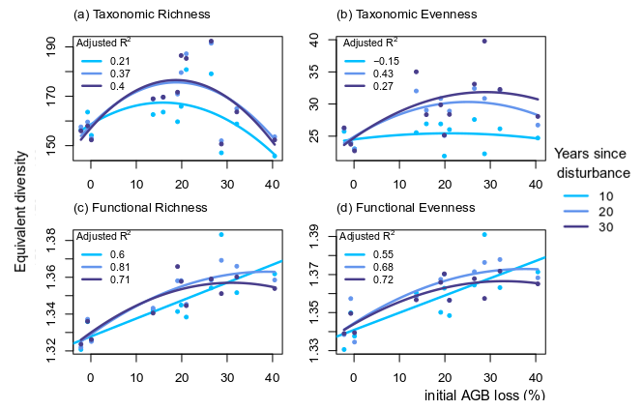**Figure 4.** Relationship between the initial %AGB loss and community taxonomic richness (a), taxonomic evenness (b), functional richness (c),and functional evenness (d) at 10, 20 and 30 years after disturbance.

## FUNCTIONAL REDUNDANCY

All disturbed plots had lower functional redundancy than control plots and followed similar hump-shaped trajectories (Fig. 5). The maximum redundancy loss was positively correlated with the disturbance intensity () and the recovery had not attained initial values for any disturbed communities after 30 years.

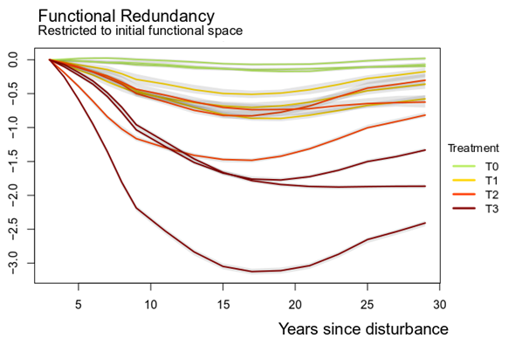

**Figure 5.** Trajectories of the functional redundancy within the initial functional space over 30 years after disturbance.

## DISCUSSION

## A CYCLIC RECOVERY OF COMMUNITY COMPOSITION

Community taxonomic and functional composition appeared resilient, following similar hump-shaped trajectories starting to return towards pre-disturbance composition after 30 years.

The taxonomic differences among local communities were already apparent before disturbance, as revealed by the distinct starting points on the NMDS axis 2. These differences were maintained throughout recovery trajectories. More than commonly thought, post-disturbance trajectories depended on community initial composition, which partly determined the pool of recruited species and constrained the trajectories towards the initial composition. The high resilience of community taxonomy, in the sense of the recovery of initial state recovery, revealed that species not belonging to the pre-disturbance community were rarely recruited because of the commonness of dispersal limitation among tropical tree species (Svenning & Wright, 2005).

Conversely, disturbed communities followed functional trajectories that are highly similar in terms of functional composition. As the composition of pre-disturbance surviving trees is representative of the initial community (Hérault & Piponiot, 2018), changes in functional composition relied upon the recruitment of species or functional types that were infrequent or absent before disturbance. Competitive pioneers became dominant benefitting from light, space and nutrient resources made available by disturbance. The recruitment of pioneers changed community functional composition in the same way for all disturbance intensity towards more resource-acquisitive strategies, moving community functional composition right along the first axis in Fig. 1 (Reich, 2014; Westoby, 1998; Wright et al., 2004). Thereafter long-lived, more resistant and shade-tolerant species excluded the first established pioneers and started the recovery of pre-disturbance functional composition, moving similarly community functional composition left along the first axis and upward along the second axis in Fig. 1.

These trajectories provided empirical support to the hypothesis that community assembly is both deterministic and historically convergent at different levels of community organization. Deterministic, trait-based processes drove community convergence in functional composition, while at the same time dispersal limitation maintained their divergence in taxonomic composition (Fukami, Bezemer, Mortimer, & Van Der Putten, 2005).

## A NEW PERSPECTIVE ON THE INTERMEDIATE DISTURBANCE HYPOTHESIS

The IDH predicted well the enhancement of taxonomic richness after disturbance, until an intensity threshold (20-25% AGB loss). It also explained the impact on the Simpson diversity and hence on community taxonomic evenness. Taxonomic evenness was somewhat decoupled from the disturbance intensity as already observed in the Guiana Shield (Baraloto et al., 2012) and in Bornean tropical forests (Cannon, 1998). Disturbance intensity determined the balance in the community between pre-disturbance surviving trees and those recruited afterward. The pool of true pioneer species specifically recruited after disturbance is restricted in the Guiana Shield to a few common genera (e.g. *Cecropia* spp*.*, *Vismia* spp.) (Guitet et al., 2018). Below the intensity threshold the size of the surviving community maintained the pre-disturbance high taxonomic richness while the recruitment of pioneers, infrequent or absent before disturbance, increased both community taxonomic richness and evenness. Beyond the intensity threshold, disturbance decreased the taxonomic richness of surviving trees, which was not offset by the enrichment of pioneers, so that the overall community taxonomic richness decreased according to the disturbance intensity (J. F. Molino & Sabatier, 2001). An intermediate disturbance hence increased the availability of resources and created opportunities for pioneers, without implying too important loss of shade-tolerant species and without preventing their maintenance in the community (Bongers et al. 2009). For community taxonomic evenness the disturbance impact was similar but milder, as the evenness is less sensitive to the loss of rare species. Taxonomic evenness trajectories, below the intensity threshold, rather represented the increasing dominance of pioneers that balanced the usual hyper-dominance of a few species in tropical forests. Beyond the intensity threshold, however, pioneers became in turn highly dominant and decreased the overall evenness (Baraloto et al., 2012).

Conversely, the IDH was disproved regarding the disturbance impact on community functional richness and evenness. Irrespective of the disturbance intensity, both community functional richness and evenness increased following the recruitment of pioneers, functionally highly different from the composition of pre-disturbance community.

Along time, taxonomic richness trajectories of all disturbed communities similarly dropped at first place, following the species loss due to disturbance, and then displayed a species gain depending on the disturbance intensity. Up to an intensity threshold, the species gain was all the more significant that the disturbance intensity increased, with the establishment of long-lived pioneers enhancing community taxonomic richness and evenness in the long term. These long-lived pioneers, functionally quite different from the functional composition, entailed as well a progressive and long-lasting increase of the functional richness and evenness (Denslow, 1980; J. F. Molino & Sabatier, 2001). Beyond an intensity threshold, though, a few short-lived pioneers occupied the vacated environmental space and prevented the establishment of other species. These short-lived pioneers were functionally very different from the pre-disturbance community and entailed a rapid and significant increase of functional richness and evenness. Already after 10 years, though, short-lived pioneers started to decline and the functional richness and evenness decreased. Likely this decrease will be followed by the establishment of long-lasting pioneers, and by the time they recruit we expect the taxonomic and functional trajectories to catch up with those observed after intermediate disturbance (L. R. Walker & Moral, 2009).

## THE FUNCTIONAL REDUNDANCY, KEY OF COMMUNITY RESILIENCE

For 15 years, the species loss during disturbance, determined by the disturbance intensity, significantly decreased the functional redundancy within the pre-disturbance functional space. The redundancy decrease was not compensated for in the first place, as the first recruited pioneers were functionally different from the pre-disturbance functional composition. Progressively though, first established species were replaced by more competitive long-lived pioneers or late-successional species resembling more the pre-disturbance functional composition and restoring the functional redundancy. This replacement was stochastic and followed the lottery recruitment rules, implying a recruitment eased for the first recruited species but then increasingly hampered by the emergence of interspecific competition (Busing & Brokaw, 2002). Along time the recovery of infrequent species was increasingly slow, so that the time to full recovery of the functional redundancy, in some communities just initiated after 30 years, was extremely difficult to estimate (Díaz et al., 2005; Elmqvist et al., 2003).

The mid-term impact of disturbance on community functional redundancy meant a lower resilience of the pre-disturbance communities, with higher chances to see the persistence of disturbance-specific species at the expense of late-successional ones (Haddad et al., 2008). Besides, the mid-term recovery of infrequent species increases the risks to loose keystone species, with unexpected ecological consequences (Chazdon, 2003; Díaz et al., 2005; Jones, Lawton, & Shachak, 1994). Apart from the functional characteristics considered here, infrequent species might indeed have unique functions in the ecosystem or be a key for some fauna (Schleuning et al., 2016).

## CONCLUSIONS

Our study revealed community recovery through the combination of deterministic processes driving their convergence in functional composition, and dispersal limitation maintaining their divergence in taxonomic composition. The IDH was validated for community taxonomic richness and, to some extent, taxonomic evenness but disproved regarding community functional richness and evenness which were enhanced for any disturbance intensity by the high functional differences of pioneers compared to late-successional functional composition. The IDH was translated in time by the recruitment, beyond an intensity threshold, of short-lived pioneers that prevented in the first years after disturbance the establishment of more diverse long-lived pioneers, recruited otherwise below the intensity threshold. The resilience of tropical forests, defined in terms of recovery to pre-disturbance state, proved tangible but requiring several decades. Still, the disturbance impact on community redundancy cautioned against the risks of infrequent species loss and the persistence of disturbance-specific communities (Hérault & Piponiot, 2018).

**ACKNOWLEDGEMENT**

We are in debt with all technicians and colleagues who helped setting up the plots and collecting data over years. Without their precious work, this study would have not been possible and they may be warmly thanked here.

**AUTHORS’ CONTRIBUTIONS**

AM, EM & BH designed the study, developed the analysis framework, interpreted the results and wrote the manuscript. All authors gave final approval for publication.

**DATA AVAILABILITY**

This article is based upon the dataset of the Paracou station, which is part of the Guyafor permanent plot network in French Guiana (Cirad-CNRS-ONF). The dataset is available upon request to the scientific director (https://paracou.cirad. fr).

**REFERENCES**

Anderson-Teixeira, K. J., Miller, A. D., Mohan, J. E., Hudiburg, T. W., Duval, B. D., & DeLucia, E. H. (2013). Altered Dynamics of Forest Recovery under a Changing Climate. *Global Change Biology*, *19*(7), 2001–2021. doi:[10.1111/gcb.12194](https://doi.org/10.1111/gcb.12194)

Aubry-Kientz, M., Hérault, B., Ayotte-Trépanier, C., Baraloto, C., & Rossi, V. (2013). Toward Trait-Based Mortality Models for Tropical Forests. *PLoS ONE*, *8*(5). doi:[10.1371/journal.pone.0063678](https://doi.org/10.1371/journal.pone.0063678)

Baraloto, C., Hérault, B., Paine, C. E. T., Massot, H., Blanc, L., Bonal, D., … Sabatier, D. (2012). Contrasting Taxonomic and Functional Responses of a Tropical Tree Community to Selective Logging. *Journal of Applied Ecology*, *49*(4), 861–870. doi:[10.1111/j.1365-2664.2012.02164.x](https://doi.org/10.1111/j.1365-2664.2012.02164.x)

Bellwood, D. R., Wainwright, P., Fulton, C., & Hoey, A. (2006). Functional Versatility supports Coral Reef Biodiversity. *Proceedings of the Royal Society B: Biological Sciences*, *273*(1582), 101–107. doi:[10.1098/rspb.2005.3276](https://doi.org/10.1098/rspb.2005.3276)

Busing, R. T., & Brokaw, N. (2002). Tree Species Diversity in Temperate and Tropical Forest Gaps: The role of Lottery Recruitment. *Folia Geobotanica*, *37*(1), 33–43.

Cannon, C. H. (1998). Tree Species Diversity in Commercially Logged Bornean Rainforest. *Science*, *281*(5381), 1366–1368. doi:[10.1126/science.281.5381.1366](https://doi.org/10.1126/science.281.5381.1366)

Carmona, C. P., Bello, F. de, Mason, N. W., & Lepš, J. (2016). Traits Without Borders: Integrating Functional Diversity Across Scales. *Trends in Ecology and Evolution*, *31*(5), 382–394. doi:[10.1016/j.tree.2016.02.003](https://doi.org/10.1016/j.tree.2016.02.003)

Chaudhary, A., Burivalova, Z., Koh, L. P., & Hellweg, S. (2016). Impact of Forest Management on Species Richness: Global Meta-Analysis and Economic Trade-Offs. *Scientific Reports*, *6*, 1–10. doi:[10.1038/srep23954](https://doi.org/10.1038/srep23954)

Chave, J., Coomes, D., Jansen, S., Lewis, S. L., Swenson, N. G., & Zanne, A. E. (2009). Towards a Worldwide Wood Economics Spectrum. *Ecology Letters*, *12*, 351–366. doi:[10.1111/j.1461-0248.2009.01285.x](https://doi.org/10.1111/j.1461-0248.2009.01285.x)

Chazdon, R. L. (2003). Tropical Forest Recovery: Legacies of Human Impact and Natural Disturbances. *Perspectives in Plant Ecology, Evolution and Systematics*, *6*(1-2), 51–71. doi:[10.1078/1433-8319-00042](https://doi.org/10.1078/1433-8319-00042)

Chesson, P. (2000). Mechanisms of Maintenance of Species Diversity. *Annual Review of Ecology and Systematics*, *31*, 343–66. doi:[10.1146/annurev.ecolsys.31.1.343](https://doi.org/10.1146/annurev.ecolsys.31.1.343)

Denslow, J. S. (1980). Gap Partitioning among Tropical Rainforest Trees. *Biotropica*, *12*(2), 47–55. doi:[10.2307/2388156](https://doi.org/10.2307/2388156)

Díaz, S., Lavorel, S., Bello, F. de, Quétier, F., Grigulis, K., & Robson, T. M. (2007). Incorporating Plant Functional Diversity Effects in Ecosystem Service Assessments. *Proceedings of the National Academy of Sciences*, *104*(52), 20684–20689. doi:[10.1073/pnas.0704716104](https://doi.org/10.1073/pnas.0704716104)

Díaz, S., Tilman, D., Fargione, J., Chapin III, F. S., Dirzo, R., Kitzberger, T., … Eardley, C. (2005). Biodiversity Regulation of Ecosystem Services. *Trends and Conditions*, 297–329.

Elmqvist, T., Folke, C., Nystrom, M., Peterson, G., Bengtsson, J., Walker, B., & Norberg, J. (2003). Response Diversity, Ecosystem Change, and Resilience. *Frontiers in Ecology and the Environment*, *1*(9), 488–494. doi:[10.2307/3868116](https://doi.org/10.2307/3868116)

Fukami, T., Bezemer, T. M., Mortimer, S. R., & Van Der Putten, W. H. (2005). Species Divergence and Trait Convergence in Experimental Plant Community Assembly. *Ecology Letters*, *8*(12), 1283–1290. doi:[10.1111/j.1461-0248.2005.00829.x](https://doi.org/10.1111/j.1461-0248.2005.00829.x)

Goulamoussène, Y., Bedeau, C., Descroix, L., Linguet, L., & Hérault, B. (2017). Environmental Control of Natural Gap Size Distribution in Tropical Forests. *Biogeosciences*, *14*(2), 353–364. doi:[10.5194/bg-14-353-2017](https://doi.org/10.5194/bg-14-353-2017)

Guitet, S., Sabatier, D., Brunaux, O., Couteron, P., Denis, T., Freycon, V., … Vincent, G. (2018). Disturbance Regimes drive the Diversity of Regional Floristic Pools across Guianan Rainsforest Landscapes. *Scientific Reports*, *8*(1), 3872. doi:[10.1038/s41598-018-22209-9](https://doi.org/10.1038/s41598-018-22209-9)

Haddad, N. M., Holyoak, M., Mata, T. M., Davies, K. F., Melbourne, B. A., & Preston, K. (2008). Species’ Traits predict the Effects of Disturbance and Productivity on Diversity. *Ecology Letters*, *11*(4), 348–356. doi:[10.1111/j.1461-0248.2007.01149.x](https://doi.org/10.1111/j.1461-0248.2007.01149.x)

Hérault, B., & Piponiot, C. (2018). Key Drivers of Ecosystem Recovery after Disturbance in a Neotropical Forest. *Forest Ecosystems*, *5*(1), 2. doi:[10.1186/s40663-017-0126-7](https://doi.org/10.1186/s40663-017-0126-7)

Hérault, B., Bachelot, B., Poorter, L., Rossi, V., Bongers, F., Chave, J., … Baraloto, C. (2011). Functional Traits Shape Ontogenetic Growth Trajectories of Rain Forest Tree Species. *Journal of Ecology*, *99*, 1431–1440. doi:[10.1111/j.1365-2745.2011.01883.x](https://doi.org/10.1111/j.1365-2745.2011.01883.x)

Hill, M. O. (1973). Diversity and Evenness : A Unifying Notation and its Consequences. *Ecological Society of America*, *54*(2), 427–432. doi:[10.2307/1934352](https://doi.org/10.2307/1934352)

Jones, C. G., Lawton, J. H., & Shachak, M. (1994). Organisms as Ecosystem Engineers. In *Ecosystem management* (pp. 130–147). Springer.

Kariuki, M., Kooyman, R. M., Smith, R. G. B., Wardell-Johnson, G., & Vanclay, J. K. (2006). Regeneration changes in tree species abundance, diversity and structure in logged and unlogged subtropical rainforest over a 36-year period. *Forest Ecology and Management*, *236*(2-3), 162–176. doi:[10.1016/j.foreco.2006.09.021](https://doi.org/10.1016/j.foreco.2006.09.021)

Lavorel, S., & Garnier, É. (2002). Predicting Changes in Community Composition and Ecosystem Functioning from Plant Traits: Revisiting the Holy Grail. *Functional Ecology*, *16*(5), 545–556. doi:[10.1046/j.1365-2435.2002.00664.x](https://doi.org/10.1046/j.1365-2435.2002.00664.x)

Liang, J., Crowther, T. W., Picard, N., Wiser, S., Zhou, M., Alberti, G., … Reich, P. B. (2016). Positive Biodiversity–productivity Relationship Predominant in Global Forests. *Science*, *354*(6309), aaf8957. doi:[10.1126/science.aaf8957](https://doi.org/10.1126/science.aaf8957)

Marcon, E. (2015). Practical Estimation of Diversity from Abundance Data. *HAL Archives-Ouvertes*, 9.

Molino, J. F., & Sabatier, D. (2001). Tree Diversity in Tropical Rain Forests: a Validation of the Intermediate Disturbance Hypothesis. *Science*, *294*(5547), 1702–1704. doi:[10.1126/science.1060284](https://doi.org/10.1126/science.1060284)

Morales-Hidalgo, D., Oswalt, S. N., & Somanathan, E. (2015). Status and Trends in Global Primary Forest, Protected Areas, and Areas Designated for Conservation of Biodiversity from the Global Forest Resources Assessment 2015. *Forest Ecology and Management*, *352*, 68–77. doi:[10.1016/j.foreco.2015.06.011](https://doi.org/10.1016/j.foreco.2015.06.011)

Piponiot, C., Sist, P., Mazzei, L., Peña-Claros, M., Putz, F. E., Rutishauser, E., … Hérault, B. (2016). Carbon Recovery Dynamics following Disturbance by Selective Logging in Amazonian Forests. *ELife*, *5*, e21394. doi:[10.7554/eLife.21394](https://doi.org/10.7554/eLife.21394)

Reich, P. B. (2014). The world-wide ’Fast-slow’ Plant Economics Spectrum: A Traits Manifesto. *Journal of Ecology*, *102*, 275–301. doi:[10.1111/1365-2745.12211](https://doi.org/10.1111/1365-2745.12211)

Réjou-Méchain, M., Tanguy, A., Piponiot, C., Chave, J., & Hérault, B. (2018). *BIOMASS: Estimating Aboveground Biomass and its Uncertainty in Tropical Forests*. *R Package Version* (Vol. 1).

Rutishauser, E., Hérault, B., Petronelli, P., & Sist, P. (2016). Tree Height Reduction After Selective Logging in a Tropical Forest. *Biotropica*, *48*(3), 285–289. doi:[10.1111/btp.12326](https://doi.org/10.1111/btp.12326)

Schleuning, M., Fruend, J., Schweiger, O., Welk, E., Albrecht, J., Albrecht, M., … others. (2016). Ecological Networks are more Sensitive to Plant than to Animal Extinction under Climate Change. *Nature Communications*, *7*, 13965.

Schmitt, L., & Bariteau, M. (1989). Management of the Guianese Forest Ecosystem : Study of Growth and Natural Regeneration (Paracou Program). *Bois et forêts Des Tropiques*, *220*, 3. doi:[0006-579X](https://doi.org/0006-579X)

Ter Steege, H., Pitman, N. C. A, Phillips, O. L., Chave, J., Sabatier, D., Duque, A., … Vásquez, R. (2006). Continental-scale Patterns of Canopy Tree Composition and Function across Amazonia. *Nature*, *443*(7110), 0–2. doi:[10.1038/nature05134](https://doi.org/10.1038/nature05134)

Svenning, J., & Wright, S. (2005). Seed Limitation in a Panamian Forest. *Journal of Ecology*, *93*(5), 853–562. doi:[10.1111/j.1365-2745.2005.01016.x](https://doi.org/10.1111/j.1365-2745.2005.01016.x)

Tilman, D., Isbell, F., & Cowles, J. M. (2014). Biodiversity and Ecosystem Functioning. *Annual Review of Ecology, Evolution, and Systematics*, *45*(1), 471–493. doi:[10.1146/annurev-ecolsys-120213-091917](https://doi.org/10.1146/annurev-ecolsys-120213-091917)

van Buuren, S., & Groothuis-Oudshoorn, K. (2011). mice: Multivariate Imputation by Chained Equations in R. *Journal of Statistical Software*, *45*(3), 1–67. doi:[10.1177/0962280206074463](https://doi.org/10.1177/0962280206074463)

Violle, C., Navas, M.-L. L., Vile, D., Kazakou, E., Fortunel, C., Hummel, I., & Garnier, E. (2007). Let the Concept of Trait be Functional! *Oikos*, *116*(5), 882–892. doi:[10.1111/j.2007.0030-1299.15559.x](https://doi.org/10.1111/j.2007.0030-1299.15559.x)

Wagner, F., Hérault, B., Stahl, C., Bonal, D., & Rossi, V. (2011). Modeling Water Availability for Trees in Tropical Forests. *Agricultural and Forest Meteorology*, *151*(9), 1202–1213. doi:[10.1016/j.agrformet.2011.04.012](https://doi.org/10.1016/j.agrformet.2011.04.012)

Walker, L. R., & del Moral, R. (2009). Transition Dynamics in Succession: Implications for Rates, Trajectories and Restoration. *New Models for Ecosystem Dynamics and Restoration*, 33–49.

Westoby, M. (1998). A Leaf-height-seed (LHS) Plant Ecology Strategy Scheme. *Plant and Soil*, *199*, 213–227. doi:[10.1023/A:1004327224729](https://doi.org/10.1023/A:1004327224729)

Westoby, M., & Wright, I. J. (2006). Land-plant Ecology on the Basis of Functional Traits. *Trends in Ecology and Evolution*, *21*(5), 261–268. doi:[10.1016/j.tree.2006.02.004](https://doi.org/10.1016/j.tree.2006.02.004)

Wright, I. J., Reich, P. B., Westoby, M., Ackerly, D. D., Baruch, Z., Bongers, F., … Villar, R. (2004). The Worldwide Leaf Economics Spectrum. *Nature*, *428*(6985), 821–827. doi:[10.1038/nature02403](https://doi.org/10.1038/nature02403)