SUPPORTING INFORMATION

POST-DISTURBANCE TREE COMMUNITY TRAJECTORIES IN A NEOTROPICAL FOREST

Mirabel A.1, Hérault B.2, Marcon E.1

1 UMR EcoFoG, AgroParistech, CNRS, Cirad, INRA, Université des Antilles, Université de Guyane.

2 INPHB (Institut National Polytechnique Félix Houphouët Boigny), Yamoussoukro, Ivory Coast

Correspondence:

*Ariane Mirabel*

*Tel: +594 594329273*

*Email:* [Ariane.Mirabel@ecofog.gf](mailto:Ariane.Mirabel@ecofog.gf)

## UNCERTAINTY PROPAGATION FRAMEWORK

The biodiversity estimator is based on the association probability between vernacular names and botanical species. The association probability is estimated by a Dirichlet trial based on the vernacular/botanical association frequency observed in the whole inventory. This association probability then allows generating theoretical inventories with complete botanical identification with the assignment of botanical species to trees with only a vernacular name. The repetition of the replacement process produces a set of theoretical inventories which diversities gives the probability distribution of the initial inventory diversity. Whenever the family or genus were recorded for a vernacular name, the pool of species sampled to replace the vernacular name was restricted to those pertaining to the same higher taxonomic level (*i.e.* species of the same genus when the species is missing, species of the same family when the genus is missing) (Fig. S1).

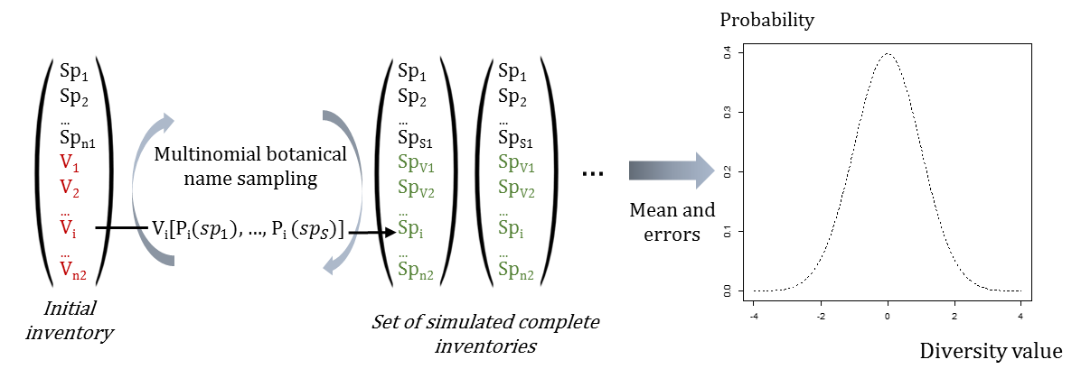

**Figure S1.** Scheme of the Bayesian process propagating the taxonomic uncertainty

## PROPORTIONS OF SEED MASS CLASSES

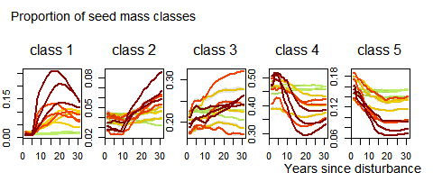

**Figure S2.** Trajectories of seed mass classes proportions over 30 years after disturbance. Colors are treatments: green (control), yellow (T1), orange (T2), red (T3).