Ariane MIRABEL

UMR EcoFoG, CNRS

Campus Agronomique

93710 Kourou

French Guiana

email: ariane.mirabel@gmail.com

Kourou, 09th of September, 2019

To the editors, *Science of the total environment*

Dear Editor,

Please find enclosed a manuscript entitled “*Post-disturbance Tree Community Trajectories in a Neotropical Forest*” by Ariane Mirabel, Eric Marcon and Bruno Hérault. We wish to submit it for publication as a Research Article in Science of the Total Environment. We believe this paper will be of great interest to your readers for the reasons detailed below.

Given the current threats to tropical forest biodiversity, it is urgent to clarify their fate in the global changing context. This manuscript offers a timely forests ecology research assessing the diversity response of a Neotropical forest to a large disturbance gradient (from 10 to 50% of Above Ground Biomass removed). We examined the taxonomic and functional facets of tree community post-disturbance trajectory in composition and diversity. We used a unique dataset from the Paracou experimental station in French Guiana, which comprises accurate botanical inventories over 30 years and large functional traits dataset.

We demonstrated a decoupling between community taxonomic and functional responses, and we explained it by the high functional redundancy of tropical tree communities. Besides, disturbance intensity proved to determine community taxonomic, but not functional response. These results revealed the extent of the still debated Intermediate Disturbance Hypothesis, which explained community taxonomic but not functional post-disturbance trajectories. Eventually, our results revealed the consistent but slow recovery of community composition, diversity, and redundancy. This study acknowledged the relevance of decades-long management cycles to ensure community recovery, and stressed the need to examine the mechanisms of community resilience.

This manuscript has not been published or accepted for publication, and is not under consideration for publication in another journal or book. All authors and institutions have seen and approved the final version of the manuscript, and all persons entitled to authorship have been so named.

We thank you for considering our manuscript for publication in Science of the Total Environment.

Please, contact me if any question remains about the manuscript.

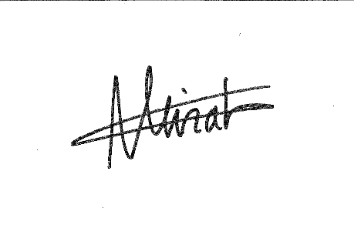Best regards,

Ariane Mirabel, in the name of all authors.