

Information Technology University

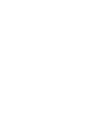
Software Engineering

Assignment 3

Instructor: Usman Younis

Submitted by:
Ariba Mumtaz BSCE22020
Atif BSCE22030
Khizar Naveed BSCE22042

CEP Assignment 3: Structural and Dynamic Models for ASTS

1. Introduction
The Automated Software Testing System (ASTS) is an advanced solution designed to automate the software testing process within a Continuous Integration/Continuous Deployment (CI/CD) pipeline. The core goal of ASTS is to streamline software testing by reducing manual effort, speeding up feedback loops, and enhancing the quality of software through automated test execution, bug tracking, and report generation.
In this assignment, we will create detailed structural and dynamic models for ASTS. These models are essential for visualizing the architecture and interactions between system components, providing insights into how ASTS functions. The class diagram represents the system's static structure, while sequence diagrams illustrate dynamic behaviors such as test execution, bug logging, and report generation.

2. Structural Model

2.1 Class Diagram and Design Pattern
The Class Diagram for ASTS illustrates the static structure of the system, showing how classes, interfaces, and their interactions are organized to fulfill system functionality. The model is based on Object-Oriented principles and follows the Interface Segregation and Dependency Injection patterns to ensure a modular and easily maintainable design.
Below is a breakdown of the key interfaces and classes in the system:

Interfaces:
- ITestExecutor:
  - Purpose: Defines the behavior for executing test cases.
  - Method: executeTest(TestCase testCase): void – Executes a specified test case and returns the execution results.
- INotificationService:
  - Purpose: Handles notifications to users regarding test results and system updates.
  - Method: notify(user: User, message: string): void – Sends notifications to the user about the status of tests (e.g., success, failure, or completion).
- IBugTracker:
  - Purpose: Provides functionality for logging and tracking bugs during test execution.
  - Method: logBug(bugReport: BugReport): void – Logs a bug report into the bug tracking system.
- IReportGenerator:
  - Purpose: Generates a report after tests are executed.
  - Method: generateReport(executions: List<TestExecution>): Report – Produces a report summarizing the test execution results.

Diagram:

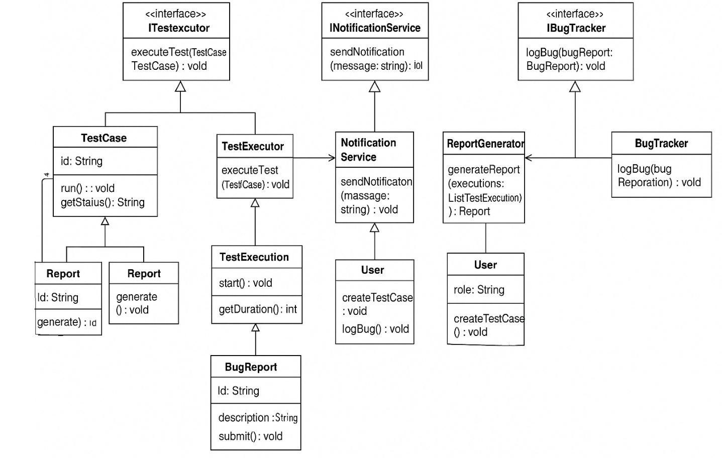

- TestCase:
  - Attributes:
    - testCaseId: int
    - description: String
    - priority: int
    - module: String
  - Methods:
    - create(): TestCase – Creates and initializes a new test case.
- BugReport:
  - Attributes:
    - bugId: int
    - description: String
    - status: String
    - screenshot: String
  - Methods:
    - log(user: User, testExecution: TestExecution, bugReport: BugReport): void – Logs a bug and associates it with the specific test execution and user.
- TestExecution:
  - Attributes:
    - executionId: int
    - status: String
    - timestamp: Date
  - Methods:
    - start(): void – Starts the test execution.
    - getDuration(): int – Returns the duration of the executed test.
- ReportGenerator:
  - Attributes:
    - reportId: String
    - executions: List<TestExecution>
  - Methods:
    - generate(): void – Generates and finalizes the report after the tests are completed.
- User:
  - Attributes:
    - userId: int
    - username: String
    - role: String (e.g., Tester, Developer)
  - Methods:
    - createTestCase(): void – Creates new test cases.
    - logBug(): void – Logs a bug in the bug tracking system.

Diagram

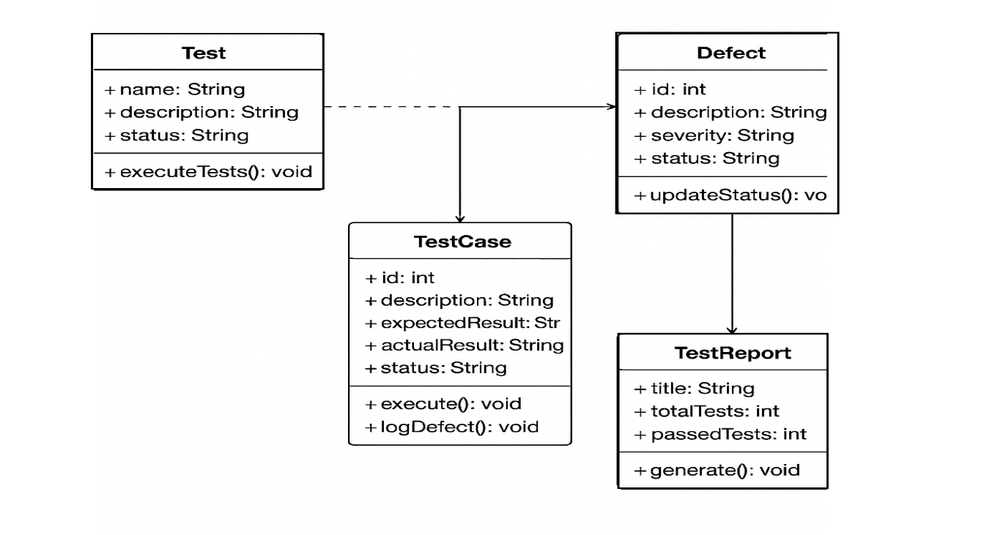

3. Dynamic Model

3.1 Sequence Diagram for Test Case Execution
The Sequence Diagram below illustrates the interactions between the Developer, CIIntegration, ITestExecutor, and TestExecution during the process of test case execution. Here's how the interaction flows:
- The Developer pushes the code to the repository, triggering the CI/CD pipeline via CIIntegration.
- CIIntegration calls the triggerTests() method to initiate test execution.
- ITestExecutor executes the test using the executeTest() method.
- After executing the test, TestExecution logs the test result, including its status and duration.

Sequence Diagram for Test Case Execution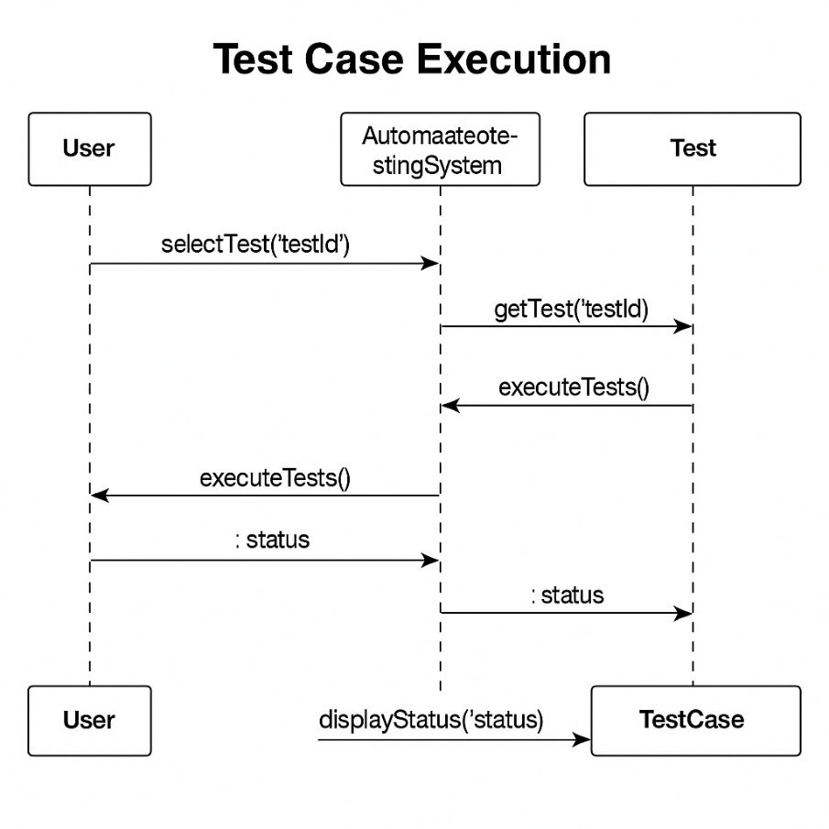

3.2 Sequence Diagram for Bug Logging & Tracking
The Bug Logging & Tracking diagram models the process of logging bugs encountered during test execution. Here's the step-by-step interaction:
- The Tester identifies an issue during test execution and calls the reportBug() method to log the bug.
- The BugReport object is created, containing the bug description, severity, and screenshot.
- IBugTracker logs the bug using the logBug() method.
- Finally, the bug information is pushed to Jira for tracking and resolution.

Sequence Diagram for Bug Logging & Tracking
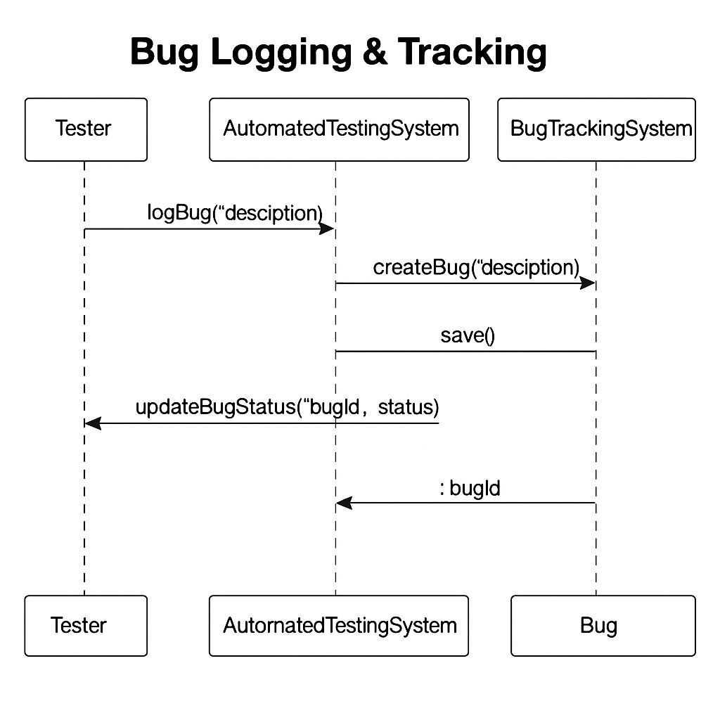

3.3 Sequence Diagram for Report Generation
The Report Generation diagram illustrates the process of generating and exporting a report after test execution. The flow goes as follows:
- The Tester calls the generateReport() method to start the report generation process.
- TestResults are fetched from the execution logs.
- ReportGenerator creates the final Report based on the execution results.
- INotificationService sends a notification to the Tester indicating that the report has been generated and is ready for review.

Sequence Diagram for Report Generation

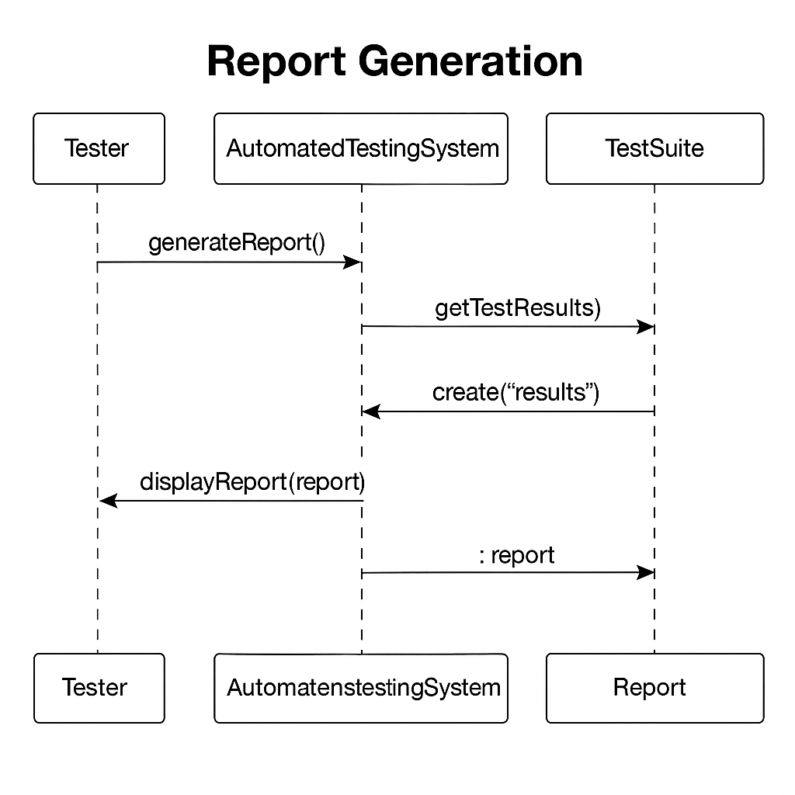

4. GitHub Repository
As required, all models, including the class diagrams, sequence diagrams, and source code, are uploaded to a GitHub repository. The repository contains:
https://github.com/AribaMumtaz/SE_Assignment1

5. Conclusion
In this assignment, we successfully developed the structural model (class diagram) and dynamic model (sequence diagrams) for the Automated Software Testing System (ASTS). These models clearly define the relationships and interactions between various system components, including test execution, bug tracking, and report generation.

6. References
- IEEE 830-1998: Software Requirements Specification Standard.
- IEEE 829-2008: Software Test Documentation.
- ISTQB Software Testing Standards.

