**Installing SPHinXsys**

* **Building Simbody, Boost and TBB**

**STEP 1:** Install Visual Studio (version 2017 or 2019). <https://msdn.itellyou.cn/>

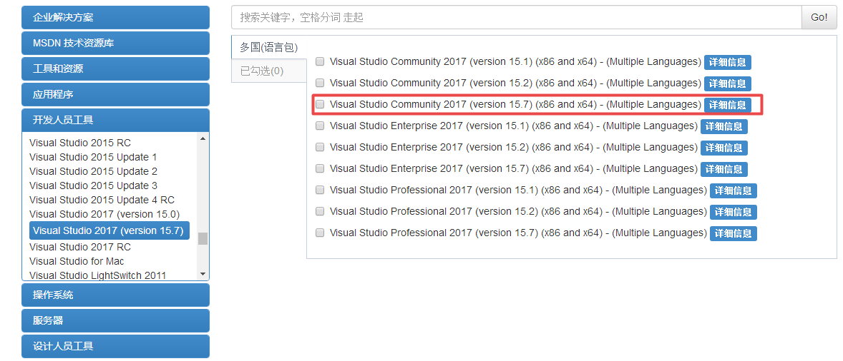

* Setup c++ environment, refer to website: <https://www.cnblogs.com/Metak/p/7471671.html>

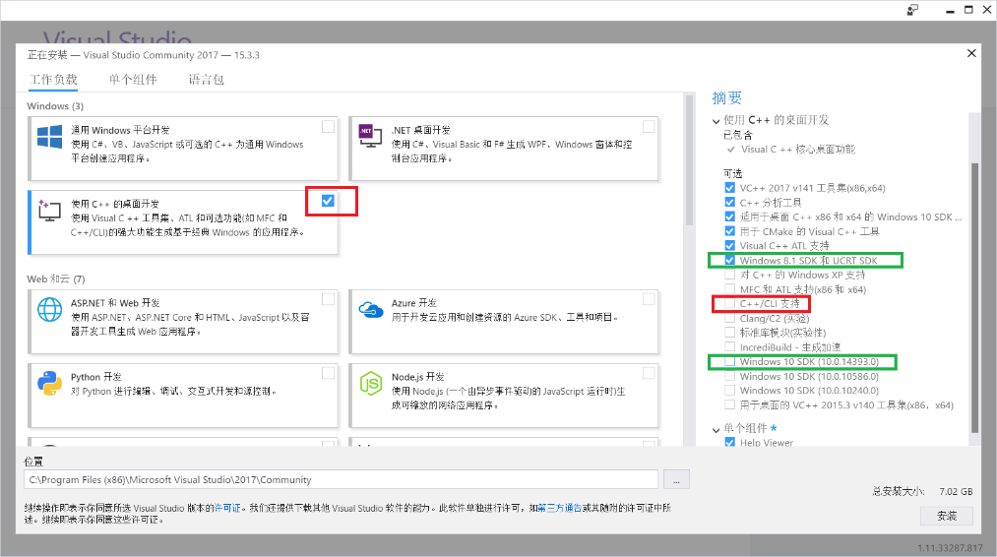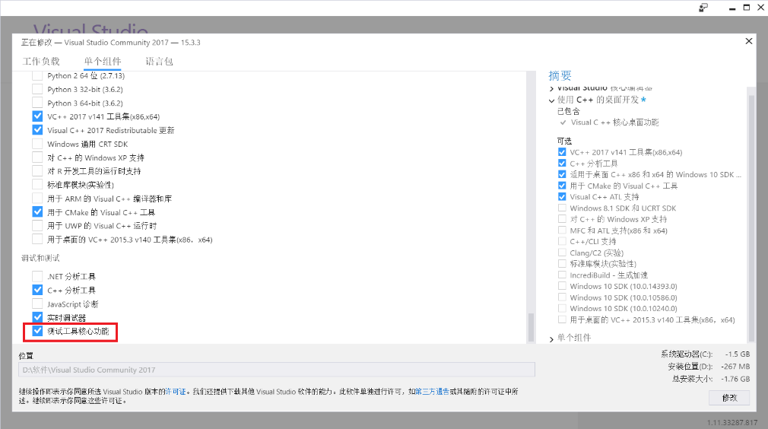

**STEP 2:** Install CMake, e.g. D:/cmake. <https://cmake.org/> . Cmake is cross-plateform project manager. It generates files for a project.

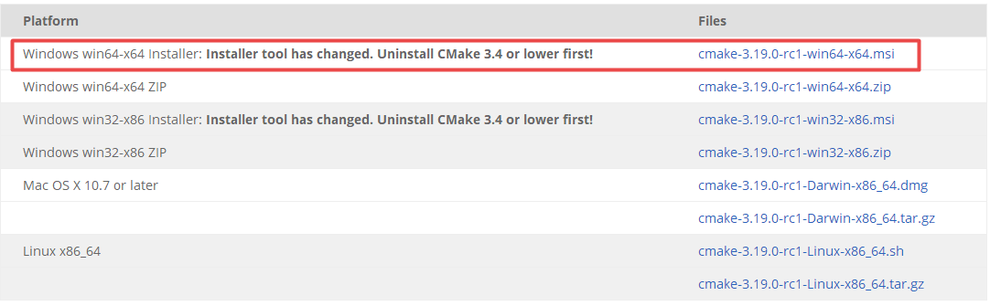

**STEP 3:** Install TBB (Thread Building Blocks).

<https://github.com/oneapi-src/oneTBB/releases/tag/2019_U9>

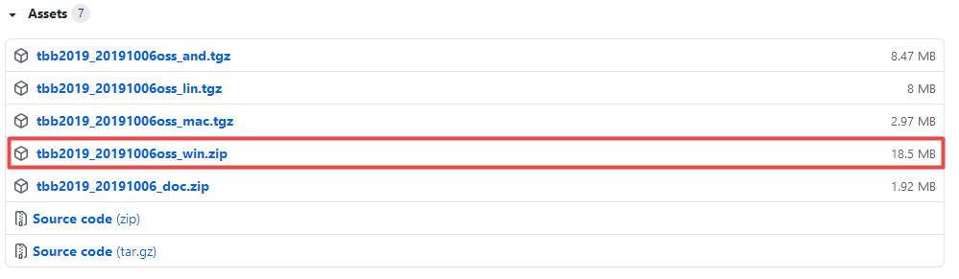

* Extract the file to the assigned folder, e.g. D:/ tbb2019_20191006oss.

**STEP 4:** Install BOOST with download from <https://sourceforge.net/projects/boost/files/boost-binaries/>, e.g. D:/ boost_1_74_0**.** Choose a boost (e.g. boost 1.74.0), and then choose the right version for your visual studio (For VS 2017 you choose msvc-14.1-64, VS2019 msvc-14.2-64.).

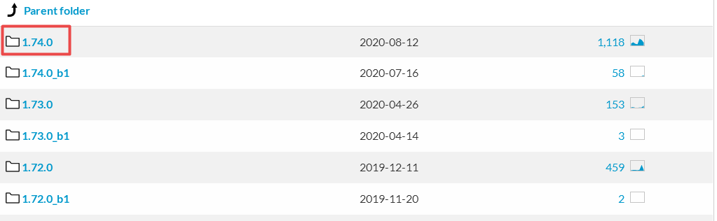

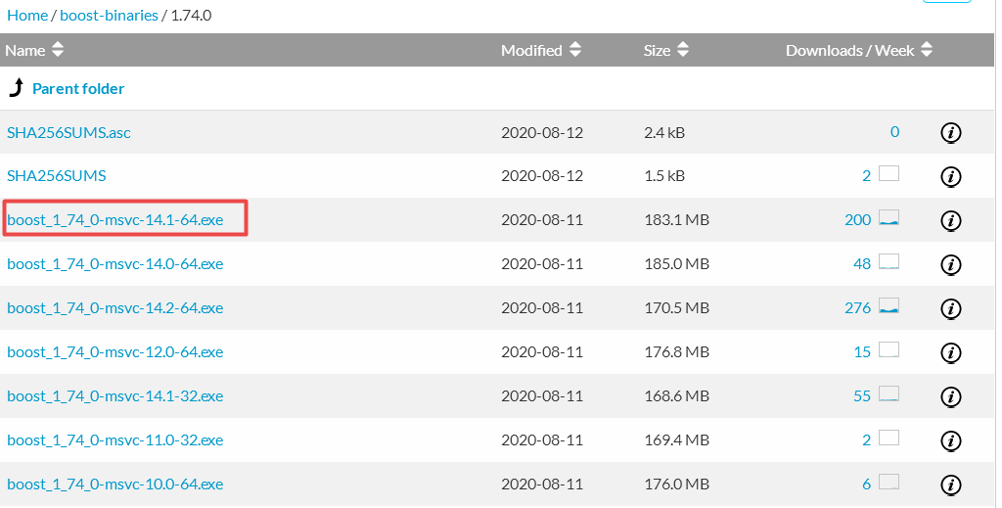

**STEP 5:** Install Simbody <https://github.com/simbody/simbody/releases>

* Choose version 3.7, unpack to source folder, like: D:\simobody-source .
* Create build folder, like: D:\simbody-build.
* Use CMake, **Configure** with option Visual Studio 2017 **x64**, change the location of CMAKE_INSTALL_PREFIX,e.g. D:\Simbody.Note that CMAKE_INSTALL_PREFIX should be a file folder (that can be changed by yourself, and will be created automatically) not in system folder.
* **Generate** the solution file for VS2017.

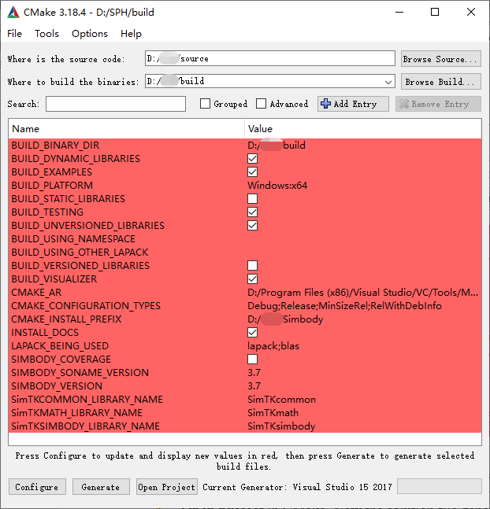

* **Open project** in CMake. Now the solution file generated by CMake is opened by Visual Studio.

Choose **RelWithDebinfo** and **x64** mode.

* Right-clicking ALL_BUILD and selecting build.
* Right-clicking INSTALL, selecting set as startup project, and then selecting build.

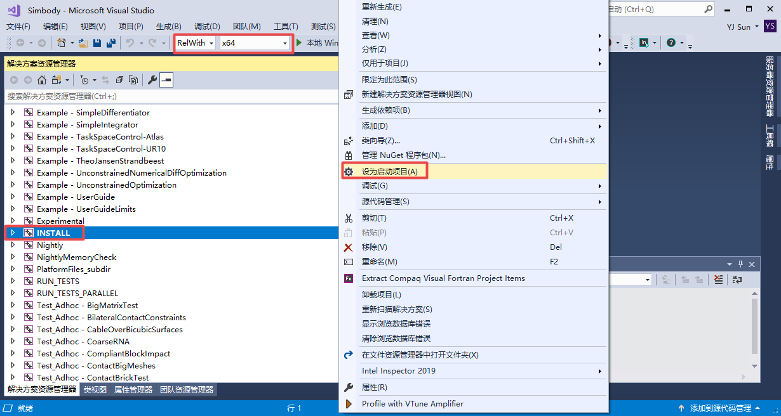

* **CHECK**. If Simbody is successfully installed, there should be a file folder named simbody in D:\ (where the CMAKE_INSTALL_PREFIX is set to).

**STEP 6:** Environment Variable settings.

* Set Environment Variable (User Variables): SIMBODY_HOME to the simbody directory.
* Set environment variable (User Variables): TBB_HOME to the tbb directory
* Set Environment Variable (User Variables): BOOST_HOME to its directory.
* Add the boost_1_74_0\lib64-msvc-14.1 path to Environmental Variable (System Variables).
* Add the tbb2019_20191006oss\bin\intel64\vc14 path to Environmental Variable (System Variables).
* Add the simbody\bin path to Environmental Variable (System Variables).
* Add the CMake\bin path to Environmental Variable (System Variables).

In Windows system, the system environment variables and PATH can be set like the following picture:

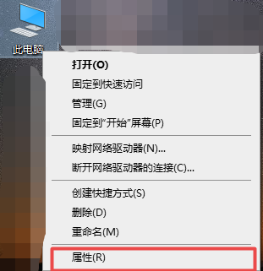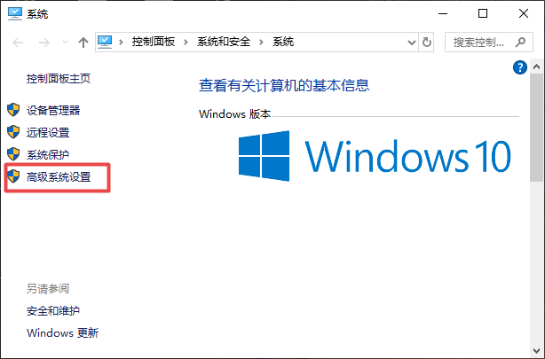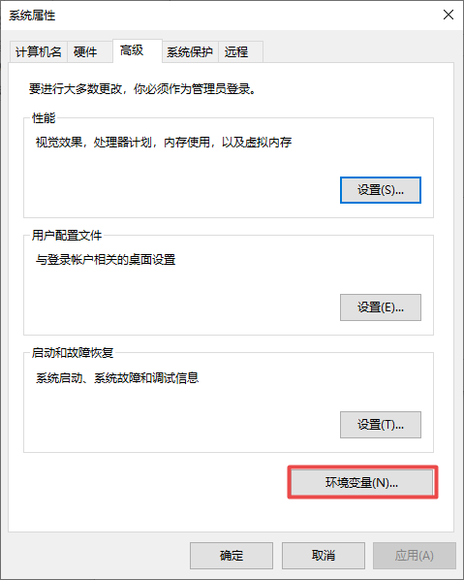

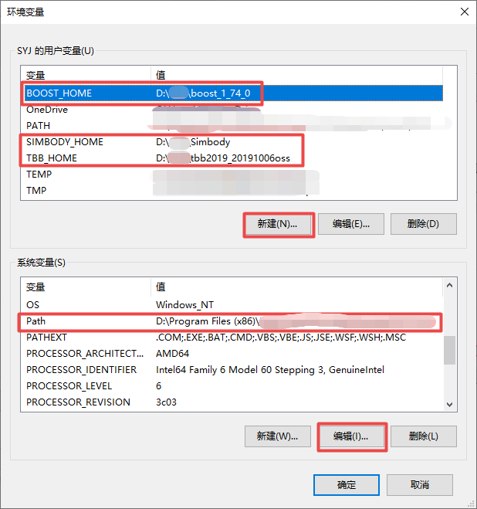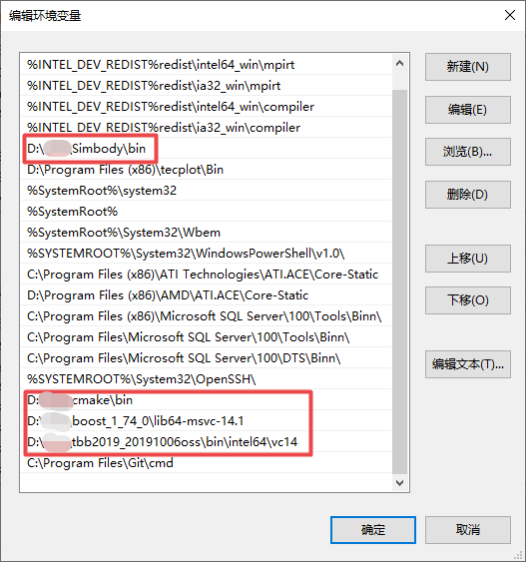

Fig1. How to set system environment variables and PATH in Windows System.

* **Building SPHinXsys project**
* Clone the newest version of SPHinXsys source files from BitBucket (https://bitbucket.org/xiangyu_hu/sphinxsys-alpha.git) to local computer using SmartGit.
* Create build folder, like: D:\SPHinXsys-build. Use CMake to build project file.
* Configure with the option **Visual Studio 2017 x64**, change the location of CMAKE_INSTALL_PREFIX, e.g. D:\SPHinXsys. Remember to create a new directory outside of the git directory to avoid upload the project files to the git- lab.

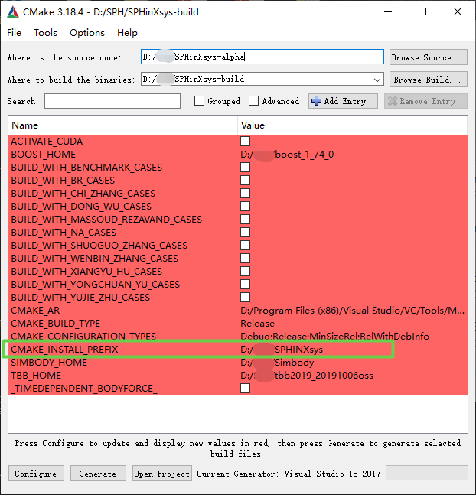

* **Generate** the solution file for VS2017.
* **Open project** in CMake. Now the solution file generated by CMake is opened by Visual Studio.
* One can choose debug or release mode to build the project file. In the SPHinXsys project, run INSTALL will produce .h, .lib and .dll libraries for external use.