CanvasUI

Technical Documentation & Model Testing Report
AI-Powered UI Design Tool — Canvas-Based Generation, Editing & HTML Export

Prepared by: <Add your name>
Date: <Add report date>
Project Repository: CanvasUI (Next.js)

1. Overview
CanvasUI is an AI-powered UI design tool. A user describes a desired interface in plain English; the app asks a large language model to translate that description into a structured array of typed canvas objects (rectangles, text, image placeholders), renders that layout on an interactive Fabric.js canvas, and lets the user refine it manually or via natural-language AI-assisted edits on individual elements. The finished design can be exported as a single self-contained, responsive HTML document.
The application supports two interchangeable AI backends, selectable per-request from the UI: Google Gemini (cloud-hosted) and Ollama (self-hosted open-weight models, run either locally or on a remotely tunnelled GPU instance such as Google Colab or Kaggle).

1.1 Core Capabilities
- Text-to-design generation: natural language prompt -> full canvas layout (30-50 objects)
- Direct manual editing: drag, resize, rotate, recolor, retype via the canvas and properties panel
- AI-assisted single-object editing: natural language instruction applied to one selected object
- HTML export: layout -> complete, semantic, responsive HTML page (Tailwind CSS), with an optional vision-based render -> compare -> correct verification pass
- Pluggable model provider: swap between Gemini and Ollama (local or remote) per request

2. Technology Stack
Layer | Technology | Purpose
Framework | Next.js 16 (App Router) | Frontend + server-side API routes, single deployable app
UI | React 19, Tailwind CSS 4 | Sidebar, properties panel, modals
Canvas engine | Fabric.js 6 | Interactive object rendering, selection, transform, screenshot capture
Cloud AI SDK | @google/genai | Gemini model calls with JSON-schema-constrained output
Local/self-hosted AI | Ollama | Runs open-weight models (Qwen2.5-VL, Qwen2.5-Coder, Qwen3.6)
HTTP client | undici | Explicit long-timeout, streaming-capable fetch for Ollama calls
Headless rendering | Playwright (Chromium) | Server-side screenshot of generated HTML for vision-based self-correction
Language | TypeScript | End-to-end static typing

3. System Architecture

3.1 Frontend
File | Responsibility
src/app/page.tsx | Top-level page: sidebar (model selector, prompt box, properties panel, export/clear actions), loading states, HTML preview modal, and the three client-side handlers that call the API routes.
src/components/DesignCanvas.tsx | Fabric.js canvas wrapper. Exposes an imperative handle (renderObjects, updateSelected, getSelectedAsUIObject, replaceObject, getAllObjects, getCanvasScreenshot) so the page component never touches Fabric APIs directly.
src/lib/types.ts | Shared UIObject and SelectedObjectProps type definitions.
src/lib/exportToHTML.ts | Deterministic objects-to-HTML serializer (absolute-position div/p markup). Present in the codebase as a non-AI fallback path but not currently wired into any route -- /api/export-html uses AI generation instead (see 3.2).

3.2 Backend API Routes
All three routes are Next.js Route Handlers running on the Node.js runtime (export const runtime = "nodejs"), each delegating to either the Gemini SDK or ollamaChat() depending on the selected model's provider.
Route | Input -> Output | Notes
POST /api/generate-objects | { prompt, model } -> { objects: UIObject[] } | Single generation pass. System prompt combines the design-system tokens with detailed layout/typography/z-order rules; output constrained to a JSON array via Gemini responseSchema or Ollama format.
POST /api/edit-object | { object, instruction, model } -> { object: UIObject } | Edits exactly one object. Result is merged over the original object so any fields a (smaller) model omits fall back to their previous value instead of disappearing.
POST /api/export-html | { objects, screenshot?, model } -> { html } | Two-pass for vision-capable models: pass 1 generates HTML from the objects (+ screenshot); pass 2 renders that HTML headlessly via Playwright, compares it against the original canvas screenshot, and asks the model to correct structural/positional mismatches. Non-vision models and requests without a screenshot skip pass 2 entirely.

3.3 Data Model — UIObject
Field | Type | Meaning
id | string | Stable identifier, referenced by replaceObject/edit-object
type | "rect" | "text" | "image" | Drives which Fabric primitive is created
role | string | Semantic role (e.g. "navbar", "cta-background") used for HTML tag inference
x, y, width, height | number | Absolute position/size on the 1200x800 canvas
z | number | Draw order; higher draws on top
fill, radius | string / number | Rect fill colour and corner radius
text, fontSize, fontWeight, textColor | mixed | Text-object styling
elevation | 0-3 | Maps to a shadow preset (none/sm/md/lg)
stroke, strokeWidth | string / number | Optional border
angle | number | Rotation in degrees, preserved on export

4. AI Model Provider Layer

4.1 Provider Abstraction (src/lib/models.ts)
A single MODEL_OPTIONS array is the source of truth for every selectable model: its id (the literal model identifier sent to the provider), a UI label, its provider ("gemini" | "ollama"), and whether it supports image input. getModelOption() resolves an id with a safe fallback to DEFAULT_MODEL_ID, then MODEL_OPTIONS[0], so an unknown or missing model id can never crash a request.

4.2 Gemini Provider
Called directly via the @google/genai SDK using GEMINI_API_KEY from the environment. Structured output is enforced with responseMimeType: "application/json" plus an explicit responseSchema (Gemini's typed Type.OBJECT/Type.ARRAY schema format). Vision requests attach the canvas screenshot as inlineData alongside the text prompt.

4.3 Ollama Provider (src/lib/ollama.ts)
Calls a self-hosted Ollama instance's /api/chat endpoint (OLLAMA_HOST env var, default http://localhost:11434). Because this project also runs Ollama remotely behind a public tunnel (see Section 5), this client needed several deliberate hardening measures beyond a plain fetch() call, found and fixed during testing:
Mechanism | Why it's necessary
Streaming responses (stream: true), manually reassembled from newline-delimited JSON chunks | A buffered (stream: false) call sends zero bytes until generation is fully complete. Over a public tunnel this idle period is exactly what gets killed by gateway timeouts (see 5.4); streaming keeps bytes flowing continuously instead.
Explicit per-request undici.Agent dispatcher with a 30-minute headersTimeout/bodyTimeout | Node's built-in fetch defaults to a 5-minute timeout. Calling undici.setGlobalDispatcher() does not reliably reach Node's built-in fetch implementation (a known undici limitation), so the dispatcher is passed directly into each fetch call instead.
Explicit options.num_ctx (16384) and num_predict (-1) on every request | Ollama's default context window (often 2048-4096 tokens) is independent of what the underlying model architecturally supports, and silently truncates long structured JSON output mid-object once exceeded -- producing a JSON syntax error on parse rather than an obvious error message.

5. Remote Model Hosting Infrastructure
Larger Ollama models (7B-27B+ parameters) exceed what's practical to run on typical local laptop hardware. To test them, Ollama is instead run on a free cloud GPU notebook and exposed back to this app over a public tunnel.

5.1 Google Colab Setup
colab/run_ollama_colab.ipynb automates the full setup on a free Colab GPU runtime (T4, 16GB VRAM):
- Installs the zstd system package (required by Ollama's installer but missing from the base Colab image), then installs Ollama
- Stops/disables Ollama's auto-started systemd service, frees port 11434, and starts ollama serve manually with OLLAMA_ORIGINS=* (without this, Ollama returns 403 Forbidden for any request whose Host header isn't localhost -- which every tunnelled request is)
- Pulls each Ollama model configured in models.ts
- Opens a public HTTPS tunnel to port 11434 via pyngrok and prints the URL to paste into .env.local as OLLAMA_HOST

5.2 Kaggle as an Alternative
Kaggle Notebooks offer the same free, notebook-based approach with one practical advantage: its free GPU quota (30 hrs/week) includes a "T4 x2" option -- two T4 GPUs, 32GB combined VRAM. Ollama automatically splits a model's layers across multiple GPUs, so a model like qwen3.6:27b (~17GB) fits entirely in VRAM instead of partially offloading to CPU, avoiding a significant inference slowdown. Setup is otherwise identical, with the "Internet" toggle in notebook settings needing to be enabled for pip install / the ngrok tunnel to work.

5.3 Known Operational Issues & Resolutions
The following issues were encountered and resolved during hands-on testing of the remote-hosting setup, in the order they surfaced:
Symptom | Root Cause | Resolution
Ollama installer fails: "requires zstd for extraction" | Base Colab image is missing the zstd package | apt-get install -y zstd before running the Ollama install script
403 Forbidden on every tunnelled request | Ollama rejects requests whose Host header isn't localhost/127.0.0.1 by default | Start ollama serve with OLLAMA_ORIGINS=*
403 persisted after the fix | Ollama's installer also registers a systemd service that silently re-occupies port 11434 on its own (unfixed) configuration | Explicitly stop/disable the systemd service and free the port before starting ollama serve manually
ERR_NGROK_8012 ("connection refused") | ollama serve was no longer running, while the ngrok tunnel process was technically still alive | Restart the Colab runtime and re-run all setup cells
ERR_NGROK_3200 ("endpoint is offline") | The Colab session itself disconnected (idle timeout or ~12h hard cap) | Restart runtime, re-run all cells, update OLLAMA_HOST with the new tunnel URL
ERR_NGROK_3004 ("endpoint offline") while Colab looked unchanged | Free ngrok tunnel sessions expire on their own schedule, independent of the Colab kernel | Re-run only the ngrok tunnel cell to open a fresh session
Request fails after exactly 5 minutes ("fetch failed") | Node's built-in fetch defaults to a 5-minute headers/body timeout; a buffered (non-streaming) Ollama call sends no bytes until done | Custom undici Agent with a 30-minute timeout, passed as a per-request dispatcher
Still fails at ~5-7 minutes via 503 / ERR_NGROK_3004, even with the longer client-side timeout | ngrok's free-tier gateway independently kills long-running idle HTTP requests, regardless of client timeout settings | Switched the Ollama call to stream: true so bytes flow continuously
Frontend shows a JSON parse error ("Expected ',' or '}' ... ") after a long generation | Ollama's default context window (num_ctx) truncated the structured JSON output before the model could close the array | Explicit options.num_ctx: 16384, num_predict: -1 on every request

6. Configured Models Reference
Source of truth: src/lib/models.ts. Selectable from the Model dropdown in the sidebar.
Label | Model ID | Provider | Vision Support | Hosting
Gemini 3.1 Flash Lite | gemini-3.1-flash-lite | Gemini | Yes | Cloud (default model)
Gemini 2.5 Flash | gemini-2.5-flash | Gemini | Yes | Cloud
Qwen2.5-VL 7B (Ollama) | qwen2.5vl:7b | Ollama | Yes | Local / Colab / Kaggle
Qwen2.5 Coder 14B (Ollama) | qwen2.5-coder:14b | Ollama | No | Local / Colab / Kaggle
Qwen3.6 27B (Ollama) | qwen3.6:27b | Ollama | Yes | Colab (T4) / Kaggle (T4x2 recommended)

7. Testing Documentation
Replace each placeholder image below with an actual screenshot captured during testing (right-click the image in Word -> Change Picture -> This Device).

Design Generation
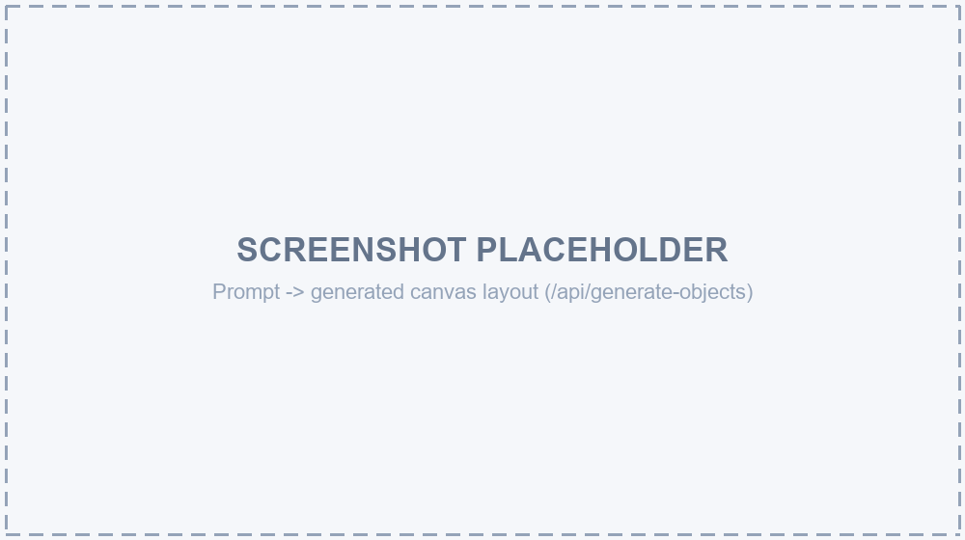
Prompt -> generated canvas layout (/api/generate-objects)
Observations: <Add notes about this test here>

Manual Canvas Editing
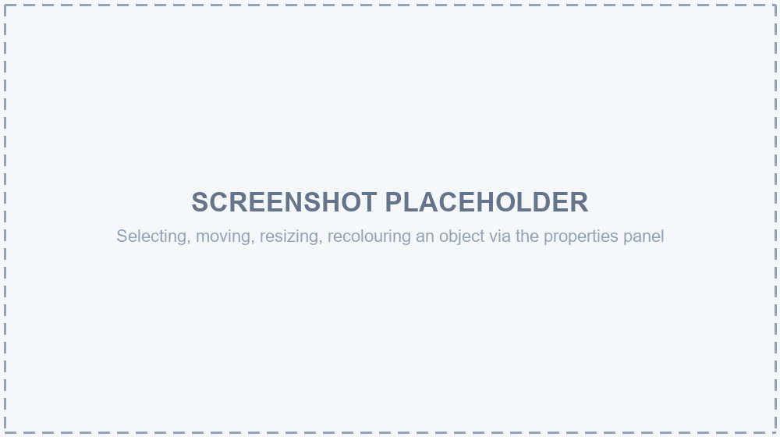
Selecting, moving, resizing, recolouring an object via the properties panel
Observations: <Add notes about this test here>

AI-Assisted Object Edit
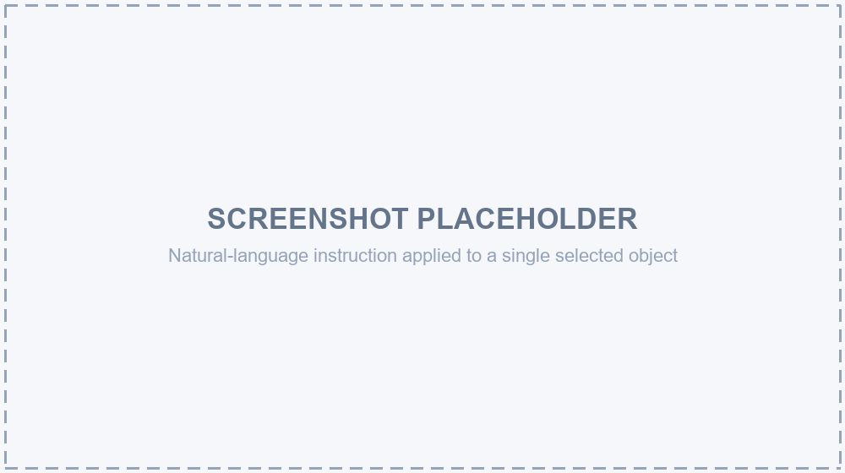
Natural-language instruction applied to a single selected object
Observations: <Add notes about this test here>

HTML Export & Preview
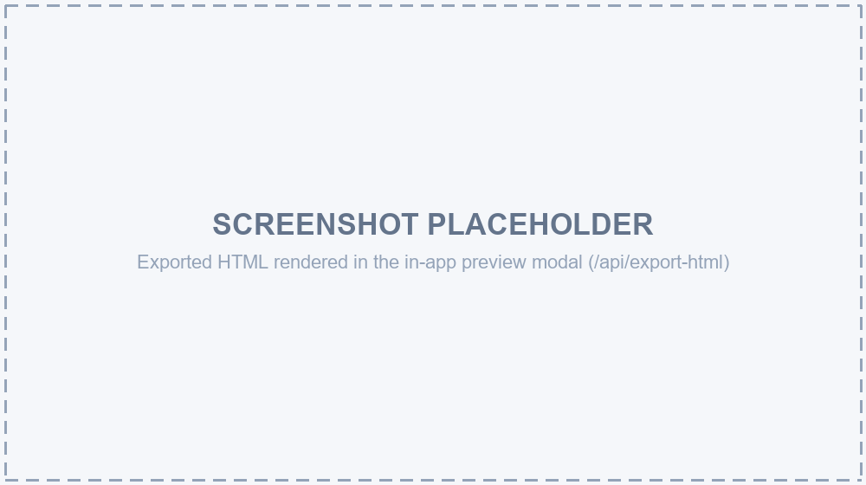
Exported HTML rendered in the in-app preview modal (/api/export-html)
Observations: <Add notes about this test here>

Remote Hosting Setup
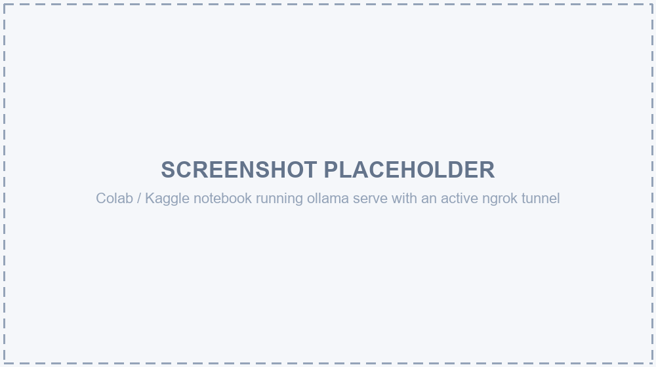
Colab / Kaggle notebook running ollama serve with an active ngrok tunnel
Observations: <Add notes about this test here>

8. Per-Model Evaluation Reports
One section per configured model. Fill in each subsection after running your own tests; fields are left blank intentionally.

8.1 Gemini 3.1 Flash Lite (gemini-3.1-flash-lite)
Test Date: Click here and type your findings.
Hosting Used: <Local / Colab / Kaggle / Cloud>
Prompts Tested: <List the prompts/instructions you tried>
Average Generation Time: <e.g. 12s, 4 min, 10 min>
Output Quality — Layout Accuracy: <Your assessment>
Output Quality — Visual Fidelity: <Your assessment>
JSON Validity / Errors Encountered: <Any truncation, malformed output, etc.>

Screenshot
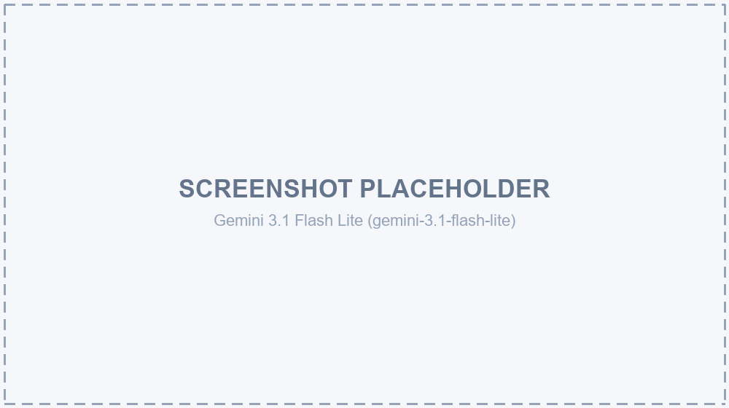
Notes / Conclusion: <Overall verdict on this model for this app>

8.2 Gemini 2.5 Flash (gemini-2.5-flash)
Test Date: Click here and type your findings.
Hosting Used: <Local / Colab / Kaggle / Cloud>
Prompts Tested: <List the prompts/instructions you tried>
Average Generation Time: <e.g. 12s, 4 min, 10 min>
Output Quality — Layout Accuracy: <Your assessment>
Output Quality — Visual Fidelity: <Your assessment>
JSON Validity / Errors Encountered: <Any truncation, malformed output, etc.>

Screenshot
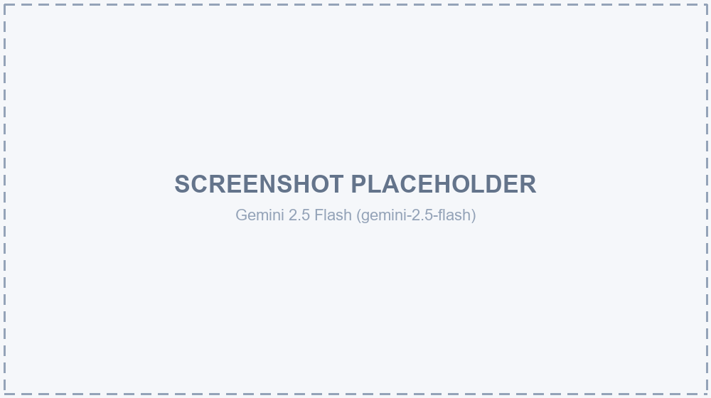
Notes / Conclusion: <Overall verdict on this model for this app>

8.3 Qwen2.5-VL 7B (qwen2.5vl:7b, Ollama)
Test Date: Click here and type your findings.
Hosting Used: <Local / Colab / Kaggle / Cloud>
Prompts Tested: <List the prompts/instructions you tried>
Average Generation Time: <e.g. 12s, 4 min, 10 min>
Output Quality — Layout Accuracy: <Your assessment>
Output Quality — Visual Fidelity: <Your assessment>
JSON Validity / Errors Encountered: <Any truncation, malformed output, etc.>

Screenshot
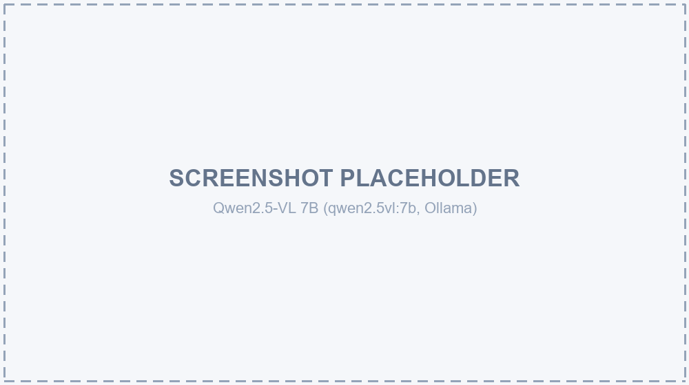
Notes / Conclusion: <Overall verdict on this model for this app>

8.4 Qwen2.5 Coder 14B (qwen2.5-coder:14b, Ollama)
Test Date: Click here and type your findings.
Hosting Used: <Local / Colab / Kaggle / Cloud>
Prompts Tested: <List the prompts/instructions you tried>
Average Generation Time: <e.g. 12s, 4 min, 10 min>
Output Quality — Layout Accuracy: <Your assessment>
Output Quality — Visual Fidelity: <Your assessment>
JSON Validity / Errors Encountered: <Any truncation, malformed output, etc.>

Screenshot
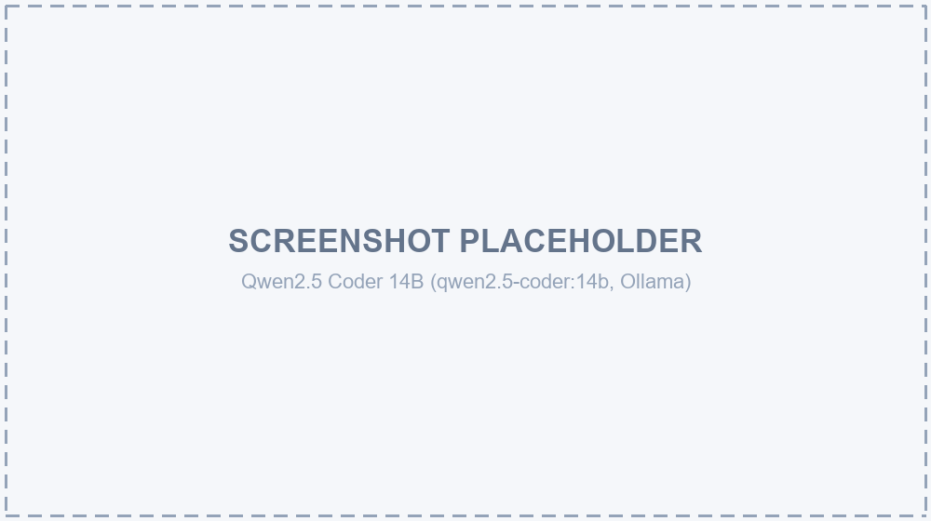
Notes / Conclusion: <Overall verdict on this model for this app>

8.5 Qwen3.6 27B (qwen3.6:27b, Ollama)
Test Date: Click here and type your findings.
Hosting Used: <Local / Colab / Kaggle / Cloud>
Prompts Tested: <List the prompts/instructions you tried>
Average Generation Time: <e.g. 12s, 4 min, 10 min>
Output Quality — Layout Accuracy: <Your assessment>
Output Quality — Visual Fidelity: <Your assessment>
JSON Validity / Errors Encountered: <Any truncation, malformed output, etc.>

Screenshot
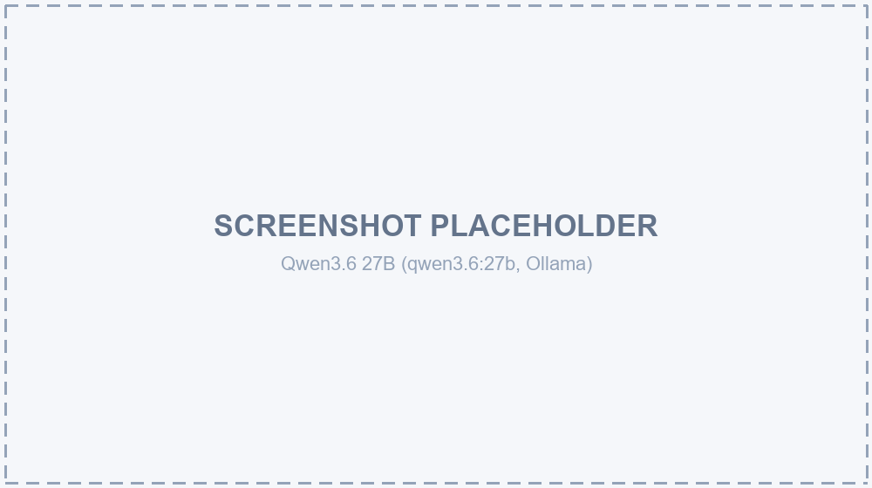
Notes / Conclusion: <Overall verdict on this model for this app>

9. Appendix A — Project File Structure
CanvasUI/
colab/
run_ollama_colab.ipynb Colab setup notebook (Ollama + ngrok tunnel)
docs/
CanvasUI_Technical_Documentation.docx
src/
app/
page.tsx Main page: sidebar, canvas area, state/handlers
layout.tsx Root layout, fonts
api/
generate-objects/route.ts Prompt -> UIObject[] design generation
edit-object/route.ts Single-object AI edit
export-html/route.ts UIObject[] -> standalone HTML (+ vision correction pass)
components/
DesignCanvas.tsx Fabric.js canvas wrapper (imperative handle)
lib/
types.ts UIObject / SelectedObjectProps types
models.ts Model provider registry
ollama.ts Hardened Ollama HTTP client (streaming, timeouts, context window)
designSystem.ts Shared design-token text injected into every AI system prompt
exportToHTML.ts Deterministic HTML serializer (not currently wired into a route)
.env.local GEMINI_API_KEY, GEMINI_MODEL, OLLAMA_HOST
package.json

9. Appendix B — Environment Variables
Variable | Purpose
GEMINI_API_KEY | API key for Google Gemini requests
GEMINI_MODEL | Default Gemini model identifier (informational; per-request model id comes from the UI selector)
OLLAMA_HOST | Base URL of the Ollama server -- http://localhost:11434 for a local instance, or a public ngrok URL when using a remotely hosted Colab/Kaggle instance

