MediDigitizer AI 2.0
Stateful LangGraph Pipeline, Self-Correcting OCR & Human-in-the-Loop Review Platform
1. Interactive Review Canvas & Drawing Overlays
The application features a premium high-resolution canvas container that renders scanned clinical document views directly in-browser. Using coordinates mapped by the grounding pipeline, the canvas overlays translucent color-coded highlighting boxes onto identified clinical entities (such as patient names, medication, dosages, and dates). Reviewers can hover over highlight blocks to preview extracted metadata or select bounding areas to trigger adjustments directly on the document's graphical surface.
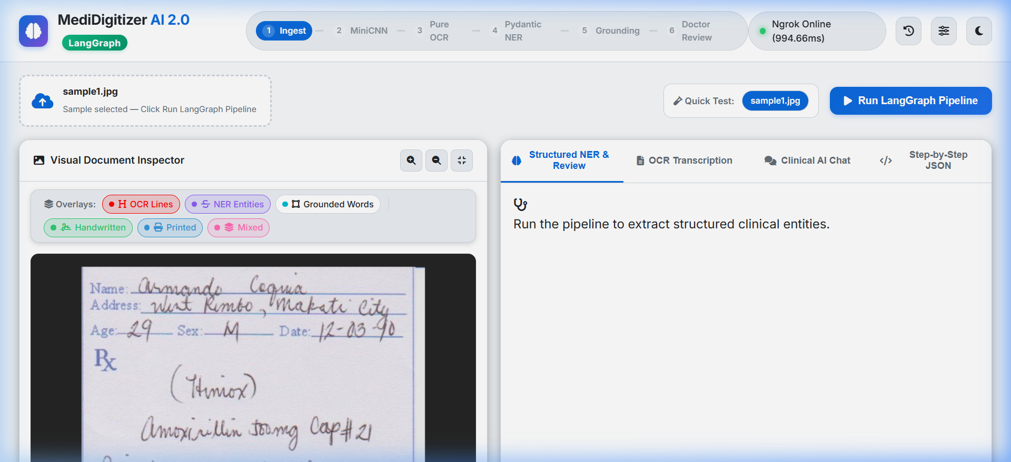
Figure 1: Visual preview of the Interactive Review Canvas dashboard
2. Human-in-the-Loop (HITL) Medical Review Breakpoint
To guarantee clinical safety, the pipeline incorporates a hard breakpoint managed by LangGraph before finalized document generation. The orchestration machine halts progress at the 'doctor_review' node, saving its state in a persistent checkpointer. This displays an interactive review drawer in the UI containing form fields pre-populated with extracted details. Medical professionals can edit spelling, modify dosage fields, or override records. Clicking the 'Approve & Finalize' button triggers the API state resume, submitting the corrections and completing the pipeline execution.
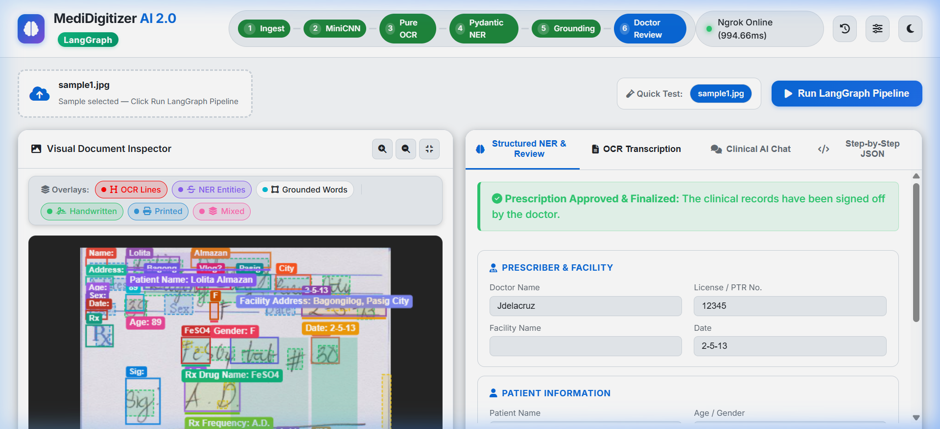
Figure 2: Visual preview of the loaded historical run and interactive review panel
3. Structured Clinical Entity Extraction (NER)
Rather than displaying raw unstructured text, the backend parses OCR transcriptions using a target Pydantic schema validation. It organizes raw clinical content into typed JSON objects including Patient Details (Name, Age, Sex, Weight, ID), Prescription Metadata (Doctor name, hospital name, registration ID, date), and a detailed Medication List (Drug name, form, dosage amount, frequency, duration, route, and instruction). This structured output is easily indexed for downstream search and database syncs.
4. Paragraph-Guided Word Grounding & Coordinate Projection
To link extracted text data back to coordinates on the original page, the pipeline utilizes a dual-coordinate projection engine. It queries the Vision-Language Model (Qwen2.5-VL) to detect text items mapped onto a normalized 1000x1000 coordinate grid, and projects those normalized points back to the image's original native pixel dimensions. This maps exactly where drug names and clinical findings are located, creating precise visual underlines and highlights.
5. Self-Correcting Zoom Re-OCR Loop
To combat fuzzy, low-confidence text and handwritten slips, the application utilizes a self-correcting logic loop. If the clinical parser flags crucial numbers (such as medication dosages) as low-confidence or mathematically inconsistent, the pipeline automatically crops the target region bounding box. It applies an image-zoom filter, runs a high-contrast local OCR pass, and merges the refined characters back into the main pipeline state prior to review, reducing manual adjustments.
6. Multi-Engine Hybrid OCR Ensemble
The OCR execution utilizes an ensemble approach. For standard printed structures, it uses a local fine-tuned Tesseract engine. For complex handwritten sentences, the pipeline delegates to local EasyOCR or bridges to remote Qwen2.5-VL Vision LLM endpoints. By checking multiple OCR sources in parallel, the backend cross-references recognized texts, achieving significantly higher accuracy.
7. MiniCNN Layout Classifier
Upon uploading a prescription image, the pipeline uses a local PyTorch MiniCNN classifier (or a height-based structural fallback) to analyze layout patches. It divides the document page into regions and classifies each box as Handwritten, Printed, or Mixed. This classification maps out the page structure, allowing the app to select the best OCR strategy for each patch (e.g. routing handwritten lines to VLMs and printed blocks to Tesseract).
8. Interactive Clinical Q&A Chat Assistant
The application houses an interactive LLM chat assistant panel directly inside the dashboard. Medical professionals can converse with the assistant about the current prescription findings. They can ask to verify drug-drug interactions, check pediatric dosage safety, suggest alternative medications, or format clean patient instructions. The assistant pulls active context directly from the parsed clinical schema, ensuring medical queries are grounded in patient facts.
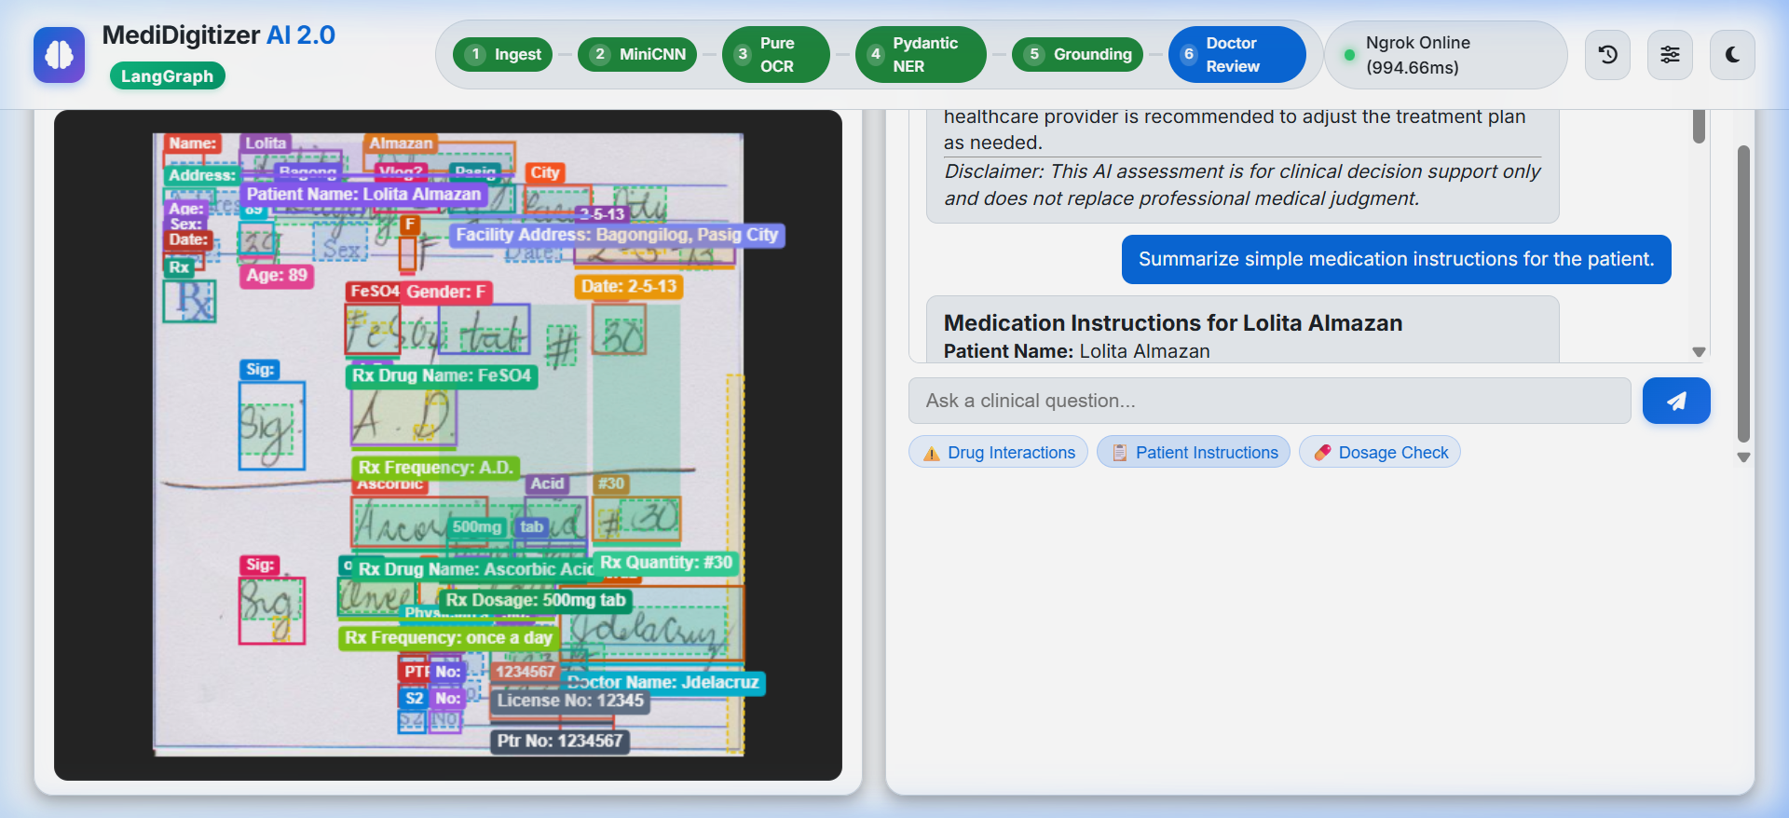
Figure 3: Visual preview of the Interactive Clinical Q&A Chat Assistant panel
9. Dynamic Configuration & Settings Manager
A dedicated configuration settings panel allows administrators to adjust tunnel URLs and toggle matching models on the fly. Users can update the active Google Colab Ngrok tunnel URL to maintain connectivity between sessions, select target models for OCR and NER tasks (e.g., frob/unlimited-ocr or Qwen2.5-VL), and enable or disable specific steps (like CNN pre-classification) to optimize resource usage based on deployment capacity.
10. Transaction History & Database Logs
The system records all digitization processes in a persistent SQLite or PostgreSQL database. The sidebar displays recent transactions, showing the patient name, timestamp, and status. Clicking any transaction reloads the complete historical state, including coordinates, validation warnings, and past chat dialogs, enabling clinical auditors to review cases seamlessly.
11. Clinical Rules & Safety Warning Engine
A rule validation engine evaluates the extracted JSON. It checks age limits, flagging adult medications prescribed to pediatric patients, and scans for potential drug interactions or missing patient metadata. Any warnings found are highlighted in the UI validation panel, alerting physicians to double-check prescriptions.
12. Approved Record Generation & PDF Export
Once the doctor approves the details, the system saves the finalized structured data. It compiles the records and exports a clean, standard clinical summary PDF containing patient details, verified medications, rules warnings, and metadata, providing a digitized record for archiving.

