**Microprocessor Lab**

Laboratory Activity No. 3

**Binary Representation of 8 LEDs in TinkerCad and Arduino Programming**

|  |
| --- |
|  |

Score

*Submitted by:*

**Ariega, Reginald A.**  
**7 AM – 10AM/ Saturday**

*Date Submitted*

**10-13-2023**

*Submitted to:*

**Engr. Maria Rizette H. Sayo**

1. Objectives

To create Arduino circuit of Binary representation (decimal 0-256 using 8 LEDs)

1. Components Used  
   1. 8 LEDs  
   2. 8 220 Ohms Resistor  
   3. Breadboard  
   4. Arduino Uno

5. Push Buttons

6. I2C LCD 16x2

1. Design and Code

**LINK:** <https://www.tinkercad.com/things/cjYRq0CduLA-amazing-stantia-leelo/editel?sharecode=evlJxvVEC3cl0qfuqZdq9_2b51iFFn3aRVIvTUutcSI>

**Circuit Design:**

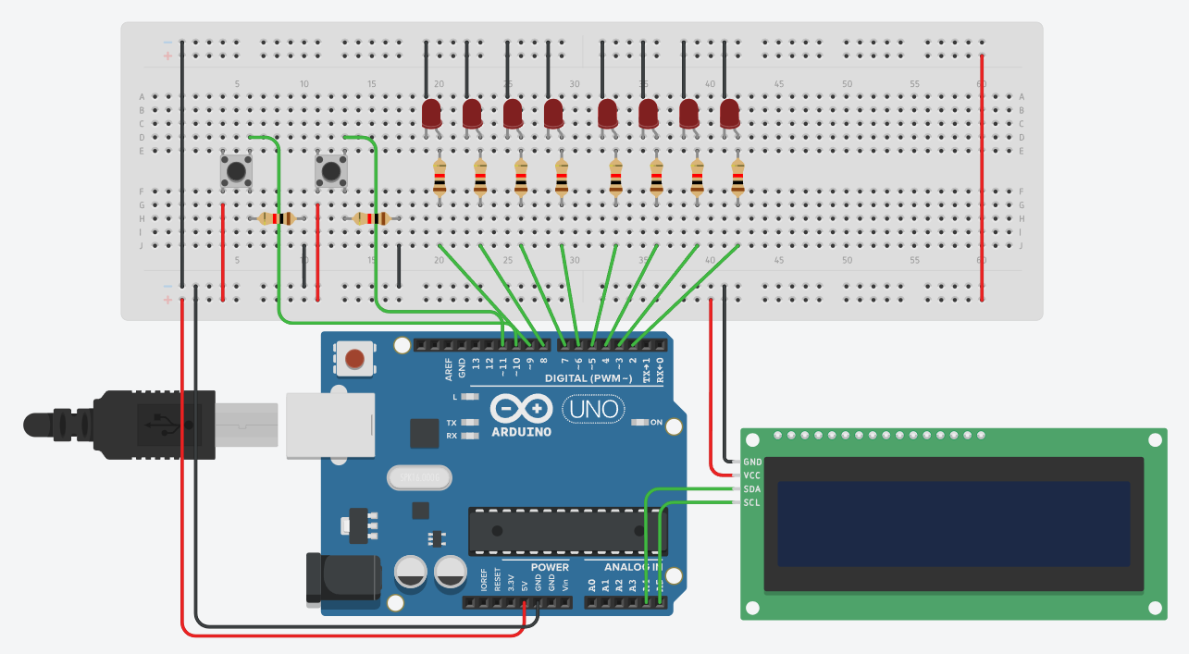

**Code Used:**

#include <LiquidCrystal_I2C.h>

LiquidCrystal_I2C lcd_1(32, 16, 2);

int ledPins[] = {2, 3, 4, 5, 6, 7, 8, 9};

int arr[] = {0,0,0,0,0,0,0,0};

int ind = 7;

int but = 10;

int but1 = 11;

void setup() {

Serial.begin(9600);

pinMode(but, INPUT);

pinMode(but1, INPUT);

for (int i = 0; i < 8; i++) {

pinMode(ledPins[i], OUTPUT);

}

lcd_1.init();

lcd_1.setCursor(0, 0);

lcd_1.backlight();

lcd_1.display();

}

void loop() {

int butState = digitalRead(but);

Serial.println(butState);

if(butState == 1){

lcd_1.setCursor(0, 0);

lcd_1.print("Dec. No: ");

for (int decimalNumber = 0; decimalNumber <= 256; decimalNumber++) {

displayBinary(decimalNumber);

delay(500);

int butState1 = digitalRead(but1);

if (butState1 == 1){

lcd_1.clear();

break;

}

}

}

delay(500);

}

void displayBinary(int decimalNumber) {

int ind = 7;

lcd_1.setCursor(0, 0);

lcd_1.print("Dec. No: ");

lcd_1.print(decimalNumber);

lcd_1.setCursor(0, 1);

lcd_1.print("Bin. No:");

for (int i = 0; i < 8; i++) {

int bitValue = (decimalNumber >> i) & 1;

arr[ind] = bitValue;

lcd_1.print(arr[i]);

digitalWrite(ledPins[i], bitValue);

ind--;

}

}

1. 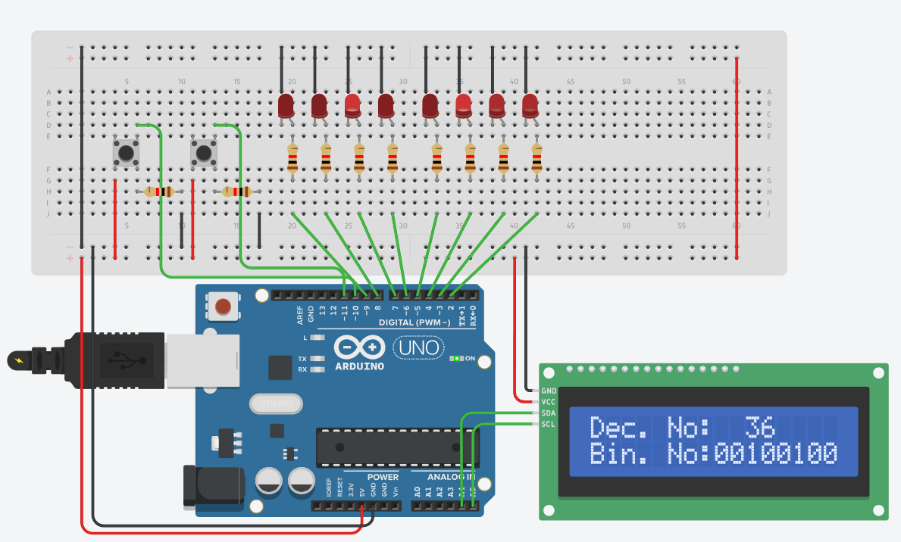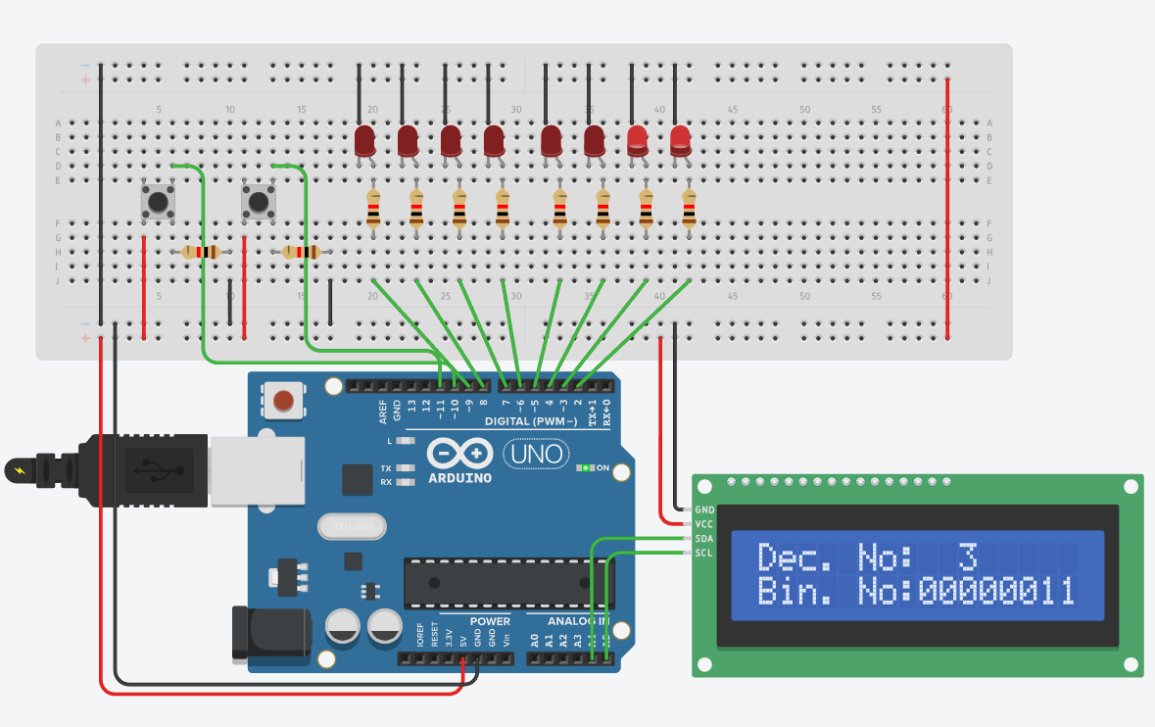 Results
2. Conclusion

Developing this system proposed a lot of challenges for me as I didn’t think of the function of the button only works by identifying its current state, and I2C LCD as it requires a library which gives me access to a different set of codes. Developing the process of the binary was hard too as I had to come up with a way where I can get the value of the current decimal number and light the led that corresponds to the value of the binary value.

Overall, it gave me a different way of thinking which I can use in the future in developing circuits like this. I learned a lot especially about the functionality of the component that I just used which is the LCD Screen, which made me think of the other applications where I can use that component. What I have learned in developing this activity will surely be implemented in the future activities.

**References**

[1] D.J.D. Sayo. “University of the City of Manila Computer Engineering Department Honor Code,” PLM-CpE Departmental Policies, 2020.

*<This is in a separate page>*