AI Multi-Model Administrative Collaboration System — Database Schema & Migration Specification
Version: v1.1
Purpose: Engineering review, API integration, database implementation, UI/UX implementation, and acceptance testing.

1. Data Layer Architecture
Continue to use PostgreSQL + pgvector + S3-compatible Object Storage. PostgreSQL stores transactional metadata and evidence metadata; Object Storage stores originals and large derived media; pgvector stores searchable embeddings. Media-aware records are added without weakening Project isolation.

2. Core Data Model
PROJECT
|-- CONVERSATION -- MESSAGE -- AI_EXECUTION -- AI_OUTPUT
|
|-- FILE
| |-- FILE_CHUNK
| |-- MEDIA_SEGMENT
| |-- VISUAL_OBSERVATION
| `-- EVIDENCE_ITEM
|
`-- PROJECT_MEMBER

3. Schema Changes
Existing users, projects, project_members, conversations, messages, files, file_chunks, ai_executions, and ai_outputs remain. The following fields/tables extend them.

3.1 messages
ALTER TABLE messages ADD COLUMN input_modalities JSONB;
ALTER TABLE messages ADD COLUMN realtime_session_id UUID;

3.2 files
ALTER TABLE files ADD COLUMN media_type VARCHAR(30);
ALTER TABLE files ADD COLUMN duration_ms BIGINT;
ALTER TABLE files ADD COLUMN capability_status JSONB;

3.3 file_chunks
Retain file_chunks for text-oriented content. Do not force timestamped media into ordinary chunks.
ALTER TABLE file_chunks ADD COLUMN source_locator JSONB;
ALTER TABLE file_chunks ADD COLUMN extraction_method VARCHAR(100);

3.4 media_segments
CREATE TABLE media_segments (
id UUID PRIMARY KEY,
file_id UUID REFERENCES files(id) ON DELETE CASCADE,
project_id UUID REFERENCES projects(id) ON DELETE CASCADE,
segment_index INTEGER NOT NULL,
start_time_ms BIGINT NOT NULL,
end_time_ms BIGINT NOT NULL,
speaker_ref VARCHAR(255),
transcript TEXT,
visual_summary TEXT,
embedding VECTOR,
metadata JSONB,
created_at TIMESTAMPTZ DEFAULT now()
);

3.5 multimodal_observations
CREATE TABLE multimodal_observations (
id UUID PRIMARY KEY,
project_id UUID REFERENCES projects(id) ON DELETE CASCADE,
file_id UUID REFERENCES files(id) ON DELETE CASCADE,
execution_id UUID REFERENCES ai_executions(id) ON DELETE SET NULL,
media_segment_id UUID REFERENCES media_segments(id) ON DELETE SET NULL,
observation_type VARCHAR(100) NOT NULL,
content JSONB NOT NULL,
confidence DOUBLE PRECISION,
status VARCHAR(30) NOT NULL CHECK (status IN ('OBSERVED','EXTRACTED','INFERRED','CONFIRMED','UNKNOWN')),
source_locator JSONB,
created_at TIMESTAMPTZ DEFAULT now()
);

3.6 evidence_items
CREATE TABLE evidence_items (
id UUID PRIMARY KEY,
project_id UUID REFERENCES projects(id) ON DELETE CASCADE,
observation_id UUID REFERENCES multimodal_observations(id) ON DELETE SET NULL,
message_id UUID REFERENCES messages(id) ON DELETE SET NULL,
claim TEXT NOT NULL,
evidence_type VARCHAR(50) NOT NULL,
confidence DOUBLE PRECISION,
confirmation_status VARCHAR(30) NOT NULL,
source_ref JSONB,
created_at TIMESTAMPTZ DEFAULT now()
);

3.7 ai_executions
ALTER TABLE ai_executions ADD COLUMN input_modalities JSONB;
ALTER TABLE ai_executions ADD COLUMN capability_tags JSONB;
ALTER TABLE ai_executions ADD COLUMN evidence_count INTEGER DEFAULT 0;
ALTER TABLE ai_executions ADD COLUMN validation_status VARCHAR(40);

3.8 ai_outputs
ALTER TABLE ai_outputs ADD COLUMN validation_results JSONB;
ALTER TABLE ai_outputs ADD COLUMN evidence_refs JSONB;
ALTER TABLE ai_outputs ADD COLUMN rendered_asset_ref TEXT;
The previous validation_passed boolean may be retained for backward compatibility, but validation_status and validation_results become the authoritative fields.

4. Indexes and Project Isolation
CREATE INDEX idx_media_segments_project_time
ON media_segments(project_id, file_id, start_time_ms);

CREATE INDEX idx_observations_project_status
ON multimodal_observations(project_id, status);

CREATE INDEX idx_evidence_project_created
ON evidence_items(project_id, created_at DESC);

CREATE INDEX idx_ai_executions_project_created
ON ai_executions(project_id, created_at DESC);
All retrieval queries must filter by current_project_id. Vector metadata must include project_id and the source file identifier. No cross-Project search is permitted.

5. Extended File / Media Processing Pipeline
Upload -> Security Check -> Type Detection -> Object Storage
-> Static Extraction OR Media Processing
-> Text Chunking / Media Segmentation
-> Embedding / Visual Index / Temporal Index
-> Evidence Metadata
-> READY

6. Processing States
State | Meaning
UPLOADED | Uploaded
PROCESSING | Extraction / segmentation / indexing in progress
READY | Required configured capabilities are available for retrieval
PARTIAL | Some capabilities are available while others failed or are pending
FAILED | Processing failed
DELETED | Removed

7. Media Retrieval
Media retrieval must support at least semantic, temporal, and source-based lookup. Example query: “What did Speaker A say around 14:20?” should return media_segment references with start/end timestamps and evidence provenance.

8. Migration Strategy
Migration | Purpose
001_init.sql | Existing core schema
002_enable_pgvector.sql | Enable pgvector
003_file_chunk_embedding.sql | File chunk embeddings
004_indexes.sql | Existing indexes
005_ai_execution_metrics.sql | Existing execution metrics
006_multimodal_file_fields.sql | Media metadata and capability status
007_media_segments.sql | Timestamped media segments
008_multimodal_observations.sql | Evidence observations
009_evidence_items.sql | Claim/evidence records
010_validation_results.sql | Structured validation results
Production schema changes must remain versioned, testable, reversible where practical, and must not be executed destructively at application startup.

Appendix: Diagram Names + Original Mermaid / UML

Figure 1: Extended Core Data Model
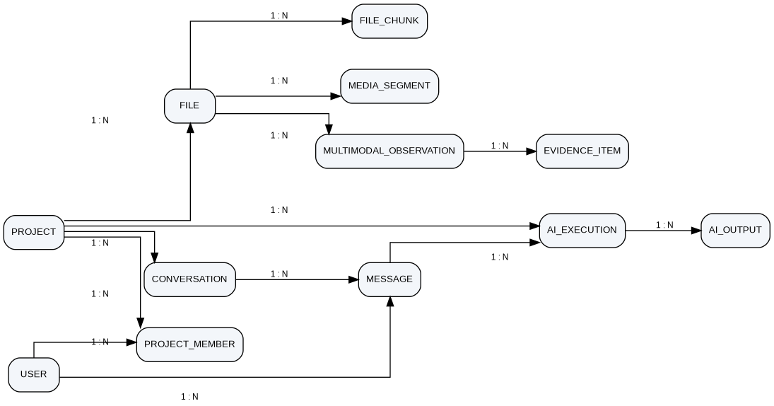
erDiagram
USER ||--o{ PROJECT_MEMBER : belongs_to
PROJECT ||--o{ PROJECT_MEMBER : has
PROJECT ||--o{ CONVERSATION : contains
CONVERSATION ||--o{ MESSAGE : contains
USER ||--o{ MESSAGE : sends
PROJECT ||--o{ FILE : contains
FILE ||--o{ FILE_CHUNK : contains
FILE ||--o{ MEDIA_SEGMENT : contains
FILE ||--o{ MULTIMODAL_OBSERVATION : produces
MULTIMODAL_OBSERVATION ||--o{ EVIDENCE_ITEM : supports
PROJECT ||--o{ AI_EXECUTION : has
MESSAGE ||--o{ AI_EXECUTION : triggers
AI_EXECUTION ||--o{ AI_OUTPUT : produces

Figure 2: Extended File Processing Pipeline
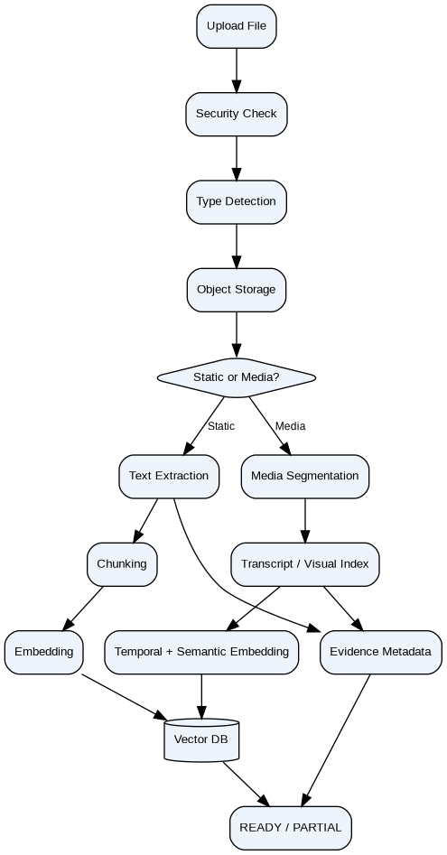
flowchart TD
A["Upload File"] --> B["Security Check"]
B --> C["Type Detection"]
C --> D["Object Storage"]
D --> E{"Static or Media?"}
E -->|Static| X["Text Extraction"]
X --> F["Chunking"]
F --> G["Embedding"]
G --> H["Vector DB"]
E -->|Media| M["Media Segmentation"]
M --> T["Transcript / Visual Index"]
T --> V["Temporal + Semantic Embedding"]
V --> H
X --> I["Evidence Metadata"]
T --> I
I --> J["READY / PARTIAL"]
H --> J

