AI Multi-Model Administrative Collaboration System — API Specification
Version: v1.1
Purpose: Engineering review, API integration, database implementation, UI/UX implementation, and acceptance testing.

1. Document Positioning
Defines the API contracts among the frontend, API Gateway, Multimodal Intake Layer, GPT-6 Luna Router, Context Retrieval, model adapters, Multimodal Evidence Layer, and Output Validator. Model providers remain replaceable and the Router remains decoupled from UI and provider SDKs.

2. Model Registry
Model | Primary Role | Priority Conditions
MODEL_E — GPT-6 Luna | Routine / high-volume / low-complexity | LOW + repetitive + explicit format
MODEL_A — Claude Sonnet 5.5 | General administration / documents | LOW–MEDIUM + text-heavy work
MODEL_B — Claude Opus 5.5 | Complex / long-context analysis | HIGH–VERY_HIGH + multi-stage analysis
MODEL_C — GPT-6.1 Sol | Logic / comparison / decision | HIGH reasoning + error finding / decision / process
MODEL_D — Gemini 3.8 Flash | Multimodal perception & verification | Image/audio/video/table/chart extraction, realtime perception where supported

3. End-to-End Flow
User -> API Gateway -> Multimodal Intake -> Router -> Context Retrieval
-> Selected Model Adapter -> Evidence / Output -> Validator -> UI
The Multimodal Intake Layer is inserted before routing so that modality and media metadata are explicit. Raw provider-specific requests remain behind adapters.

4. Public API

4.1 Create Project
POST /api/projects — Request: name, description. Response: project_id, name, created_at.

4.2 Upload File
POST /api/projects/:projectId/files — supports existing static files plus media assets subject to configured allowlists. Response includes file_id, processing_status, media_type, and capability_status.
{
"file_id": "uuid",
"processing_status": "PROCESSING",
"media_type": "VIDEO",
"capability_status": {
"transcript": "PENDING",
"visual_index": "PENDING",
"temporal_index": "PENDING"
}
}

4.3 Create Conversation
POST /api/conversations.

4.4 Send Message
POST /api/conversations/:conversationId/messages — supports text, attachments, image/audio/video references, and streaming.
{
"content": "...",
"attachments": ["file_uuid_1"],
"input_modalities": ["text", "image"],
"realtime": false
}

5. Internal Router API
POST /internal/ai/route
{
"message_id": "uuid",
"project_id": "uuid",
"conversation_id": "uuid",
"original_message": "...",
"conversation_context": [],
"project_context_summary": "...",
"available_files": [],
"multimodal": {
"required": true,
"modalities": ["image"],
"realtime": false,
"visual_spatial_reasoning": true,
"temporal_retrieval": false
}
}
{
"routing": {
"recommended_model": "MODEL_D",
"confidence": 0.94,
"task_complexity": "MEDIUM",
"task_type": ["VISUAL_PROCESS_RECONSTRUCTION"],
"reasoning_required": true,
"multimodal_required": true,
"required_capabilities": ["OCR", "SPATIAL_RELATION_EXTRACTION"],
"long_context_required": false,
"project_context_required": true
},
"task": {
"objective": "...",
"role": "...",
"context": [],
"source_data": [],
"constraints": [],
"instructions": [],
"verification": []
},
"output_specification": {
"language": "en-US",
"format": "structured_json",
"required_sections": ["observations", "uncertainties"],
"audience": "general_administrative_user"
}
}

6. Model Adapter Contract
interface AIModelAdapter {
execute(request: ModelRequest): Promise<ModelResponse>;
estimateCost(request: ModelRequest): Promise<CostEstimate>;
healthCheck(): Promise<boolean>;
}

interface ModelRequest {
model: string;
systemInstruction: string;
taskInstruction: string;
context: ContextPackage;
multimodalInputs?: MultimodalInput[];
outputSchema: JSONSchema;
maxOutputTokens?: number;
}
Business logic must not directly call a provider SDK. Realtime voice/video sessions should use a Realtime Model Adapter behind the same provider-independent boundary.

7. Multimodal Evidence API
POST /internal/evidence/observations
{
"execution_id": "uuid",
"source_file_id": "uuid",
"observations": [
{
"type": "EDGE",
"from": "Applicant",
"to": "Manager",
"confidence": 0.95,
"status": "OBSERVED",
"source_ref": {"page": 1}
}
]
}

8. Context Retrieval API
Context Retrieval must return relevant documents, text chunks, media segments, evidence items, previous decisions, and retrieval metadata. Queries must remain Project-scoped.
{
"project_summary": "...",
"relevant_conversation": [],
"relevant_documents": [],
"relevant_file_chunks": [],
"relevant_media_segments": [],
"evidence_items": [],
"previous_decisions": [],
"retrieval_metadata": {
"query": "...",
"sources": [],
"scores": []
}
}

9. Output Validator
Validation Layer | Checks
Structural | JSON Schema, required sections, Markdown/Mermaid syntax
Semantic | Completeness, contradictions, business logic, boundary conditions
Evidence | Claims linked to source evidence; inference/confirmation status
Visual | SVG/DOM geometry, overflow, accessibility, visual readability
Maximum retry remains 2. Fallback model switching applies to model-generation failures; user confirmation is preferred when evidence is incomplete or materially ambiguous.

10. Error Model and Observability
- Existing provider errors remain: PROVIDER_TIMEOUT, PROVIDER_RATE_LIMIT, PROVIDER_AUTH_ERROR, PROVIDER_INVALID_REQUEST, PROVIDER_SERVER_ERROR, MODEL_OUTPUT_INVALID, CONTEXT_TOO_LARGE, UNKNOWN_ERROR.
- Add MULTIMODAL_INPUT_UNSUPPORTED, MEDIA_PROCESSING_FAILED, EVIDENCE_AMBIGUOUS, REALTIME_SESSION_FAILED, VISUAL_QA_FAILED.
- Execution logging should include modality, provider/model, latency, TTFT where applicable, media duration, input/output tokens where available, cost, validation status, and evidence counts.

11. SLA / Performance
Metric | Baseline / Target
Router decision | <3 sec
Chat TTFT | <5 sec
API acknowledgement | <500 ms excluding model generation
Retry | Maximum 2
Realtime voice | Target to be confirmed during provider feasibility review
Media ingestion | Asynchronous; UI must expose processing state

Appendix: Diagram Names + Original Mermaid / UML

Figure 1: Message and Multimodal Execution Flow
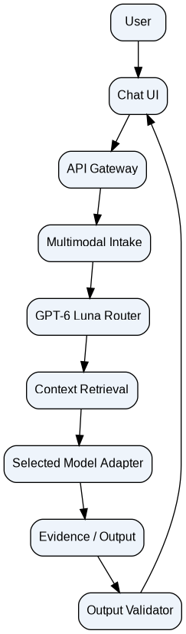
flowchart TB
U["User"] --> UI["Chat UI"]
UI --> API["API Gateway"]
API --> I["Multimodal Intake"]
I --> R["GPT-6 Luna Router"]
R --> C["Context Retrieval"]
C --> M["Selected Model Adapter"]
M --> E["Evidence / Output"]
E --> V["Output Validator"]
V --> UI

Figure 2: Capability-Based Model Routing
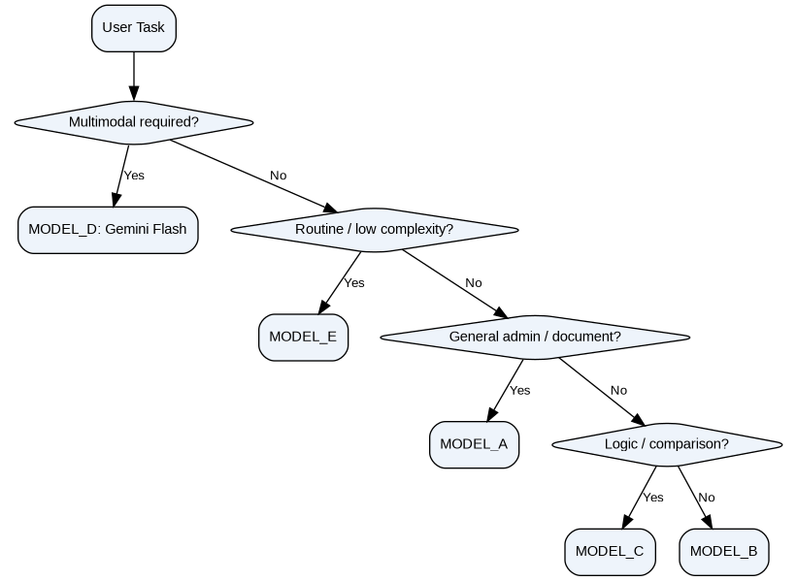
flowchart TD
S["User Task"] --> Q{"Multimodal required?"}
Q -- Yes --> D["MODEL_D: Gemini Flash"]
Q -- No --> R{"Routine / low complexity?"}
R -- Yes --> E["MODEL_E"]
R -- No --> A{"General admin / document?"}
A -- Yes --> A1["MODEL_A"]
A -- No --> C{"Logic / comparison?"}
C -- Yes --> C1["MODEL_C"]
C -- No --> B["MODEL_B"]

Figure 3: Context and Evidence Retrieval
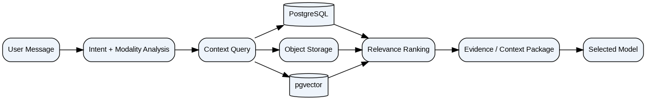
flowchart LR
M["User Message"] --> I["Intent + Modality Analysis"]
I --> Q["Context Query"]
Q --> DB[("PostgreSQL")]
Q --> F["Object Storage"]
Q --> V[("pgvector")]
DB --> R["Relevance Ranking"]
F --> R
V --> R
R --> E["Evidence / Context Package"]
E --> S["Selected Model"]

