AI Multi-Model Administrative Collaboration System — UI/UX & Figma Specification
Version: v1.1
Purpose: Engineering review, API integration, database implementation, UI/UX implementation, and acceptance testing.

1. Document Positioning
The UI remains a work workspace rather than an AI model control panel. The multimodal extension must make voice, image, audio, and video interaction natural without exposing provider, prompt, token, or RAG concepts to ordinary administrative users.

2. Information Architecture
Area | Purpose
Project Home | Projects and recent work
Chat Workspace | Primary AI interaction
File Center | Project documents and media
Conversation History | Previous conversations
Evidence / Sources | Review source observations and confirmations when needed
Feedback | Rate AI results
Settings | Account and Project permissions

3. Core User Flow
Login -> Project Home -> Project Workspace -> Chat
-> Text / Voice / Image / Media Input
-> Processing / Clarification
-> Streaming or Structured Result
-> Evidence Review when needed
-> Feedback
Model names remain hidden in normal user mode. The interface should expose only meaningful status and source information.

4. Composer and Multimodal Input
Mode | User Action | UI Behavior
Text | Type message | Existing composer behavior
Voice | Press and hold / start voice session | Realtime state, transcript preview, cancel/finish controls
Image | Attach or capture image | Preview, processing status, optional detected-structure summary
Audio / Video | Attach media | Upload progress, processing state, duration, searchable-ready status
Voice mode should be implemented against a provider-independent realtime session abstraction. The UI must not assume Gemini is the permanent provider.

5. Conversational Process Discovery UX
VOICE SESSION
-> Listening
-> AI Clarifying
-> User Answer
-> Process Draft
-> Review Uncertain Items
-> Confirm
-> Generate Mermaid / Document
When a process is incomplete, the UI should ask focused clarification questions rather than silently inventing missing rules.

6. Visual Whiteboard / Screenshot Review
After an image is processed, display a lightweight evidence overlay or structured summary. Distinguish confirmed, inferred, and unresolved items. Users should be able to correct labels, arrow direction, or missing branches before final generation.
Visual State | Meaning | Interaction
Confirmed | Supported by source or user confirmation | Normal display
Inferred | Model interpretation | Show confidence / review affordance
Unresolved | Ambiguous or missing | Ask user / highlight
Source | Original image/media reference | Open source at relevant page/time

7. Media / Meeting Review
File Center and Chat should support timestamped citations for media. A result such as “the leave-policy decision around 14:20” should open the source media at the relevant time when the platform supports it.

8. AI Response and Evidence
- Streaming remains supported for text responses.
- Structured multimodal extraction may render as cards or a process-draft panel before final prose.
- When a result depends on evidence, show clickable source references.
- If evidence is ambiguous, show a clear confirmation request instead of presenting uncertain business rules as facts.

9. Visual QA and Rendering Review
Rendered Mermaid/SVG output should pass deterministic UI checks before display. MODEL_D may provide an additional visual readability assessment. User-facing status can be “Layout checked” or “Needs layout adjustment”; provider/model details remain hidden unless Admin/Developer mode is enabled.

10. Model Transparency
Mode | Visible Information
General User | AI status, source/evidence, confirmation requests
Admin / Developer | Model, task type, confidence, tokens, latency, cost, validation status, modality and evidence counts

11. File Center
Field | Examples
Filename | policy_meeting.mp4
Type | PDF / Image / Audio / Video
Size | 125 MB
Duration | 01:02:14 for media
Status | Processing / Ready / Partial / Failed
Capabilities | Transcript / Visual Index / Temporal Search
Uploaded | Timestamp
Actions | Preview / Open / Retry / Delete

12. Feedback UX
Action | Purpose
Positive | Successful result
Negative | Open short reason selector
Regenerate | Generate again
Copy | Copy result
Source / Evidence | Open source location
Negative feedback reasons remain: incorrect, incomplete, too complex, too verbose, misunderstood request, wrong format. Add optional reasons for multimodal issues: incorrect transcription, wrong visual interpretation, wrong timestamp, and unsupported media.

13. Responsive / Accessibility
- Desktop-first and mobile-supported.
- Chat, attachments, evidence panels, and media controls must not cause horizontal overflow.
- Define focus states, keyboard navigation, ARIA labels, sufficient contrast, and accessible status announcements.
- Visual QA must include mobile viewport checks, but measurable overflow should be determined by deterministic browser tests rather than visual-model judgment alone.

14. Figma Deliverables
Page / Component | Required States
Login | Desktop + Mobile
Project Home | Empty / Normal / Error
Chat | Empty / Typing / Listening / Clarifying / Streaming / Completed / Error
Voice Session | Idle / Listening / Processing / Clarifying / Confirming / Completed / Error
Multimodal Attachment | Uploading / Processing / Ready / Partial / Failed
Evidence Review | Observed / Inferred / Unresolved / Confirmed
Media Viewer | Timeline / Timestamped source / Transcript
File Center | Empty / Uploading / Ready / Partial / Failed
Feedback | Positive / Negative
Admin AI Metrics | Model / latency / token / cost / validation / modality
Create variables/tokens for spacing, radius, typography, surface, border, status, focus, and button states. Use component variants for interaction and processing states.

15. Chat State Machine
EMPTY -> COMPOSING -> SENDING -> ROUTING -> STREAMING -> COMPLETED
COMPOSING -> LISTENING -> PROCESSING -> CLARIFYING -> CONFIRMING -> COMPLETED
SENDING -> PROCESSING_MEDIA -> EVIDENCE_REVIEW -> STREAMING
COMPLETED -> RETRYING -> STREAMING
ROUTING / STREAMING / PROCESSING_MEDIA -> ERROR

Appendix: Diagram Names + Original Mermaid / UML

Figure 1: Main UI Architecture
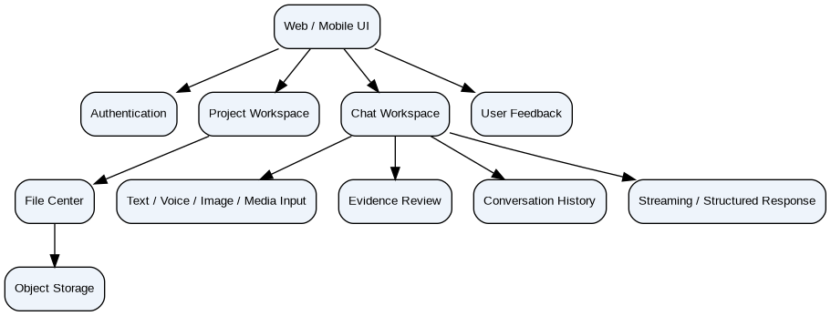
flowchart TB
UI["Web / Mobile UI"] --> AUTH["Authentication"]
UI --> PRJ["Project Workspace"]
UI --> CHAT["Chat Workspace"]
CHAT --> INPUT["Text / Voice / Image / Media Input"]
CHAT --> EVID["Evidence Review"]
PRJ --> FILES["File Center"]
FILES --> STORE["Object Storage"]
CHAT --> HIST["Conversation History"]
CHAT --> STREAM["Streaming / Structured Response"]
UI --> FB["User Feedback"]

Figure 2: Multimodal User Flow
flowchart LR
LOGIN["Login"] --> HOME["Project Home"]
HOME --> PROJECT["Project Workspace"]
PROJECT --> CHAT["Conversation"]
CHAT --> INPUT["Text / Voice / Image / Media"]
INPUT --> ROUTE["AI Routing"]
ROUTE --> PROC["Processing / Clarification"]
PROC --> RESULT["Result"]
RESULT --> EVID["Evidence Review"]
EVID --> CONF["Confirm if Needed"]
CONF --> FB["Feedback"]
PROJECT --> FILES["Files"]
FILES --> PREVIEW["Preview / Timestamp"]
PREVIEW --> CHAT

Figure 3: Chat State Machine
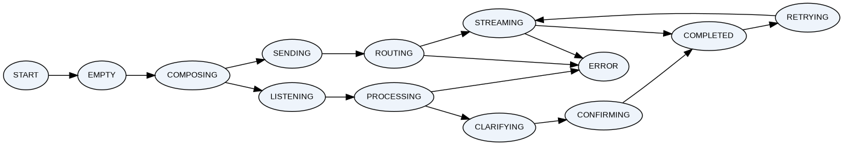
stateDiagram-v2
[*] --> EMPTY
EMPTY --> COMPOSING
COMPOSING --> SENDING
SENDING --> ROUTING
ROUTING --> STREAMING
STREAMING --> COMPLETED
COMPOSING --> LISTENING
LISTENING --> PROCESSING
PROCESSING --> CLARIFYING
CLARIFYING --> CONFIRMING
CONFIRMING --> COMPLETED
COMPLETED --> RETRYING
RETRYING --> STREAMING
ROUTING --> ERROR
STREAMING --> ERROR
PROCESSING --> ERROR

