AI Multimodal Extension Specification
Version: v1.1
Purpose: Engineering review, API integration, database implementation, UI/UX implementation, and acceptance testing.

1. Document Positioning
This specification extends the existing multi-model administrative collaboration system. It does not replace the current API Gateway, Router, Model Adapter, Context Retrieval, Project isolation, or Output Validator architecture. It introduces a Multimodal Intake Layer, Multimodal Evidence Layer, media-aware retrieval, conversational process discovery, and multi-layer validation.
Architecture principle: MODEL_D (Gemini Flash) should be treated as a Multimodal Perception & Verification component rather than as a second general-purpose reasoning center. It observes, extracts, segments, and visually verifies evidence; business truth remains subject to confirmation and reasoning by the orchestration and reasoning layers.

2. Design Goals
- Allow administrative users to provide process information naturally through text, voice, images, screenshots, whiteboards, audio, and video.
- Convert multimodal input into structured, traceable evidence that downstream reasoning models can consume.
- Preserve provider independence through adapters; do not hard-code Gemini into the public API contract.
- Distinguish observed facts, model inferences, unknowns, and user-confirmed facts.
- Use deterministic software checks for properties that can be measured reliably, and multimodal models for human-perception checks.
- Preserve Project isolation and evidence traceability throughout retrieval and generation.

3. Target Multimodal Capabilities
Capability | Recommended Role | Priority | Key Constraint
Voice-to-Flow | Conversational process discovery | P0 | Provider realtime/audio API must support required streaming and structured output
Whiteboard / Screenshot Understanding | Visual process reconstruction | P0 | Spatial relations are evidence, not automatically confirmed business rules
Meeting Audio/Video Ingestion | Temporal multimodal retrieval | P1 | Requires media segmentation, timestamps, speaker metadata, and storage/indexing
Rendered UI / Diagram Visual QA | Visual verification | P1 | Combine deterministic geometry/accessibility checks with visual-model review

4. Revised Multimodal Architecture
User / UI
-> API Gateway
-> Multimodal Intake Layer
-> AI Router
|
+--> MODEL_D: Multimodal Perception & Verification
+--> Reasoning Models: Claude / GPT family
+--> Logic / Decision Model
|
v
Multimodal Evidence Layer
-> Context Assembly / Retrieval
-> Output Generator
-> Multi-layer Validator
-> UI
The Multimodal Intake Layer normalizes modality metadata before routing. The Evidence Layer stores observations and provenance so that downstream models do not need to treat raw multimodal model output as unquestioned truth.

5. Evidence Model
Status | Meaning | Allowed Use
OBSERVED | Directly detected in the source modality | May be cited as source evidence
EXTRACTED | Structured representation produced from an observation | May be passed to reasoning with provenance
INFERRED | Model-derived interpretation not explicitly present in the source | Must be marked as inference and should not silently become business truth
CONFIRMED | Explicitly confirmed by the user or authoritative source | May be used as confirmed process logic
UNKNOWN | Information is missing or ambiguous | Should trigger clarification when material

6. Voice-to-Flow: Conversational Process Discovery
Voice -> Realtime Multimodal Adapter -> Transcript / Entities / Steps
-> Uncertainty Detection -> Clarifying Question
-> User Confirmation -> Confirmed Process Model
-> Reasoning Model -> Mermaid / BPMN / Administrative Document
- Gemini Flash may perform low-latency conversational perception and extraction when the provider API supports it.
- The system should maintain an interview state rather than treating every utterance as an isolated prompt.
- Questions should target missing branches, actors, conditions, exceptions, and return paths.
- Only confirmed or appropriately evidenced rules should enter the final process model.

7. Visual Whiteboard / Screenshot Reconstruction
- Extract text, nodes, arrows, spatial relationships, labels, and visible form fields.
- Attach confidence and source coordinates where supported.
- Present uncertainty visually: confirmed / inferred / unresolved.
- Never invent approval limits, rejection behavior, or organizational rules that are absent from the source.

8. Meeting Audio / Video Ingestion
Long-form media should not be represented only as ordinary file_chunks. Introduce media segments with start/end timestamps, speaker metadata when available, transcript, visual observations, and provenance. Retrieval should support semantic, temporal, speaker, and evidence-oriented queries.
FILE
|-- TEXT_CHUNK
|-- MEDIA_SEGMENT (start_time, end_time, speaker, transcript)
|-- VISUAL_OBSERVATION
`-- EVIDENCE_ITEM

9. Visual QA
Visual QA must be hybrid. Deterministic checks should validate SVG/DOM geometry, viewport overflow, accessibility attributes, and measurable layout constraints. MODEL_D may then assess human-perceived readability, visual ambiguity, or diagram legibility. A QA aggregator combines both results.
Rendered Output
+--> Deterministic QA (DOM/SVG/geometry/accessibility)
+--> MODEL_D Visual QA
|
v
QA Aggregator
|
PASS / WARNING / NEEDS_CONFIRMATION / RETRY / FAIL

10. Routing Contract Changes
"multimodal": {
"required": true,
"modalities": ["image", "audio", "video"],
"realtime": false,
"media_duration_ms": null,
"visual_spatial_reasoning": false,
"temporal_retrieval": false
}
The router should select capabilities, not merely a provider. Provider selection remains an implementation concern of the Model Registry / Adapter Layer.

11. Validation Model
Layer | Examples | Preferred Mechanism
Structural | JSON Schema, Markdown, Mermaid syntax | Deterministic
Semantic | Missing branches, contradictions, boundary conditions | Reasoning model
Evidence | Claim-to-source and confidence checks | Evidence layer + deterministic rules
Visual | Overlap, overflow, readability, accessibility | Deterministic + MODEL_D

12. Engineering Feasibility / Open Questions
- Confirm the exact Gemini Flash API capabilities, supported media types, realtime transport, structured output, context limits, pricing, and retention policy before implementation.
- Define storage and retention limits for audio/video originals and derived segments.
- Define speaker-identification policy and privacy handling.
- Define whether visual bounding boxes and timestamp-level citations are available from the selected provider or must be generated by preprocessing services.
- Define deterministic SVG/DOM QA implementation and browser test coverage.
- Keep the extension behind feature flags until provider and infrastructure feasibility is confirmed.

Appendix: Diagram Names + Original Mermaid / UML

Figure 1: Multimodal Extension Architecture
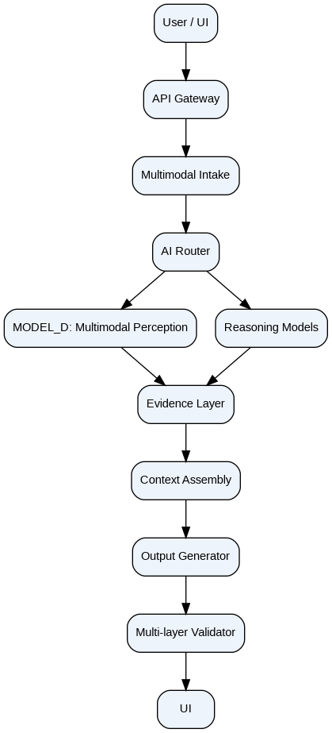
flowchart TB
U["User / UI"] --> G["API Gateway"]
G --> I["Multimodal Intake"]
I --> R["AI Router"]
R --> D["MODEL_D: Multimodal Perception"]
R --> M["Reasoning Models"]
D --> E["Evidence Layer"]
M --> E
E --> C["Context Assembly"]
C --> O["Output Generator"]
O --> V["Multi-layer Validator"]
V --> UI["UI"]

Figure 2: Evidence State Model
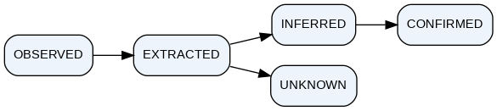
flowchart LR
O["OBSERVED"] --> X["EXTRACTED"]
X --> I["INFERRED"]
I --> C["CONFIRMED"]
X --> U["UNKNOWN"]

