1. **How to execute the source code.**

**1.1 Models for all the coverage option were saved separately in 7 python files, compressed in the ‘final code’ package. Put the files under the spark folder.**

**1.2 Change the path in the python files**

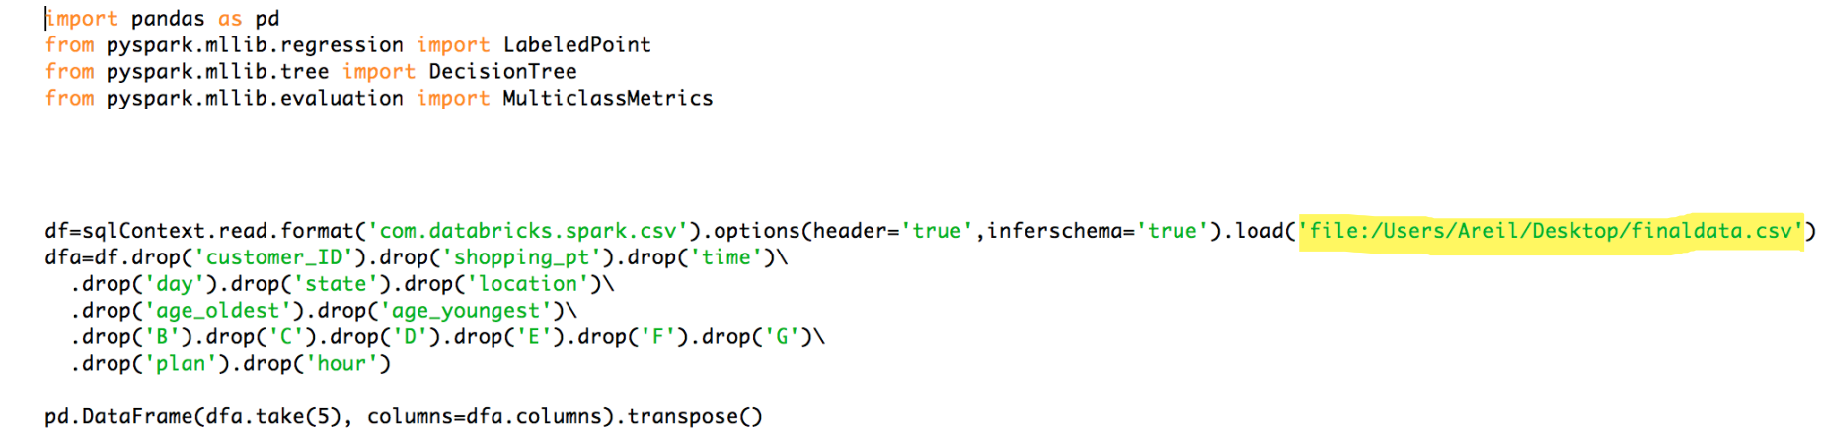

In order to execute the file accurately, it should be changed to correct absolute path for csv file.

**1.3 Use the following spark-submit code to run the python file:**

./bin/spark-submit --packages com.databricks:spark-csv_2.10:1.3.0 --master local[3] [filename](e.g. a.py) [file:/the local path of the file.]

Each file is the decision tree code for A—G option.

**1.4 After execute .py file, the results will appear and pay attention to the accuracy.**

**1.5 Exit**

**2. Frontend**

**Webpage:** [**http://allstate.efj26cyzfh.us-west-2.elasticbeanstalk.com/prediction/customer/**](http://allstate.efj26cyzfh.us-west-2.elasticbeanstalk.com/prediction/customer/)

**2.1 View history transaction:**

By clicking the customer id listed in the transaction list site, users can view the detail information of a customer, and the prediction based on their personal info is listed on the left.

**2.2 Predict purchase option for new customer:**

By clicking the ‘add customer’ button, users are redirected to the information form page. Fill all the input box and click the ‘submit’ button. The new data will then be stored into the backend database. After submitting the form, the system automatically skips to the Transaction List page. Users can view the outcome in the detail page.

**2.3 Search by customer id:**

To avoid the tedious operation of looking for a specific customer through a long transaction list, a simple fuzzy search function is provided by the system. Enter the customer id in the search input box, the system will display the search result.