Telecom Operator — System Requirements Specification | Version 1.0 | [Date]

Document Title | Telecom SRS – QE Test Reference Pack [DEMO]
Project | Telecom Platform Quality Engineering Program
Prepared By | [Author / QE Team]
Review Status | Draft — For Review
Document Version | v1.0
Date | [YYYY-MM-DD]
Scope | SIM Provisioning · Data Plans · IVR Routing · OTP Authentication

1. Purpose & Scope

This document captures high-level functional requirements for a Telecom Operator network platform. It is structured as a test-ready artefact, enabling the QE testing agent to derive Test Scenarios (TS) and Test Cases (TC) from both textual acceptance criteria and embedded process flow diagrams.
Requirements marked with an 🖼 Image Requirement callout contain process diagrams. The testing agent is expected to extract and parse these diagrams to generate path-coverage test scenarios in addition to the textual criteria below each.

REQ-001 | SIM Card Activation & Provisioning

Requirement ID | REQ-001
Feature Area | Network Provisioning / BSS-OSS Integration
Priority | P1 – Critical
Linked Module | SIM Management, MSISDN Registry, SMS Gateway
Owner | Network Engineering / QE

1.1 Description

When a subscriber inserts a new SIM card, the system shall automatically detect the SIM within the network, validate the IMSI against the HLR, and complete full BSS/OSS provisioning within 60 seconds. Upon successful activation, a Welcome SMS shall be dispatched to the registered MSISDN and the SIM status shall transition to ACTIVE.

1.2 Acceptance Criteria

# | Acceptance Criterion | Test Type | Priority
AC-01 | System detects SIM insertion and starts the 60-second provisioning timer. | Functional | Critical
AC-02 | IMSI is validated against the HLR; invalid IMSI returns error code SIM_REJECT_001. | Functional | Critical
AC-03 | MSISDN and service plan are assigned in BSS/OSS within the 60-second window. | Functional | Critical
AC-04 | Welcome SMS is delivered to the subscriber within 30 seconds of SIM activation. | Functional | High
AC-05 | SIM status transitions to ACTIVE only after successful BSS/OSS provisioning. | Functional | Critical
AC-06 | Provisioning failure triggers an OSS alert and logs error with timestamp and IMSI. | Negative | High
AC-07 | End-to-end activation completes in under 60 seconds under normal network load. | Performance | High
AC-08 | Duplicate IMSI registration is rejected and logged. | Negative | Critical

1.3 Process Flow Diagram [Image Requirement]

🖼 Image Requirement: The diagram below defines the SIM Activation flow. The testing agent shall extract each node and decision branch to generate happy-path, alternative-path, and error-path test scenarios covering all YES / NO branches.

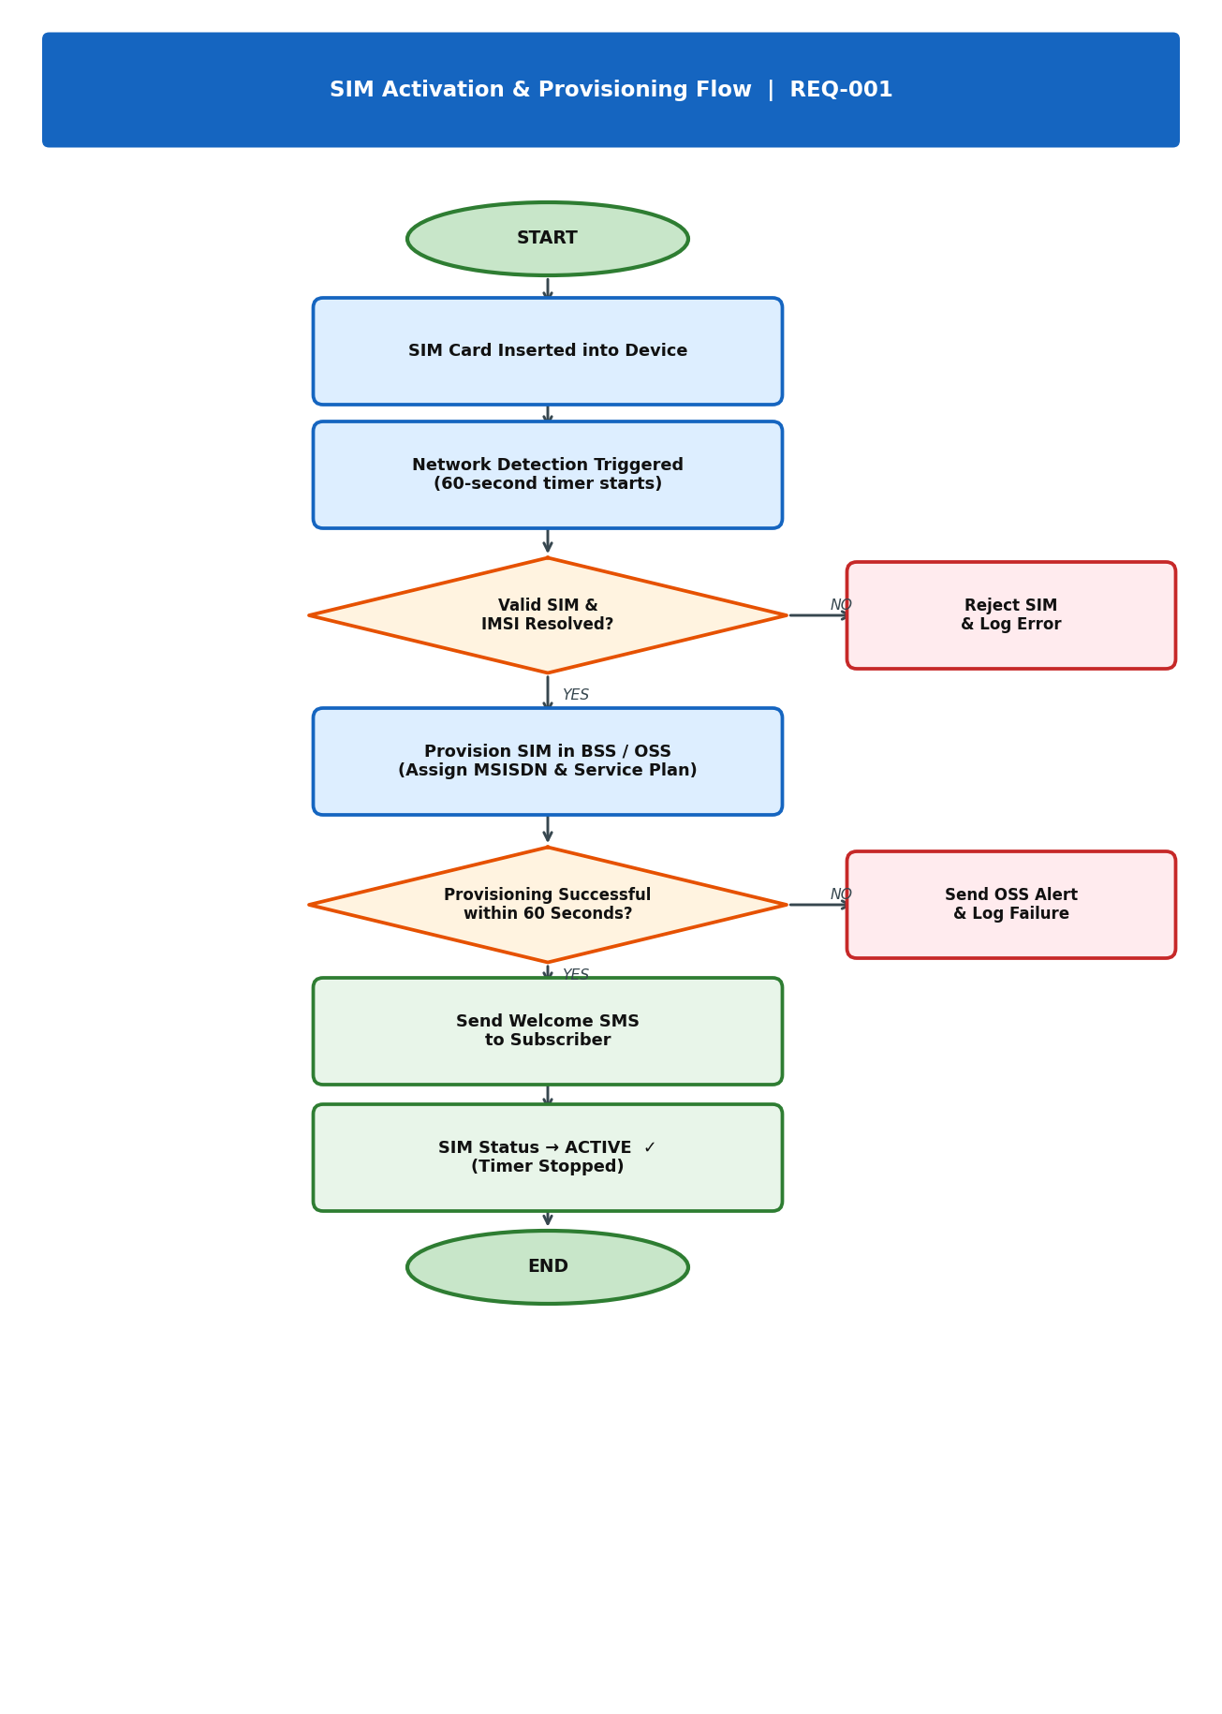
Figure 1 — REQ-001: SIM Activation & Provisioning Flow
📌 Testing Agent Note: Paths to cover: (1) Valid SIM → Provisioned → SMS sent → ACTIVE. (2) Invalid IMSI → Reject & Log. (3) Valid IMSI but provisioning timeout → OSS Alert.

REQ-002 | Prepaid Data Plan Management & Throttling

Requirement ID | REQ-002
Feature Area | Data Policy Enforcement / PCRF
Priority | P1 – Critical
Linked Module | PCRF, Policy Engine, SMS Gateway, Subscriber Profile
Owner | Product Engineering / QE

2.1 Description

The system shall monitor each prepaid subscriber's data consumption in real time via the PCRF. Threshold-based notifications and speed controls must be enforced automatically as defined below. Once the data cap is fully exhausted, the subscriber's data throughput shall be throttled to 128 Kbps (no hard block) until the plan is renewed or a top-up is applied.

2.2 Throttling Threshold Rules

Usage Level | Trigger Condition | Action | Notification
< 80 % | Normal consumption | Full speed (no cap) | None
≥ 80 % | Soft threshold breach | Continue full speed | SMS Alert: "You have used 80% of your data."
100 % | Data cap reached | Throttle to 128 Kbps | SMS Alert: "Data exhausted. Throttled speed active."
Top-Up | Credit applied | Restore full speed | SMS Confirmation: "Your data has been renewed."

2.3 Acceptance Criteria

# | Acceptance Criterion | Test Type | Priority
AC-01 | PCRF updates data usage counter within 5 seconds of each session end. | Functional | Critical
AC-02 | SMS alert is sent within 60 seconds of the 80% threshold being crossed. | Functional | High
AC-03 | Data speed is throttled to ≤ 128 Kbps within 10 seconds of cap exhaustion. | Performance | Critical
AC-04 | Subscriber is not completely blocked; HTTP/DNS traffic remains reachable at 128 Kbps. | Functional | Critical
AC-05 | Top-up or plan renewal restores full speed within 30 seconds of credit application. | Functional | High
AC-06 | Duplicate threshold SMS is not sent if already dispatched in the same session. | Negative | Medium
AC-07 | Usage counter resets to zero at plan renewal date; historic data archived in CDR. | Functional | High

REQ-003 | IVR Self-Service Call Routing

Requirement ID | REQ-003
Feature Area | Customer Experience / Contact Centre
Priority | P2 – High
Linked Module | IVR Engine, CTI Platform, BSS Balance API, Payment Gateway
Owner | CX Engineering / QE

3.1 Description

The IVR system shall present a self-service menu to all inbound callers within 3 seconds of call connection. The menu shall support three primary service paths: Balance Enquiry (Press 1), Bill Payment (Press 2), and Technical Support (Press 3). Callers pressing 0 at any point shall be transferred directly to a live agent queue.
If a caller presses an invalid key or remains silent for 10 seconds, the IVR shall replay the menu. After three consecutive invalid inputs, the call shall be escalated to an agent queue.

3.2 Acceptance Criteria

# | Acceptance Criterion | Test Type | Priority
AC-01 | IVR greeting plays within 3 seconds of call connection. | Performance | Critical
AC-02 | Press 1 routes to Balance Enquiry; balance is read via TTS within 5 seconds. | Functional | Critical
AC-03 | Press 2 routes to Bill Payment; payment confirmation SMS sent after success. | Functional | Critical
AC-04 | Press 3 routes to Technical Support; available agent gets connected within 30 s. | Functional | High
AC-05 | When no agent is available (Press 3), caller is placed in callback queue with ETA. | Functional | High
AC-06 | Press 0 at any menu level immediately transfers the caller to live agent queue. | Functional | Critical
AC-07 | Invalid key or 10-second silence replays the current menu (max 3 retries). | Negative | High
AC-08 | After 3 invalid inputs, the call is escalated to an agent queue automatically. | Negative | Critical
AC-09 | IVR handles concurrent calls without degradation (load: ≥ 500 simultaneous calls). | Performance | High

3.3 IVR Call Flow Diagram [Image Requirement]

🖼 Image Requirement: The diagram below defines the complete IVR menu tree and routing logic. The testing agent shall traverse each branch (Press 1, 2, 3, 0; invalid/timeout; no-agent path) to generate end-to-end call-flow test scenarios and validate all exit conditions.

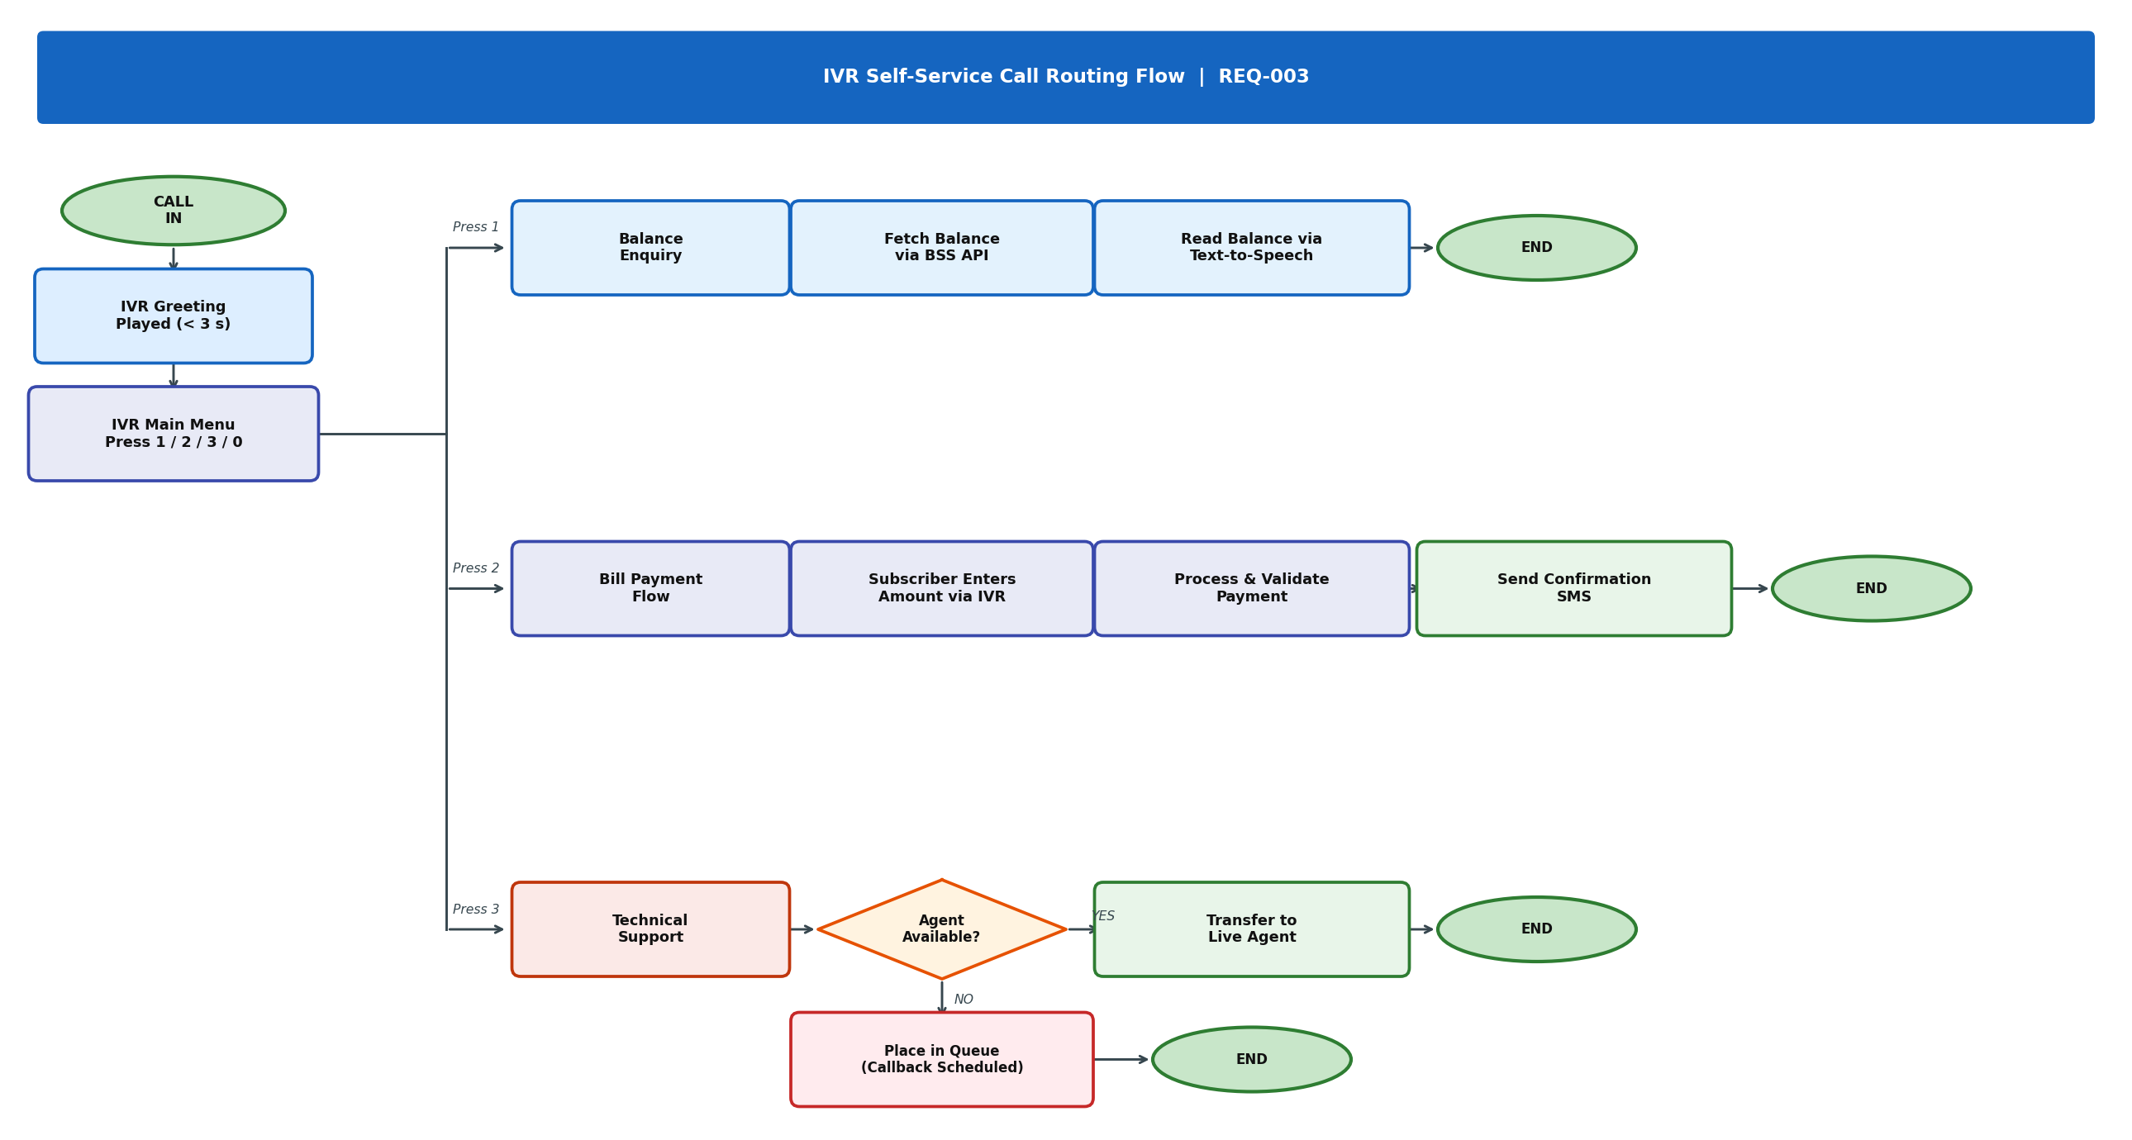
Figure 2 — REQ-003: IVR Self-Service Call Routing Flow
📌 Testing Agent Note: Paths to cover: (1) Press 1 → fetch balance → TTS read → END. (2) Press 2 → enter amount → payment process → SMS confirmation → END. (3) Press 3 + agent available → transfer → END. (4) Press 3 + no agent → queue → END. (5) Press 0 → immediate agent transfer. (6) 3× invalid input → auto-escalate.

REQ-004 | Self-Care Portal – OTP Authentication

Requirement ID | REQ-004
Feature Area | Security / Identity & Access Management
Priority | P1 – Critical
Linked Module | Self-Care Web Portal, SMS OTP Gateway, Auth Service
Owner | Security Engineering / QE

4.1 Description

All subscribers accessing the Self-Care Portal shall be authenticated via a One-Time Password (OTP) delivered to their registered mobile number before any account management function is made available. The OTP mechanism must comply with security requirements for session integrity, expiry enforcement, and brute-force protection.

4.2 OTP Business Rules

Rule | Specification
OTP Format | 6-digit numeric code, cryptographically random
OTP Delivery Channel | SMS to the registered MSISDN only
OTP Expiry | 5 minutes from time of dispatch
Max Retry Attempts | 3 consecutive failures → account locked
Account Lock Duration | 30 minutes; auto-unlocks thereafter
OTP Re-send Cooldown | 60 seconds between consecutive OTP requests
Session Validity | 15 minutes of inactivity triggers session expiry
Audit Logging | All OTP events (request, success, failure, lock) logged with timestamp and IP

4.3 Acceptance Criteria

# | Acceptance Criterion | Test Type | Priority
AC-01 | OTP is a 6-digit numeric code delivered via SMS within 30 seconds of request. | Functional | Critical
AC-02 | OTP expires after exactly 5 minutes; submission post-expiry returns OTP_EXPIRED error. | Functional | Critical
AC-03 | Correct OTP within validity window grants access to the Self-Care Portal. | Functional | Critical
AC-04 | Each OTP is single-use; reuse of a consumed OTP returns OTP_ALREADY_USED error. | Security | Critical
AC-05 | Three consecutive incorrect OTPs lock the account for exactly 30 minutes. | Security | Critical
AC-06 | Re-send OTP request within 60-second cooldown returns COOLDOWN_ACTIVE error. | Negative | High
AC-07 | OTP is not delivered to an unregistered or suspended MSISDN. | Security | High
AC-08 | All OTP events are logged: timestamp, MSISDN (masked), IP, event type, outcome. | Security | Critical
AC-09 | Account auto-unlocks after 30-minute lock window without manual intervention. | Functional | High
AC-10 | Session timeout after 15 minutes of inactivity forces re-authentication via OTP. | Security | High

Quality Engineering Practice · Demo Reference Document | INTERNAL — FOR QE USE ONLY

