Title: | Door control module  SW Architecture

History
Issue status  (Index) | Maturity/Date  (draft/invalid/valid)  (dd-mmm-yyyy) | Author  Department | Check/Release  Department | Description
1.0 | Draft  04-0ct-20 | Miguel Garcia | Miguel Garcia | Creation of the document

Table of Contents
1 Purpose 3
2 Definitions and abbreviations 3
3 Realization constraints and targets 3
4 SW Functional Architecture 3
4.1 Table of functions 3
4.2 Table of functional Interfaces 4
4.3 Functional Interface 4
4.4 Functional Interaction 4
5 SW Physical Architecture 5
5.1 Physical Decomposition 5
5.2 Table of SW components 5
5.3 Table of Physical Interfaces 5
5.4 Physical Interfaces 6
5.5 Physical Interaction 6
5.6 Describe Dynamic Behavior 6
5.6.1 OS tasks 6
5.6.2 Interrupt Handling 6
5.6.3 Power Modes 7
5.7 Synchronization Mechanisms 7
6 Function to Physical Allocation 7
7 SW Requirements Allocation 8
8 SW Integration Plan 8
9 Functional Safety 8

Purpose
Crate the first release of the architecture to the project “Door control module” based on the requirements described and reviewed in the traceability matrix template and the requirements check list.

Definitions and abbreviations
Definitions
Special Byte | Special byte received to change the baud rate 55h

Abbreviations
Only SW Architecture specific abbreviations.
References
N° | Document name | Reference
1  2 | Traceability_matrix_template_v2  Requirement _check _list

Realization constraints and targets

Correct operation of a system which controls, supervises and administrates the door-locking, window position and the associated HW diagnostics of a 4-door vehicle.

A system that has no trouble in resolving operations for 4 doors independently

A system that has clear modularity to reuse parts in each of the 4 door configurations

A system that can respond efficiently to both remote and manual inputs

A system that can operate with a set of dynamic restrictions, for example limiting the window control based on a window lock functionality as well as the physical limitations of the window state.

A system that has always enough information about itself to interact with other car systems.

SW Functional Architecture
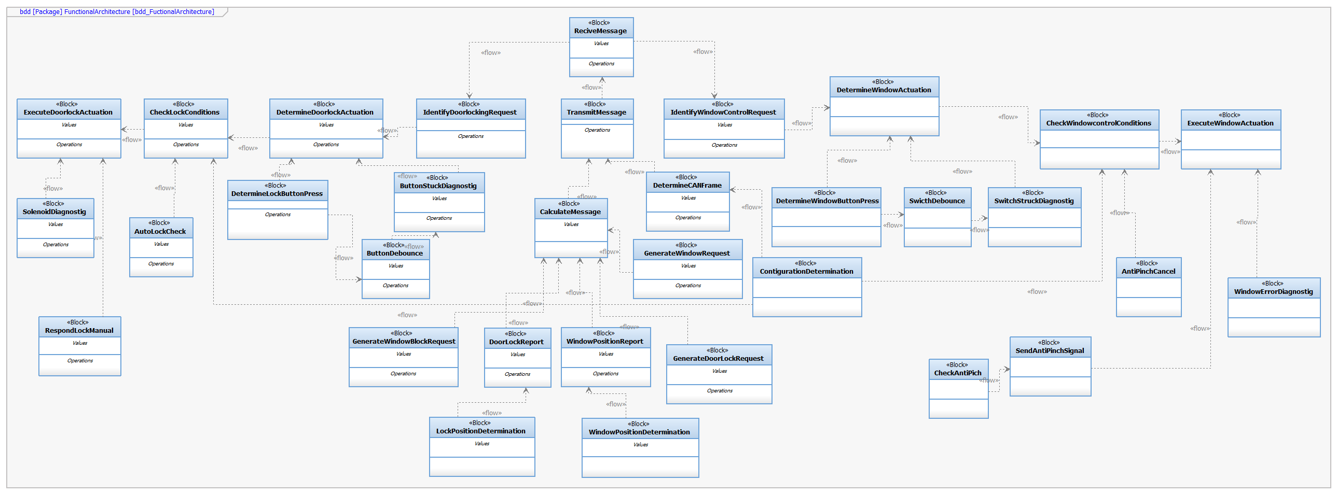

Table of functions
Function Name | Description
DetermineLockButtonPress | Function that checks for lock button presses and identifies the time pressed to execute the correct window actuation or choose the correct element for the request
DetermineWindowButtonPress | Function that checks for window control switch presses and identifies the time pressed to execute the correct window actuation or choose the correct element for the request
CheckLockConditions | Function that receives crucial information and a lock request that determines if a lock actuation should be executed
CheckWindowcontrolConditions | Function that receives crucial information and a lock request that determines if a lock window actuation should be executed
ExecuteWindowActuation | Function that executes the window actuation
DetermineWindowActuation | Function that determines the appropriated window action based on the window state, the time of the button pressed and other conditions
IdentifyWindowControlRequest | Function that identifies if a window control operation has been requested in a message from the driver door
ExecuteDoorlockActuation | Function that executes the door locking actuation
DetermineDoorlockActuation | Function that determines the appropriated window action based on the lock state and other conditions
IdentifyDoorlockingRequest | Function that identifies if a door locking operation has been requested in a message from a front door
RespondLockManual | Function that blocks software lock operations and gives priority to the lock manual mode, works per individual front door
CalculateMessage | Function that formulates massages based on the CAN frame registered in the configuration.
TransmitMessage | Function that Transmits the calculated message thought the CAN network
ReciveMessage | Function that receives the calculated message thought the CAN network
DoorLockReport | Function that identifies and reports the door locking state to send it when the lock button changes positions
ContigurationDetermination | Function that identifies the door based on the original configuration
DetermineCANFrame | Function that identifies the CAN frame for the messages based on the ContigurationDetermination’s results
CheckAntiPich | Fuction that checks for window interference during window control open actuations
SendAntiPinchSignal | Function that generates and sends a emergency cancel window actuation request, followed by a global open actuation
AntiPinchCancel | Function that sends a signal to CheckWindowcontrolConditions to block all operations for 15 seconds
WindowPositionDetermination | Function that determines the window position based on past locations and actuations
WindowPositionReport | Function that reports the window position to construct the message
ButtonDebounce | Function that checks for the button debounce conditions and acts upon it
SwicthDebounce | Function that checks for the switch debounce conditions and acts upon it
WindowErrorDiagnostig | Function that stops window control actuations for a power cycle when detecting a window error state.
ButtonStuckDiagnostig | Function that inhibits the button functionality for a power cycle when a button stuck state is reported
SwitchStuckDiagnostig | Function that inhibits the switch functionality for a power cycle when a button stuck state is reported
SolenoidDiagnostig | Function that inhibits the door locking functionality for a power cycle when a door look state is reported
AutoLockCheck | Function that checks externally for auto lock conditions and sends a signal to generate a lock request per unlock door
GenerateWindowRequest | Function that detects and generates a remote window control request and reports the details to construct the CAN message
GenerateDoorLockRequest | Function that detects and generates a remote door lock request and reports the details to construct the CAN message
GenerateWindowBlockRequest | Function that detects and generates a remote window block request and reports the details to construct the CAN message

Table of functional Interfaces
 | Description
iMessage | Format that describes a CAN message following a special framework sent through the network
iActionReports | Information associated with the building of the message, reported in strings with 2 possible contents
iHardwareSignal | Digitalized hardware signal from peripherals
iDigitalSignal | Digital signal indicating special events
iRequestsIdentify | Information associated with a special message that can only be sent through the front doors CAN frames.
iPosReports | Information associated with building a message that describes a position or a state
iKeyInfo | Information associated with the exchange of data related to the validation of conditions

Functional Interface
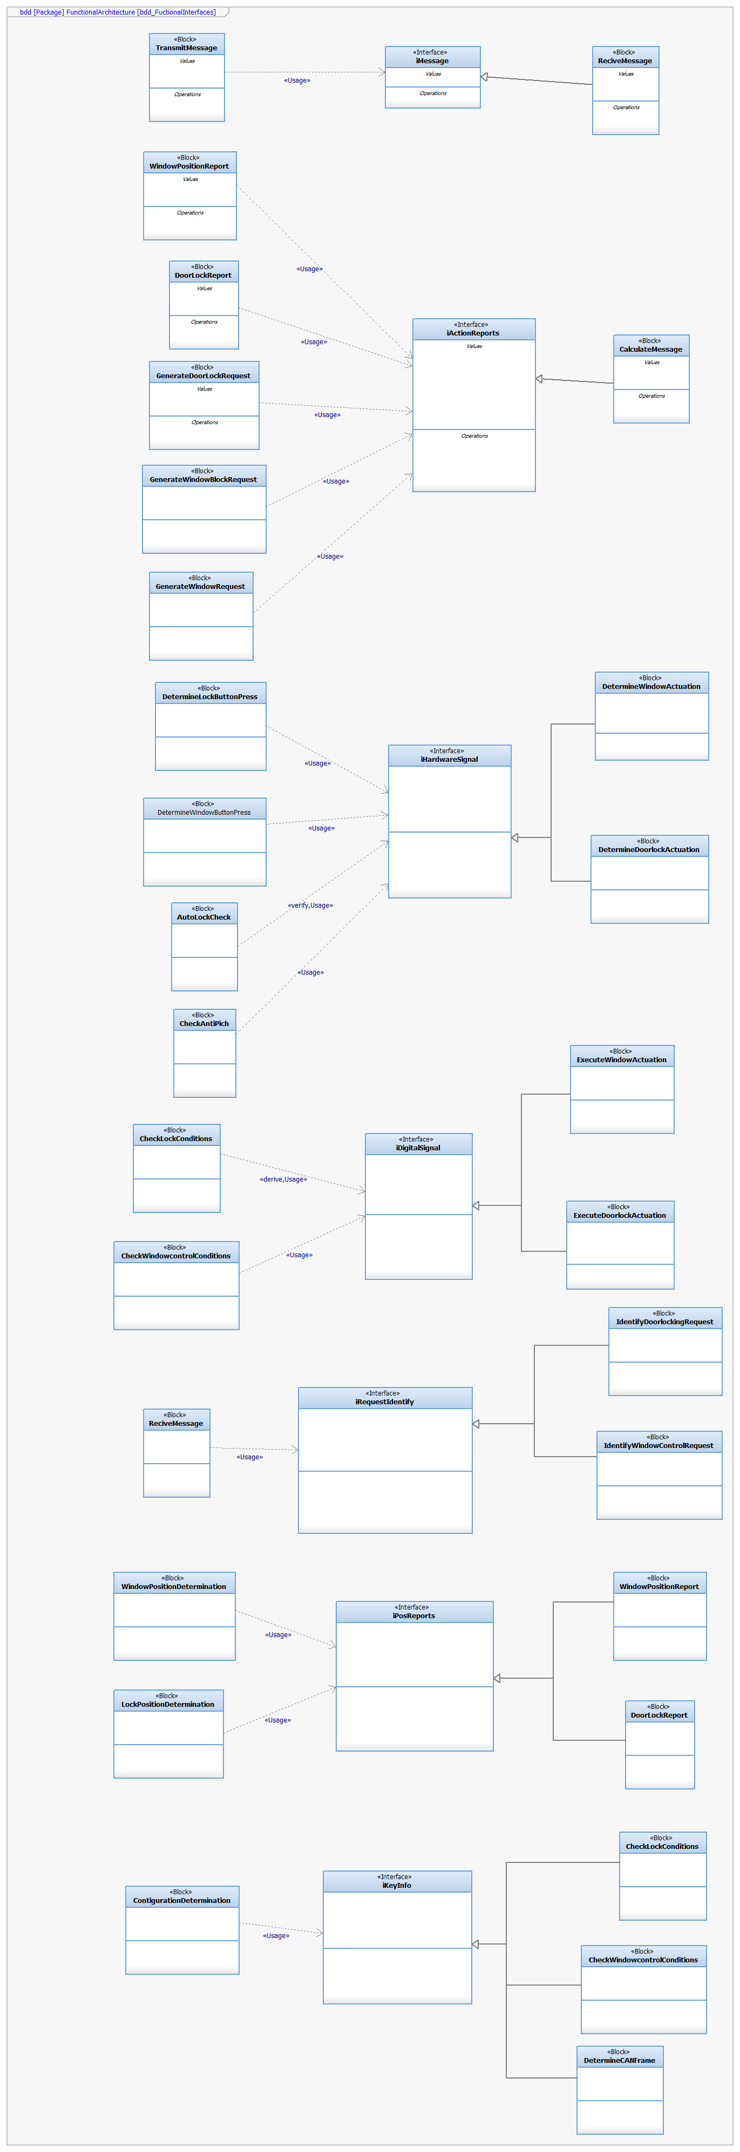
Interface still lacks detail and should be reviewed before publishing

Functional Interaction
A door lock functional interaction:
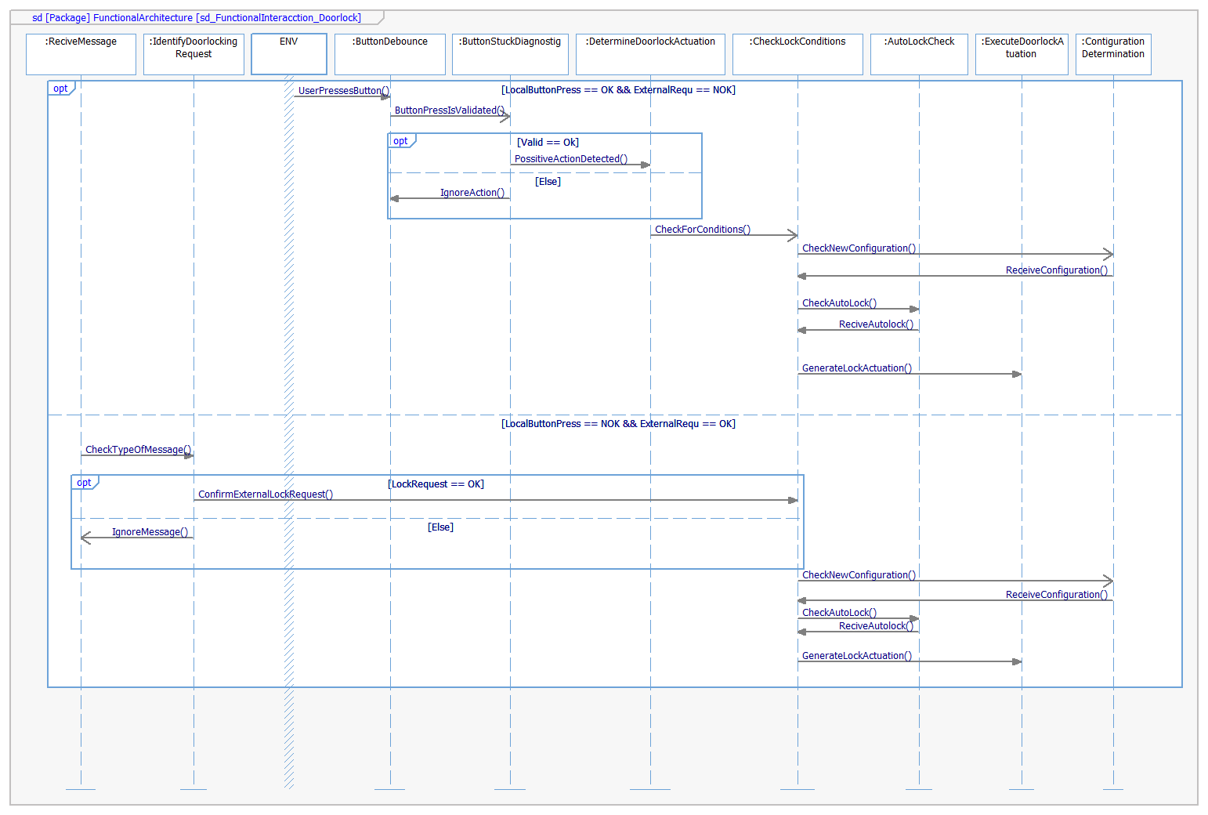
A window control functional interaction:
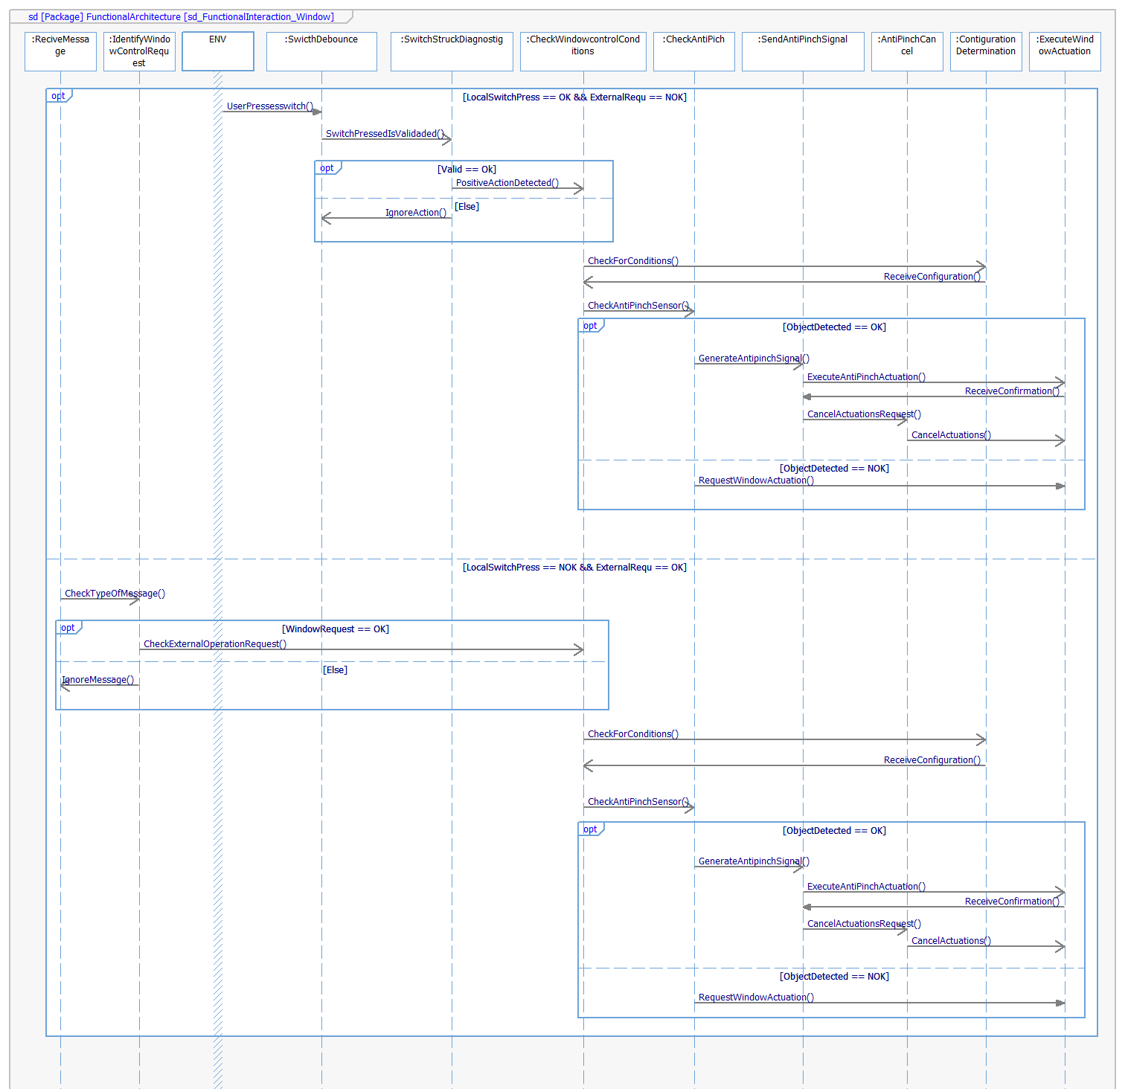

SW Physical Architecture
Define Physical architecture that will be implemented on Software with its corresponding SW decomposition.
Identify different SW Components with its corresponding interaction among them.
Identify and describe the signals and events used to share information among SW Components.

Physical Decomposition
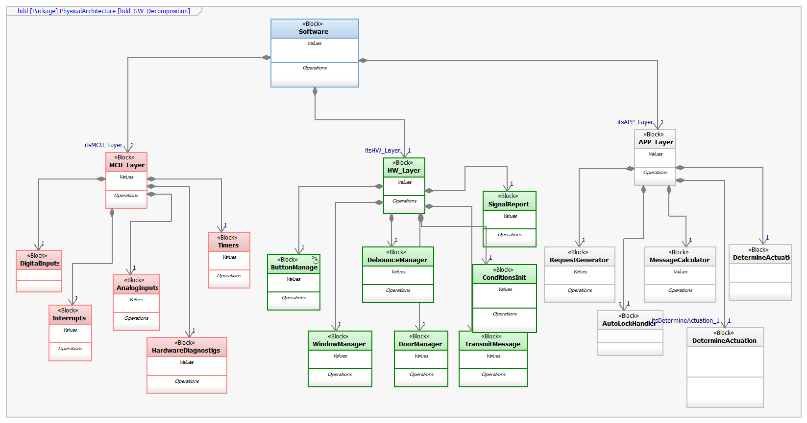.

Table of SW components
SWC Name | Description | Estimated Size (KB)
DebouceManager | Administrates switch and button debounce protocols | 1
AnalogInputs | Reads analog inputs | 1
DigitalInputs | Reads digital inputs | 1
Timers | Administrates the controller’s timers for synchronic applications | 2
SignalReport | Reports and identifies the states of relevant actions | 3
HardwareDiagnostigs | Handles important hardware diagnostics of the system | 2
ConditionsInit | Initialize conditions and configuration | 3
RequestGenerator | Generates the signal requests | 4
AutoLockHandler | Checks for the auto lock conditions actively and generates auto lock signals | 5
MessageCalculator | Calculates messages for the transmission through the CAN network | 2
TransmitMessage | Sends formatted messages through the CAN network | 3
DetermineActuation | Determines the correct window actuation based on a remote request or a button pressed | 2
AntiPinchSystem | Checks for the anti-pinch conditions actively and generates anti pinch signals | 3
ButtonManager | Manages button and switches states and functionalities | 4
WindowManager | Manages window actuations | 3
DoorManager | Manages Door locking actuations | 1
DetectRequest | Detects messages with request traits | 1
ConditionsHandler | Manages the dynamics of the conditions | 2
Interrupts | Manages interrupts | 3

Table of Physical Interfaces
Operation | Description
iAnalogSignal | Interface designed to exchange digitalized analog signals
iDigitalSignal | Interface designed to exchange info about a request post CAN detection
iMessage | Interface designed to exchange information following the corresponding CAN Frame
iSignalReports | Interface designed to report request
iPositionReport | Interface designed to report information about window and door states calculations
iActuations | Interface designed to exchange information about solicited window or door actuations
iKeyInfo | Interface designed to exchange information about conditions and conditions changes

Physical Interfaces
Fiscal interface diagram is not yet ready to be documented, isn’t mature enough

Physical Interaction
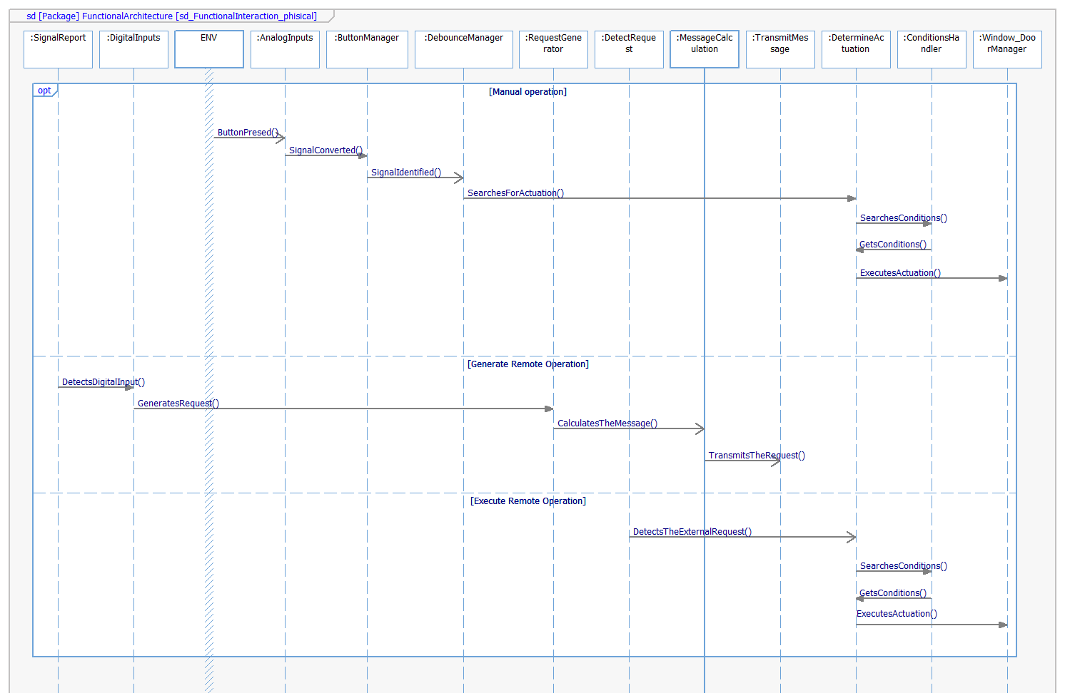
More details should be added in the future

Describe Dynamic Behavior
This chapter shall be used to describe at physical level the runtime behavior of the SW.

OS tasks
OS task | Description | Periodicity | Period | Priority | CPU Load
Check for CAN Messages | Continuously check for operation request solicited by other doors | 25 ms | 1 | 1 | 2%
Administrate Button debounce | Executes button/switch debounce during button/switch presses | 100 ms | 1 | 2 | 3%
Identify CAN Requests | Continuously evaluate every message when detected to search for remote requests | 50 ms | 1 | 3 | 2%
Control window Actuations | Execute the all the actions related to the determined window actuation | 50 ms | 1 | 2 | 4%
Control door actuations | Execute the all the actions related to the determined door actuation | 50 ms | 1 | 1 | 4%
Check operation conditions | Continuously checks for actualizations for the operating conditions | 100 ms | 1 | 1 | 2%
Read sensors | Reads external sensors | 25 ms | 1 | 1 | 1%
Auto lock Check | Reads the auto lock conditions on a moving car | 100 ms | 1 | 2 | 1%
Anti-pinch check | Reads the window sensor and the anti-pinch conditions during window actuations | 15 ms | 1 | 3 | 5%
Read states | Calculates states based on sensor reads | 25 ms | 1 | 2 | 3%
Listen to CAN Messages | Periodically listens for CAN message updates | 50 ms | 1 | 2 | 3%

Interrupt Handling
ISR task | Description | Priority | CPU Load
Button Press | Button interrupt to brake idle state and respond to the manual actuation request | 1 | 2%
Anti-pinch total interrupt | Request to immediately cancel all window actuations and start the anti-pinch procedure | 2 | 1%
Auto lock actuation priority | Request to immediately cancel the lock idle state and start the Auto lock procedure | 2 | 1%
Request received | Interrupt to immediately respond to remote door lock instructions or window operations request | 2 | 2%

Power Modes

Low Power Mode
The system does not operate in low power mode.

High Power Mode
All the system’s functions are declared in a high-power mode state.

Synchronization Mechanisms
To synchronize the system, we used an atom code approach

Function to Physical Allocation
Perform the allocation of function to a SW component. One function shall be allocated to one SW component (if this cannot be achieved indicate a clarification wich part of the function shall be allocated to every SW component). One SW component might have
Function | SW component | Clarification
DetermineLockButtonPress | ButtonManager | It should operate with both button presses
DetermineWindowButtonPress | ButtonManager | It should operate with both button presses
CheckLockConditions | ConditionsHandler
CheckWindowcontrolConditions | ConditionsHandler
ExecuteWindowActuation | WindowManager
DetermineWindowActuation | DetermineActuation
IdentifyWindowControlRequest | DetectRequest | The receive and identify request have been unified
ExecuteDoorlockActuation | DoorManager
DetermineDoorlockActuation | DetermineActuation
IdentifyDoorlockingRequest | DetectRequest | The receive and identify request have been unified
RespondLockManual | DoorManager
CalculateMessage | MessageCalculator
TransmitMessage | TransmitMessage
ReciveMessage | DetectRequest | The receive and identify request have been unified
DoorLockReport | SignalReport
ContigurationDetermination | ConditionsInit
DetermineCANFrame | ConditionsHandler
CheckAntiPich | AntiPinchSystem
SendAntiPinchSignal | AntiPinchSystem
AntiPinchCancel | AntiPinchSystem
WindowPositionDetermination | SignalReport
WindowPositionReport | SignalReport
ButtonDebounce | DebouceManager
SwicthDebounce | DebouceManager
WindowErrorDiagnostig | HardwareDiagnostigs
ButtonStuckDiagnostig | HardwareDiagnostigs
SwitchStuckDiagnostig | HardwareDiagnostigs
SolenoidDiagnostig | HardwareDiagnostigs
AutoLockCheck | AutoLockHandler
GenerateWindowRequest | RequestGenerator
GenerateDoorLockRequest | RequestGenerator
GenerateWindowBlockRequest | RequestGenerator

Low level components like interrupts, digital, analog and timers where not conciderd on the functionality sector, however they will be implemented

SW Requirements Allocation
Elements located in the traceability matrix template

SW Integration Plan
Identify the dependencies for SW construction. Identify hierarchy for implementation. Indicate the integration steps for SW construction.

Integration Step | Description | SW components | Comments
1.-Sensors and signals | Integrate all related to the detection of signals | AnalogInputs, DigitalInputs, Timers, SignalReport,
2.-Button interactions | Complement all related to the button interaction and debounce | HardwareDiagnostigs, ButtonManager, Interrupts, DebounceMannager
3.-Actuation identifications | Integrate steps related to the request identification and validation | DetermineActuation, ConditionsInit, DetectRequest, ConditionsHandler
4.-Actuation executions | Integrate all function related to the execution of actuations | AutoLockHandler, AntiPinchSystem, WindowManager, DoorManager
5.-Request generation | Add the components related to the request generation | RequestGenerator, MessageCalculator, TransmitMessage

Functional Safety
This chapter will be fill during Module 5

