**安装必要构建工具**

$ sudo apt install build-essential autoconf automake autotools-dev pkg-config bc curl gawk git bison flex texinfo gperf libtool patchutils mingw-w64 libmpc-dev libmpfr-dev libgmp-dev libexpat-dev libfdt-dev zlib1g-dev libglib2.0-dev libpixman-1-dev libncurses5-dev libncursesw5-dev meson libvirglrenderer-dev libsdl2-dev -y

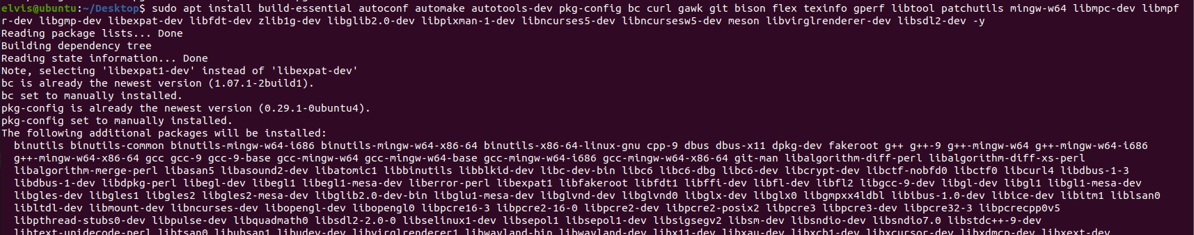

$ sudo add-apt-repository ppa:deadsnakes/ppa

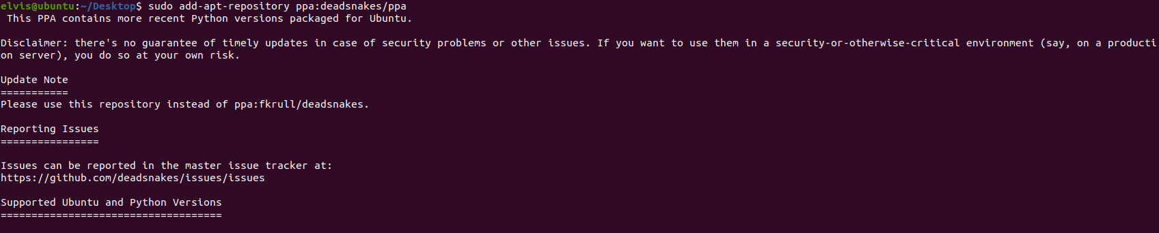

$ sudo apt update

$ sudo apt install python3.9 python3-pip -y --fix-missing

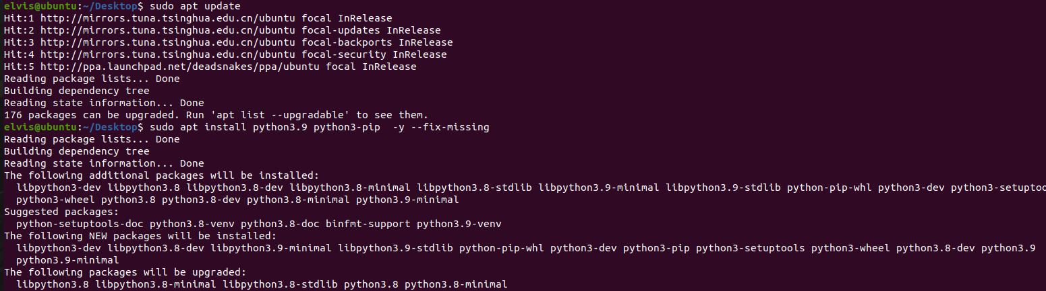

$ pip3 install meson



**下载编译支持视频输出的 qemu**

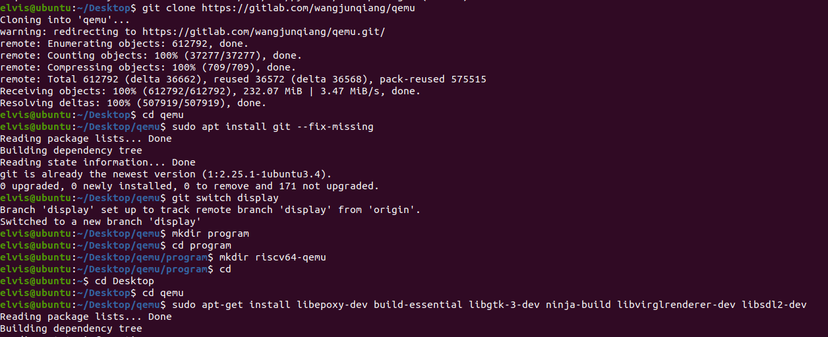

**配置riscv64-qemu**

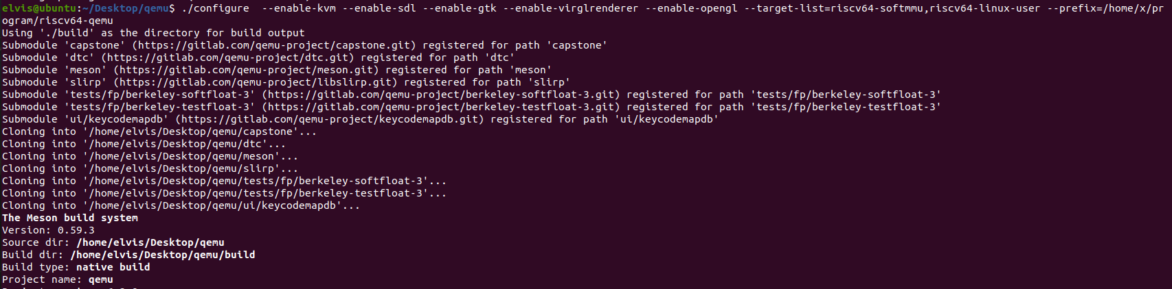

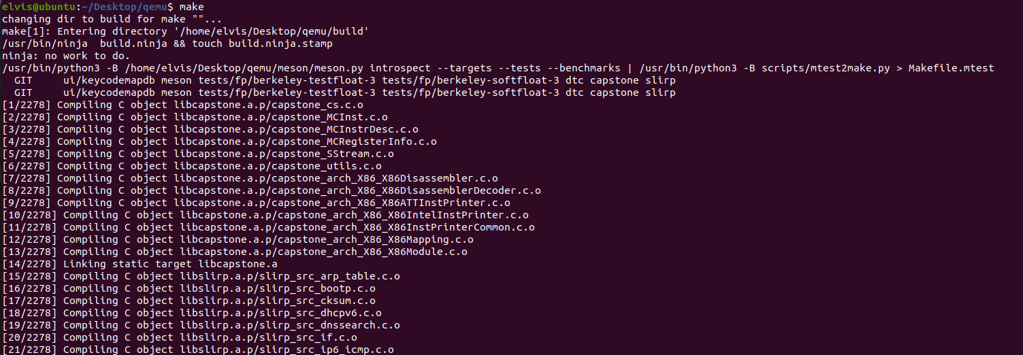

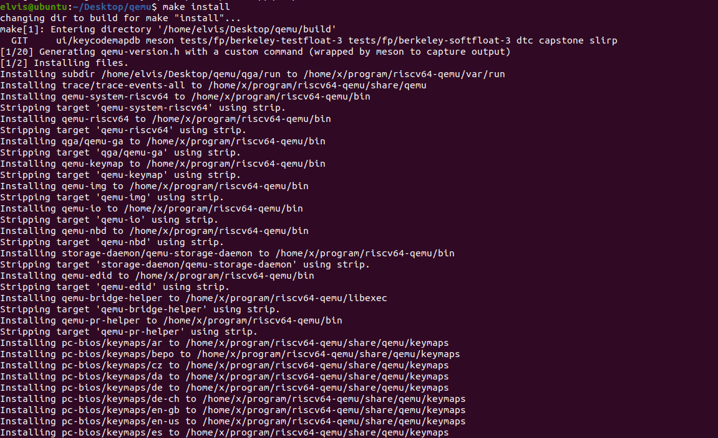

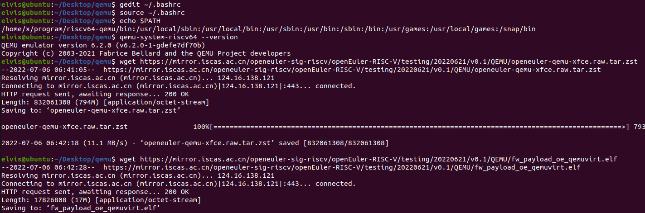

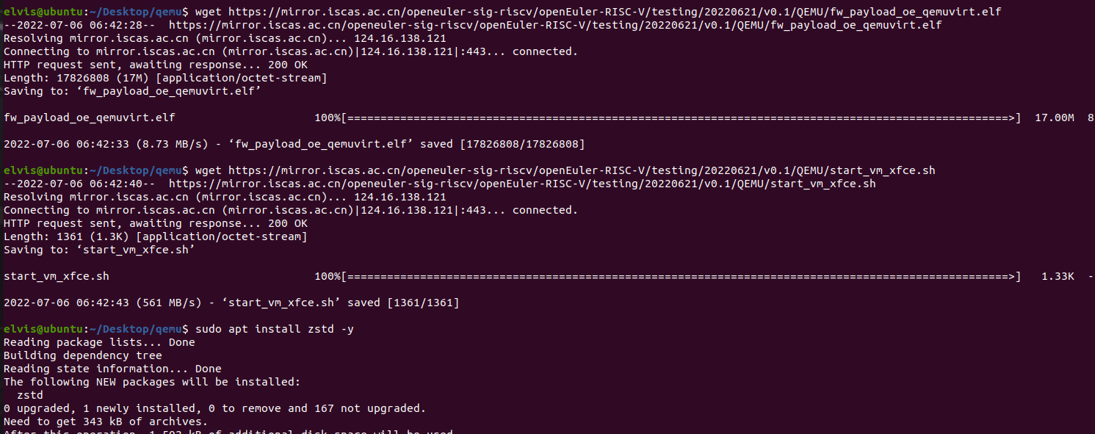

**启动Xfce**

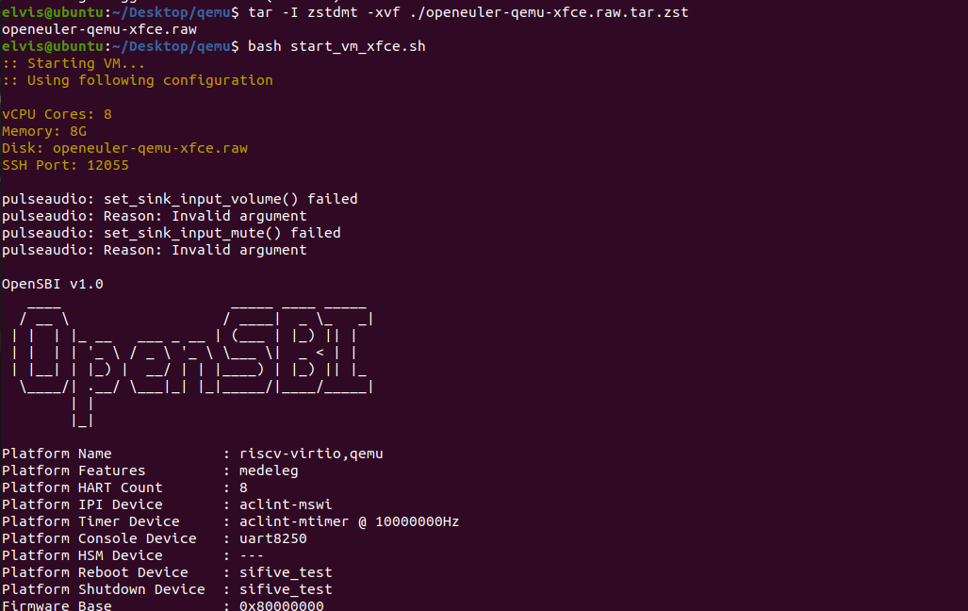

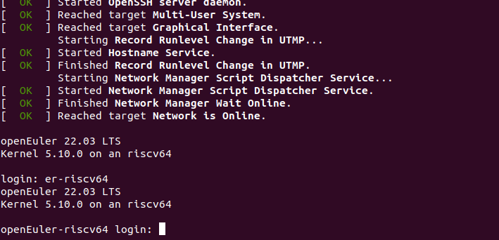

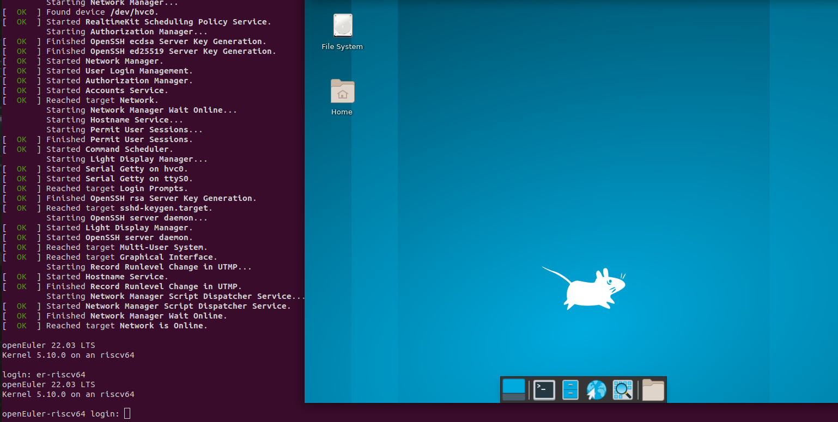

**注意事项：**

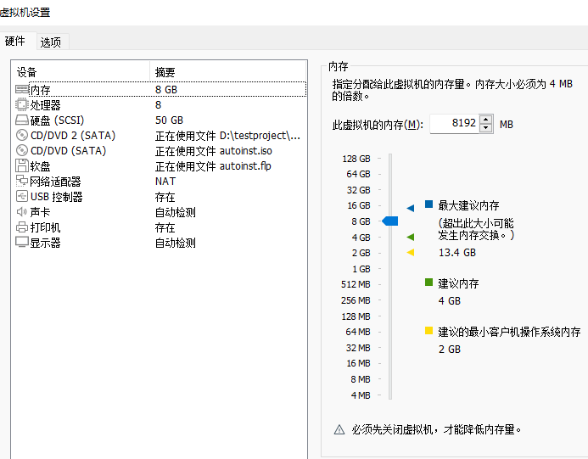

**亲测如上图配置可以解压成功openeuler-qemu-xfce.raw.tar.zst.**

**硬盘容量必须设置较大否则解压不成功，Xfce启动失败。**