**在 qemu 上的 openeuler risc-v 中启动并测试 xfce**

以 Ubuntu 为例，查看软件源上是否有qemu-rv64的二进制安装包

sudo apt update

sudo apt-cache search all | grep qemu

安装必要的构建工具

sudo apt install build-essential

下载编译支持视频输出的 qemu

git clone <https://gitlab.com/wangjunqiang/qemu>

cd qemu

git switch display

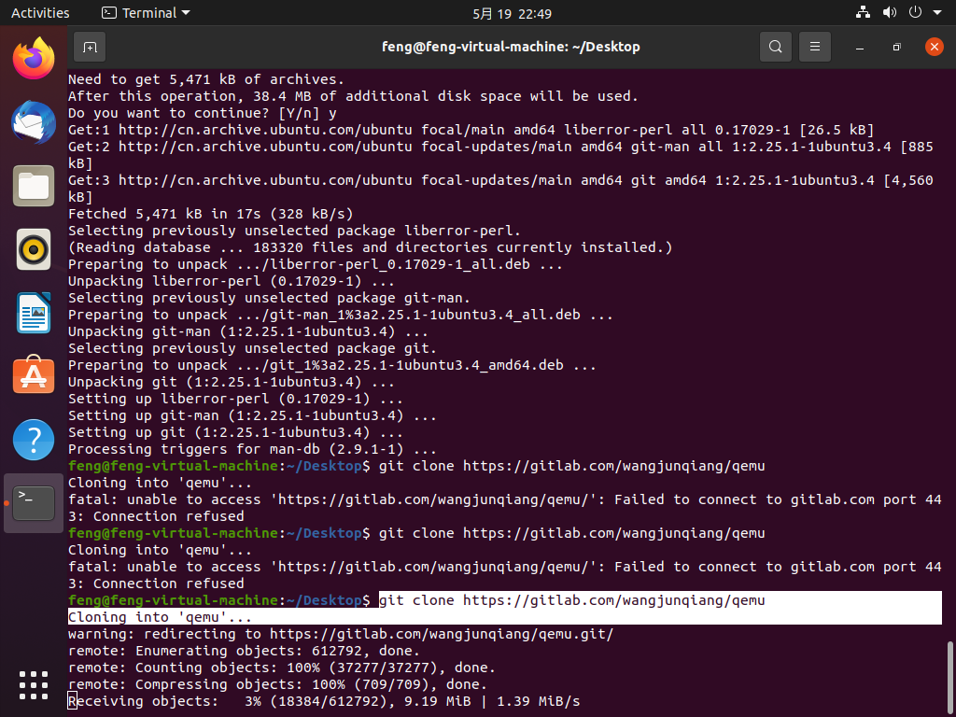

**创建文件夹/home/feng/program/**riscv64-qemu

**编译：中间需要安装多个依赖包**

ERROR: Cannot find Ninja解决方法

$ apt-get install ninja-build

ERROR: glib-2.56 gthread-2.0 is required to compile QEMU解决办法

$ sudo apt install libglib2.0-dev -y

$ sudo apt install libepoxy-dev

ERROR: Dependency "gtk+-3.0" not found, tried pkgconfig解决办法

$ sudo apt-get install libgtk-3-dev

sudo apt install build-essential autoconf automake autotools-dev pkg-config bc curl gawk git bison flex texinfo gperf libtool patchutils mingw-w64 libmpc-dev libmpfr-dev libgmp-dev libexpat-dev libfdt-dev zlib1g-dev libglib2.0-dev libpixman-1-dev libncurses5-dev libncursesw5-dev meson libvirglrenderer-dev libsdl2-dev -y

**编译**

./configure --target-list=riscv64-softmmu --prefix=/home/feng/program/riscv64-qemu --enable-kvm --enable-sdl --enable-gtk --enable-virglrenderer --enable-opengl

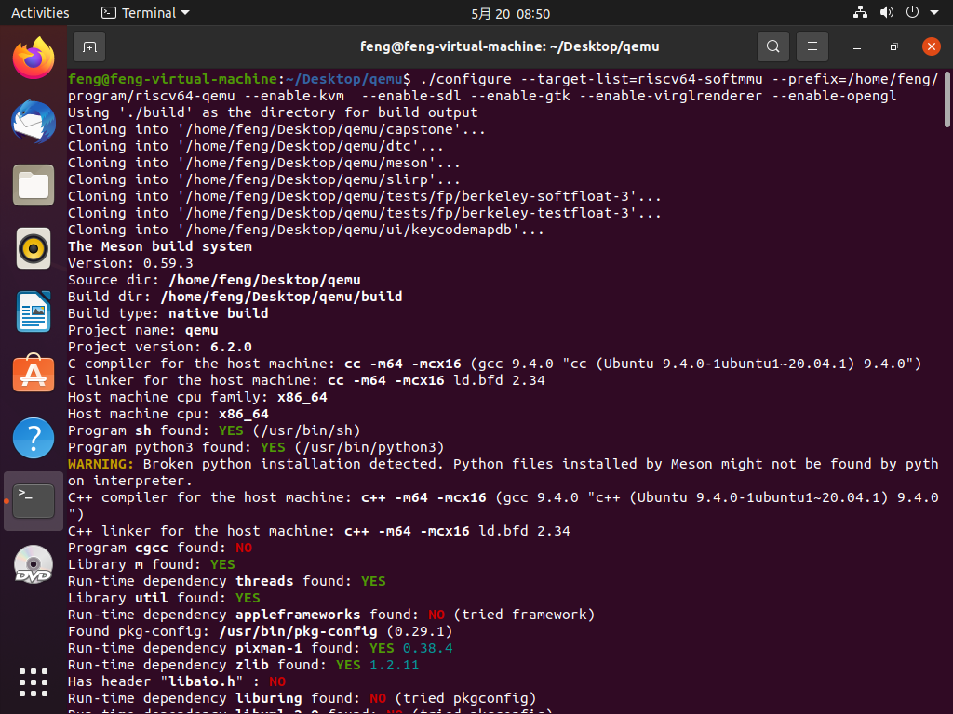

安装

make

**make install**

配置环境变量

$ vim ~/.bashrc

$ export QEMU_HOME=/home/feng/program/riscv64-qemu

$ export PATH=$QEMU_HOME/bin:$PATH

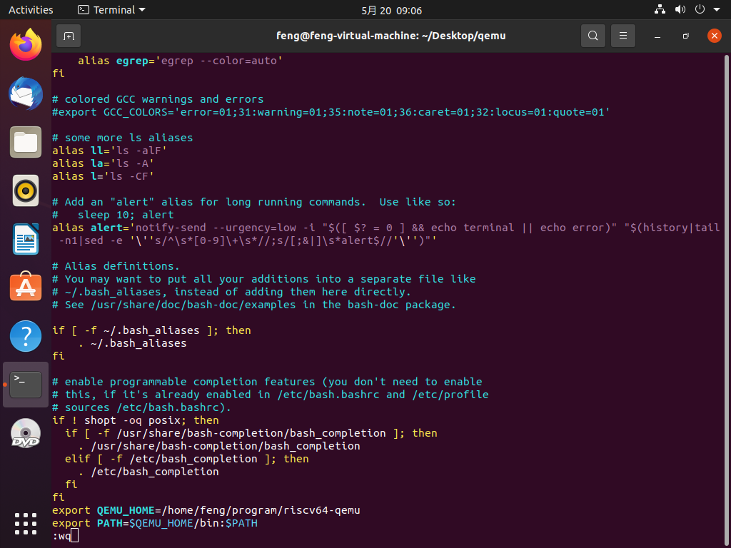

检查是否添加成功

$ source ~/.bashrc

$ echo $PATH

验证安装是否正确

qemu-system-riscv64 --version

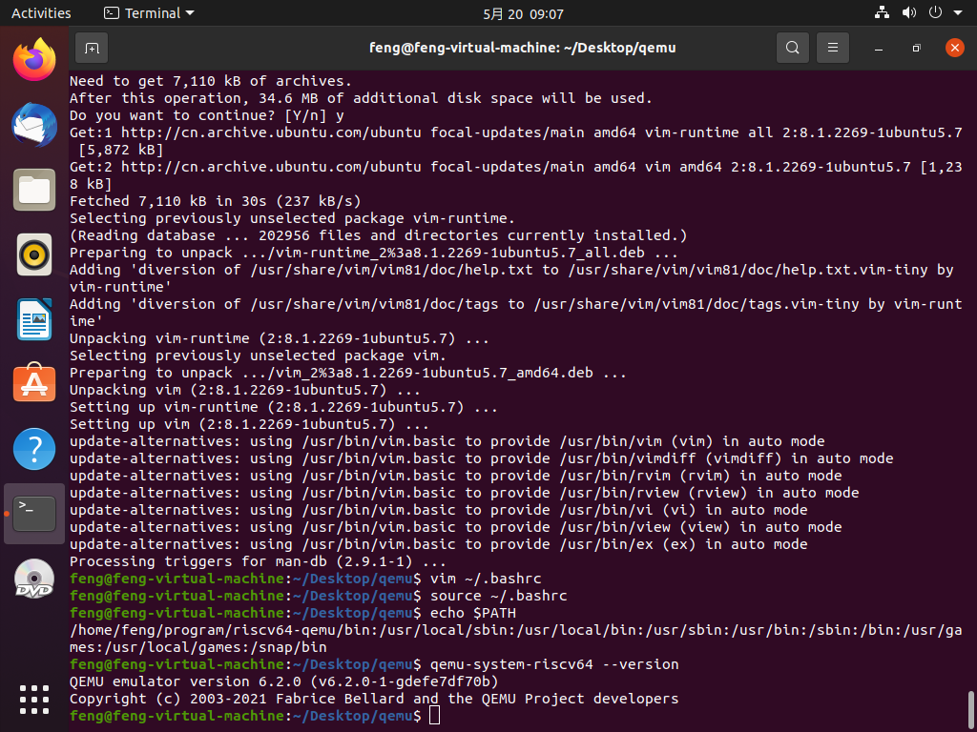

下载 openeuler risc-v 文件系统(与riscv-openeuler/chapter3/class1放进同一文件夹中)

wget https://mirror.iscas.ac.cn/openeuler-sig-riscv/openEuler-RISC-V/development/deprecated/2203/Image/openEuler-22.03.riscv64.qcow2  
git clone <https://gitee.com/yunxiangluo/riscv-openeuler.git>

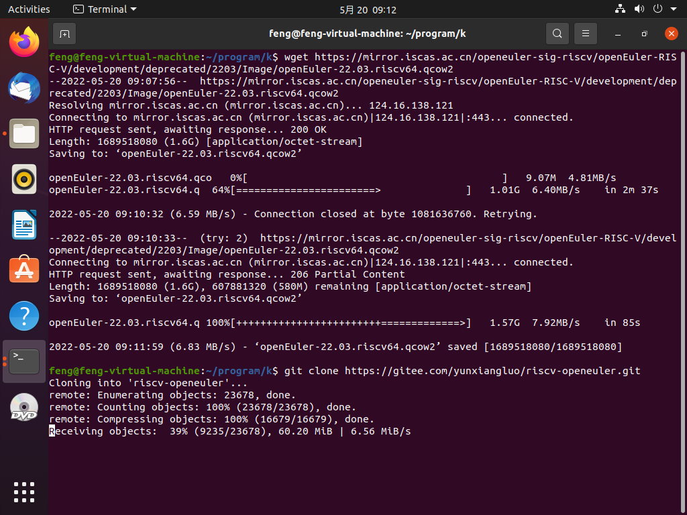

在刚进入的文件夹打开命令窗口

qemu-system-riscv64 \  
 -nographic -machine virt \  
 -smp 4 -m 4G \  
 -display sdl -vga std \  
 -kernel Image \  
 -append "loglevel=3 swiotlb=1 console=ttyS0 rw root=/dev/vda1" \  
 -drive file=openEuler-22.03.riscv64.qcow2,format=qcow2,id=hd0 \  
 -object rng-random,filename=/dev/urandom,id=rng0 \  
 -device virtio-rng-device,rng=rng0 \  
 -device virtio-blk-device,drive=hd0 \  
 -device virtio-net-device,netdev=usernet \  
 -netdev user,id=usernet,hostfwd=tcp::12055-:22 \  
 -device qemu-xhci -device usb-tablet -device usb-kbd

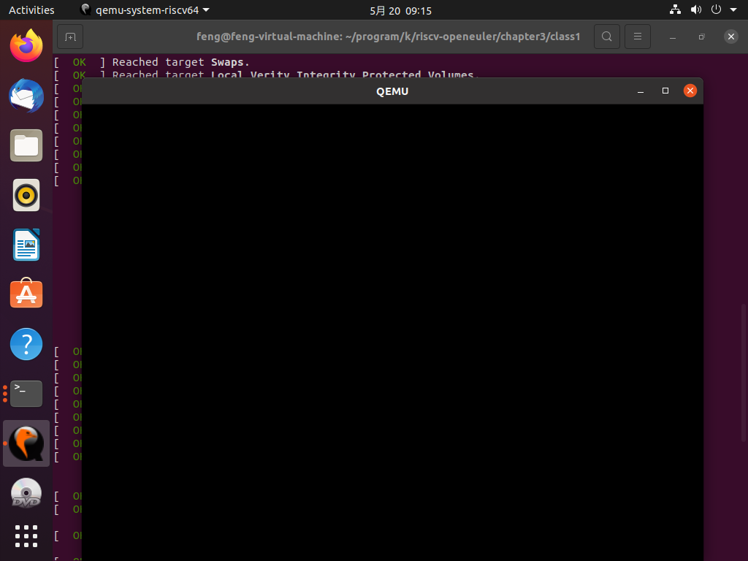

安装Xfce

openeuler risc-v 启动以后，增加以下 repo：

vim /etc/yum.repos.d/openEuler.repo

删除原有内容，复制以下内容

[22.03]   
name=22.03   
baseurl=http://obs-backend.tarsier-infra.com:82/openEuler:/22.03/openEuler_2203/   
enabled=1   
gpgcheck=0   
   
[22.03Epol]   
name=22.03Epol   
baseurl=http://obs-backend.tarsier-infra.com:82/openEuler:/22.03:/Epol/openEuler_22.03_Epol/   
enabled=1   
gpgcheck=0

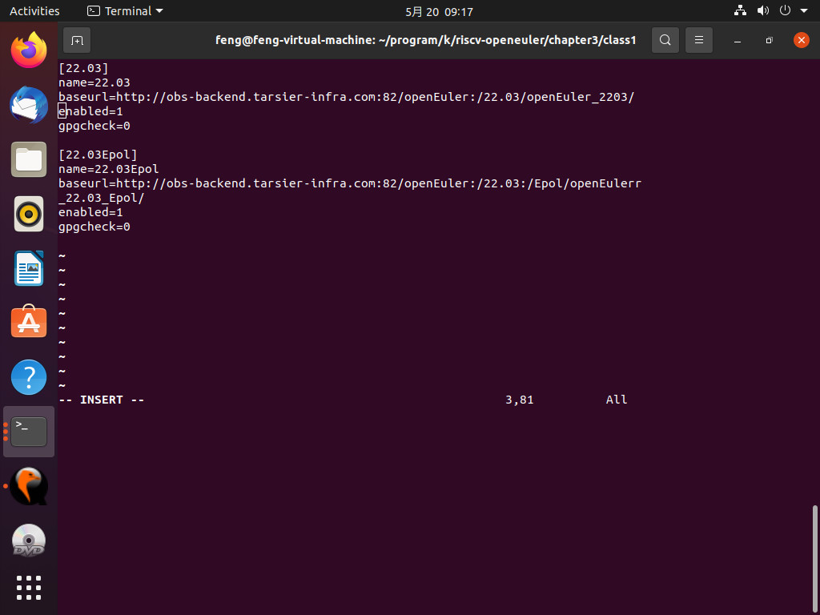

yum install libxfce4util xfconf libxfce4ui exo garcon thunar thunar-volman tumbler xfce4-appfinder xfce4-panel xfce4-power-manager xfce4-settings xfdesktop xfwm4 xfce4-session xfce4-terminal –y

yum install xorg-x11-xinit xorg-x11-server -y   
dnf upgrade pango   
yum update glib2

启动Xfce4桌面

startxfce4

