Best Place for

an Asian Restaurant

in Lasing Capital Area

**11/7/2018**

**Applied Data Science Capstone**

# **Introduction**

My client is going to open an Asian restaurant in Lansing Capital Area, which includes Lansing, East Lansing, Okemos, Haslett, Mason, and Holt. He want to know in which place to open the Asian restaurant will be more profitable and more competitive.

In developing the recommendation, we need to make clearly that the following factors should be taken into consider:

* Population distribution in Lansing Capital Area
* Restaurants distribution in Lansing Capital Area
* Popularity of the restaurant in Lansing Capital Area

# **Data**

From <https://simplemaps.com/data/us-zips>, we get all zip code for Lansing Capital Area. And from website [https://www.zipdatamaps.com/{zipcode}](https://www.zipdatamaps.com/%7Bzipcode%7D), we can get population information for each zip code region.

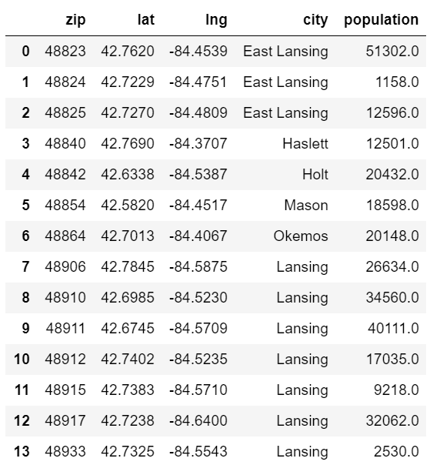

# **Methodology**

With the zip code for Lansing Capital Area, we can use Foursquare to locate venues. Extracting the venues of restaurant can provide us the distribution of restaurants. Combine with population distribution, we can know the expectation guests for each restaurants. Analysis the popularity type of restaurant in each region. Using k-means method to cluster those venues, then we can figure out where is the best place to open an Asian Restaurant in Lasing Capital Area.

# **Results**

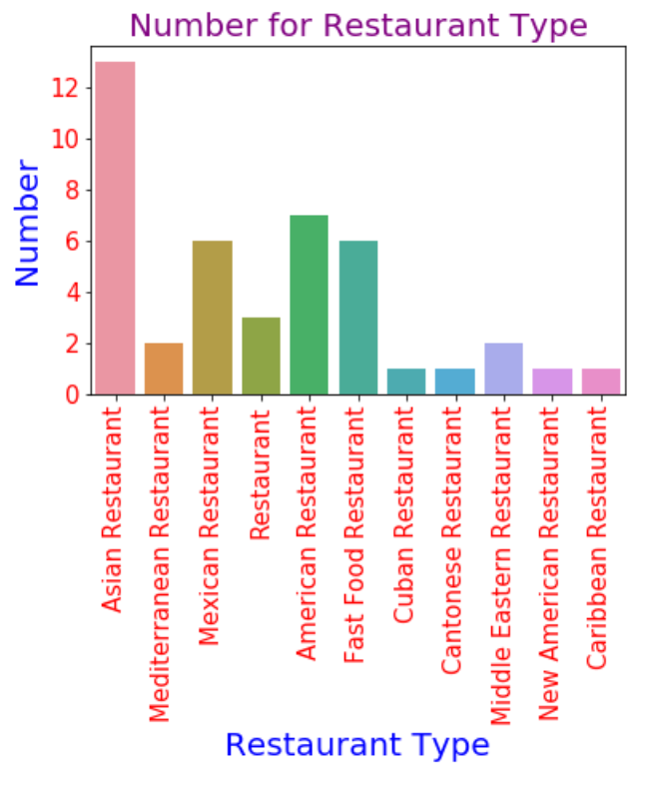

The largest number is Asian Restaurant.

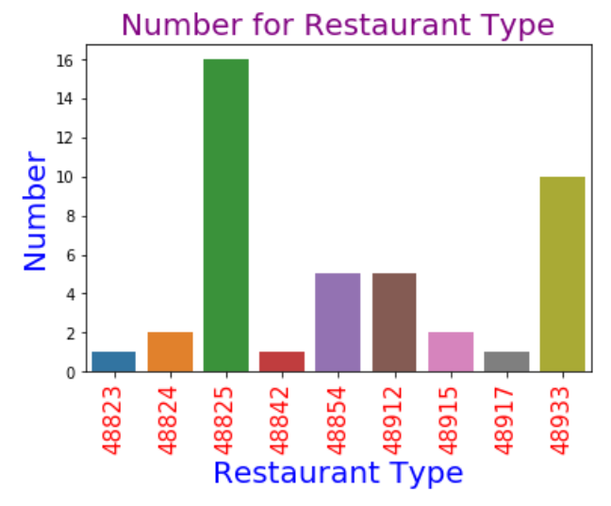

The 48825 region has the most restaurant number.

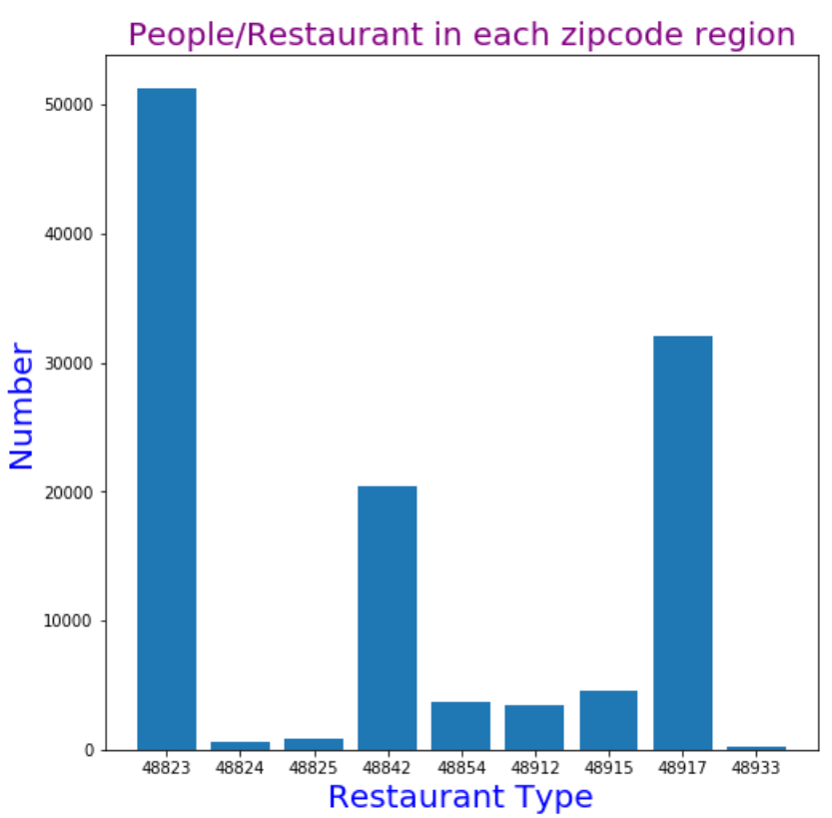

Consider the population in each region, the expected guest for each restaurant has the maximum value in 48823 region.

Using k-mean method to cluster these region by restaurant’s popularity.

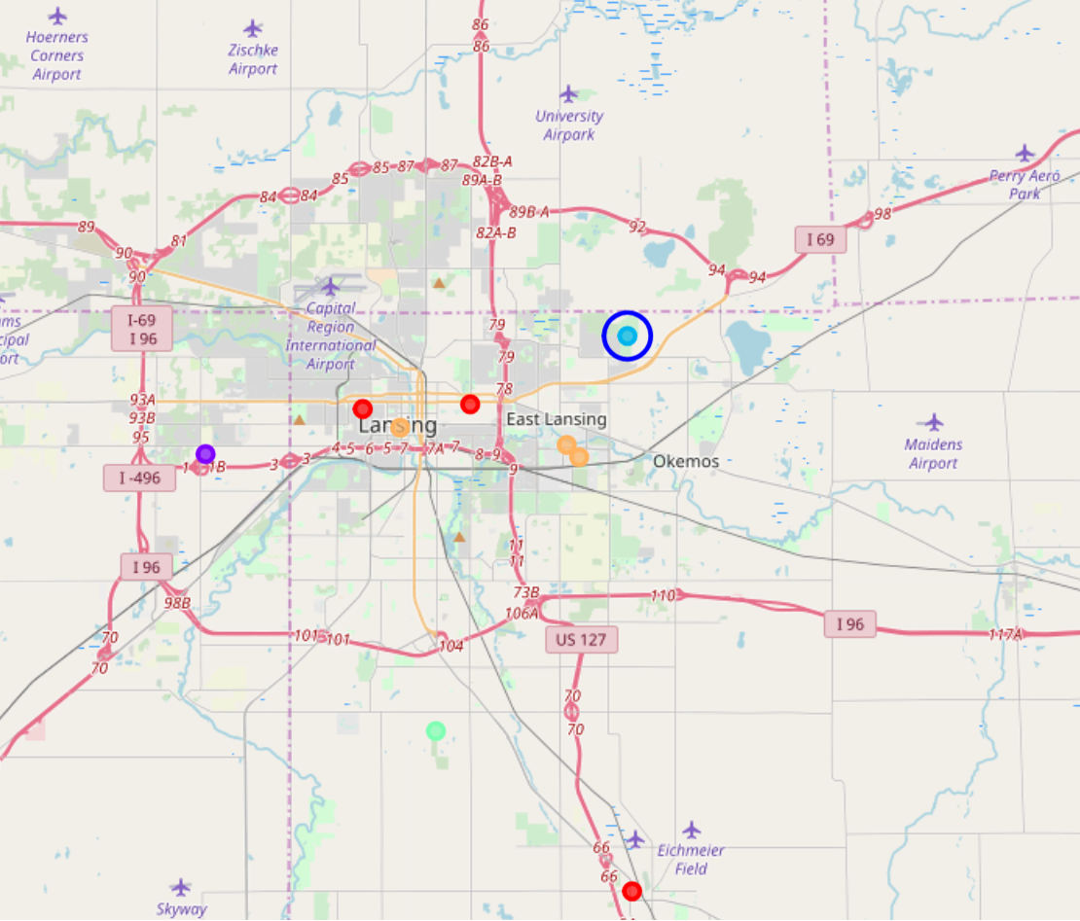

**Discussion**

Although 48825 region has the most restaurants, the population in this region is not much. The average expected guest is not much. For 48823 region, there has only one restaurant and has the most average expected guest. According to the analysis, we found that the best place to open an Asian Restaurant is in 48823 region.

**Conclusion**

In this report, we collected the zip code and population of Lasing Capital Area from internet. Using foursquare API to locate venues in these regions. Then clustering these regions with k-mean method. Finally, we figure out the best region to open an Asian restaurant in Lasing Capital Area is in 48823 region.