1. 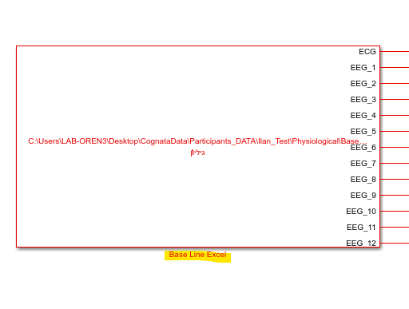Open model : "BaseLine_Excel.slk", update the sheet into "base Line Excel.slk" block and run the model for 60 sec
2. Open script : "Mean_Sd.m" and run, we able to see in the workspace the sd and mean of the HR and Ratio

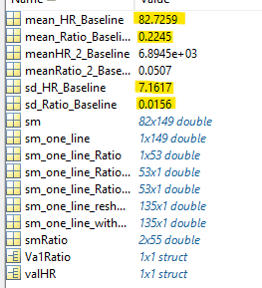

1. Open functions : "probability_of_menta_load_RATIO/HR.m" and put the variables from (2) in place

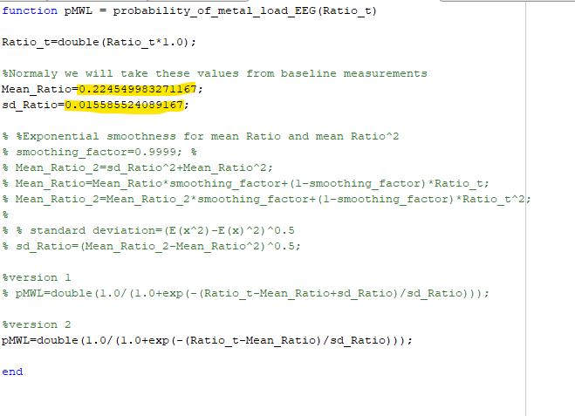



* Open model : "BaseLine_Excel.slk", update the stress sheet into "stress Excel " block

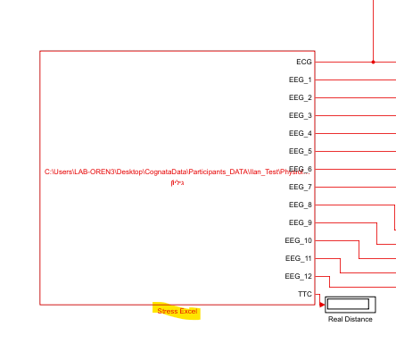

* In the constant blocks put the (2) variables

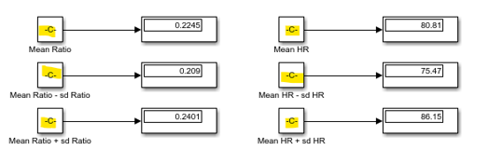

* Run the model