# Generic

nb lines: 114528 lines

# Year of publication

## Lots of books published between 1983 and 2006

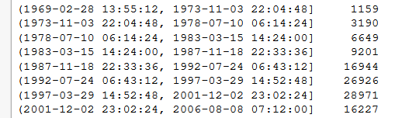

[…]

## Years intervals representing at least 5% of books in our dataset

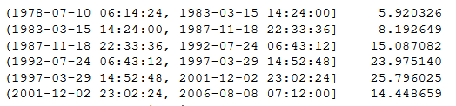

# Languages

## Cleaning

Some languages were ***coded in several words*** :

* "Catalan; Valencian" => ca
* "English, Middle (1100-1500)" en
* "Multiple languages" en
* "zh-CN" zh
* "zh-TW" zh
* Replaced by their ***ISO 639 coding*** :

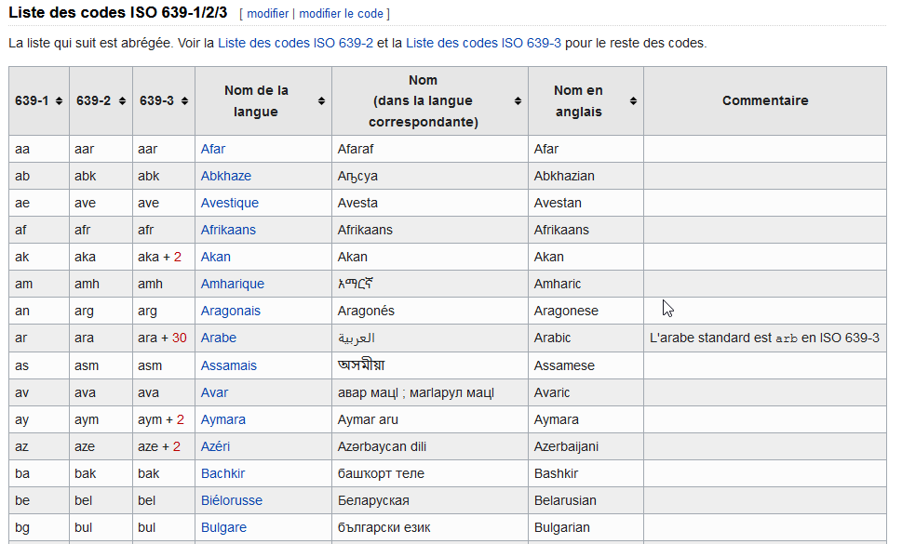

[…]

Then some languages are coded with ***words instead of ISO 639 coding***

* Replaced by their ISO 639 coding

## Mainly english books

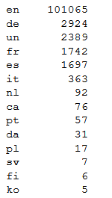

[…]

# Awards

## Books with lost of awards (before cleaning)

The maximum number of awards for a same book is 27 !

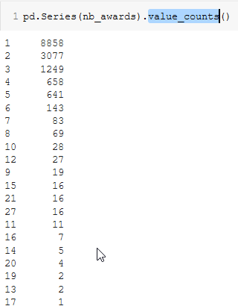

* Harry Potter and the Sorcerer's Stone (at indice 2809) !!!!

## Kind of awards (before cleaning)

* list saved in ***"awards_names.csv"***

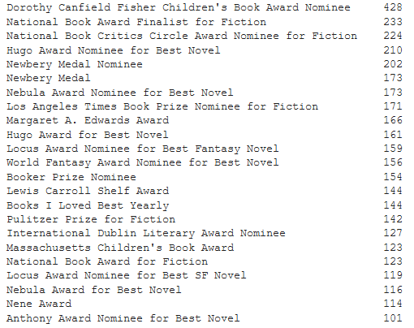

[…]

## Cleaning

For each book:

* split according to ***","*** in order to obtain the list of awards
* then split according to ***"("*** in order to keep only the name (and not the date)

A list of all cleaned awards has been created in ***"awards_names.csv"***

I ***kept only one award name per book***, the most famous awards in each cells (compared to the previously created list).

## Kind of awards (after clening)

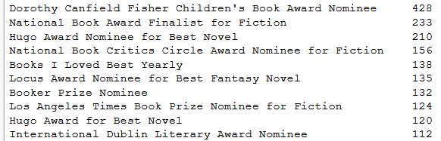

[…]

* It remains 613 kind of awards.

# Categories

## Before cleaning

5010 categories

* Categories with only one element saved in ***"cat_one_book.csv"***

### Lots of Fiction : 35.28 % of all books

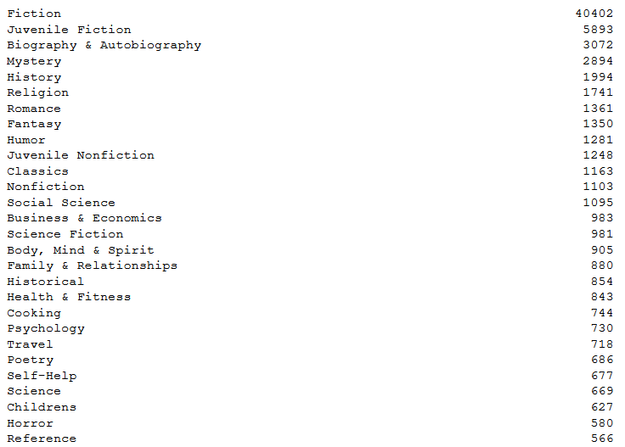

[…]

### Repartition of the number of elements insed categories : lots of categories with less than 80 books inside



[…]

### To keep 95% of the most important categories, we could keep the 3989 first categories (on 5010)

### Categories representing at least 1% of all the books

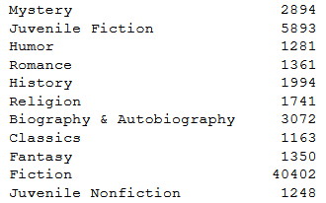

## Cleaning

The cleaning has been performed in several steps :

* 1st categories with ***"&"*** inside : a second column "Category_other" has been created to take the 2nd term after the "&"
* Then the category words between ***"(…)"*** has been put inside "Category_other" column, and the first term only remains on the "Category" column
* Then the category words with ***","*** has been splitted in two : the first term before the "," on "Category" column, and all the remaining termns in "Category_other" column

## After cleaning & both columns

### Lots of Fiction : 35.28 % of all books

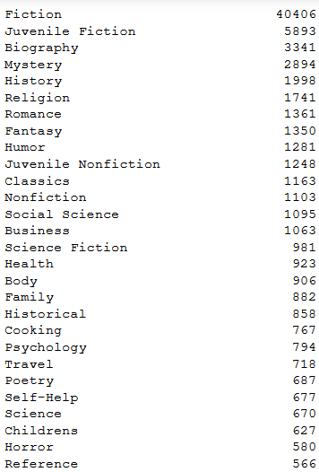

[…]

* Quite the same as previously

### Repartition of the number of elements insed unified categories : lots of categories with less than 140 books inside

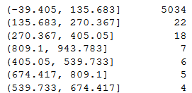

[…]

### To keep 95% of the most important unified categories, we could keep the 4143 first categories (on 5113)

### Unified categories representing at least 1% of all the books

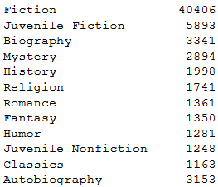

# Author genres

## Cleaning

Cleaning (on Colab ) as multiple author genres in one cells, genres separated by ***&***

* 2 columns : "author_genres" and "author_genres_other"

## author_genres

* author genres with only one element inside saved in ***"author_gender_one_book.csv"***

### Lots of Literature as author gender

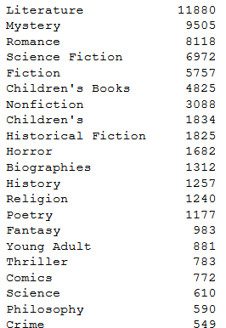

[…]

### Repartition of the number of elements insed author genres : lots of author genres with less than 240 books inside

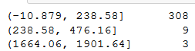

[…]

### To keep 95% of the most important author genres, we could keep the 303 first author genres (on 338)

### author genres representing at least 1% of all the books

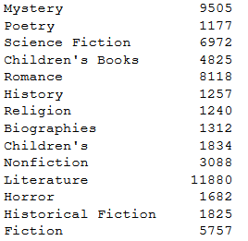

* Mystery, Romance, History, Religion, biography and fiction in common with categories.
* The same after cleaning categories.

## author_genres_other

* author genres with only one element inside saved in ***"author_other_gender_one_book.csv"***

### Lots of Fiction as author other gender

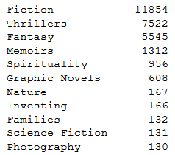

[…]

### Repartition of the number of elements insed author other genres : lots of author other genres with less than 120 books inside



[…]

### To keep 95% of the most important author other genres, we could keep the 34 first author other genres (on 39)

### author other genres representing at least 1% of all the books

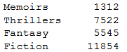

## Both columns

* author unified genres with only one element inside saved in ***"author_unified_gender_one_book.csv"***

### Lots of Literature as unified author genres

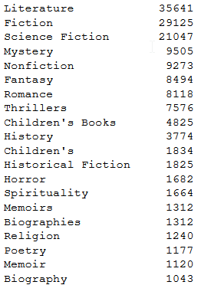

[…]

### Repartition of the number of elements insed unified author genres : lots of author genres with less than 180 books inside

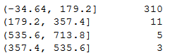

[…]

### To keep 95% of the most important unified author genres, we could keep the 324 first author other genres (on 352)

### unified author genres representing at least 1% of all the books

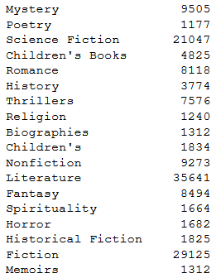

* Thriller, Fantasy, Spirituality and Memoirs is appearing ***from the author_genres column***
* Mystery, Romance, History, Religion, Biography, Fantasy, Fiction in common ***with categories***.
* The same after cleaning categories

# Duplicates

## Cleaning

***Duplicates have been removed***. Duplicates have been serached according to :

* ***ISBN*** comparison

*Remark : ISBN 13 values seem to be very often 9780000000000*

* *Column corrupted, no used then !*

Then ***title + author*** (exact comparison) have been compared. Duplicates have been :

* duplicates saved in ***"Books_Duplicates.csv"***
* ***removed from "bothWebSites_InternetSearch_AllBooks_BookCrossing_cleaned.csv"***

# Category and author genre

## Selection of the most famous categories

* Joined categories of
  + "Books_Duplicates.csv"
  + + "bothWebSites_InternetSearch_AllBooks_BookCrossing_cleaned.csv" selected,
    - saved in ***"Sel_cat_autgenr.csv"***
      * Variable sel_cat
* Joined categories of
  + "Books_Duplicates.csv"
  + + "bothWebSites_InternetSearch_AllBooks_BookCrossing_cleaned.csv" NOT selected,
    - saved in ***"Other_cat_autgenr.csv"***
      * Variable other_cat

Joined categories of

* "Books_Duplicates.csv"
* + "bothWebSites_InternetSearch_AllBooks_BookCrossing_cleaned.csv",

and the number of each categories are:

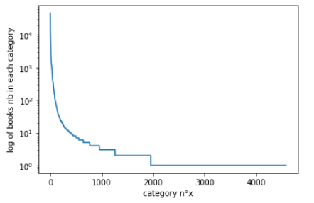

Zoomed view around the 2000th category :

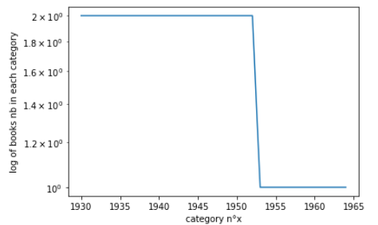

I could chose to keep only the first 1953ieth categories…

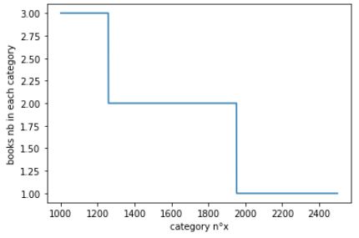

…but it corresponds to categories with only 2 books inside.

The first ***403*** categories have at least 10 books inside : it' my limit ;

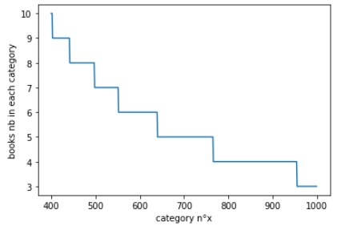

## Cleaning an Creation of train data set

* Skip Gram model saved in ***"skipGram_cat.model"***

FAILURE :

gensim.downloader.load('glove-wiki-gigaword-50')

and gensim.downloader.load('word2vec-google-news-300')

* NOK because our words categories are not inside

AND colab do not accept such huge data set loading !

I have joined content of columns (in "sent" variable) of "Books_Duplicates.csv"and "bothWebSites_InternetSearch_AllBooks_BookCrossing_cleaned.csv" :

* "book_description"
* "Category"
* "Category_other"
* "author_genres"
* "author_genres_other"

Cleaning of "book_description" column by remowing

* ***stopwords***
* ***words of length < 2***
* ***'...'***

I used the last version of Word2Vec inside gensim.models :

* construction of vocabulary
* model training
  + Skip Gram
  + numerical vector of length 50

## Find the Category the most close to the selected categories

* Udpate of file ***"Other_cat_autgenr.csv"***
  + Variable other_cat

I used the previous model to find for each categories inside other_cat the closest category inside sel_cat, with model.wv.most_similar_to_given.

## Cleaning of Category and Author_genre

I have ***updapted the Category and author_genre columns of*** "bothWebSites_InternetSearch_AllBooks_BookCrossing_cleaned.csv" ONLY ***thanks to those previous w2v link***.

# Category_other and Category_other

There are 612 unique values inside Category_other.

There are 38 unique values inside author_genres_other.

* No additional cleaning with word2vec performed, too few values.

# ISBN meaning

An ISBN is an ***International Standard Book Number***.

## History

The initial ISBN identification format was devised in 1967, based upon the 9-digit Standard Book Numbering (SBN) created in 1966.

The ISBN identification format was conceived in 1967 in the United Kingdom by ***David Whitaker*** (regarded as the "Father of the ISBN") and in 1968 in the United States by Emery Koltay.

The 10-digit ISBN format was developed by the [International Organization for Standardization](https://en.wikipedia.org/wiki/International_Organization_for_Standardization) (ISO) and ***was published in 1970*** as international standard ISO 2108.

## Nation dependant

The method of ***assigning an ISBN is nation-specific*** and varies between countries, often depending on how large the publishing industry is within a country.

ISBN issuance is country-specific, in that ISBNs are issued by the ISBN registration agency that is responsible for that country or territory regardless of the publication language.

The ranges of ISBNs assigned to any particular country are based on the publishing profile of the country concerned, and so the ranges will vary depending on the number of books and the number, type, and size of publishers that are active.

## What is identified

Any book made publicly available, whether for sale or on a gratis basis, can be identified by ISBN.

An ISBN is assigned to each separate edition and variation (except reprintings) of a publication. For example, an [e-book](https://en.wikipedia.org/wiki/E-book), a [paperback](https://en.wikipedia.org/wiki/Paperback) and a [hardcover](https://en.wikipedia.org/wiki/Hardcover) edition of the same book will each have a different ISBN

*Remark : Other identifiers exist :*

* *the International Standard Serial Number (ISSN), identifies periodical publications such as magazines and newspapers.*
* *The International Standard Music Number (ISMN) covers musical scores.*

## Who ask for ISBN creation

It is always the publisher of the book who should apply for the ISBN.

## Various formats

* ISBNs were 10 digits in length up to the end of December 2006.
* Since 1 January 2007 they now always consist of 13 digits.

An ***ISBN-10*** is converted to ***ISBN-13*** by prepending "978" to the ISBN-10 and recalculating the final checksum digit using the ISBN-13 algorithm.

Currently the barcodes on a book's back cover are ***EAN-13*** ([European Article Number](https://en.wikipedia.org/wiki/European_Article_Number)).

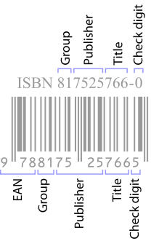

*Remark : They may have a separate barcode encoding five digits called an EAN-5 for the currency and the recommended retail price.*

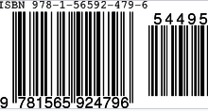

## Mathematic formula

ISBNs are calculated using a specific mathematical formula and include a check digit to validate the number.

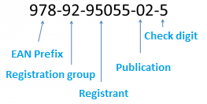

Each ISBN consists of 5 elements with each section being separated by spaces or hyphens. Three of the five elements may be of varying length:

* ***Prefix element*** – currently this can only be either 978 or 979.
  + It is always 3 digits in length.

Bookland is a fictitious country that exists solely in EAN for the purposes of non-geographically cataloguing books in the otherwise geographically keyed EAN coding system.

* ***Registration group element*** – this identifies the particular country, geographical region, or language area participating in the ISBN system.
  + This element may be between 1 and 5 digits in length

|  |  |  |
| --- | --- | --- |
| Prefix | Registration group | Meaning |
| 978 | 0 or 1 | English-speaking countries |
|  | 2 | French-speaking countries |
|  | 3 | German-speaking countries |
|  | 4 | Japan |
|  | 5 | Russian-speaking countries |
|  | 600–625 |  |
|  | 65 |  |
|  | 7 | People's Republic of China. |
|  | 80–94  *ex 80*  *ex 85* | *Czech Republic; Slovakia*  *Brazil* |
|  | 950–989  *ex 960* | *Greece* |
|  | 9917–9989  *ex 9971* | *Singapore* |
|  | 99901–99983  ex 99921 | *Qatar* |
| 979 | 8 | United States of America |
|  | 10 | France |
|  | 11 | Republic of Korea |
|  | 12 | Italy |

* ***Registrant element*** - this identifies the particular publisher or imprint.
  + This may be up to 7 digits in length
* ***Publication element*** – this identifies the particular edition and format of a specific title.
  + This may be up to 6 digits in length
* ***Check digit*** – this is always the final single digit that mathematically validates the rest of the number. It is calculated using a Modulus 10 system with alternate weights of 1 and 3.
  + For a 10 digits ISBN :



* + For a 13 digts ISBN:



## Errors in usage

Publishers and libraries have varied policies about the use of the ISBN check digit. Publishers sometimes fail to check the correspondence of a book title and its ISBN before publishing it; that failure causes book identification problems for libraries, booksellers, and readers.

For example, ISBN 0-590-76484-5 is shared by two books :

* Ninja gaiden®: a novel based on the best-selling game by Tecmo (1990)
* and Wacky laws (1997), both published by Scholastic.

The ***Library of Congress catalogue*** contains books published with invalid ISBNs, which it usually tags with the phrase "Cancelled ISBN".

However, book-ordering systems such as Amazon.com will not search for a book if an invalid ISBN is entered to its search engine.